專科醫師甄審影像題參考用答案卷 RECTUM
題目 | 答案
- 簡述病人癌症相關檢查主要重點發現。
(image/lab/surgical/pathology/risk factors)
- 完整定義病人之癌症分期，使用AJCC^{8th} 及其他主要分期系統。
- 依照實證醫學指引，提出病人之完整治療規劃，包括其他Multimodality輔助治療，並簡述indications, benefits & risks相關證據。 | NCCN: for T3, N+: preOP CCRT -> TME -> CAPEOX  XRT + continuous infusion 5-FU  5-FU 225 mg/m2 IV over 24 hours 5 or 7 days/week during XRT  CAPROX:  Oxaliplatin 130 mg/m2 IV day 1.  Capecitabine 1000 mg/m2 PO twice daily days 1–14 every 3 weeks. Repeat every 3 weeks to a total of 6 months perioperative therapy.  German rectal trial  T3-4 N+ s/p TME + adj C/T (pre vs post CCRT)  Pre CCRT 增加sphincter preserve / LC, 降低acute/late toxicities, NS in OS/DM/PFS。  2011 Korean Trial  CCRT + OP vs OP + CCRT, NS in DFS, OS, LC, 增加sphincter preserve。
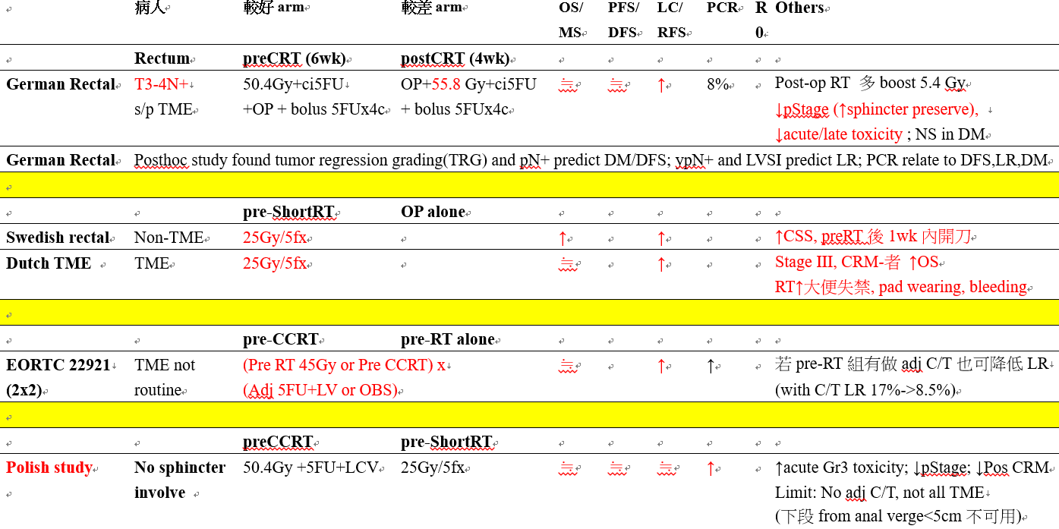

- 如果安排病人接受放射治療
a. 明確定義CT simulation:  - Patient positioning and immobilization  - CT image acquisition (thickness)  - Scanning localization 範圍  - 3DCT/4D CT/gating | -採用舒適之仰臥姿勢，病患腳部擺放在腳踝固定器(ankle fix device)上，提高病患之穩定度。 視病患穩定狀況考慮施用真空墊(vacuum bag)作為固定模具。  將治療中心標記在下腹部皮膚上，若使用真空墊固定的表面也要畫上標記。若想減少小腸之照射，可以俯臥姿勢，並使用腹式板(belly board)。  -電腦斷層之掃描範圍約從第3腰椎到恥骨下5公分，切片厚度為3 ~5毫米。  -3DCT技術
- 明確定義治療靶區之GTV、CTV及PTV範圍 | Nancy Lee, Target Volume Delineation for Conformal and Intensity-Modulated Radiation Therapy  GTV: visible gross tumor  CTV-H  GTV+1.5-2cm(上下)/1-2cm(四周) including rectum, mesorectum, presacral; 1-1.5cm into bladder  CTV-standard  上緣:L5/S1 (2cm above GTV)  Mesorectum, presacral, internal iliac,  ; external iliac (T4);int/ext iliac +0.7cm (ext之anterior + 1-1.5cm)  1-1.5cm into bladder  下緣:pelvic floor (2cm below GTV)\  PTV-H/standard = CTV-H/standard + 3-5mm
- 明確定義Radiation modality (2D/3D/ 4D,IMRT/Arc/SRS) | Arc
- 明確定義治療靶區之放射劑量及次數:  - Treatment volume (GTV, CTV, PTV)  - Prescription dose  - Fractionation schedules  - Beam energy  - Image procedures (KV imaging /cone beam CT/MV CT) | 15 MV, IGRT with cone-beam CT (NCCN suggestion)  PTV standard:45 Gy / 25 fx  PTV-H: boost 5.4 Gy / 3fx (to total 50.4 Gy)  (Unresectable: >54Gy)  Short RT:5Gy x 5
- 明確定義相關正常組織之放射線劑量限制  - Dose to critical structures  - Tolerance level (TD5/5) | RTOG 0822  Small bowel: V45 < 65 cc; V40 < 100 cc;  V35 < 180 cc; V30 < 300 cc  Unil kidney: V18 < 2/3 of kidney  Femoral head: V50 < 0.5 cc  Bladder: V50 < 0.5 cc V40 < 40%
- 明確定義放射治療電腦計劃之評估方法及標準 | 50.4 Gy isodose surface encompass 100% CTV-H  50.4 Gy isodose surface encompass ≧ 95 % PTV-H  100% PTV-H receive ≧ 95% prescribed dose  No more than 20% of PTV-H receive ≧ 110% prescribed dose  No more than 1% of PTV-H receive ≦ 93% prescribed dose  No more than 1 c.c. outside PTV-H receive ≧ 110% prescibed dose  ---  45 Gy isodose surface encompass 100% CTV-Standard (CTV-S)  45 Gy isodose surface encompass ≧ 95 % PTV-Standard (PTV-S)  100% PTV-S receive ≧ 95% prescribed dose  No more than 20% of PTV-S receive ≧ 110% prescribed dose  No more than 1% of PTV-S receive ≦ 93% prescribed dose  No more than 1 c.c. outside PTV-S receive ≧ 110% prescibed dose
- 簡述放射治療可能引發之副作用 | Acute：diarrhea，dysuria，fatigue，skin irritation  Late：diarrhea，urgency，proctitis，change bowel habit，anastomic stircture，bowel obstruction  Chemo：hematologic toxicity
- 畫出GTV及CTV之 contour

