- 有關甲狀腺癌的敘述，下列敘述何者為誤？
  - Papillary thyroid carcinoma最常見的甲狀腺癌病理組織分化，且是甲狀腺癌中預後最好的。
  - 甲狀腺癌的重要預後因子包括histology，年紀，腫瘤大小，放射性碘的濃度(radioactive iodine concentration)。
  - 診斷為anaplastic thyroid carcinoma的病人數佔全部甲狀腺癌的比例<5%，但卻造成約20~50%的甲狀腺癌死亡數
  - Differentiated papillary carcinoma的預後較好，其中tall cell及columnar cell variants的預後最佳
    - D (甲狀腺癌)
      - 易
        - Principle and Practice of Radiation Oncology, 6th ed, 2013, Chapter 50
          - (A) P920. PTC is the most common histologic type, representing approximately 80% to 90% of all thyroid cancer diagnosis, and the has the best prognosis of all thyroid malignancies.
(B) P926 Table 50.5. Prognostic factors included age, gender, family history, tumor size, focality/laterality, extrathyroid extension, histologic grade, lymph node metastasis, distant metastasis, and radioactive iodine concentration.
(C) P921. ATC comprise < 5% of all malignant thyroid
neoplasms. This is the most aggressive form of thyroid carcinoma, accounting for 14% to 50% of all thyroid cancer deaths.
(D) P920. Tall cell and columnar variants are commonly associated with poor prognostic features.
- 有關甲狀腺癌的敘述，下列敘述何者為誤？
  - Hürthle cell carcinoma及poorly differentiated carcinoma較不會吸收Radioactive Iodine。
  - Medullary thyroid carcinoma origin為parafollicular C cell，因此不會吸收Radioactive Iodine。
  - 兒童時期接受過頭頸部RT會增加thyroid cancer發生機率，且通常為分化差且預後較差的腫瘤。
  - 甲狀腺癌最容易發生遠端轉移的位置為lung。
    - C (甲狀腺癌)
      - 中等
        - Principle and Practice of Radiation Oncology, 6th ed, 2013, Chapter 50
          - (A) (B) P921 Table 50.2.
Frequent do not concentrate RAI: Tall cell and columnar cell variants of papillary carcinoma, Hürthle cell carcinoma, Poorly differentiated carcinoma.
Never concentrate RAI: Anaplastic carcinoma, Medullary carcinoma
(C) P922. Radiation-induced thyroid cancer is pathologically indistinguishable from spontaneous forms of the disease and is not associated with more aggressive biology or poorer prognosis.
(D) P927. Roughly 10% of the patients with PTC and 25% of those with FC develop distant metastasis, with the lungs being the most common site of involvement.
- 關於RT對甲狀腺癌的治療結果，下列敘述何者有誤？
  - 根據PMH experience (Brierley et al. 2005)，differentiated thyroid cancer手術後若發現有microscopic residual disease，則給予術後放射線治療可提升局部控制率。
  - 根據PMH experience (Brierley et al. 2005)，differentiated thyroid cancer手術後，針對高風險族群包括:年紀>60歲，margin positive或extrathyroid extension，給予術後放射線治療可增加cause-specific survival。
  - 根據Hong Kong experience (Chow et al. 2002)，papillary thyroid cancer接受thyroidectomy後，發現有microscopic residual tumor，則給予術後放射線治療可提升局部控制率。
  - 根據Kim et al.在2003年發表的文章，pT4 or node positive的differentiated thyroid cancer的病人，在接受過手術及I-131的治療後，接受術後放射線治療可提升局部控制率。
    - C (甲狀腺癌)
      - 難
        - Principle and Practice of Radiation Oncology, 6th ed, 2013, Chapter 50
          - P933, Table 50.14.
(C) Gross residual tumor after thyroidectomy給予術後放射線治療才有local regional control benefit
- 有關甲狀腺癌的敘述，下列何者有誤？
  - Papillary carcinoma及follicular carcinoma屬於differentiated cancer，大部分會吸收I-131，預後較好。
  - Insular thyroid carcinoma origin為poorly-differentiated cancer，對I-131吸收較差，預後比Papillary carcinoma差。
  - Anaplastic thyroid carcinoma發生機率低，腫瘤不吸收I-131，預後很差。
  - Medullary thyroid carcinoma中有部分腫瘤會吸收I-131，預後跟follicular carcinoma相似。
    - D (甲狀腺癌)
      - 易
        - Principle and Practice of Radiation Oncology, 6th ed, 2013, Chapter 50
          - (D) P921. Medullary thyroid carcinoma never concentrate RAI，預後比follicular carcinoma差。
- 有關甲狀癌(thyroid cancer)之描述，下列何者為是？
  - Thyroglobulin是常用的生化指數，可用於所有甲狀腺癌患者的追蹤。
  - 根據AJCC 8th edition，年紀小於45歲的differentiated thyroid cancer只有stage I及stage II兩種期別。
  - Thyroid cancer於AJCC staging均可區分為I-IV期，主要是依據年紀，腫瘤大小，有無淋巴轉移，有無遠端轉移來決定分期。
  - 抑制TSH的表現，有助於減少differentiated thyroid carcinoma的復發。
    - D (甲狀腺癌)
      - 中等
        - Principle and Practice of Radiation Oncology, 6th ed, 2013, Chapter 50
          - (A) P935. Thyroglobulin (Tg)適用於differentiated thyroid carcinoma的追蹤。
(B) AJCC 8th edition: < 55歲。
(C) AJCC 8th edition: Anaplastic carcinoma全屬於第四期。
- 有關甲狀腺癌(thyroid cancer)之敘述，下列何者為誤？
  - 甲狀腺癌最易移轉的頸部淋巴結為level 6。
  - 以疾病預後來看papillary thyroid cancer > follicular carcinoma > anaplastic carcinoma。
  - Follicular carcinoma較papillary thyroid cancer容易淋巴轉移。
  - Thyroid cancer 最容易遠端轉移之處為肺部。
    - C (甲狀腺)
      - 中等
        - Peres and Brady’s – Principles and Practice of Radiation Oncology, 6th edition
          - (C) P927. Lymph node metastases are more common with papillary thyroid cancer than follicular cancer (46% vs. 25%)。
- 有關甲狀腺癌的治療，下列敘述何者為誤？
  - 對於Differentiated thyroid carcinoma，維持較高的TSH level對腫瘤控制有好處
  - 若為復發高風險的Hürthle cell carcinoma，應維持TSH level < 0.1 mU/L，且需注意是否攝取足夠的calcium及vitamin D。
  - 若為低復發風險的甲狀腺癌，應維持TSH level在0.1-0.5 mU/L。
  - 使用levothyroxine使應注意補充鈣及維生素D。
    - A (甲狀腺)
      - 易
        - NCCN Guideline Version 2.2019. Thyroid Carcinoma
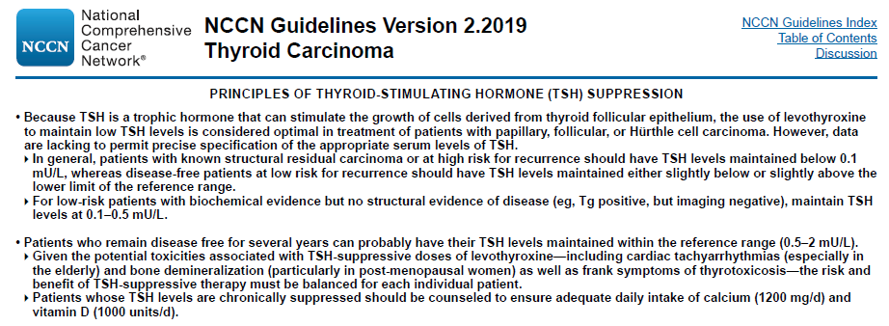
- 有關Medullary thyroid carcinoma之敘述，下列何者為非？
  - 來源於parafollicular C-cells。
  - 80%來自於familial multiple endocrine neoplasia (MEN) type II
  - MEN 2A包含有medullary thyroid carcinoma, pheochromocytomas, and parathyroid tumors。
  - MEN 2B包含有medullary thyroid carcinoma, pheochromocytomas, Marfanoid habitus, and mucosal neuromas。。
    - B (甲狀腺癌)
      - 中等
        - Eric K. Hansen, Mack Roach III, et al. Handbook of Evidence-based Radiation Oncology, 3rd edition. Chapter 11.
          - (B) P245. 20%。

