NPC:
#2020/6 Network-meta-analysis of chemotherapy in nasopharyngeal carcinoma (MAC-NPC): An update on 8,221 patients.
OS方面:
1.有Taxane的ind C/T + CCRT 優於
2.CCRT + adj C/T 優於
3.無Taxane的ind C/T + CCRT
4.優於CCRT alone
(1.和3.相比有無taxane的ind C/T效果也符合Tax 323-324之結論 有T好)
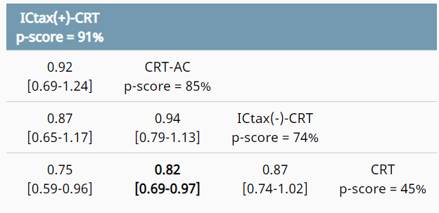

#華南醃魚是危險環境因子。EBV主要和non-keratinizing(WHO IIA/IIB)鼻咽癌相關。
#IgA-antiVCA和IgG-EA診對鼻咽癌敏感性都很高；但是IgA-antiVCA的特異性較高
#plasma EBV-DNA比IgA-antiVCA更加敏感與專一，且可反映出NPC的tumor load。可用來評估療效、預測recurrence rate及long term survival。

2001 JCO: EBV-DNA in PBCs related to higher DM and lower OS
DNA was extracted from peripheral-blood cells (PBCs) and analyzed by a nested PCR using primers specific to Epstein-Barr virus nuclear antigen 1 (EBNA-1). The presence of EBNA-1 DNA in PBCs is a novel, important risk factor for patients with NPC that indicates a significantly higher risk of DM and lower OS.

2003 JCO: CCRT better than RT in 5y OS
Stage III to IV (M0) NPC were randomly allocated into two arms. The 5-year overall survival rates were 72.3% for the CCRT arm and 54.2% for the RT-only arm.

2004 NEJM:
pre tx EBV DNA > 1500 => lower OS (3y OS:95 vs 70) and RFS；
post tx persistently detectable EBV-DNA after 1 week => lower OS (3y OS:90 vs 20) and RFS
Stage III or IV (M0) NPS s/p 10 weekly chemotherapy treatments followed by radiotherapy. OS(P<0.001) and RFS (P=0.02) were significantly lower among patients with pretreatment plasma EBV DNA concentrations of at least 1500 copies per milliliter than among those with concentrations of less than 1500 copies per milliliter.
Patients with persistently detectable plasma EBV DNA had significantly worse OS (P<0.001) and RFS (P<0.001) than patients with undetectable EBV DNA one week after the completion of radiotherapy.

2004 IJROBP: CCRT優於RT only in low risk => high risk應該加neo or adj C/T
(high risk: N>6cm, 多LN至少一個>4cm, SCF N, cT4N2)
A total of 284 patients with Stage III to IV (M0) NPC were analyzed retrospectively. They were treated by either radiotherapy (RT) alone or CCRT. We divided patients into high-risk and low-risk subgroups according to our experience. High-risk patients met at least one of the following criteria: (1) nodal size >6 cm, (2) supraclavicular node metastases, (3) 1992 AJCC stage T4N2, (4) multiple neck node metastases with 1 node >4 cm. Concurrent chemoradiotherapy is superior to RT alone for low-risk patients but inadequate for high-risk patients. Adding neoadjuvant and/or adjuvant chemotherapy would be a reasonable approach for high-risk patients.

- INT0099 NPC => CCRT + C/T vs RT alone
#CCRT(70Gy+cisplatin 100mg/m2 Q3W x 3c)+adjuvant cisplatin 80mg/m2+5-FU 1000mg/m2 x Q4W x3c
#病人中以nonkeratinizing undifferentiated carcinoma最多，SqCC最少。
#以第七八版分期來看收案對象為第二-四期病人
#CCRT+C/T比起RT alone增加3y PFS/OS。(5y OS:67/37%)
#CCRT有更多急性和晚期副作用。只有63%完成三次CCRT，55%完成三次adj RT。
- 2016/2019孫逸仙大學發表的induction C/T + CCRT vs CCRT alone，對象都是stage III-IV排除T3-4N0的NPC。結果induction C/T(2016 TPF / 2019 GP)都有提升DFS和OS。
- 喉癌器官保留治療
#RTOG 9111 Ind C/T 100mg + 5 FU CI 1000mg Q3W x 3c + RT or largenectomy vs
CCRT (cisplatin 100mg Q3W + 70Gy) vs RT alone (70Gy, SCF 50Gy)上述larynx preservation rate:72% / 84% / 67%。=>CCRT有最佳的器官保留率和LC，但NS in OS。
#VA larynx trial: induction C/T + RT vs OP + RT，前者LC較差，QoL較好。但NS in OS/吞嚥/語言。
#TREMPLIN study在2013發表，研究stage III-IV larynx or HPX，結論是induction C/T後，不管使用cisplatin為主的CCRT或是加上cetuximab，對於喉保留率無統計學差異。
- CCRT vs RT alone
#GORTEC 9401收錄stage III-IV OPX cancer比較CCRT (70Gy + Carboplatinc/5FU x 3c) vs RT alone發現CCRT有較高的OS/LC。[C/T benefit to conventional Fx]
#GORTEC 99-02 for stage III-IV之頭頸癌的CCRT化療使用carbo+5FU，並發現搭配conventional fx (70Gy/7wk)比起CCRT(70Gy/6wk) 或very accelerated fx alone (64.8Gy/3.5wk)有較高的PFS (37.6%/34.1%/32.2%)
#German ARO 95-06的病人九成為stage III-IV OPX或HPC，結果CCRT比起RT可提升OS/LC
#Mayo clinic比較頭頸癌CCRT的治療，發現weekly cisplatin和high dose cisplatin NS in OS
#MACH-NC analysis中頭頸癌病人年紀越大，接受化療的好處越不顯著。<50歲和>70歲相比，有無化療的5yOS提升率差距為八倍(24% vs 3%)。[不是三倍]。C/T+RT相較於RT alone增加4.5% (CCRT 6.2%) OS [不是2.5%]。無論是postop/definitive, conventional/altered fx CCRT都比RT alone提升OS。單一化療和多藥物化療相比無顯著差異，但使用platin based效益最佳。
#Pingnon et al =2009的MACH-NC meta-A發現CCRT增加5y OS 6.2% {不是2.5%}，主要歸功於LC的增加(13.5%)，而非DM減少 (DM並沒有顯著下降)。此外CCRT相對於sequential C/T 的好處在OPX和LYNX更為明顯。對於>70歲者，加上化療的好處則不明顯HR=0.97)。
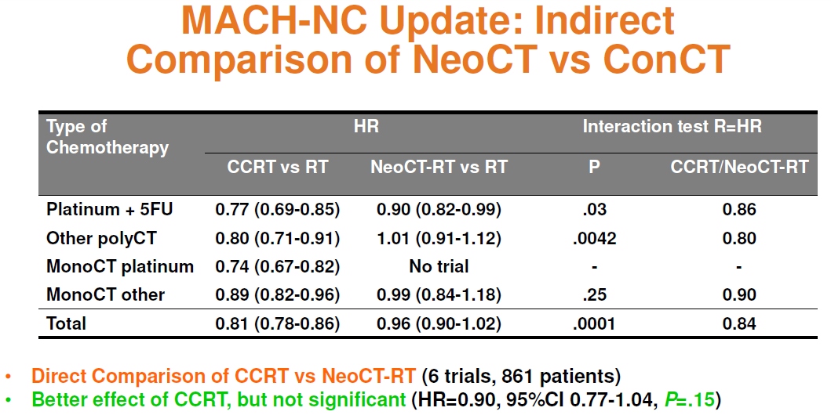

- Ind C/T
#TAX 323/324之TPF都是Taxotere, Cisplatin, 5-FU
#TAX 323/324中，放射治療過程中，兩個試驗之實驗組對照組副作用沒有差異。
#TAX 323的實驗組中，ind C/T若沒有disease progression則於4-7wk內開始RT。結果使用紫杉醇
於ind C/T(TPF vs PF) + RT改善DFS和OS，但有較高的血液毒性和化療致死性。
#TAX 324 是比較PF和TPF + CCRT [w/I carbo,非RT alone]，結果使用紫杉醇可以增加LC和OS，但NS in DM其中，TPF組的長期gastrotomy和tracheosotmy機率都比較低，但沒有統計差異。subgroup分析中HPV+病人接受TPF者OS較佳，但因人數太少沒有統計差異。
#Gortec 2000-01使用TPF當ind C/T比起PF而言有更高的tumor response
#PARADIGM顯示CCRT再加上ind TPFx3c後並未提升OS/PFS [PFS也沒有提升]，但增加副作用(如febrile neutropenia)
#DeCIDE trial比較 +/-ind TPF + CCRT(hyperFx RT + docetaxel/5FU/Hydroxyurea)。Ind TPF沒有提升OS但增加嚴重副作用皆近一倍(48%vs27%)
#Spanish HN Ca Cooperative trial顯示CCRT再加上ind C/T後並未提升OS
#以器官保留的角度來看 ind C/T + CCRT vs CCRT誰優誰劣仍有爭議

- Adj RT:RTOG 9501 / EORTC 22931
#這兩個trial口腔癌皆不到三成，兩者都有收錄兩個LN+以上的病人
#22931有較高比率的HPX，9501有較高比率的OPX
#EORTC 22931發現CCRT增加OS/DFS/LC
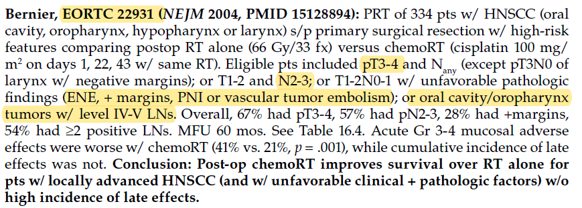
#若手術後僅有一個危險因子為>=兩個LN+，則CCRT比起RT並無顯著好處
#RTOG 9501發現CCRT在ENE或margin+的病人相比RT alone增加DFS/LC，但是在OS只是有好的trend [不是顯著增加OS]，而其他subgroup或ALL PT的DFS/LC/OS都沒差。
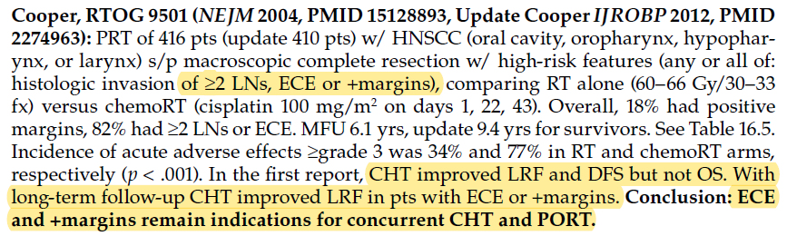
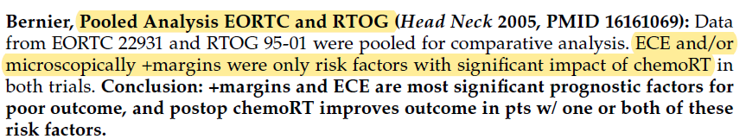
- 頭頸癌用標靶治療
#Extreme study顯示使用以鉑類為主的化療中加入Cetuximab可增加復發頭頸癌病人MS
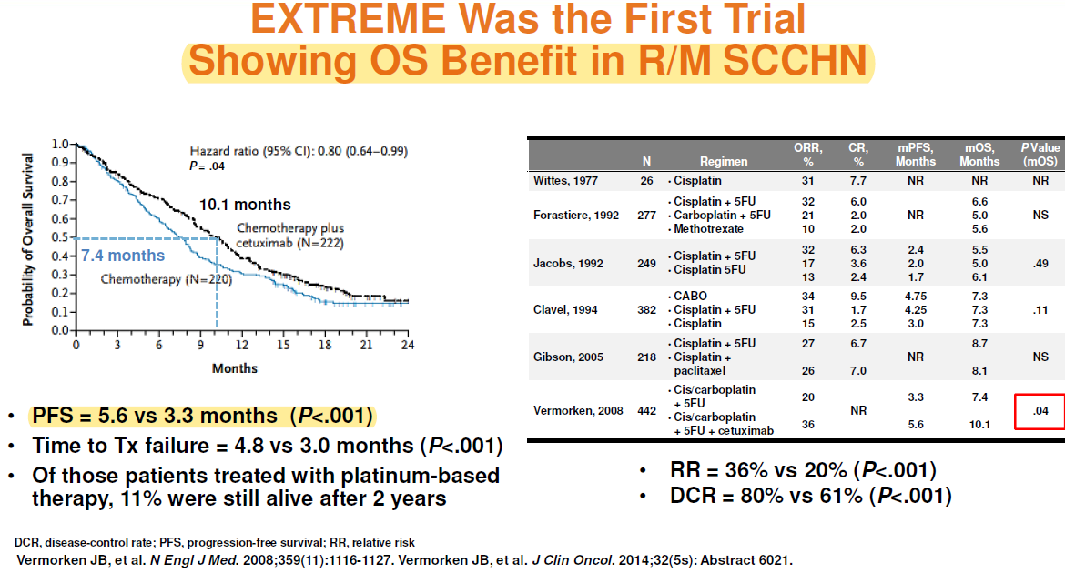
#Bonner’s study:所選取的族群包括OPX, HPX, LYNX cancer。Cetuximab + RT比起RT alone，增加LC及提升5y OS。且發生>Gr2皮膚反應者，整體存活率較佳。Subset analysis，cetuximab的好處在口咽癌或是altered fx族群中最顯著。［不是ＨＰＸ族群］
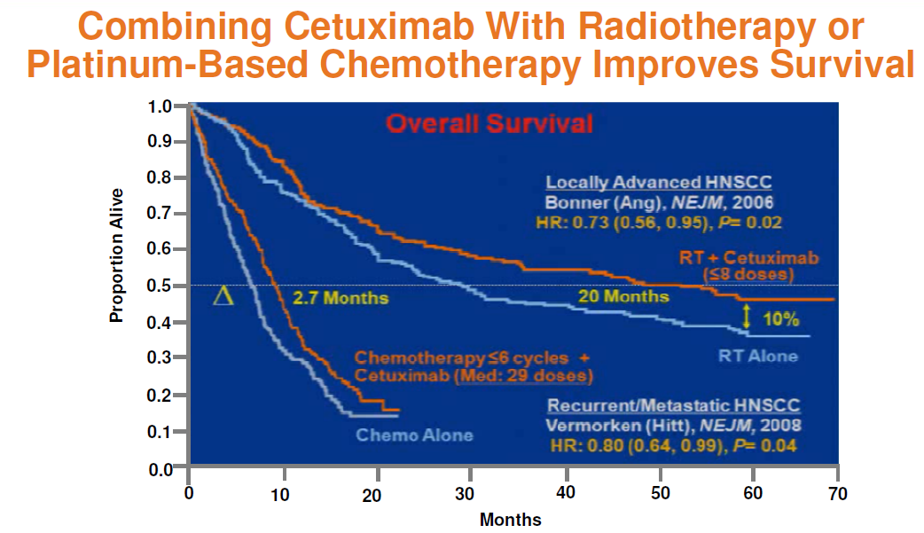
#RTOG 0234顯示術後使用bio-CCRT比起單純使用CCRT (RTOG 9501)有較好的outcome
#RTOG 0522 顯示在CCRT(cisplatin)上併用cetuximab並不增加LC/DFS/OS [也不會增加LC]，但增加Gr3-4的muscositis and skin reaction(SS) [但不增加dysphagia]。其中OPX的病人佔大多數，但沒收NPC病人。HPV+的LC /OS較好且有統計差異。EGFR並不影響療效。
#RTOG1016:for HPV+ OPX，CCRT vs RT+cetuximab=>cetuximab未達成non-inferior
- 分次改變(altered fx)
#RTOG 9003四個arm研究不同fraction的RT alone，發現Hyper fx及altered fraction with ccBoost較傳統有更好的DFS和LC，但OS只有hyperFX增加OS
# EORTC 22791 For OPX，用高分次(hyper Fx)RT比傳統分次有較好的5yLC
#DANANCA顯示每周六次+nimorazole，比傳統有較好的LC，但好處只顯現在分化中-佳(Gr1-2)的，對分化差(Gr3)的沒有幫助 [不是分化差幫助最大]
# Accelerated RT加上同步化療無法提升LC [103考古=>應該是指RTOG 0129]
# MARCH meta-analysis: altered fx可以提升LC(6.4%)和OS(增加5y OS 3.4%) 尤其是hyperFx。
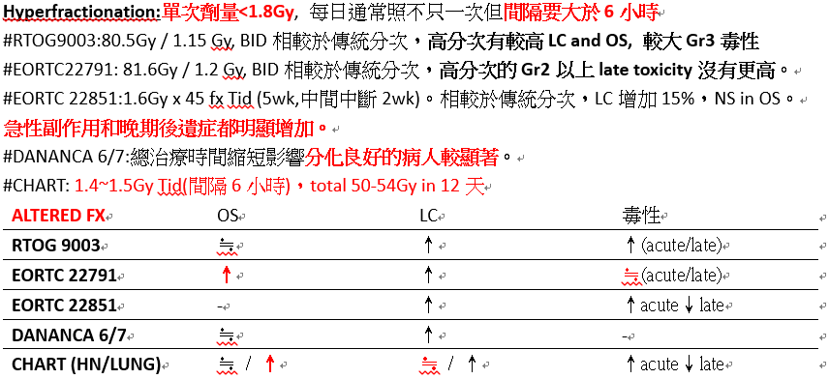
- RTOG 0129[只有針對口咽癌研究]
#CCRT之chemo為cisplatin alone。比較CCRT 70Gy/7wk vs accelerated ccboost 72Gy/6wk，NS in OS(47%)/LC(37%)/acute and late Gr3-5 toxicity(37%)
#6成(68%)病人為HPV陽性[不是四成陽性]，相較HPV陰性有較佳的3yOS/LC
#HPV+比起HPV-死亡風險可降低超過一半 3yOS:82% vs 54%。
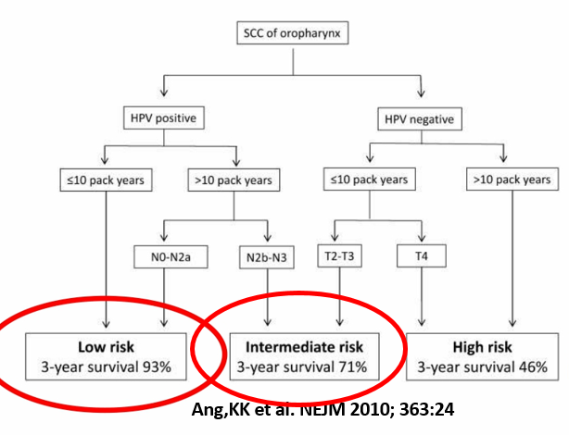[risk會考]
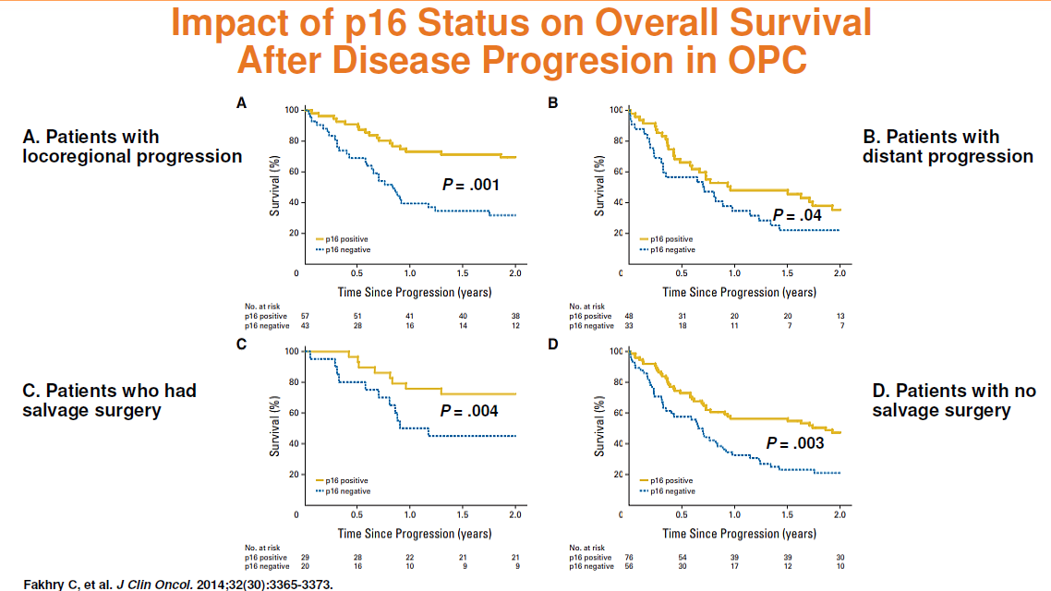

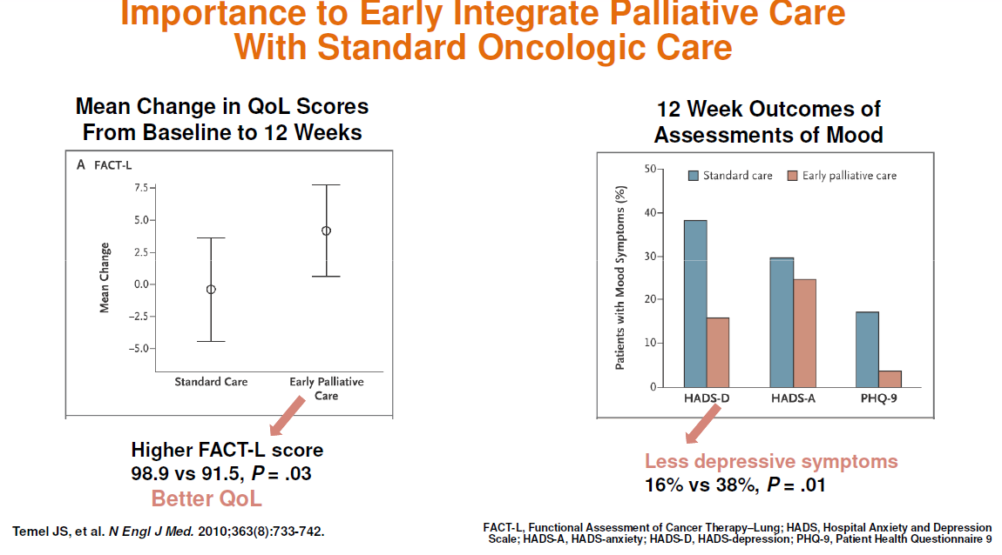
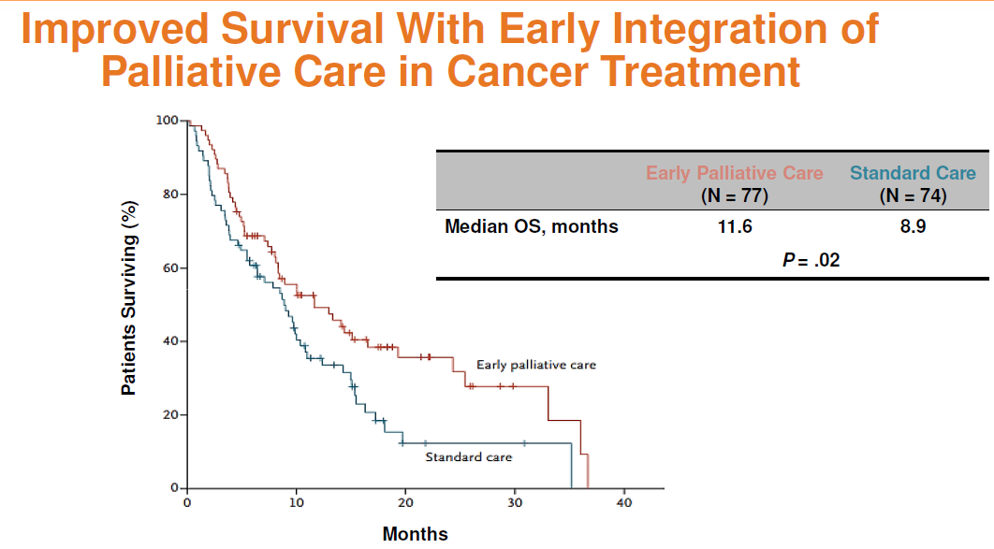
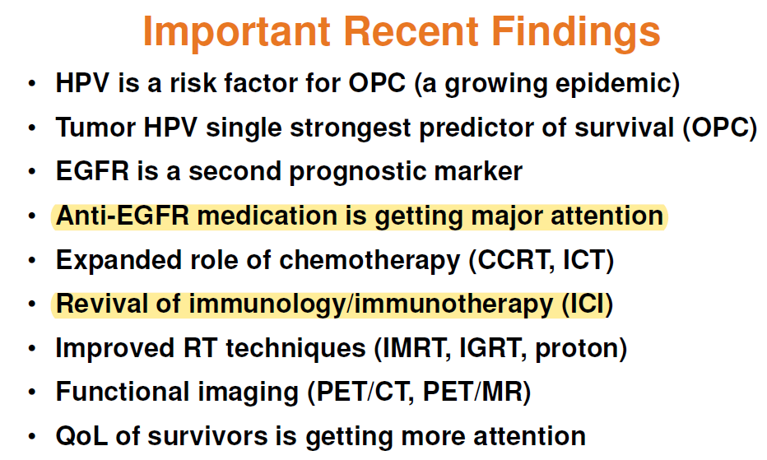

Immune TX (checkmate 141-nivolumab)
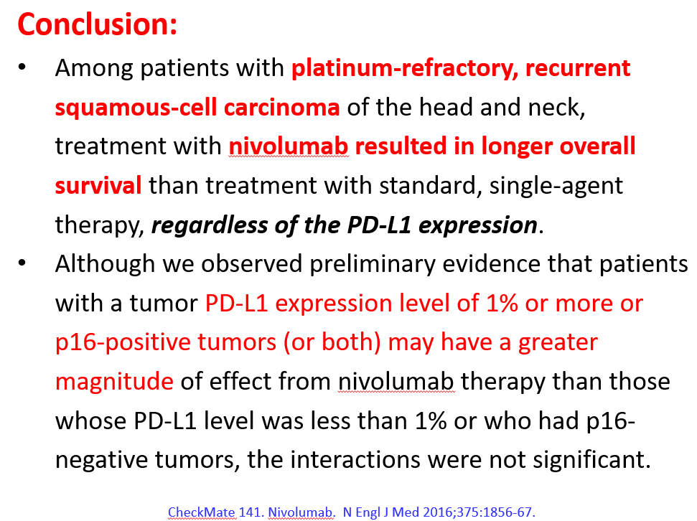
Immune TX (keynote 040 pembrolizumab)
