「以下為範例出題格式，請各委員出題時，請以下列格式繕打，切勿變更其格式，謝謝！」
- 有關台灣原發腦部惡性腫瘤之描述，下列何者為誤？
  - 跟據民國101年國健署癌登報告，發生率及死亡率均屬國人十大癌症
  - 神經膠母細胞瘤(Glioblastoma)比例最高，將近四成
  - 年紀愈大發生率愈高
  - 男性發生率及死亡率均大於女性
    - A (CNS tumor)
      - 低等
        - 衛生福利部國民健康署民國101年癌症登記報告; p92-93
          - P92, 發生率的排名於男性為第19位、女性為第19位; 死亡率的排名於男性為第13位、女性為第12位.
- 下列何者非RPA classification預測malignant gliomas預後的指標？
  - Age
  - Mental status
  - Karnofsky performance status
  - Tumor size
    - D (CNS tumor)
      - 低等
        - Principles and Practice of Radiation Oncology, sixth edition, Carlos A. Perez, Luther W. Brady; Chapter 35, p659; 2013.
          - P659, RPA classification: age, KPS, duration of symptoms, and mental status
- 有關神經膠母細胞瘤(Glioblastoma)之描述，下列何者為誤？
  - 為high-grade glioma之大宗，佔了大約四分之三的比例
  - 接受適當治療，平均存活14個月
  - Secondary比Primary(de novo)少見且預後較差
  - 關於術後的放射治療，目前尚無明確證據支持將劑量提升至 >60 Gy 會有較佳的療效
    - C (CNS tumor)
      - 中等
        - Principles and Practice of Radiation Oncology, sixth edition, Carlos A. Perez, Luther W. Brady; Chapter 35, p659-660; 2013.
          - P660, secondary GBMs arise in younger patients and are associated with a more favorable prognosis than for those with primary GBM.
- 有關神經膠母細胞瘤(Glioblastoma)之描述，下列何者為誤？
  - 目前有證據指出>60歲的老人可以考慮hypofractionated short-course RT
  - 根據EORTC-NCIC trial，RT with concurrent temozolomide followed by adjuvant temozolomide能比RT alone有更好的overall survival
  - Methylated MGMT gene的病人預後較差
  - Temozolomide是目前唯一被證實能延長overall survival的化療藥物
    - C (CNS tumor)
      - 中等
        - Principles and Practice of Radiation Oncology, sixth edition, Carlos A. Perez, Luther W. Brady; Chapter 35, p662; 2013.
          - P662, MGMT methylation was associated with improved median overall survival.
- 有關anaplastic glioma之描述，下列何者為誤？
  - 影像學上有1/3的腫瘤不會對顯應劑顯影
  - 組織學上可能會看到necrosis or neovascularization
  - Alleic loss of 1p & 19q為好的預後因子
  - 根據RTOG 9402 (Cairncross G, 2013)，針對1p/19q codeleted的病人，PCV (procarbazine, CCNU, vincristine)化學治療後接放射治療，會比單獨放射治療有更佳的overall survival
    - B (CNS tumor)
      - 中等
        - Principles and Practice of Radiation Oncology, sixth edition, Carlos A. Perez, Luther W. Brady; Chapter 35, p664; 2013.
          - P664, Histologically these tumors have increased cellularity, nuclear atypia, and marked mitotic activity, without necrosis or neovascularization.
- 針對low-grade non-pilocytic glioma ，下列哪位病人是屬於high-risk, 所以在maximal safe resection後還須考慮輔助性化療或放療？
  - Astrocytoma, 36 y/o, KPS < 70, tumor dimension 8 cm
  - Astrocytoma, 42 y/o, KPS > 70, tumor dimension 1 cm
  - Oligodendroglioma, 38 y/o, tumor crossing midline, tumor dimension 5 cm
  - Oligodendroglioma, 52 y/o, KPS > 70, tumor dimension 4 cm
    - B (CNS tumor)
      - 高等
        - Principles and Practice of Radiation Oncology, sixth edition, Carlos A. Perez, Luther W. Brady; Chapter 35, p666-667; 2013.
          - P666, EORTC 22844/22845 multivariate analysis: 3 or more of these features are considered high risk – age 40 years or order, astrocytoma histology, maximum diameter ≧6 cm, tumor crossing the midline, and presence of neurologic deficits.

- 有關meningioma之描述，下列何者為誤？
  - 大約八成為Grade 1
  - 比較常發生於男性
  - 無症狀的Grade 1 meningioma可以觀察而不需治療
  - Grade 2 or 3的meningioma如果maximal resection後無輔助放射治療，則五年復發率為41~100%
    - B (CNS tumor)
      - 中等
        - Principles and Practice of Radiation Oncology, sixth edition, Carlos A. Perez, Luther W. Brady; Chapter 35, p672; 2013.
          - P672, more common in women
- 關於聽神經鞘瘤(Acoustic Neuroma)及神經纖維瘤(Neurofibroma)之描述，何者錯誤？
  - 兩側聽神經瘤與第二型神經纖維增生性基因缺陷(NF2, neurofibromatosis type 2)有關
  - 神經纖維瘤與第一型神經纖維增生性基因缺陷(NF1, Neurofibromatosis type 1)有關
  - 神經纖維瘤經total resection或near-total resection後，局部復發機率仍有30%-50%
  - <3cm的單側聽神經瘤，放射手術(Radiosurgery)的局部控制率與外科手術相近
    - C (Central Nervous System)
      - 中等
        - Perez and Brady’s Principles and Practice of Radiation Oncology, Esward C. Halperin, Carlos A. Perez, Luther W. Brady et. al; Chapter 35, p675; 6th edition.
          - P674, They may be sporadic or associated with NF2, with bilateral vestibular schwannomas being pathognomonic of this disease.P675, Neurofibromas differ from neurilemomas in their cellular composition and growth pattern. Although neurofibromas also arise from peripheral nerves, they are most commonly multiple and associated with NF1. …Treatment: In patients in whom a near-total or total resection is achieved, the tumor recurrence rate is <10%. In patients in whom a subtotal resection is achieved, tumor recurrence may occur in one-third to one-half. Adjuvant radiotherapy may reduce the rate of recurrence to that of complete resection…. Radiosurgery provides similar local control with less morbidity than surgery for small (<3 cm) unilateral tumors.
- 有關顱咽瘤(Craniopharyngioma)之描述，下列何者為誤？
  - 由Rathke Pouch上皮殘留組織衍生而來
  - 好發位置在蝶鞍上區域(Suprasellar region)
  - 生長緩慢，常由固體狀(Solid)及囊狀(Cystic)構造組成
  - 部分切除併術後放射治療的局部控制率仍較手術完全切除者差
    - D (Central Nervous System)
      - 中等
        - Perez and Brady’s Principles and Practice of Radiation Oncology, Esward C. Halperin, Carlos A. Perez, Luther W. Brady et. al; Chapter 35, p674; 6th edition.
          - P674, Craniopharyngiomas arise from epithelial remnants of the Rathke pouch and are typically found in the suprasellar region in children or adolescents. They account for <5% of all CNS neoplasms in adults. They are slowly growing tumors that often have solid and cystic components, the latter filled with lipoid, cholesterol-laden (“crankcase oil”) fluid…With a limited surgical procedure (partial resection or cyst aspiration plus biopsy) followed by radiotherapy, local control and survival rates are nearly equivalent to those achieved with complete resection, with survival rates of 89% and 77% at 5 and 10 years, respectively, as compared with 53% to 37% for patients who have had subtotal resection alone…
- 下列敘述何者為誤？
  - 最常見的腦下垂體腺瘤(Pituitary adenoma)為Prolactinoma
  - 治療Prolactinoma的首選治療為transsphenoidal surgical resection
  - 整個腦下垂體經放射線照射45-50Gy後，約有10%-30%發生腦下垂體功能低下
  - 腦下垂體後葉分泌oxytocin和vasopressin
    - B (Central Nervous System)
      - 中等
        - Perez and Brady’s Principles and Practice of Radiation Oncology, Esward C. Halperin, Carlos A. Perez, Luther W. Brady et. al; Chapter 36, p678-p680; p683; 6th edition.
          - P678, These cells transit through the pituitary stalk to the posterior lobe where the two posterior lobe hormones, oxytocin and vasopressin, are stored. P680, 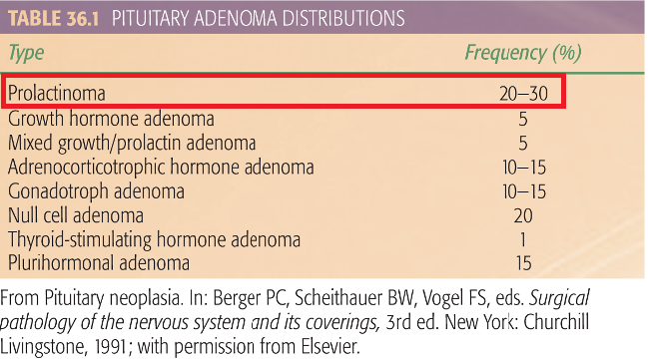 P679Box 36.1, … An initial therapy for most prolactinomas is with a dopamine agonist such as bromocriptine, lysuride, or pergolide. Medical intervention usually decreases adenoma function and size. Initial therapy for other pituitary adenomas is transsphenoidal surgical resection…P683, Additionally, doses ranging from 45 to 50 Gy to the whole pituitary gland carry substantial risk of causing hypopituitarism. This is reported in the range of 10% to 30% in some series…
- 有關中樞神經系統腫瘤 (Tumors of Central Nervous System)之描述，下列何者為誤？
  - 成人原發性中樞神經系統腫瘤最常見的是腦膜瘤(Meningioma)
  - 佔小兒腫瘤約20%，僅次於急性白血病
  - Turcot’s syndrome: 原發性腦腫瘤併大腸直腸癌
  - 成人的神經膠腫瘤(Glioma)，其組織學上大多數為良性病灶
    - D (Central Nervous System)
      - 中等
        - Handbook of Evidence-based Radiation Oncology, Eric K. Hansen, Mack Roach III;Chapter 2, p31; 2010.
          - P31, Adult primary CNS tumors: 30–35% meningioma, 20% GBM, 10% pituitary, 10% nerve sheath, 5% low-grade glioma, <5%, anaplastic astrocytoma, <5% primary CNS lymphoma. Children: 20% of all pediatric tumors (second to ALL)…. Turcot’s syndrome: primary brain tumors with colorectal CA. Of adult gliomas, ~80% are high-grade and ~20% are low-grade.
- 關於顱內動靜脈畸形(AVM, Arteriovenous Malformation)之描述，下列何者為誤？
  - 有自發性出血的風險，可能引發死亡
  - 立體定位放射手術(SRS, Stereotactic Radiosurgery)後可降低出血機率
  - 立體定位放射手術(SRS)原理是使血管壁逐漸增厚及產生小血栓
  - 放射手術(Radiosurgery)須針對動靜脈畸形(AVM)的餵食動脈(Feeding Arteries)治療
    - D (Central Nervous System)
      - 易
        - Handbook of Evidence-based Radiation Oncology, Eric K. Hansen, Mack Roach III;Chapter 2 P66-P67; 2010.
          - P66, Annual rate of spontaneous hemorrhage ~2–4% with morbidity 20–30% per bleed and mortality 1%/year or 10–15% per bleed…There is a period of decreased risk of hemorrhage during latent interval after SRS treatment before complete angiographic resolution…SRS produces progressive thickening of the vascular wall and luminal thrombosis…P67, Treatment of AVM by SRS: Treat entire nidus, but not feeding arteries or draining veins
- 有關原發性脊管腫瘤(Primary Spinal Canal Tumors)之描述，下列何者為誤？
  - 可分硬膜外(Extradural)、硬膜內髓質外(Intradural-extramedullary)及硬膜內髓質內(Intradural-Intramedullry)三大類
  - 發生機率之排列為硬膜內髓質內>硬膜內髓質外>硬膜外
  - 硬膜外腫瘤最常見的是meningioma
  - 懷疑脊管腫瘤時，不需在MRI前急做腰椎穿刺(Lumbar puncture)檢查
    - B (Central Nervous System)
      - 中等
        - Perez and Brady’s Principles and Practice of Radiation Oncology, Esward C. Halperin, Carlos A. Perez, Luther W. Brady et. al; Chapter 37, p685,p687; 6th edition.
          - P685, Frequency of primary spinal canal tumors: extradural(few), intradural-extramedullary(70%), intradural-intramedullary(30%)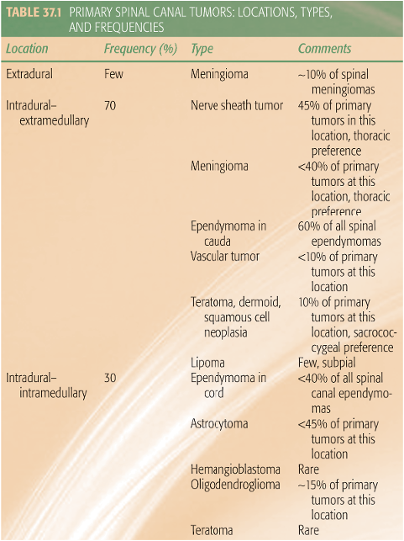 P687, A patient suspected of having a spinal canal neoplasm should not be subjected to a lumbar puncture before MRI. Symptoms may be exacerbated after a spinal tap because of shifting of the spinal cord and incarceration before the tumor can be localized adequately.
- 有關primary CNS lymphoma之描述，下列何者為誤？
  - 對化學治療及放射治療敏感
  - 化療的regimen 與其他部位淋巴癌的標準化療regimen相同
  - 針對小於六十歲並且體能狀態佳的病人，高劑量的Methotrexate-based chemotherapy後加上全腦放射治療是標準的治療方式
  - 沒必要手術切除腫瘤
    - B (CNS tumor)
      - 中等
        - Principles and Practice of Radiation Oncology, sixth edition, Carlos A. Perez, Luther W. Brady; Chapter 35, p670-672; 2013.
          - P671, The standard systemic lymphoma chemotherapy regimens are ineffective for PCNSL.
- 有關ependymoma之描述，下列何者為誤？
  - 成人大多長在spinal canal，而小孩則是顱內較常見
  - 復發以local relapse為主
  - 標準的治療方式為手術切除後接受全腦脊髓放射治療 (craniospinal irradiation)
  - 化學治療目前尚無明確治療上的角色
    - C (CNS tumor)
      - 中等
        - Principles and Practice of Radiation Oncology, sixth edition, Carlos A. Perez, Luther W. Brady; Chapter 35, p669-670; 2013.
          - P670, Postoperative radiotherapy is considered the standard, but no prospective trials have validated its role. Craniospinal irradiation is used only in patients with disseminated disease.

