2011 GI 考題 (Perez part G: Gastrointestinal tumors: stomach, pancreas, liver and hepatobiliary tract, colon and rectum, anal cancer)

1. ( ) 關於造成胃癌 (gastric cancer) 危險因子的敘述，下列何者有誤?
- 攝取大量煙燻或是高鹽分食物。
- 高低社經地位。
- 飲食少量蔬菜及水果。
- 不用冰箱保存食物。
(1 答案) : B
(1 難易度)：
(1 參考文獻)： Perez and Brady’s principles and Practice of radiation Oncology Chapter 55, p1318
(1 註解)： p 1318 Risk factors include high intake of smoked and salted foods, low intake of fruits and vegetables, low socioeconomic status, and decreased use of refrigeration.

2. ( ) 根據 U.S. GI Intergroup Gastric Adjuvant Trial (Chemoradiotherapy after surgery compared with surgery alone for adenocarcinoma of stomach or GE junction. NEJM 2001) 的敘述，下列何者是胃癌術後放射治療的適應症?
- 侵犯至muscular wall。
- 侵犯至submucosa。
- 以上皆是。
- 以上皆非。
(2 答案) : A
(2 難易度)：
(2 參考文獻)： Perez and Brady’s principles and Practice of radiation Oncology Chapter 55, p1323
(2 註解)： p 1323 The results of the U.S. GI Intergourp Gastric Adjuvant Trial has changed the standard of care in the U.S. to the use of both chemotherapy and radiation therapy in the postoperative setting for patients with disease extension through the gastric wall and/or with nodes positive for tumor.
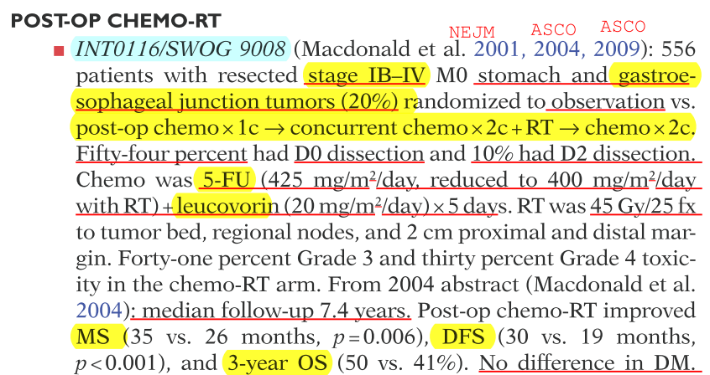
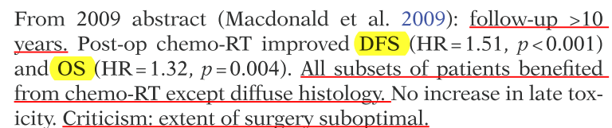
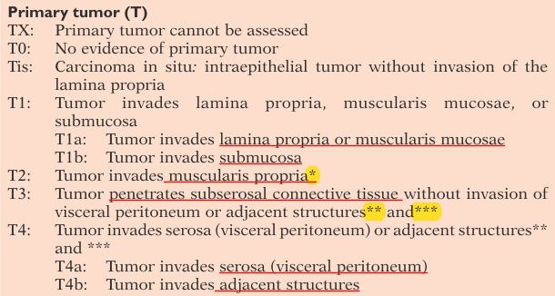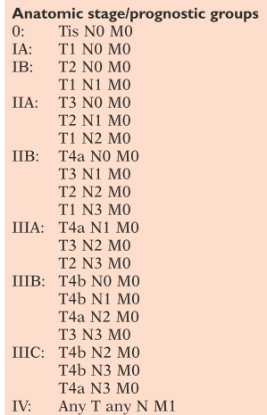
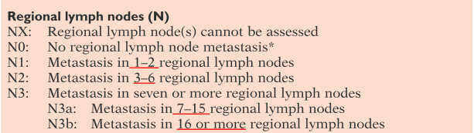
3. ( ) 若是胃癌在幽門部位(antrum/pylorus/distal one-third of stomach)且淋巴結陽性，下列何者為非必要放射治療範圍?
A) Celiac。
B) Suparpancreatic。
C) Splenic hilum。
D) Porta hepatis。
(3 答案) : C
(3 難易度)：
(3 參考文獻)： Perez and Brady’s principles and Practice of radiation Oncology Chapter 55, p1326
(3 註解)： p 1326 Table 55.11: Impact of site of primary gastric lesion and TN stage on irradiation volumes – antrum/pylorus/distal one-third of stomach (general guidelines); Splenic hilum optional for N+ disease.

4. ( ) 關於胰臟主要區域淋巴分布(regional lymphatics)，下列何者為非?
A) Porta hepatis。
B) Superior mesenteric。
C) Celiac。
D) Splenic。
(4 答案) : D
(4 難易度)：
(4 參考文獻)： Perez and Brady’s principles and Practice of radiation Oncology Chapter 56, p1336
(4 註解)： p 1336 The abundant pancreatic lymphatics have many connections with those of the duodenum. Regional drainage is to superior and inferior pancreaticoduodenal, porta hepatis, celiac, and superior mesenteric lymph nodes.

5. ( ) 關於胰臟癌敘述，下列何者為非?
A) 大約90%為腺癌(adenocarcinomas)。
B) 約2/3位在胰臟體部(body of pancreas) pancreatic head。
C) 若在胰臟體部(body of pancreas)主要症狀之一為疼痛。
D) 在45歲以後發生率大幅上升。
(5 答案) : B
(5 難易度)：
(5 參考文獻)： Perez and Brady’s principles and Practice of radiation Oncology Chapter 56, p1336-1337
(5 註解)： p 1336-1337 Incidence increase sharply after age 45 years. Patients with tumors in the pancreatic body or tail usually present with pain and weight loss. Approximately 90% of pancreatic cancers are adenocarcinomas, and at least two-thirds are found in the head of pancreas.

6. ( ) 關於胰臟癌術後治療之主要臨床實驗的敘述，下列何者為非?
A) GITSG trial 顯示術後化放療(adjuvant chemoradiotherapy)比術後觀察(observation)有益處(survival benefit)。
B) ESPAC-1 顯示有化放療(with chemoradiotherapy)比無化放療(no chemoradiotherapy沒有益處(survival benefit)。
C) ESPAC-1 顯示有化療(with chemotherapy)比無化療(no chemotherapy)有益處(survival benefit)。
D) RTOG 9704 顯示化放療配合maintenance Gemcitabine比化放療配合maintenance 5-FU有益處(survival benefit)。
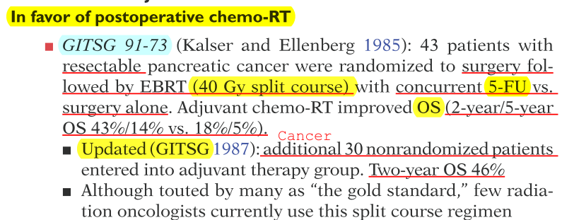
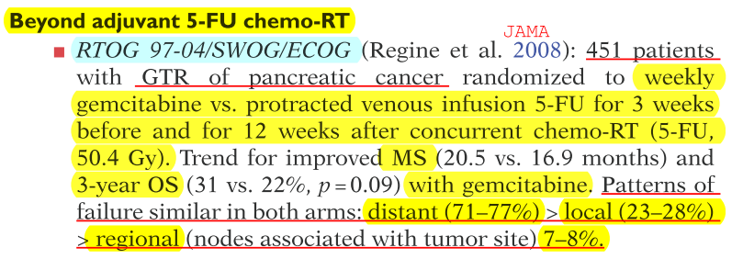
(6 答案) : B
(6 難易度)：
(6 參考文獻)： Perez and Brady’s principles and Practice of radiation Oncology Chapter 56, p1341-1342
(6 註解)：GITSG: patients receiving chemoradiotherapy had a longer median survival and improved 2-year survival; ESPAC-1: There was no survival difference between the 175 patients who received adjuvant chemoradiation and the 178 patients who did not receive therapy (median survival 15.5 months vs. 16.1 months; p = .24). There was, however, a survival benefit found for the patients who received adjuvant chemotherapy (n = 238) compared to those who did not (n = 235) (median survival 19.7 months vs. 14 months; p = .0005). RTOG 9704: Results showed a survival advantage in patients with resected pancreatic head carcinoma receiving maintenance gemcitabine versus maintenance 5-FU. The 3-year overall survival rate of 187 patients with resected pancreatic head carcinoma receiving maintenance gemcitabine with chemoradiation was 32%. In contrast, the 3-year overall survival rate of 194 patients receiving maintenance 5-FU with chemoradiation was 21%.

7. ( ) 關於肝癌(HCC)之放射治療適應症，下列何者為非?
A) 體積大且無法切除之腫瘤。
B) 緩解非阻塞性黃疸。
C) 緩解肝門靜脈栓塞。
D) 與肝動脈化學栓塞治療合併運用。
(7 答案) : B
(7 難易度)：
(7 參考文獻)： Perez and Brady’s principles and Practice of radiation Oncology Chapter 57, p1353
(7 註解)：Indications for conformal radiotherapy include large unresectable HCC, relieving portal vein thrombosis and obstructive jaundice, failure of prior TACE and as part of combined modality treatment with TACE, and percutaneous ablation therapy.

8. ( ) 關於膽管癌(cholangiocarcinoma)之敘述，下列何者正確?
A) Intrahepatic cholangiocarcinoma佔全部膽管癌65-70% 5-10%。
B) 遠端膽管癌相對較容易被切除。
C) Intraheptic cholangiocarcinoma另外被稱為Klatskin tumor Perihilar tumors involving the bifurcation of the hepatic duct。
D) Klatskin tumor接近肝管分枝匯流處(hepatic duct confluence)為 Bismuth type I II。
(8 答案) : B
(8 難易度)：
(8 參考文獻)： Perez and Brady’s principles and Practice of radiation Oncology Chapter 57, p1357-1359
(8 註解)：Intrahepatic cholangiocarcinoma accounts for 5% to 10% of all biliary tract cancers; Perihilar tumors involving the bifurcation of the hepatic duct are also called Klatskin tumors (100). These tumors were further classified by Bismuth et al. (16) as tumors below the confluence of the left and right hepatic ducts (type I), tumors reaching the confluence (type II), tumors occluding the common hepatic duct and the right or the left hepatic duct (types IIIa and IIIb, respectively), and tumors that are multicentric or that involve the confluence and both the right and left hepatic ducts (type IV). Patients with distal duct carcinoma have the highest rate of curative resection as compared with proximal duct carcinoma.

9. ( ) 關於膽囊腺癌(adenocarcinoma of gallbladder)治療之敘述，下列何者為非?
A) 並無有相關文獻顯示術後放射線治療可增加存活率(survival benefit)。
B) 淋巴腺轉移與原發部位分期(primary tumor stage)有相關。
C) 復發危險因子其中之一為perineural invasion。
D) 骨轉移較少發生。
(9 答案) : A
(9 難易度)：
(9 參考文獻)： Perez and Brady’s principles and Practice of radiation Oncology Chapter 57, p1361
(9 註解)：The lymph node metastasis rate is associated with primary tumor stage. Factors predicting recurrence are positive surgical margins, lymph node metastasis, and perineural invasion. Several retrospective analyses demonstrate that postoperative radiotherapy improved local control and survival. The most frequent sites of involvement are liver, peritoneum, and lung, with less frequent spread to ovaries, spleen, bones, and other organs.

10. ( ) 關於大腸癌術後合併化放療，下列何者建議較為不適當?
A) 侵犯鄰近構造(adjoining structures)。
B) 合併穿孔或婁管(complicated with perforation or fistula)。
C) 侵犯至手術邊緣(incomplete resection)。
D) 侵犯多處淋巴結(multiple lymph nodes)。
(10 答案) : D
(10 難易度)：
(10 參考文獻)： Perez and Brady’s principles and Practice of radiation Oncology Chapter 58, p1371
(10 註解)：Adjuvant tumor bed irradiation with concurrent 5-FU–based chemotherapy should be considered for patients with tumors (a) invading adjoining structures, (b) those complicated by perforation or fistula. and (c) where incomplete resection is performed.

11. ( ) 針對直腸癌的預後，下列何者為最主要因素?
A) 腫瘤侵犯範圍(tumor extent by AJCC staging)。
B) 年齡。
C) 淋巴血管侵犯(lymph-vascualr invasion)。
D) 組織病理分級(histopathological grade)。
(11 答案) : A
(11 難易度)：
(11 參考文獻)： Perez and Brady’s principles and Practice of radiation Oncology Chapter 58, p1372-1373
(11 註解)：Tumor extent as defined by the American Joint Committee on Cancer (AJCC) staging clearly remains the dominant determinant of survival. Other patient factors such as age, gender, and ethnicity have little association with outcome but may affect choice of therapy. Histopathological grade is of borderline significance, however, and signet cell cancers have a particularly poor outcome. In some reports lymph-vascular invasion has been shown on univariate analysis to have a negative impact on survival.

12. ( ) 在比較直腸癌術前化放療以及術後化放療的主要臨床試驗(CAO/ARO/AIO-94 study performed by the German Rectal Cancer group)，下列敘述何者為非?
A) 術後化放療有較高的淋巴轉移機率(nodal positivity)。
B) 術前化放療有較低的局部復發(less local failures)。
C) 術前化放療比較可以保留括約肌(sphincter preservation)。
D) 術前化放療有較好一樣的存活率。
(12 答案) : D
(12 難易度)：
(12 參考文獻)： Perez and Brady’s principles and Practice of radiation Oncology Chapter 58, p1379
(12 註解)：There was significant tumor downstaging after preoperative combined modality treatment with an 8% pathological complete response rate. Nodal positivity was 25% in the preoperative versus 40% in the postoperative arm. The sphincter preservation rate in 188 patients with low-lying tumors (declared by the surgeon prior to randomization to require an APR) revealed that 39% versus 19% had a sphincter-preserving low anterior resection (p = 0.004) in the preoperative versus the postoperative arm. There were fewer acute (27% vs. 40%) and late toxicities (14% vs. 24%) in preoperative-treatment group. Thus, preoperative combined preoperative chemotherapy and radiation therapy resulted in significantly less local failures in the pelvis by half and also provided twice the sphincter preservation. Importantly, there was no difference in overall survival or disease-free survival between the two arms.

13. ( ) 直腸癌復發後治療的敘述，下列何者為非?
A) 有文獻報告針對已做過50.4 Gy而復發的直腸癌再進行化放療(45 30 Gy, 1.2 Gy BID)之後針對腫瘤再加上6-20 Gy boost。
B) 治療方向應如同T4疾病。
C) 大約10%的T1或T2N0的患者會有術後復發的機率。
D) 若是復發在pelvic sidewall則預後較差。
(13 答案) : A
(13 難易度)：
(13 參考文獻)： Perez and Brady’s principles and Practice of radiation Oncology Chapter 58, p1379-1380
(13 註解)：Recurrent rectal cancer is often approached the same way as T4 disease with an aggressive treatment plan of combined chemotherapy and radiation therapy followed by surgery and then adjuvant chemotherapy. Approximately 10% of patients with T1 and T2N0 disease will fail locally after surgery, usually due to an inadequate lymph node dissection. Because the pelvic sidewall is a difficult surgical resection, these recurrences face worse. The 5-year overall survival is approximately 20%. Long-term results of reirradiation for patients with recurrent rectal carcinoma were reported by Mohiuddin et al. One-hundred and three patients who developed locoregional recurrence after surgery with preoperative or postoperative radiation treatment (median dose 50.4 Gy) were reirradiated with concurrent 5FU continuous infusion. Patients were treated with opposed laterals or a three-field technique with a posterior field and two laterals to the presacral area and gross tumor volume with 2- to 4-cm margin. Patients received 30 Gy (1.2 Gy twice a day) or 30.6 Gy (1.8 Gy every day) followed by a boost of 6 to 20 Gy to gross tumor volume (2 cm margin).

14. ( ) 下列何者不是可能造成肛門癌之危險因子?
A) 病毒感染。
B) 抽煙。
C) 因Crohn’s disease或ulcerative colitis造成的慢性肛門發炎。
D) 免疫功能低下。
(14 答案) : C
(14 難易度)：
(14 參考文獻)： Perez and Brady’s principles and Practice of radiation Oncology Chapter 58, p1384
(14 註解)：The most significant risk factors so far identified are sexually transmissible viruses, immunosuppression, and tobacco smoking. Chronic anal inflammation due to inflammatory bowel disease has also been discounted as a risk factor. Using Danish health registers, a cohort study of 2,723 patients with Crohn's disease and 6,334 patients with ulcerative colitis who were followed for an average of 10 years found no significant increase in the incidence of anal cancer.

15. ( ) 關於肛門癌之主要臨床試驗，下列何者為非?
A) UKCCCR比較單獨放療及合併化放療，後者有較低的局部復發。
B) 已沒有初步randomized trial報告cisplatin及5FU效果比mitomycin及5FU還要好。
C) EORTC比較單獨放療及合併化放療，兩者在存活率上沒有差別。
D) RTOG 8704比較放療配合5FU及mitomycin或是單獨配合5FU，前者有較好的disease free survival。
(15 答案) : B
(15 難易度)：
(15 參考文獻)： Perez and Brady’s principles and Practice of radiation Oncology Chapter 58, p1386-1388
(15 註解)：Table 59.3
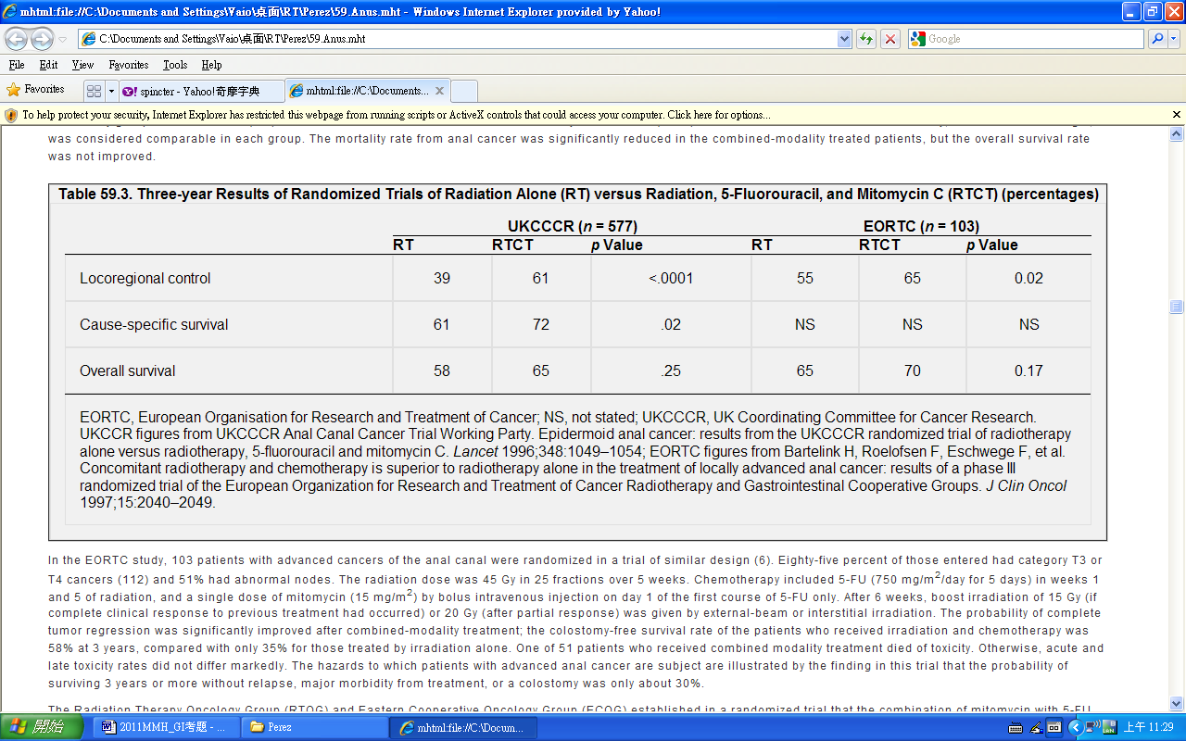
The Radiation Therapy Oncology Group (RTOG) and Eastern Cooperative Oncology Group (ECOG) established in a randomized trial that the combination of mitomycin with 5-FU and radiation is more effective than 5-FU alone with radiation (36). At 5 years, the rates of colostomy (11% vs. 22%; p =.02) significantly favored treatment with radiation, 5-FU, and mitomycin, although colostomy-free survival rates did not differ significantly. There was no significant difference in overall survival rates (67% vs. 65%), although the disease-free survival rate was improved by the three-agent combination (67% vs. 50%; p =.006). Acute hematologic toxicity was more common in the patients who received mitomycin, but the rates of other acute and late toxic effects were similar in each treatment group. Four of 146 (2.7%) patients who received both 5-FU and mitomycin suffered fatal toxicity as did 1/145 treated with radiation and 5-FU alone. Of greater, and continuing, interest has been the combination of radiation, 5-FU, and cisplatin, which has produced levels of tumor control comparable to those produced by radiation, 5-FU, and mitomycin. This combination has proven effective against squamous cell cancers in other sites, and cisplatin may act as a radiation sensitizer, a property lacking in mitomycin as currently used in clinical practice. However, the first report from a randomized trial did not show any superiority for cisplatin and 5-FU over mitomycin and 5-FU.

