GU 考題 I
1. ( ) 關於攝護腺癌 (Prostate cancer) 的敘述，下列何者有誤
- 最主要的細胞型態是腺癌 (adenocarcinoma)。
- 淋巴轉移好發部位包括internal iliac, obturator, external iliac nodes。
- 僅有25 77%的攝護腺癌具有多發性病灶 (multifocal disease)。
- Roach formula估計淋巴轉移機率的公式為 2/3 PSA + (Gleason score - 6) × 10
(1 答案) : C (Prostate cancer)
(1 難易度)：易
(1 參考文獻)： Perez and Brady’s principles and Practice of radiation Oncology Chapter 62, p1442-1448
(1 註解)： p 1446 Multifocality is characteristic of prostate cancer. Jewett reported that multiple foci of disease were found throughout the prostate in 77% of prostatectomy specimens. Wise et al. noted that only 17% of 486 patients treated by radical retropubic prostatectomy had one carcinoma detected by 3-mm step-section histologic examination.

2. ( ) 關於攝護腺癌 (Prostate cancer) RTOG 9413研究的敘述，下列何者有誤
- 2x2的隨機分組。
- 針對High risk patients所做的研究，尤其是Roach formula估計淋巴轉移機率大於15%的病人。
- 當比較whole pelvic RT (WPRT)和prostate-only RT (PORT)時，WPRT不可改善總存活率 (overall survival)。
- 當使用neoadjuvant hormonal therapy合併WPRT或PORT時，WPRT有趨勢改善progression-free survival，但無統計顯著差異。
(2 答案) : C (Prostate cancer)
(2 難易度)：中
(2 參考文獻)： Lawton CA. An Update of the Phase III Trial Comparing Whole Pelvic to Prostate Only Radiotherapy and Neoadjuvant to Adjuvant Total Androgen Suppression: Updated Analysis of RTOG 94-13, With Emphasis on Unexpected Hormone/Radiation Interactions. Int J Radiat Oncol Biol Phys. 2007 Nov 1;69(3):646-55.
(2 註解)： No statistically significant differences were found in PFS or overall survival between whole pelvic RT (WPRT) compared with prostate-only RT (PORT). A trend towards a difference was found in PFS (p = 0.065) in favor of the WPRT + NHT arm compared with the PORT + NHT and WPRT + AHT arms.
RTOG 94-13 (1995-99) -- whole pelvis vs prostate only, also 2x2 ADT
Randomized. 1323 patients. High risk patients with estimated risk of LN involvement of 15% or more by the Roach equation and PSA < 100. Pts with T2c-T4 tumors and Gleason >=6 were allowed regardless of LN risk. 2x2 randomization. Randomized to whole-pelvic (WP) vs prostate-only (PO) RT, and combined neoadjuvant + concurrent hormonal therapy (NCHT) vs adjuvant hormonal therapy (AHT).
RT: Dose 70.2 Gy to prostate. For WP RT, 50.4 Gy to pelvis (16x16 field), followed by boost to prostate only. PO RT was to prostate + SV only. Hormones: For NCHT, total of 4 months - 2 months before and 2 months during RT. For AHT, began following RT for total of 4 months.
7-years; 2007 PMID 17531401 -- "An Update of the Phase III Trial Comparing Whole Pelvic to Prostate Only Radiotherapy and Neoadjuvant to Adjuvant Total Androgen Suppression: Updated Analysis of RTOG 94-13, With Emphasis on Unexpected Hormone/Radiation Interactions." (Lawton CA, Int J Radiat Oncol Biol Phys. 2007 Nov 1;69(3):646-55.) Median F/U for alive patients 7.0 years
Outcome: PFS WPRT+NHT 62% vs. PORT+NHT 66% vs. WPRT+AHT 69% vs. PORT+AHT 62% (NS); also no difference in OS. By pairs (as designed), no difference between WPRT and PORT, and no difference between NHT and AHT. No difference in LF or DM
Toxicity: No difference in RT Grade 3+ toxicity among the 4 arms
Conclusion: No benefit for NHT + WPRT compared with PORT + AHT
3. ( ) 關於攝護腺癌 (Prostate cancer) RTOG 9202研究的敘述，下列何者有誤
- 針對locally advanced prostate cancer所做的研究，比較RT合併4 months (ST-ADT) 或2 years androgen deprivation therapy (LT-ADT)。
- LT-ADT無法改善總存活率 (overall survival)。
- LT-ADT可顯著減少biochemical failure和遠端轉移。
- 針對Gleason score 8-10的病人做subgroup分析，LD-ADT可顯著減少biochemical failure和遠端轉移，但無法可以改善總存活率 (overall survival)。
(3 答案) : D (Prostate cancer)
(3 難易度)：中
(3 參考文獻)： Horwitz EM. Ten-Year Follow-Up of Radiation Therapy Oncology Group Protocol 92-02: A Phase III Trial of the Duration of Elective Androgen Deprivation in Locally Advanced Prostate Cancer. J Clin Oncol. 2008 Apr 14.
(1 註解)： Subset analysis for patients with Gleason score 8-10: Overall survival ST-ADT 32% vs. LT-ADT 45% (statistically significant); all other end-points were also statistically significant.
- RTOG 92-02 (1992-95) -- 4 months versus 2 years ADT
  - Randomized. 1554 patients with locally advanced PCA. T2c-T4 (T2 45%, T3 50%); PSA <150 (PSA <=30 in 67%), allowed N+ (N+ 4%, Nx 87%) but excluded LN+ at common iliac or higher chains. Goserelin 3.6 mg SC qM + flutamide 250 mg TID for 2 months before and 2 months during XRT. Then Arm 1) observation (ST-ADT) vs. Arm 2) 2 years of goserelin (LT-ADT). XRT pelvis 45 Gy, followed by a boost to 65-70 Gy.
  - 10-years; 2008 PMID 18413638 -- "Ten-Year Follow-Up of Radiation Therapy Oncology Group Protocol 92-02: A Phase III Trial of the Duration of Elective Androgen Deprivation in Locally Advanced Prostate Cancer." (Horwitz EM, J Clin Oncol. 2008 Apr 14 [Epub ahead of print]). Median F/U 11.3 years
    - Outcome: 10-year DFS ST-ADT 13% vs. LT-ADT 22% (SS), DSS 84% vs. 89% (SS), LR 22% vs. 12% (SS); OS 52% vs. 54% (NS)
    - Subset analysis (GS 8-10): OS ST-AST 32% vs. LT-AST 45%; all other points also SS
    - Conclusion: LT-ADT is superior to ST-ADT for DFS; not powered for OS. On subgroup analysis, GS 8-10 has survival advantage

4. ( ) 關於攝護腺癌 (Prostate cancer) SWOG-8794 / RTOG 90-19 / INT-0086研究的敘述，下列何者有誤
- 針對接受radical prostatectomy發現有extraprostatic disease的病人所做的隨機分組研究，如extracapsular extension (ECE), seminal vesicles invasion或positive surgical margin，比較接受術後放射治療和觀察兩組病人的預後。
- 其中術後放射治療的劑量為50 60-64 Gy，技術為four fields，照射prostatic fossa
- 約33%的觀察組病人最後接受salvage radiotherapy。
- 術後放射治療顯著降低PSA和復發。
(4 答案) : B (Prostate cancer)
(4 難易度)：易
(4 參考文獻)： Thompson IM Jr. Adjuvant radiotherapy for pathologically advanced prostate cancer: a randomized clinical trial. JAMA. 2006 Nov 15;296(19):2329-35.
(4 註解)： In the RT arm of the trial, four fields RT with 60-64 Gy was delivered to prostatic fossa.
- SWOG-8794 / RTOG 90-19 / INT-0086 (1988-95) -- Adjuvant RT vs. observation
  - Randomized. 473 patients, radical prostatectomy with extraprostatic disease (ECE, SV+, or SM+). Pelvic LND required until 1995, when very low risk patients (T1a or T2a GS2-6 PSA <10, T1b-c GS2-5 PSA <10, T2b GS2-6 PSA <6, T2c GS2-6 PSA <4) were exempt. Randomized (within 16 weeks of RP) to Arm 1) Prostatic fossa RT 60-64 Gy vs Arm 2) observation. No concurrent hormones . RT field non-3D, 4-field, 9x9 or 10x10 cm. Primary endpoint mets-free survival
  - 10-years; 2006 PMID 17105795 — "Adjuvant radiotherapy for pathologically advanced prostate cancer: a randomized clinical trial." (Thompson IM Jr, JAMA. 2006 Nov 15;296(19):2329-35.) Median F/U 10.6 years
    - Outcome: Mets-free survival RT 65% vs. observation 57% (p=0.06), median 14.7 years vs. 13.2 years. However, 33% of observation group received salvage RT for disease relapse instead of observation alone. bNED (defined as <=0.4) RT 64% vs. 35% (SS), median TTF 10.3 yrs vs observation 3.1 yrs (SS). Recurrence free survival 61% vs. 47% (SS). Hormones initiated in 10% vs 21%. No difference in OS.
    - Rectal complications 3% vs 0%, urethral strictures 18% vs 9%, total urinary incontinence 6% vs 3%.
    - Conclusion: Adjuvant RT decreases PSA and clinical recurrence by ~50%.

5. ( ) 關於陰莖癌 (Penile cancer)的敘述，下列何者有誤
- HPV 16是主要相關的病毒。
- 主要的細胞型態是squamous cell carcinoma。
- 若有骨盆腔淋巴結轉移，則五年存活率約20%以下
- 侵犯corpus spongiosum為T3 T2。
(5 答案) : D (Penile cancer)
(5 難易度)：中
(5 參考文獻)： Perez and Brady’s principles and Practice of radiation Oncology Chapter 60, p1520-1525
(5 註解)： p 1523: T2 -- Tumor invades corpus spongiosum or cavernosum
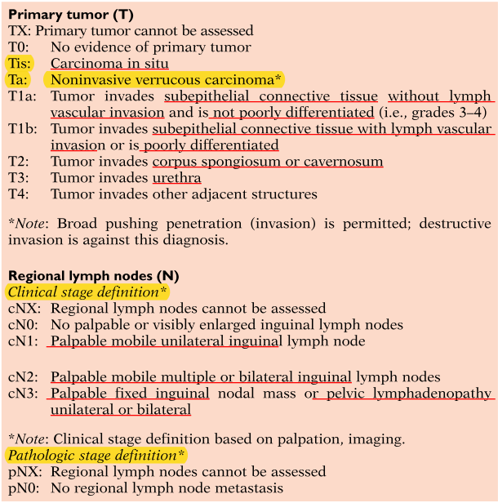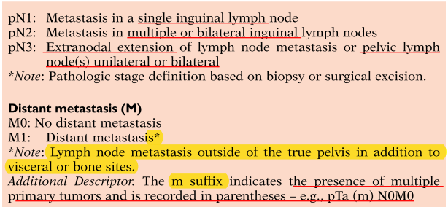
6. ( ) 根據Lausanne在2006年publish關於陰莖癌 (Penile cancer)的敘述，下列何者有誤
- 比較手術切除和放射治療(器官保留)，二者總存活率 (overall survival) 以手術切除較佳相同。
- 比較手術切除和放射治療(器官保留)，二者局部控制率以手術切除較佳。
- 接受放射治療的病人的陰莖保留率約52%。
- 放射治療五年後，陰莖仍保持完整的比率約43%。
(6 答案) : A (Penile cancer)
(6 難易度)：難
(6 參考文獻)： Ozsahin M. Treatment of penile carcinoma: To cut or not to cut? Int J Radiat Oncol Biol Phys. 2006 Nov 1;66(3):674-9.
(6 註解)： 5-year overall survival: surgery 53% vs. RT 56% (not statistically significant).

GU 考題 II
1. ( ) 關於腎細胞癌 (Renal cell carcinoma) 的敘述，下列何者有誤
- 腎細胞癌好發年齡為55到60歲，男女比例為1.5比1。
- 抽菸、高血壓及體重輕重的人，其罹患腎細胞癌的風險會增加。
- 腎細胞癌可能與von Hippel–Lindau (VHL) 疾病有關。
- 最主要的細胞型態是腺癌 (adenocarcinoma)。
(1 答案) : B (Renal cell carcinoma)
(1 難易度)：中
(1 參考文獻)： Perez and Brady’s principles and Practice of radiation Oncology Chapter 60, p1397-1400
(1 註解)： p 1397 High body weight and hypertension also are associated with a higher relative risk for development of these tumors

2. ( ) 關於腎細胞癌 (Renal cell carcinoma) 的敘述，下列何者有誤
- 侵犯到腎靜脈或下腔靜脈的病人，預後較差。
- 腫瘤侵犯至橫隔膜之上的下腔靜脈，其T stage為 T3c。
- 遠端淋巴轉移的機率是20%。
- 細胞型態有sarcomatoid分化的病人，預後較clear cell carcinoma 佳差。
(2 答案) : D (Renal cell carcinoma)
(2 難易度)：中
(2 參考文獻)： Perez and Brady’s principles and Practice of radiation Oncology Chapter 60, p1399-1402
(2 註解)： p 1401 The spindle cell or sarcomatoid variants of renal cell carcinoma are associated with a statistically significant inferior 5-year survival rate, compared with pure clear or clear and granular histologic variants
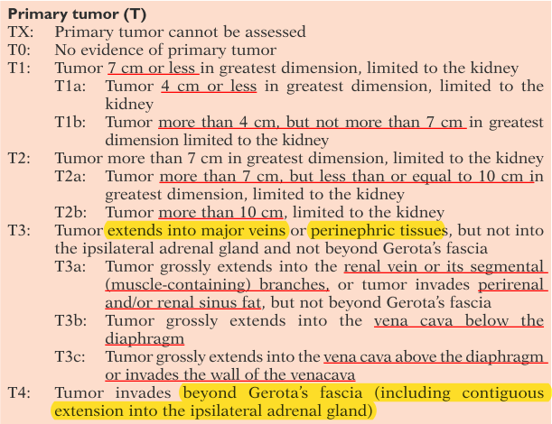
3. ( ) 關於膀胱癌 (Bladder cancer) 的敘述，下列何者有誤
- 膀胱癌好發在中年，年齡為50-55 60-70 歲的病人。
- 膀胱癌的產生與許多環境因子有關，其中最重要的是抽菸。
- 其主要症狀為無痛性血尿(painless hematuria)，佔了75%。但有20%的病人在診斷時，沒有任何臨床症狀(asymptomatic)。
- 其主要細胞型態為Transitional cell carcinoma (TCC)，佔90%以上。但是在血吸蟲盛行之區域，細胞型態則以squamous cell carcinoma為主，佔50%以上。
(3 答案) : A (Bladder cancer)
(3 難易度)：易
(3 參考文獻)： Perez and Brady’s principles and Practice of radiation Oncology Chapter 61, p1412-1413
(3 註解)： p 1412 Carcinoma of the bladder in this country primarily affects males between 60 and 70 years of age, and its incidence is increasing

4. ( ) 關於表淺型膀胱癌(Superficial bladder cancer)的敘述，下列何者有誤
- 約50 85 %的膀胱癌為表淺低分化(superficial-low grade)的腫瘤。
- 表淺型腫瘤的首選治療為TURB。若病理結果為T1且無殘餘腫瘤(residual disease)，則應追加BCG灌注。
- 約15%的表淺型腫瘤 (Superficial tumor, Ta or T1)在五年內會進展成肌肉侵犯型(muscle-invasive tumor, T2-T4)。
- 表淺腫瘤進展成肌肉侵犯型腫瘤(muscle-invasive tumor)與腫瘤分化(tumor grade)、腫瘤大小(tumor size)、是否為多發性病灶(solitary or multiple lesions)以及膀胱頸是否侵犯 (bladder neck involvement)等因子有關。

(4 答案) : A (Bladder cancer)
(4 難易度)：易
(4 參考文獻)： Perez and Brady’s principles and Practice of radiation Oncology Chapter 60, p1412-1415
(4 註解)： p 1412 As many as 85% of patients diagnosed with TCC of the bladder have superficial low-grade tumors (Ta, T1), which are confined to the mucosa

5. ( ) 關於侵犯型膀胱癌(Muscle-invasive bladder cancer)治療的下列敘述，何者有誤
- Radical cystectomy為侵犯型膀胱癌(Muscle-invasive bladder cancer)之標準治療，可以達到最好的長期存活率(long term survival)，最低的局部復發率(local recurrence rate)。
- 目前尚無其他治療方式可與膀胱切除之結果相匹敵。
- TCC對於放射治療之敏感性相當好普通。
- Radical cystectomy可提供準確的病理期別診斷，並且作為選擇輔助療法(adjuvant therapy)的參考。

(5 答案) : C (Bladder cancer)
(5 難易度)：難
(5 參考文獻)： Perez and Brady’s principles and Practice of radiation Oncology Chapter 61, p1415
(5 註解)： p 1412 primary TCC of the bladder tends to be a tumor moderately sensitive to radiation therapy

6. ( ) 關於膀胱癌(bladder cancer)的器官保留(organ preservation)之敘述，下列何者有誤
- 器官保留(organ preservation)治療是個combined-modality therapy。
- RTOG 89-03試圖比較neoadjuvant methotrexate, cisplatin, and vinblastine (MCV) chemotherapy之使用與否，在膀胱保留治療上的效益。
- RTOG 89-03的結果發現，使用neoadjuvant MCV chemotherapy 可以不能增加complete remission (CR) rate，使得病人得以接受膀胱保留的治療。
- RTOG 89-03的結果發現，使用neoadjuvant MCV chemotherapy 對於5年存活率 5-year overall survival沒有顯著影響。

(6 答案) : C (Bladder cancer)
(6 難易度)：難
(6 參考文獻)： J Clin Oncol. 1998 Nov;16(11):3576-83.
Phase III trial of neoadjuvant chemotherapy in patients with invasive bladder cancer treated with selective bladder preservation by combined radiation therapy and chemotherapy: initial results of Radiation Therapy Oncology Group 89-03.
(6 註解)：Two cycles of MCV neoadjuvant chemotherapy were not shown to increase the rate of CR over that achieved with our standard induction therapy or to increase freedom from metastatic disease. There was no impact on 5-year overall survival
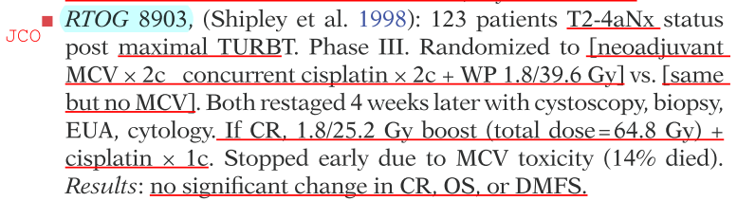
- RTOG 89-03 (1990-93) -- Selective chemo-RT bladder sparing +/- induction MCV x2 cycles
  - Phase III. Stopped prematurely due to severe neutropenia and sepsis. 123 of 174 patients. cT2-T4a. Randomized to Arm 1) 2 cycles of MCV before, or Arm 2) no MCV before RT 39.6/22 with concurrent cisplatin 100 mg/m2 q3w x2 courses (per RTOG 88-02), cystoscopy 4 weeks later. If CR, consolidative RT 25.2/14 with concurrent cisplatin 100 mg/m2, else radical cystectomy. Total RT dose 64.8/36
  - 1998 PMID 9817278 — "Phase III trial of neoadjuvant chemotherapy in patients with invasive bladder cancer treated with selective bladder preservation by combined radiation therapy and chemotherapy: initial results of Radiation Therapy Oncology Group 89-03." (Shipley WU, J Clin Oncol. 1998 Nov;16(11):3576-83.) Median F/U 5 years
    - Outcome: pCR MCV+ 61% vs MCV- 55%. r-year bladder preservation 36% vs 40% (NS). DM 33% vs 39% (NS). 5-year OS 48% vs 49% (NS) Predictors for worse outcome hydronephrosis and incomplete TURBT
    - Conclusion: 2 cycles of MCV did not increase CR rate, change DM rate, or impact OS. High toxicity.

7. ( ) 關於睪丸癌(Testicular cancer)的敘述，下列何者有誤
- 好發年齡在20-40歲之間。
- 可能與隱睪症、母親受孕時的賀爾蒙不平衡、低生殖力或不正常精蟲分析、免役抑制以及遺傳有關。
- 95%的睪丸癌為生殖細胞瘤(germ-cell tumor)，分為精母細胞瘤(seminoma) or非精母細胞瘤(nonseminoma)兩種。
- 得到精母細胞瘤(seminoma)病人的平均年齡比非精母細胞瘤(nonseminoma)病人的早晚十年。

(7 答案) : D (Testicular cancer)
(7 難易度)：中
(7 參考文獻)： Perez and Brady’s principles and Practice of radiation Oncology Chapter 61, p1503-1504
(7 註解)：Nonseminomas have an age-specific incidence peak 10 years earlier than that of seminomas.

8. ( ) 關於睪丸癌(Testicular cancer)的敘述，下列何者有誤
- T stage對於早期非精母細胞瘤(nonseminoma)與精母細胞瘤(seminoma)的預後，不具有診斷價值for seminoma。
- 第一期精母細胞瘤(seminoma)的復發與否，與腫瘤大小(tumor size)、精小管(rete testis)之侵犯與病人年齡(patient age)有關，。
- 放射治療在非精母細胞瘤(nonseminoma)並無角色
- 精母細胞瘤(seminoma)以放射治療或化學治療為主

(8 答案) : A (Testicular cancer)
(8 難易度)：難
(8 參考文獻)： Perez and Brady’s principles and Practice of radiation Oncology Chapter 61, p1506-1512
(8 註解)：T stage is not useful in predicting risk of relapse in stage 1 seminomas, where tumor size and rete testis invasion are of independent prognostic value.

9. ( ) 下列何者不是睪丸癌(Testicular cancer)的poor prognosis factor
- 非肺部轉移
- AFP >10,000 ng/mL
- HCG >50,000 IU/L
- LDH >正常值的10倍

(9 答案) : A (Testicular cancer)
(9 難易度)：易
(9 參考文獻)： Perez and Brady’s principles and Practice of radiation Oncology Chapter 61, p1507 Table 64.7
(9 註解)：The factors most strongly associated with a poor prognosis were mediastinal primary, nonpulmonary visceral metastases, or the presence of grossly elevated tumor markers (AFP >10,000 ng/mL, HCG >50,000 IU/L or lactate dehydrogenase [LDH] >10 × normal).
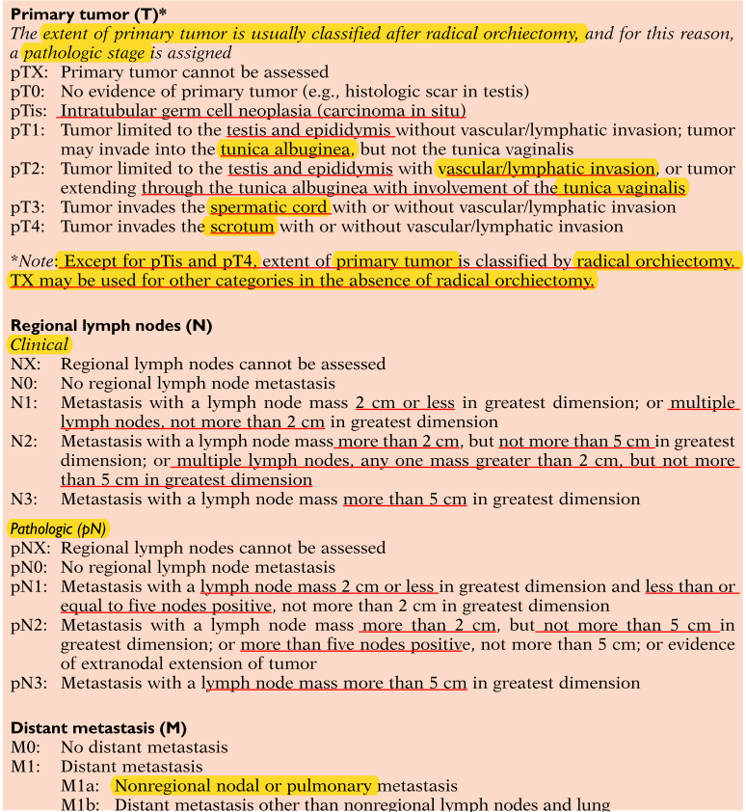
S0 - serum markers within normal limits
S1 - LDH < 1.5 * upper limit of normal, AND hCG < 5000 mIu/mL, AND AFP < 1000 ng/mL
S2 - LDH 1.5 - 10 * normal range, OR hCG 5000-50,000, OR AFP 1000-10,000
S3 - LDH > 10 * normal range, OR hCG >50,000, OR AFP > 10,000

