HES/Sarcoma

- Which is the most common subtype of Hodgkin lymphoma in developed countries?
  - Lymphocyte predominant
  - Lymphocyte depleted
  - Nodular sclerosis
  - Mixed cell type
    - Ans: C
    - Ref: Principles and Practice of Radiation Oncology, sixth edition, Carlos A. Perez, Luther W. Brady; Chapter 77, p1533-1534; 2013
      - Nodular sclerosis classical HL is the most common histologic subtype diagnosed in developed countries.
- Which is the most appropriate primary treatment for stage I/II non-bulky typical follicular lymphoma according to NCCN guideline?
  - Involved-site radiation therapy (ISRT) 24-30 Gy
  - 3 cycles of R-CHOP followed by ISRT to 30-36 Gy
  - Close observation and treatment at progression
  - Involved-field radiation therapy to 4 Gy in 2 fractions
    - Ans: A
    - Ref: NCCN guideline – B-cell lymphomas, Version 3.2017, FOLL-3 & NHODG-D
- 58歲男性，因頸部腫塊三個月就診，大小約5公分，切片後診斷為follicular lymphoma，PET scan發現左側頸部level III有一明顯FDG uptake之淋巴結，身體其他部位並無異常，抽血報告發現WBC: 7800/uL、Hgb: 11.5g/dL、PLT: 180 × 10³ /uL、LDH: 576 IU/L，依據FLIPI分類，此病患是屬於哪個risk group ?
  - Very low risk
  - Low risk
  - Intermediate risk
  - Poor risk
    - C (本項請再註明，出題的科別細項，以利歸類)
      - 中
        - Perez & Brady's Principles and Practice of Radiation Oncology 6th edition, P.1552-1553
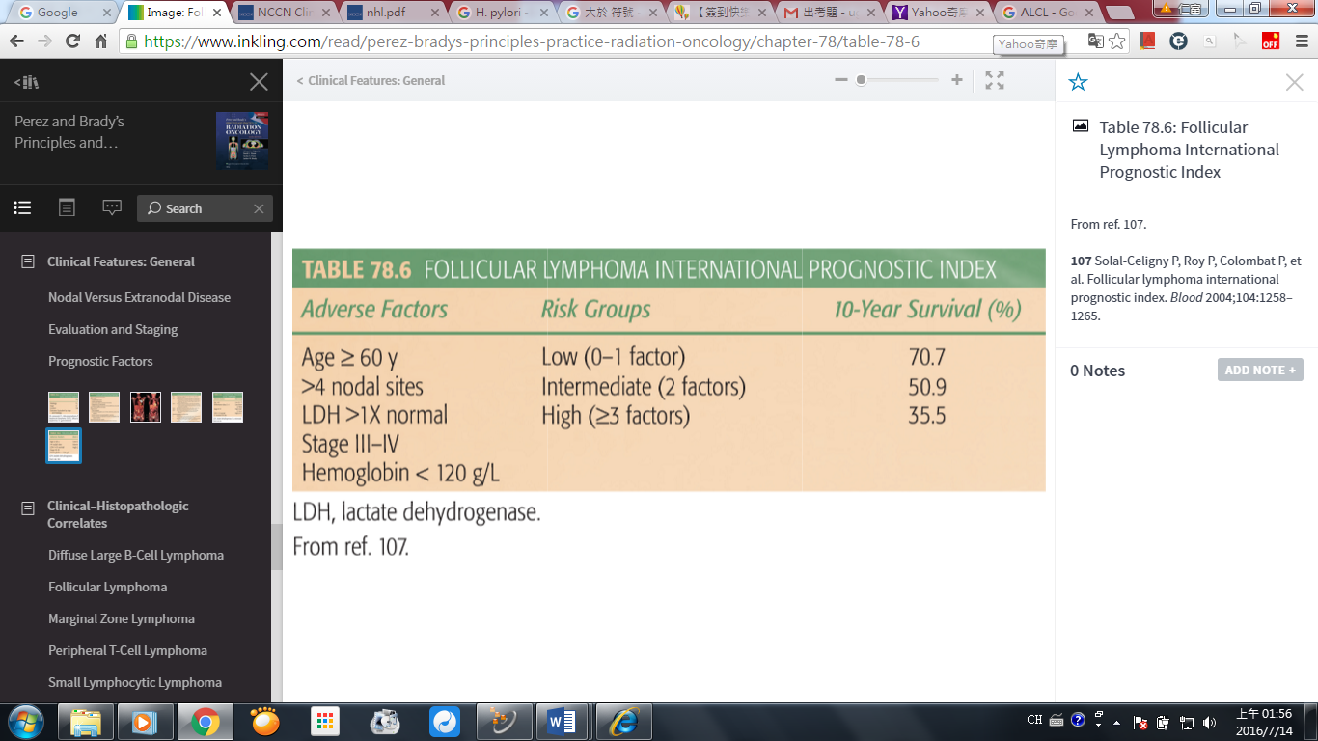

- 下列關於Orbital lymphoma的敘述，何者錯誤?
  - 發病年齡大約60歲
  - 2/3病人的病理型態是屬於marginal zone lymphoma
  - 八成的病人會有雙眼的侵犯
  - Orbital MALT lymphoma建議全眼球做放射線照射，以防marginal miss
    - C (本項請再註明，出題的科別細項，以利歸類)
      - 易
        - Perez & Brady's Principles and Practice of Radiation Oncology 6th edition, P.1569
Orbital lymphomas comprise approximately 4% of all ENL. They typically arise in superficial tissues such as conjunctiva and eyelids and are most commonly seen in an older population, with a median age of approximately 60 years. Histopathologically, approximately two-thirds of these tumors are MZL. Most of the remainder are DLBCL.

- 有關Hodgkin lymphoma的敘述，下列何者為誤？
  - 通常原發於淋巴結，並且有8成病人會以頸部淋巴結腫大表現，但只有5成病人有mediastinal disease
  - 最常見的臨床表現為會痛的頸部淋巴腫塊
  - 孩童的Hodgkin lymphoma預後比成人好，因此治療策略也不同
  - B symptoms包含fever, night sweating, weight loss
    - B (Reticuloendothelial System)
      - 易
        - Perez and Brady’s Principle and Practice of Radiation Oncology 6th edition
          - P1531-1532 Chapter 77: Anatomy, Epidemiology and Risk Factors, Natural History and Clinical Presentations
- 下列primary cutaneous lymphoma，何者預後最好？
  - Primary cutaneous marginal zone B-cell lymphoma (PCMZL)
  - Mycosis fungoides (MF)
  - Lymphomatoid papulosis
  - Extranodal NKT cell lymphoma

    - C (Lymphoma Cutaneous)
      - 易
- 下列關於非何杰金氏淋巴瘤(Non-Hodgkin Lymphoma)的敘述，何者為誤？
  - t(8:14)和peripheral T-cell lymphoma有關
  - Trisomy 12, t(14;19)和chronic lymphocytic leukemia有關
  - Trisomy 3, t(11:18)和gastric mucosa-associated lymphoid tissue lymphoma有關
  - t(14;18)常見於follicular lymphoma
    - A (Non-Hodgkin Lymphoma)
      - 簡易
        - Radiation Oncology: A question-Based Review, Boris Hristov, Steven H. Lin, John P. Christodouleas - Second edition; Chapter 71, p484; 2014.
          - P484, t(14;18) is seen in 90% of FLs. This results in overexpression of antiapoptotic Bcl-2. Chromosome 13 deletion, t(14;19), and trisomy 12 are associated with SLL and CLL. Trisomy 3 (60%) and t(11:18) (25%–40%) are associated with MALT lymphoma. c-myc overexpression t(8:14) is associated with Burkitt lymphoma.
- 下列關於Diffuse large cell lymphoma 的敘述何者錯誤?
  - 為最常見的extranodal Non-Hodgkin lymphoma。
  - 常出現BCL-2及BCL-6的基因表現。
  - Bulky lesion目前定義為≧10 cm
  - 不良的預後因子包括 >60歲、ECOG ≧2、LDH上升、>1 involved nodal region及stage III/IV。
Ans: C
NCCN Guideline 2.2015 BCEL-3: Nonbulky(<7.5 cm); bulky(≧7.5 cm)

