 | Esophagus | Stomach | Rectal cancer  Colon cancer | Pancreas
T1a | Lanima propria / muscularis muscosae | 同eso | 同eso | <=0.5cm
T1b | Submucosa | 同eso | 同eso | <1cm
T1c |  |  |  | <=2cm
T2 | Muscular propia | 同eso | 同eso | <=4cm
T3 | Adventitia | Subserosa  (omentum, lig) | Pericolorectal tissue | >4cm
T4a | 肋心腹橫膈、無名靜脈 | Serosa  (visceral peritoneum) | visceral peritoneum  (包括侵犯其他段之colon rectum) | T4:侵犯celiac, SMA, common hepatic a.
T4b | Aorta/呼吸道  /脊椎骨 | Adj organ(不含12指腸、食道) | Adj organ
N1a | N1: 1-2個 | N1: 1-2個 | 1個 | N1: 1-3個
N1b |  |  | 2-3個
N1c |  |  | deposit
N2a | N2: 3-6個 | N2: 3-6個 | 4-6個 | N2: 4-6個
N2b |  |  | 7個
N3a | N3: >=7個 | <=15個
N3b |  | >15個
Rectal: M1a:1site or organ (multiple mets in 1 organ even pair),
M1b:>=2 sites or organ, M1c:peritoneal involve

 | HCC | Anal | Pancreas
T1a | <=2cm | <=2cm | <=0.5cm
T1b | >2cm且LVSI- |  | <1cm
T1c |  |  | <=2cm
T2 | >2cm且LVSI+  ；多顆 | >2cm | <=4cm
T3 | >5cm | >5cm | >4cm
T4 | 侵犯主要血管(肝門、肝靜)分支  侵犯膽囊以外周邊器官  侵犯臟層腹膜 | 侵犯周邊器官  (陰/尿道/膀胱) | 侵犯celiac, SMA, common hepatic a.
N1a | N1=N+ | Inguinal/mesorectal/int iliac | N1: 1-3個
N1b |  | Only Ext iliac
N1c |  | a+b
N2 |  |  | N2: 4-6個

 | cEsophagus Sq | cEsophagus Aden | cGastric | pGastric | ypGastric | Pancreas | HCC | ColoRectal | Anal
0 | Tis | Tis | Tis | 0 |  | 0 |  | Tis | Tis
IA | I:T1N0-1 | I:T1N0 | I:T1+N0 | =1 | I:<=2 | T1 | T1a | I: T1-2N0 | I: T1N0
IB |  |  |  | =2 |  | T2 | T1b
IIA | II:others | T1N1 | T1+N+ | =3 | II:<=4 | T3 | T2 | T3N0 | T2N0
IIB |  | T2N0 | T3+N0 | =4 |  | N1 |  | T4aN0 | T3N0
IIC |  |  |  |  |  |  |  | T4bN0
IIIA | III:T3N1 or N2 | III:T3+ or N1 | III:T3+N+ | <=6 | III:>4 | III:  T4 / N2 | T3 | <=3 | <4:T1-2N1
IIIB |  |  |  | <=8 (T3N3a =6例外) |  |  | T4 | <=5 | =4:T4N0
IIIC |  |  |  | >8 |  |  |  | >=6 | >4:T3-4N1
IVA | T4 or N3 | T4b or N2+ | T4b | IV:M1 | IV:M1 | IV:M1 | N1 | M1a | IV:M1
IVB | IVB:M1 | IVB:M1 | IVB:M1 |  |  |  | IVB:M1 | M1b
IVC |  |  |  |  |  |  |  | M1c
補充 |  |  | Peritonem cytology+ 也算M1 | TxNy看x+y數字和  N3b or T4b ->算5.5 | TxNy看x+y數字和  *N3b -> 5.5 |  |  | N+的Tx+Ny 看數字和  *N2b算3分  *T4b算5分 | Stage III 看Tx+Ny數字和  *N1算1.5分

I, IIA, IIB, III, IVA, IVB => cEso ADA / cGastric /
Stage I 分AB: pGastric / Pancreas / HCC
Stage II 不分AB: cEso Sq / ypGastric / HCC
Stage IIC: Colorectal
Stage III 分ABC: pGastric / HCC (沒IIIC) / Colorectal / Anal
Stage IV 不分AB:pGastric / Pancreas / Anus
Stage IVC: Colorectal

 | Intrahepatic  (T大小) | Perihilar Bile duct  (klatskin tumor) | Distal bile duct  (T深度) | Gallbladder  (T深度-層)
Tis | Intraductal tumor | High grade displasia | Hi G displasia
T1a | <=5cm | 肌肉纖維組織侵犯  (沒超出wall) | DOI < 5mm | Lamina propia
T1b | >5cm |  |  | Muscle layer
T2a | 肝內血管 invasion or 多顆 | Adipose tissue | DOI 5-12mm | 腹膜側 軟組織
T2b |  | 肝臟實質 |  | 肝側 軟組織
T3 | Visceral peritoneum | Uni br of portal v /hepatic a | DOI > 12mm | 侵犯serosa (臟層腹膜)、肝胃12指胰/網膜/肝外膽管
T4a | 侵犯肝外器官 | 2nd biliary duct + 對側大血管或雙側大血管 | Celiac a. , SMA, Common Hep a. | 主portal v. or hepatic a. 或兩個管外器官
T4b
N1 | N+ | 1-3個 | 1-3個 | 1-3個
N2 |  | 4個以上 | 4個以上 | 4個以上
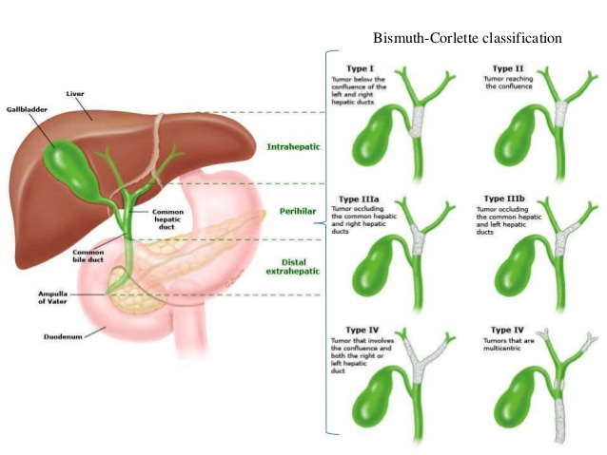
 | Intrahepatic | Perihilar Bile duct  (klatskin tumor) | Distal bile duct | Gallbladder
0
IA | T1a | T1 | T1N0 | T1
IB | T1b
IIA | T2 | T2 | T+N=2 | T2a
IIB |  |  | 剩下的 | T2b
IIIA | T3 | T3 | N2 | T3
IIIB | T4 | T4 | T4 | N1
IIIC |  | N1
IVA | N1 | N2 | M1 | T4
IVB | M1 | M1 |  | N2 or M1
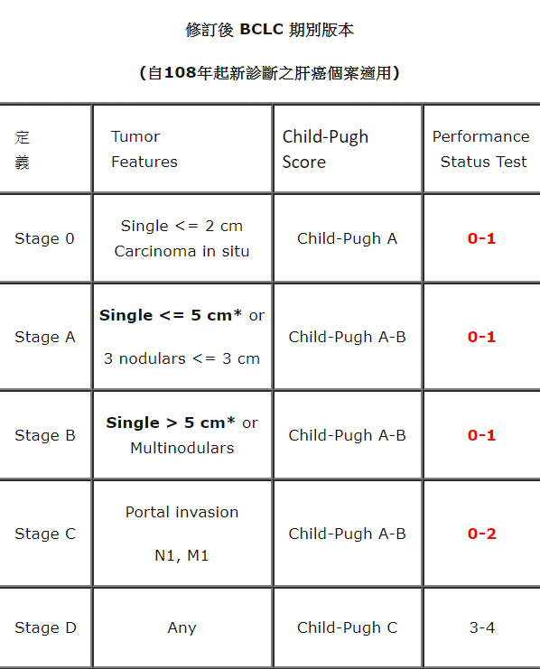
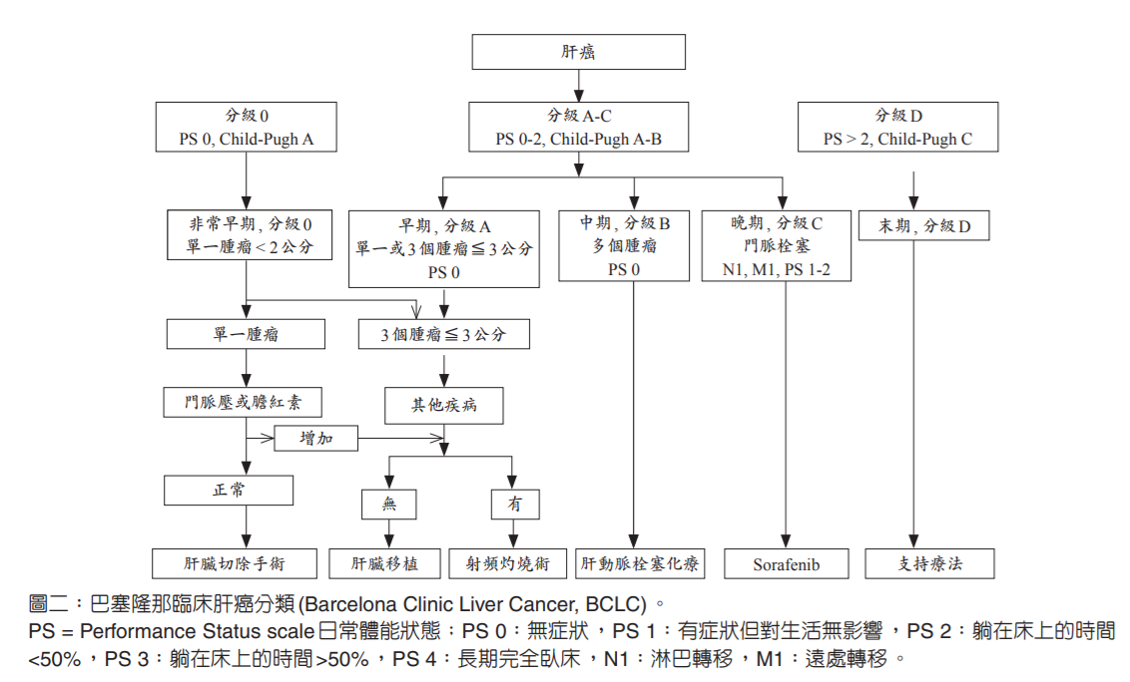
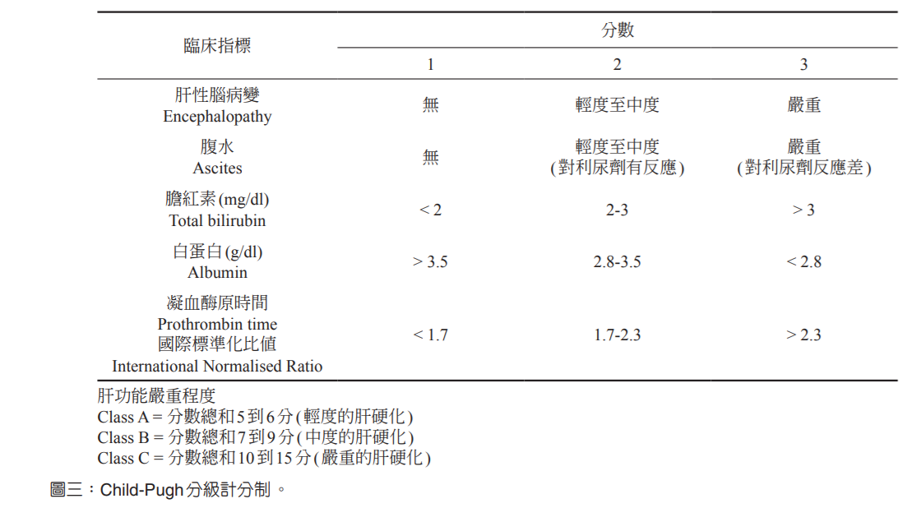
ALBI計算公式為：0.66×log ₁₀（總膽紅素）-0.085×（白蛋白），膽紅素單位為μmol/L，白蛋白單位為g/L。1 级（低于 -2.60）， 2 级（-2.59~-1.39），3 级（高于 -1.39）越大越糟

