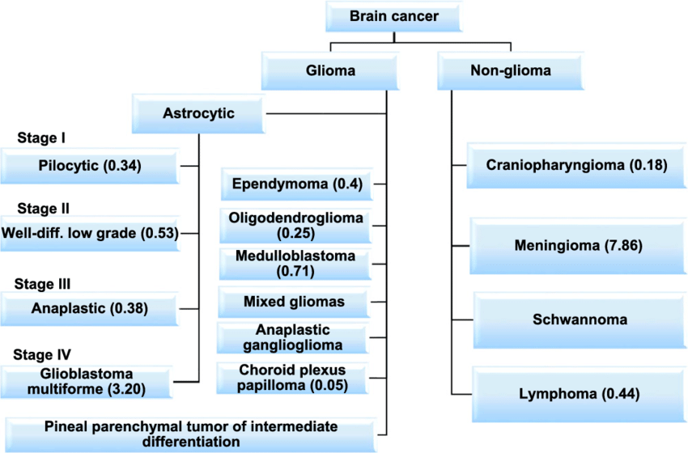

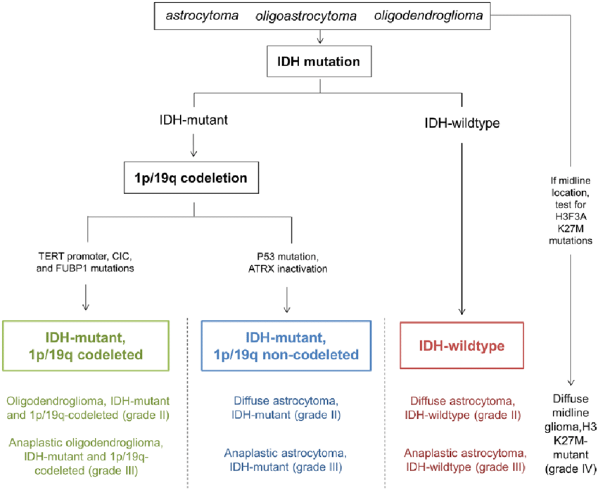

 | 病人 | 較好arm | 較差arm | OS/MS | PFS/DFS | Others
HighGr Glioma
EORTC 26899  /NCIC | GBM 16% Bx 40% GTR | Adj RT (60) + caTMZ | Adj RT alone (60) | ↑ 5y 10v2 |  | MS:14.6 vs 12.1m  MS(TMZ):21.7(MGMT甲) vs 12.7m
RTOG 0525 | GBM s/p OP | 60 Gy + caTMZ (stupp) | 60 Gy + caTMZ (增加服藥天數和cycle) | ≒ | ≒ | Increasing the number  of days of TMZ not improve OS or PFS, 無論MTMG status。
2012 STUP TTF | Rec GBM | TTF | C/T | ≒ | ≒ | 5y PFS:21 vs 15%, TTF ↓toxicity
2015 JAMA | New GBM s/p OP | RT+caTMZ  +TTF | RT+caTMZ | ↑16v21m | ↑ 7vs4m
RTOG 9402 | AO/AOA  KPS≧60 | PCVx4c+RT (50.4->59.4)  (間隔6wk) | RT (50.4->59.4) | ≒ | ↑  2.6v1.7y | IDH wild-type : PCV no benefit  IDH mutated PCV ↑ MS  (無論1p19q codelete與否)
EORTC 26951 | AO/AOA | RT (45->59.4) + PCV x 6c  (間隔4wk) | RT (45->59.4) | ↑ | ↑ | IDH mutation and 1p/19q codel ↑OS/PFS  MGMT methylation status 無關。因為此二trial, NCCN prefer 先adj RT 再PCV
LowGr Glioma
EORTC 22845 | LGG  PS 0-2 | Adj RT (54Gy) | OBS + slvageRT | ≒ | ↑ 5y  5.3 vs 3.5y | RT↓seizure rate
EORTC 22844 | LGG ages 16 to 65, KPS ≥60 | Adj RT 59.4 | Adj RT 45 | ≒ | ≒
RTOG 9802 | LGG in pts <40 years s/p GTR have >50% risk of progression at 5 years and should be closely followed with consideration of adjuvant treatment. Poor prognostic factors included large tumor size (≥4 cm), astrocytoma or mixed oligoastrocytoma histology and residual disease ≥1 cm by MRI.

 | 病人 | 較好arm | 較差arm | OS/MS | NeuroFu | LC | Others
Mets
RTOG 9508 | 1-3 mets, ≦4cm | WBRT+SRS boost | WBRT 37.5/15 | ≒  ↑ if 1 met |  | ↑ | SRS:15/18/24 Gy by RTOG 9005  ↑ KPS
NCCTG N0574 | 1-3 mets, <3cm | SRS | WBRT+SRS | ≒  10.4v7.4 | ↑ | ↓ | But WBRT↓QoL, neuro func  =>prefer SRS alone
Anoyama | 1-4 mets, ≦4cm  (49% 1 met) | SRS | WBRT 30/10  +SRS | ≒ | ≒ | ↓ | SRS: >2cm, 18-20 Gy, 若否22-24Gy, w/i WBRT, SRS boost dose x 0.7  NS in neuro preservation
Chang (Lancet) | 1-3 mets | SRS | SRS + WBRT | ↑# | ↑ | ↓ | #baseline imbalance  WBRT ↓ neuro func
EORTC 22952 | 1-3 mets | SRS or OP | SRS or OP + WBRT 30/10 | ≒ |  | ↓ | NS in PS change, Auther thought can omit WBRT w/i image f.u.
Meta-A (上三篇) |  | SRS | SRS + WBRT | WBRT ↑LC, but <50y/o SRS alone had OS benefit
N107C | 1-4 mets w/i op 1 lesion, cavity<5cm | Adj SRS to  bed + residual | Adj WBRT | ≒  12m |  |  | Cognitive decrease Free Survival favor SRS (3.7v3m), SBRT 12-20 / 18-24 Gy
JCOG0504 | 1-4 mets w/i op 1 lesion (≥3 cm) | Adj SRS to  bed + residual | Adj WBRT | ≒ | ↑ |  | 90 days cognitive function favor SRS
RTOG 9005 | (Ph II) HI (Max dose / prescribed dose) ≥2 ↑ Toxicity ; 3.1-4cm-> 15 Gy / 2.1-3cm -> 18 Gy / ≦2cm-> 24Gy
Preserve cognitive
RTOG 0614 |  | WBRT+  memantine | WBRT | ≒ | ↑ |  | 5,10,15,20 mg 各1wk,  keep 20mg 24 wk
RTOG 0933 | Mets from hippocampus>5mm | IMRT-HART | WBRT (historic data) |  | ↑  decline 7 v 30% |  | Hippocampus + 5mm constrain:  Dmax < 16Gy, D100%≦9 Gy

CNS
 | HGG (Nancy LEE) | LGG | Ependymoma (intracranial 小兒多) | Spine Primary (成人多)
CTV | CTV 46:postop T2 flair + cavity + T1 contrast residual +2cm  CTV 60:cavity + T1 contrast residual +2cm  (CTV可跨中線) | (pre/post T2 flair + post T1 contrast) + 1-2cm | pre/post T2 flair + post T1 contrast:  areas that are touched by preop tumor volume plus postop signal abnormality + 1-2cm | GTV + 上下 1-2cm
PTV | CTV+3-5mm | CTV+3-5mm | CTV+3-5mm | CTV+3-5mm
Dose | Standard: 60/2 or 59.4/1.8  (Phase I: 46/2 or 45-50.4/1.8 => boost)  Large: 54-55.8/1.8 or 57/1.9  Poor PS, elderly: 34/10 or 40.05/15  Elderly, fragil: 25/5 | Standard: 45-54  IDH wild: 59.4 -60 | Standard:54-59.4  CSI (if brain/spine/CSF mets):  Brain-S2 (thecal sac底):36/20  Boost spine lesion to 45,  below conus (L1-2):54-60  Boost primary intracranial site to 54-59.4 | 45-54 Gy/1.8  below conus (L1-2):54-60  Spine Ependymoma(成人多)

 | PCNSL | Meningiomas | Brain METs | Spine mets
CTV | s/p MTX => WBRT  之後無論CR/PR都可用  cytarabine+ etoposide 治療  未必要RT | GTV + 3-5mm? | WBRT  Standard: 30/10 or 37.5/15  Poor prognosis: 20/5  Better prognosis: memantine  or HART (預期活>4m)  SRS:  9005:15Gy(3.1-4),18Gy(2.1-3),24Gy(~2cm)  >3cm:27/3fx or 30/5fx | Conventional:  8/1, 20/5, 30/10  SRS:  16-24/1, 24/2,  24-27/3, 30-35/5  BED ≦ 60, 間隔6wk can reTx  If 15/1 or 40/20的較高劑量，間隔6m才可以reRT
PTV |  | CTV + 3-5mm
Dose | CR:23.4  <CR:30-36, boost to 45  RT alone: 24-36 boost to 45  If spine/CSF mets  =>intra CSF C/T + focal RT(不用CSI) | Gr I: 45-54 (EBRT)  12-16 (SRS)  Gr II:54-60  Gr III:59.4-60

 | Medulloblastoma | GCT (AFP<10, B-HCG<50) | NGGCT
CTV | Posterior Fossa (high risk boost)  Ant: post clinoid  Sup: 1 cm higher than midpoint of foramen magnum and vertex  Post: internal occipital protuberance  Field = PF + 1 cm  New standard risk boost:  cavity +1.5 cm | T2 MRI下  Whole Ventricular Volume:  (GTV + 5mm) + lateral, third and fourth ventricle + suprasellar and pineal cisterns +/- prepontine cistern | Posterior Fossa (boost CTV)
PTV | CTV+3-5mm | CTV + 3-5mm | CTV + 3-5mm
Dose | 術後四周內開始  Standard risk:  CSI:30-36 => 54-55.8 +/- C/T  Or  CSI:23.4 => 54-55.8 + C/T  High risk  CSI:36 => 54-55.8 + C/T | 先給20Gy，效果好可診斷(過去)  Local Germinoma:  WVRT:21-24 Gy  Boost primary to 40-45 Gy  CSF+ Germinoma  (類似standard risk medullo)  CSI:24 Gy => GTV to 45 Gy  Or  EP 2-4c + WVRT 18 + IFRT to 30 | if labs suggest NGGCT, then treat as NGGCT(不管病理. Treat like high-risk medullo: all get chemo, usually get CSI. Certain tumors do not need histo confirmation per ACNS 1123, e.g., bifocal pineal + suprasellar tumors, pineal lesions w DI, or mild elevation of HCG or AFP)  Platin C/T + CSI 30-36 => 50.4-54  Or  C/T + CSI 36 => boost PF to 54  Or  OP+C/T+/- CSI 36 => 50.4  (不鼓勵手術因為增加morbidity)

小兒

 | Ewing Sarcoma | Nephroblastoma (Wilm tumor)
TX | Ind C/T + OP/RT/CCRT + C/T+/-RT | s/p op:risk:VL/L/Standard/H  VL:obs ／ L:C/T ／ Standard:Flank CCRT + C/T  H(rupture):WART + C/T ／ H(unrup): Flank CCRT + C/T
CTV | Definitive RT:  GTV1=pre C/T T + bone  CTV1=GTV1 + 1-1.5cm  GTV2= pre + post C/T T  CTV2=GTV2 + 2cm | Flank RT:(AP/PA)  preGTV + 1cm; include diaphragm, shield FemorHead  pN+ cover diphra crux to obturator底 cross midline 1cn beyond VB +para A (T11-L4)  WART:(AP/PA) 1.5cm above diaphragm, to inf border:Pubic symphysis, block Fhead  WLI: Whole lung (1cm above 1st rib-L1), Mediastinum+1cm to block edge
PTV | CTV+5mm | ---
Dose | Preop:36 (rare do)  Definitive RT  CR: PTV1:45/25  Not CR: 45=>55.8  Rib primary w/I effusion  =>hemit-thorax 15/10  Lung mets:  =>WLRT 15/10=>boost GTV-M to 45 | Flank RT:(AP/PA)  Standard:10.8=>21.6; High:19.8=>30.6  WART:(AP/PA)  High FH:10.5=>21; High UH:19.8  GTV-N:19.8/11 or 21/14  WLRT:  10.5/7 (>12m) or 12/8 (<12m) => 19.5|; rapid CR with C/T may omit RT  Whole liver:19.8/11  Brain: >16y:30.6/1.8; <16y:21.6/1.8 => 32.4/1.8  Bone: >16y:30.6; <16y:25.2

 | Neuroblastoma | Retinoblastoma | Atypical Teratoid Rhaboid Tumor (ATRT)
TX | Risk: L/Int/High  L: (4S and FH and no N-myc)  GTR or STR + C/T  INT: +/-C/T +OP + CT  (RT少用，可21-24/1.5 to residual)  -------------------  H: C/T + OP + transplant + C/T +RT  (RT:4-6wk after移植 or after 4c C/T) | Stage II-III: C/T + RT 45Gy  Stage IV: C/T +/- stem cell Rescue + RT  IVA: residual < 5mm or CR, no RT  residual > 5mm, RT 36 Gy  IVB(CNS mets)  if residual:CSI + pineal/cranium boost  (36) (50.4) (45)  Bil. Dz:各自survey  Extraoccular dz: RT + C/T for palliative | Multimodality therapy  Mainstay of tx is resection  Chemo Vary  RT similar to high risk medulloblastoma
CTV | GTV1: pre/post tx by CT/MIBG  [不一定要包含術前體積]  CTV1:GTV1+1cm  GTV2:residual dz>1cc for boost  CTV2:GTV2+1cm | Cover entire retina and 5-8mm of optic n.  Pre tx dz + 5mm
PTV | +5mm | + 5mm
Dose | PTV1=>PTV2:21.6/12=>36/20  DM<5 site: 21.6/12  4S, no s/s:OBS  4S, yes s/s:  C/T +RT to whole liver 4.5/1.5  Cord compression:  <3y:9/1.8；>3y:21.6/1.8 | Residual after C/T: 35-46 Gy /1.8-2 Gy | >3y, CSI: 36=>54-55.8  <3y, 50.4-54 to primary, NO CSI  Diffuse spine mets:  spine to 39.6=> focal to 45  => Cauda to 50-54

 | Craniopharyngioma | Opatic pathway glioma | Diffuse Intrinsic Potine Glioma (DIPG) / Midline Glioma / Brain stem glioma
TX | Max safe resection + RT | Chemo first,尤其<10y  RT delay until >10y, progression, declined  visual acuity | Steroid for control edema
CTV | GTV: residual dz, inc cyst  CTV: GTV + 0.5-1cm |  | Tumor + stem + 0.5-1cm,
PTV | +3-5mm |  | +1cm limited to skull falx, tentorium
Dose | EBRT  54 Gy (<54 Gy w/I poor LC)  SRS:  12Gy if <2cm and > 5mm from optics | 45-54 Gy / 1.8 Gy  Never SRS 因CN2 tolerance 8Gy | EBRT: 54/30  HyooFx: 3 Gy x13, or 5.5 Gy x 6  Rec:2 Gy x 12 to GTV + 0.5cm

 | Rhabdomyosarcoma
TX | Fav site: Orbit, non para-meningeal HN, non-bladder/prostate GU, Billiary/Liver [此外Unfavor site]  Risk Group: Low risk: embryonal ／ Int risk: alveolar or R2 /unresectable embryonal stage II-III ／ High risk:M+  Tx: GTR + RPLND for paratesticular, axillary or inguinal LND for extremity／pelvic LND for prostate, bladder, if positive => M+;  No RT for vagina/cervix/uterus Embryonal s/p induction C/T with CR, Mets site R0, Bx->VAC  Group I extremity s/p amputation or Group I paratesticular s/p orchiectomy, Low risk Group1 stage 1-3:s/p OP +C/T  No surgery for Parameningeal, Bladder/prostate, Vagina/cervix/uterine, Orbit
CTV | Pre C/T, preOP tumor and mets at dx + 1cm
PTV
Dose | C/T: VA or VAC  Low risk: Group I-II OP+C/T+RT (36Gy for N0, 41.4 Gy for N1)  Group III OP+C/T+RT (50.4Gy except orbit 45Gy)  Int risk: OP + C/T +/- reOP if possible + RT:50.4Gy  High risk: +/-OP + C/T+RT (50.4Gy except orbit 45Gy); High risk non CR/R0 mets; R1 36 Gy; R2 or no OP:50.4 Gy

