 | Esophegus | Gastric | Pancreas (Nancy Lee)
CTV | GTV-T:上下4cm,半徑1cm  GTV-N:+ 0.5-1cm | Coverage of LN + residual stomach + anastomosis(EGJ), duodenal stump | ParaA:Rt 2.5cm, Lt 1cm, Ant 2cm, Post 0.2cm  PJstomy, PV, SMA, Celiac, tumor(bed) + 1cm
PTV | + 0.5-1cm | GTV/positive margin+1.5 cm; CTV+1cm | +0.5cm
Elective N | 頸段:SCF  上段:SCF+paraEso  中段:paraEso  下段:paraEso,小彎,splenic,Celiac Ax | Proximal (fundus,cardia,EGJ)  (雙胃雙脾雙肝+celiac+  3-5cm margin to dital esophagus)  celiac, perigastric, left gastric a.  splenic a./hilar, hepatic a./portal  Middle (Body)  (雙胃雙脾雙肝雙幽+celiac+胰12)  雙幽: supra/sub pyloric  Distal (Antrum,pylorus)  (雙胃雙脾雙肝雙幽+celiac+胰12+  3-5cm margin to duodenal stump) | Neo Tx: (Preopanc只照GTV)  for borderline resect:4-8wk後RT  Dose: 36/2.4 or 45-54/1.8-2  Adj Tx:  C/T為主or C/T+CCRT+/-C/T  D:45-46/1.8-2 to bed, anastomosis, can boost 9Gy  Definitive Tx:  Induction C/T + CCRT or SBRT  Dose:45-54/1.8-2 (SBRT:30-45/3fx or 25-45/5fx)  Rec: (基本同上)  LN:在postop之外controversial，若使用=>C/T降劑量  Definitive Head:胰12/上胰/肝門/celiac/SMA,V/ParaA  Body/tail: 胰12/上胰/胰門//肝門/celiac/SMA,V/ParaA  PostOp 胰Jeju接口/tumor bed/肝門/celiac/SMA/Para
Dose | PreOP:41.4-50.4; PostOP:45-50.4  Definitive:50-50.4  =>higher dose can be to 頸段(60-66) | 45-50.4 higher dose may be to margin+
Constrain | NCCN | NCCN | RTOG1102 (Neo/Def) | RTOG0848 (Adj)
Bowel | Max<PTV prescribed ; D05≦45 | V45≦195cc | Max≦55 (含12指/空 | Max≦54; V45≦15; V50≦10
Cord | Max≦45 | Max≦45 | D0.03cc≦45 | Max≦45
Heart | V30≦20-30 ; Dm≦30 | V30≦20-30 ; Dm≦30 | ----------------------- | -----------------------
Lungs | V30≦15 ; V20≦20 ; Dm < 20  (越低越好;金標準尚未確立) | V20≦30 ; Dm < 20 | Nancy Lee: V15≦30 ; Dm < 30
Liver | V30≦20 ; V20≦30 ; Dm < 25 | V30≦33 ; Dm < 25 | Dm < 30 | Dm < 25
Kidney | V18≦33; Dm < 18 | V20≦33; Dm < 18 | V18≦30; V18≦10(單腎 | 3D: V18≦50(R); V18≦35(L)  IM: Dm < 18; V18≦15(單腎
Stomach | Max<54 ; Dm<30 | ----------------------- | Neo/Def/Adj皆同Bowel

 | Rectal (preop)-Nancy Lee | Anal (兩種dose給法 NCCN vs 0529) | HCC - Nancy Lee
CTV | CTV-H  GTV+1.5-2cm(上下)/1-2cm(四周)  including rectum, mesorectum, presacral; 1-1.5cm into bladder  CTV-standard  上緣:L5/S1 (2cm above GTV)  Mesorectum, presacral, internal iliac,  ; external iliac (T4);int/ext iliac +0.7cm (ext之anterior + 1-1.5cm)  1-1.5cm into bladder  下緣:pelvic floor (2cm below GTV) | 若GTV已經被挖掉，可把anal canal作為替代的GTV-T  CTV-gross: Dose-PH III  Not CR, T3-4,N+=>boost to 50.4-59.4  T+2.5cm ; N+1cm; w/i mesorectum  CTV-high Dose: PH II 45.0/1.8  CTV gross + Mesorectum, presacral (1cm), int/ext iliac (inferior to SI joint), obturator LN+/- inguinal LN (if involved)  CTV-low Dose: PH I 30.6/1.8  上緣:L5/S1  CTV gross + CTV high + int/ext iliac (superior to SI joint) +/- inguinal LN (if not involved)  下緣:(2cm below GTV) | GTV: Liver tumor, Lipidol retaining T, thrombus  CTV: 3-5mm around GTV  2-3mm around GTV thrombus  附近的RFA zone, Bland thrombus..  CTV不可越過天然屏障
PTV | +0.5-1cm | +0.5-1cm | 4DCT + 呼吸調控; GTV/CTV + 0.5-2 cm
Dose | CTV standard:45  CTV-H: boost to 50.4  (Unresectable:>54Gy)  Short RT:5Gy x 5 | RTOG0529 (SIB):T2N0 28fx; others 30fx  T2N0 T34N0 N+ N>3cm  PTV-T 50.4 54 54 54  PTV-N 42 45 50.4 54 | GTV: 39-54 Gy / 5-6 fx  CTV: 27.5-30 Gy / 5-6fx
Constrain | RTOG 0529 | RTOG 0529 | Quantec < 5% RILD; EBM
Bowel | V30<200cc; V35<150cc; V45<20cc | V30<200cc; V35<150cc; V45<20cc | Liver(扣掉GTV): Dm < 30-32 / Dm < 28 (Child A)  Whole liver: <28 (2Gy/fx); <21 (3Gy/fx)  SBRT:  Liver: >700cc received < 15 Gy in 3-5 fx  (扣GTV): Dm < 13/3 fx; <18/6 fx; <6 Gy (Child B)
Bladder | V35<50; V40<35; V50<5 | V35<50; V40<35; V50<5
股骨頭 | V30<50; V40<35; V44<5 | V30<50; V40<35; V44<5
外陰 | V20<50; V30<35; V40<5 | V20<50; V30<35; V40<5
Iliac crest | V30<50; V40<35; V50<5 | V30<50; V40<35; V50<5
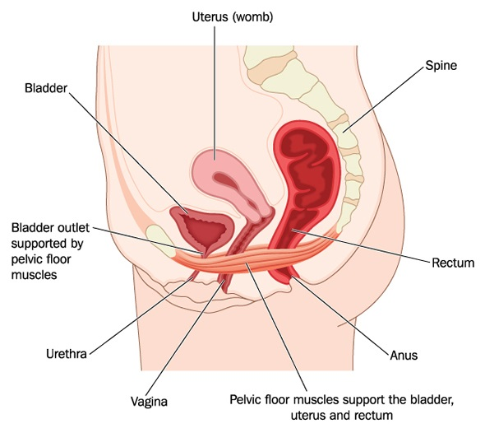
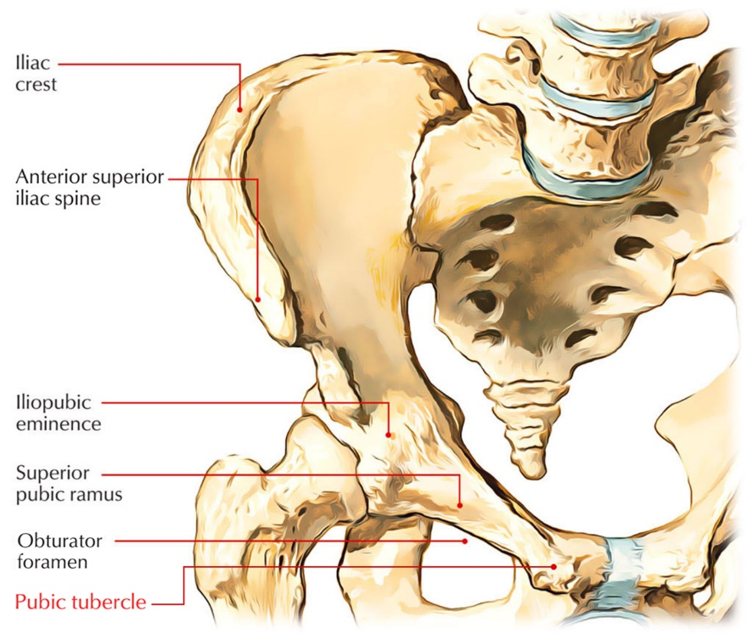
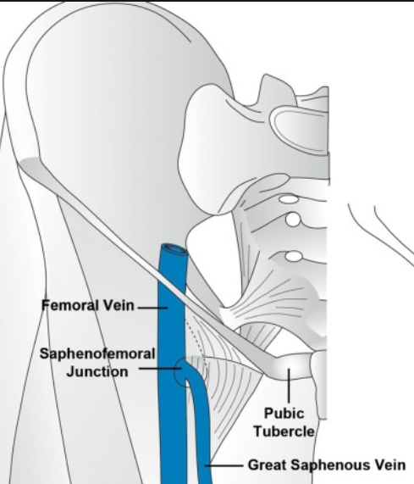

Inginal LN:upper edge of the superior pubic rami ~ SF junction(Pubic tubercle)之下2cm
