HEMA
Risk Factors for CNS Mets [TBI-LBP]
–– Testicular relapse –– Burkitt’s lymphoma –– Immunocompromised
–– Lymphoblastic –– BM+ –– Parameningeal

Technique (mostly for HL): IFRT, ISRT, and INRT
–– Total-LI/SubTotal-LI: 1970s+; 30–45 Gy;
TLI – mantle followed by inverted Y + spleen (usually 2-3w break).
STLI: mantle + upper abdominal (w/o pelvic).
–– EFRT: 1980s+ – usually mantle or inverted Y; covers involved region + uninvolved region.
Inverted Y = PA + pelvic fields.
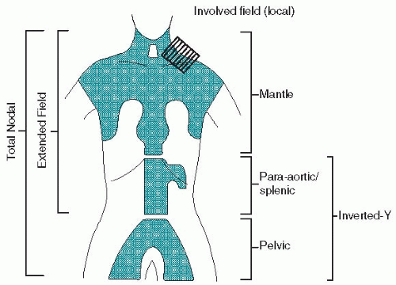
–– IFRT (do not use this anymore!) – 1995+; 20–30 Gy; site of clinically involved LN, Kaplan/Rye group (per below); LN grouping not clearly defined; depends on bony anatomy; 2D
–– Cervical/supraclav: extends from base of the skull to clavicles.
–– Axilla: C5/6, tip of scapula or 2 cm below LNs, ipsi transverse process, flash axilla.
–– Mediastinum:
–– PA field:
• Top of T11 or 2 cm above pre-chemo volume to aortic bifurcation (bottom L4) or 2 cm below pre-chemo volume.
• Encompass lateral transverse processed of L-spine and 2 cm from post-chemo volume.
–– Pelvic field:
• Includes external iliac, inguinal, femoral nodes, middle SI joint to 5 cm below lesser trochanter;
• lateral border includes greater trochanter, medial border at obturator foramen, including 2 cm beyond involved nodes

–– ISRT: 3D; 2008+; pre-chemo GTV determines CTV (carve out bone, lung); becoming the SOC (site/standard of care?)
Supine, head extended, alpha cradle, arms akimbo.
–– Pure ISRT: GTV + ~1 cm = CTV. CTV + 1 cm = PTV
Routine in the USA; optimal pre-tx imaging not available. Not possible to reduce CTV to same extent as INRT.
–– INRT: subtype of ISRT where prechemo imaging available, no margin for imaging limitations;
upfront PET-CT mandatory in tx position; typically, pregnant women not eligible because CT and PET are avoided.
• INRT alone acceptable for NLPHL(Nodular lymphocyte-predominant Hodgkin lymphoma),though CTV is more
generous (~3–5 cm along vessel).
• INRT is the SOC for early-stage fav HL per ILROG, if pre-treatment imaging in the treatment position is available.
–– INRT contours (Specht, IJROBP, 2014)
(A) Prechemotherapy GTVCT on prechemotherapy CT scan.
(B) Prechemotherapy GTVPET on prechemotherapy CT scan.
(C) Postchemotherapy GTVCT on postchemotherapy CT scan.
(D) Postchemotherapy GTVPET on postchemotherapy CT scan.
(E) Clinical target volume, created by modifying GTVCT and GTVPET, on the postchemotherapy CT scan.
–– Take into account tumor shrinkage, anatomic changes.
–– CTV encompasses all initial lymphoma volume while still respecting normal structures (e.g., lungs, CW, muscles).
–– ITV = CTV + margin, create by using 4D CT or fluoro to account for motion.
–– ITV + setup error margin = PTV. Use DIBH (Deep inspiration breath hold radiotherapy) if involving mediastinum.
–– Start at 3–4w after completing chemo.

Total Body Irradiation (TBI)
–– Dose of RT alone to achieve immunosuppression is too high and would cause toxicity. Combine with chemo. RT targets all anatomic compartments, while chemo is unable to penetrate sanctuary sites (e.g.,brain, testes).
–– Lymphocytes are both sensitive to RT and chemo; however, some may be present in areas of low blood supply or sanctuary sites where chemo is not effective, but RT is.
Indications
–– Bulk >5 cm at time of recurrence
–– PR to salvage chemo or persistent disease posttransplant

Pretransplant Preferred
–– Irradiating large volume of BM. –– LC will affect the transplant.
–– Suboptimal response to chemo. –– Residual dz. pretransplant such as FDG-avid tumor or >2 cm tumor.

Posttransplant Preferred
–– Large radiation exposure to the lung –– Delay in transplant undesirable
–– Maximal cytoreduction desired for RT planning –– Recurrence localized

Common regimens:
• 2 Gy x 1 fraction. Non-myeloablative.
• 2 Gy, BID, for 3 days, to a total dose of 12 Gy.
• If not giving etoposide for conditioning, some protocols call for 13.8 Gy in 1.65 Gy fx, BID.
–– Technique: 18 MV preferred over lower Energy beams to improve homogeneity.
–– AP/PA or opposed laterals with lung blocks.
–– Use beam spoiler to increase surface dose.

Planning
–– Typically 400 cm SSD.
–– Large SSD reduces the % change in PDD due to ISL.
–– 40 × 40 cm tx field becomes 160 × 60 cm at 4 m SSD
–– Dose per MU is 1/16 of the dose at 100 cm SSD.
Benefits Over Chemo
–– No “sanctuary” sites (e.g., testes, brain).
–– Dose delivered independent of blood supply.
–– Dose delivered independent of renal, hepatic function.
–– No cross-resistance with chemo.
–– Dose can be homogenous.
–– Dose tailored to boost areas at risk and spare sensitive organs (e.g., lungs w/ lung blocks).
Toxicities of TBI
–– Nausea, parotitis (腮腺炎), fatigue, and erythema are most common.
–– Radiation pneumonitis and RT-induced malignancies are relatively uncommon.

Hodgkin’s Lymphoma (HL)
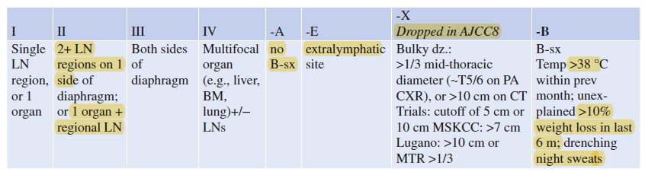
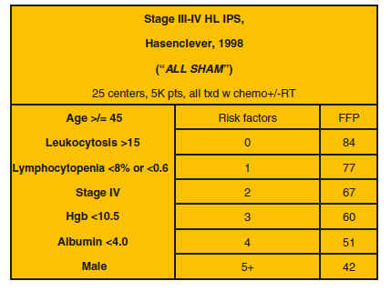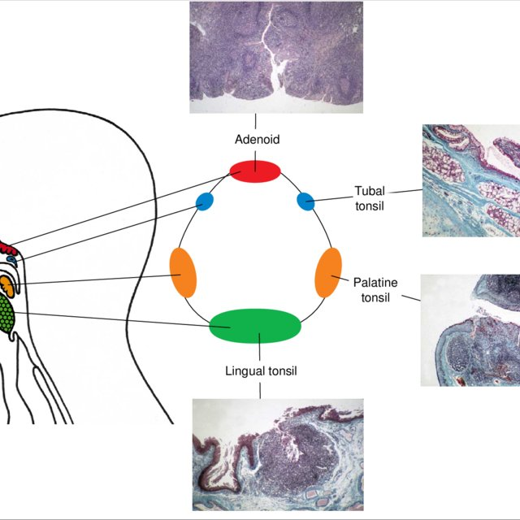
–– Early stage favorable/unfavorable and NLPHL: 10-yr. OS = 90% – 10-yr. EFS = 85%.
–– Advanced stage: • 10-yr. OS = 80% – 10-yr. EFS = 75%

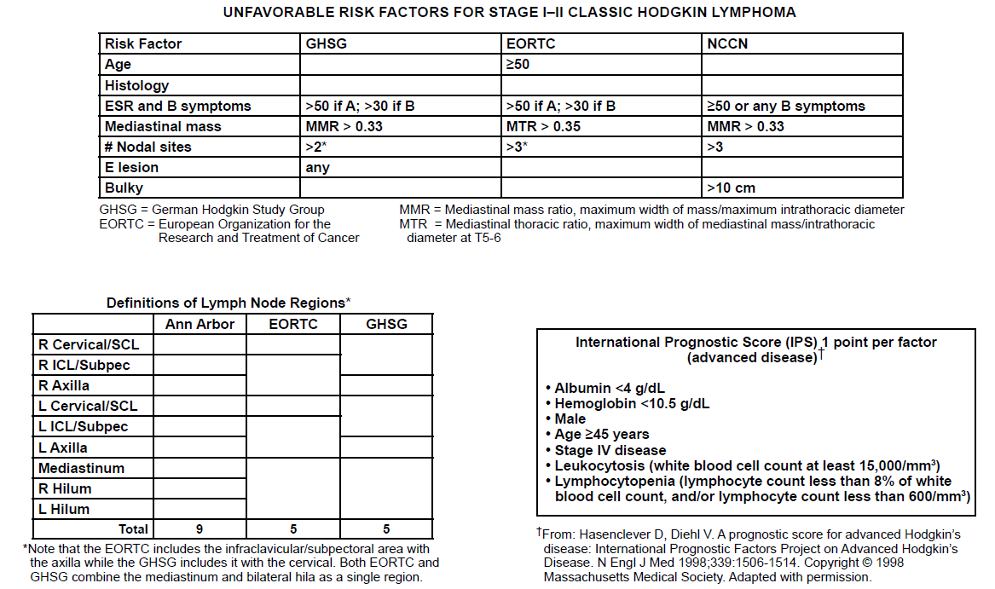

PETs and Deauville PET Criteria
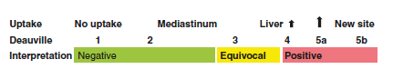
–– 1: No uptake –– 2: Uptake ≤ mediastinum –– 3: Mediastinum < uptake ≤ liver
–– 4: ↑Moderately compared to liver –– 5a: ↑Markedly compared to liver –– 5b: New FDG avid site

–– 1–2 are neg; 4–5 are positive; 3 can be either, depending on goal of study (e.g., esc vs de-esc). Usually negative.
–– Restaging PET/CT is 2 weeks after day 15 of last cycle of ABVD. If Deauville 4 on interim PET-CT, the ast PET-CT is 6–8 wk. after chemo or 8–12 wk. after RT.
–– Do not perform 7-10d after chemo to avoid false positive from inflammation.
–– Interim PET is + in 14% F and 24% UF patients.

Constraints (per ILROG):
–– Lung: V20 <20%; mean lung <12 Gy. –– Heart: mean <15 Gy.
–– Bone growth affected at 8 Gy. –– Breast tissue growth affected at 5–10 Gy.
–– Thyroid: >15 Gy as soc. w/ 30% risk insufficiency.
–– TD 5/5:
• Testes: 2 Gy (permanent sterility), 0.5 Gy (temporary azoospermia).
• Oocytes. Sterilization by 2 Gy. Failure by 6–10 Gy (single fx), 12–15 Gy fractionated in age <40.

Toxicity
–– Dermatitis, post scalp hair loss, xerostomia, dental caries (fluoride x 2 years after RT), esophagitis, thyroid dysfunction, Lhermitte’s, herpes zoster, pneumonitis, and pericarditis.
–– Lhermitte’s: 20% in HL, likely from chemo. No correlation w/ dose. Should resolve w/time.
–– Adriamycin: cardiomyopathy (limit is 450 mg w/ RT, 550 w/o RT).
–– Bleomycin: pulmonary fibrosis.
–– Vinblastine: neuropathy and hair loss.

Late Effects Monitoring (After 5 Years)
–– Optimize cardiovascular health, baseline echo, and stress test q10y, especially if cardiac RT.
–– Carotid ultrasound at 10 y if neck RT.
–– If splenic RT → pneumo, meningo, flu vaccines q5y.
–– Chest XR/CT qyr if at risk for lung ca.
–– Female age >25: Start breast mammo 10 years after treatment or at 40, whichever earlier if chest or axillary RT.Get annual breast MRI at age 40 or 10 yrs. after RT.
• Cumulative risk of breast cancer in 30y after treatment for HL 19% (~0.7% per year) and 26% for women <21 yo.

HL
 | 病人 | arm | PFS | Comment
 | Early
GHSG  HD 10 | Fav | ( 2 ABVD or 4 ABVD ) x ( IFRT 20 or 30 ) | 87.4  87.2 | 4 C/T + 30 vs 2 C/T + 20, NS in 10y PFS  => 2 ABVD + 20 German standard
RAPID | 68% Fav  32% UnFav | 3 ABVD -> D3-5: ABVD + IFRT 30  -> D1-2: IFRT 20 or OBS | 90-94 | 3y PFS NS  D1-2:ABVD alone is non inferior to ABVD + RT
CALGB 50604 | Fav | 2 ABVD -> D4-5: 2 eBEACOPP + IFRT 30.6  -> D1-3: 2 ABVD | 66  90 | D1-2/3/4-5: 3yP PFS:94/77/67  PET (-) 2+2 ABVD 可行
EORTC  H10F | Fav | 2 ABVD -> 1 ABVD + INRT 30-36 [a]  2 ABVD -> D4-5: 2 eBEACOPP + INRT 30-36 [b]  -> D1-3: 2 ABVD [c] | [a] vs [b]: eBEACOPP ↑ 5y PFS:77->90%  => PET + 若後續用 eBEACOPP + RT增加PFS  [a] vs [c]: ABVD alone ↓ 5y PFS:99->87%  => PET – 若加上RT仍增加PFS  NS in OS
EORTC  H10U | UnFav | 2 ABVD -> 2 ABVD + INRT 30-36 [a]  2 ABVD -> D4-5: 2 eBEACOPP + INRT 30-36 [b]  -> D1-3: 4 ABVD [c]
GHSG  HD 11 | UnFav | ( 4 ABVD or 4 BEACOPP ) x ( IFRT 20 or 30 ) |  | BEACOPP ↑ Toxicity  4 ABVD + 20 ↓ FFTF, 其他三個差不多  => 4 ABVD + 30 is standard
GHSG  HD 14 | UnFav  < 60 y/o | 2 eBEACOPP + 2 ABVD + IFRT 30  4 ABVD + IFRT 30 | 95.4  89.1 | Escalated “2+2” ↑ PFS ↑ FFTF  => For < 60 y//o, Escalated “2+2 is standard
HL
 | 病人 | arm | PFS | Comment
 | Advance
UK  RATHL | 包含  IIA≧ 3 LN  or IIA bulky | 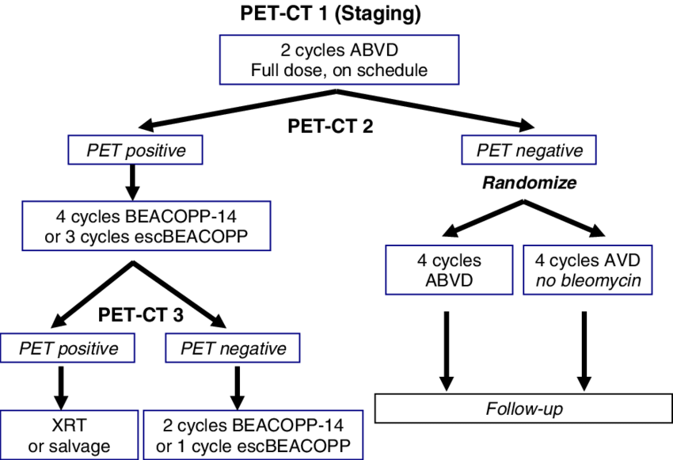 |  | PET 2:87% neg (D1-3)  => 4 ABVD vs 4 AVD, 3y PFS 85%, NS  => receive Consolidation ISRT 2.6% vs 4.3%  =>↓pul. Event in AVD arm  => AVD is not noninferior but results remain excellent and bleomycin omission may be reasonable (as accepted by NCCN. (PET- : 2 AVBD 2+4 AVD +/- ISRT)
ECOG 2496 | 包含I-II bulky | 6-8 ABVD + IFRT 36 to bulky mediastum LN  12 Standford V + RT 35 to Pre>5cm and spleen GTV | 74v71  (NS) | subgroup IPS 3-7, ABVD group ↑ 5y FFS, trend in OS  => 6-8 ABVD + IFRT 36 to bulky med remain standard
GHSG  HD 12 | 包含IIB w/I Bulky or E-lesion | (8 eBEACOPP or 4 eBEACOPP + 4 BEACOPP) x  (30 Gy to initially Bulky/R≧1.5cm or OBS) |  | RT ↑ 5y FFTF ↑ PFS, NS in OS  Non RT arm有11% receive RT  8 eBEACOPP remain standard, support + RT
GHSG  HD 15 | Non Bulky | (8 eBEAOPP or 6 eBEAOPP or 8 eBEAOPP₁₄)  => IFRT 30 (if PET + or R≧2.5cm) or OBS | FFTF: 84/89/85%, 11% s/p RT, mortality higher in 8 eBEAOPP  => 6 eBEACOPP + PET guided RT is standard

NHL: 偏向結論-RT ↑ PFS, NS in OS
 | 病人 | arm | OS | EFS | LC | Comment
 | I/II
SWOG  8736 | I, IE, II, IIE  (int / high Gr) | 3 CHOP + IFRT (40-50Gy) [好]  8 CHOP | ↑ | ↑ |  | 8y OS/PFS開始overlap, 10y NS
ECOG  1484 | Buky I, IE, II, IIE  (int grade) | 8 CHOP + IFRT (30-40Gy) [好]  8 CHOP | ≒ | ↑ | ↑
GELA  93-1 | ≦60 y/o, IPI=0  I,II (E or Bulky ok) | 3 CHOP + IFRT (40 Gy)  3 ACBVP [好] | ↓ | ↓ | ≒ | C/T alone預後較佳，但ACBVP較毒
GELA  93-4 | >60 y/o, age IPI=0  I,II (E or Bulky ok) | 4 CHOP + IFRT (40 Gy) [好]  4 CHOP | ≒ | ≒ | ↑ | RT start after C/T > 5w for 50% pt

