Sarcoma
 | Trunk and Extremities | Retroperitoneum
T0
T1 | <=5cm | <=5cm
T2 | <=10cm | <=10cm
T3 | <=15c | <=15c
T4 | >15cm | >15cm
N1 | N+ | N+

 | Trunk and Extremities | Retroperitoneum
IA | T1G1 | T1G1
IB | T2-4G1 | T2-4G1
II | T1G2 | T1G2
IIIA | T2G2 | T2G2
IIIB | T3G2 | T3G2 or N1
IV | N1 or M1 | M1

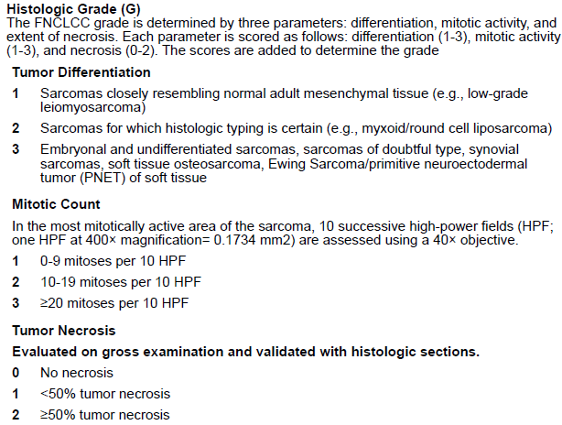

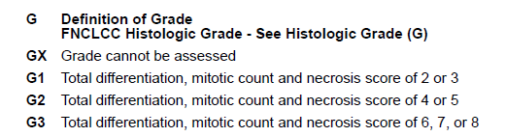

Skin cancer
 | SqCC of HN | BCC (no AJCC)
T0
T1 | ≦2
T2 | ≦4
T3 | >4 or minor bone invasion or PNI or DOI>6mm
T4a | Gross bone(marrow) invasion
T4b | Skull base
N1 | 同單 且 <=3cm
N2a | 同單 且 >3cm
N2b | 同多
N2c | 對
N3a | >6cm
N3b | ENE+
pN1 | 同單 且 <=3cm
pN2a | 同單 且 >3cm 或  N1 且 ENE +
pN2b | 同多
pN2c | 對
pN3a | >6cm
pN3b | N2-3 且 ENE +

 | Skin SqCC of HN | Unknown primary | NPC | OPX p16+  (clinical) | OPX p16+  (pathology) | Mucosa melanoma of HN
I | T1N0M0 |  | T1N0M0 | <=T2N1M0 | <=T2N1M0 | No prognostic stage
II | T2N0M0 |  | T2 or N1 | T3 or N2 | 非Ｉ非ＩＩＩ
III | T3 or N1 | N1 | T3 or N2 | T4 or N3 | >=T3 N2
IV | T4 or N2 or M1 | N2 | T4 or N3 | Stage IV: M1 | Stage IV: M1
 |  | N3 | M1
 |  | M1

