SKIN SCC/BCC
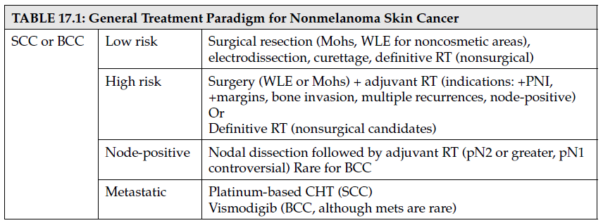
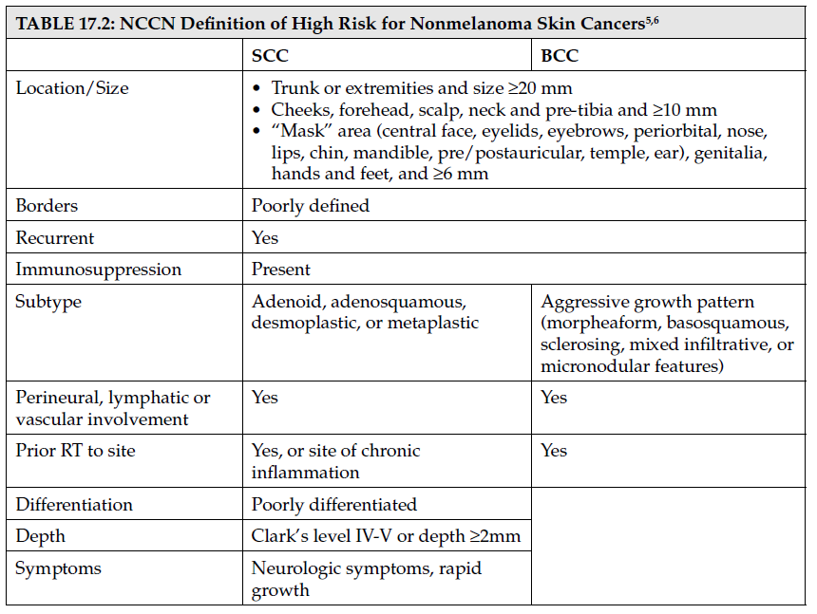

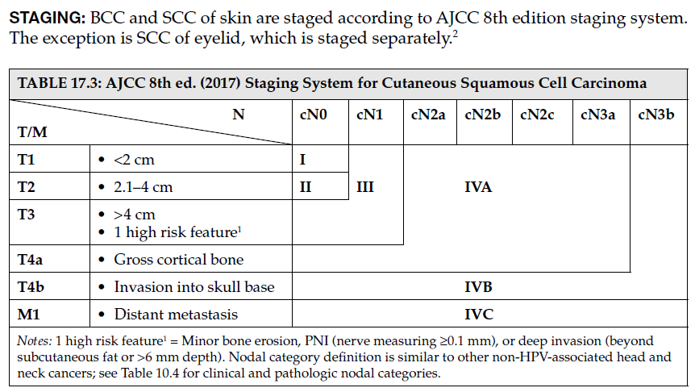

BCC
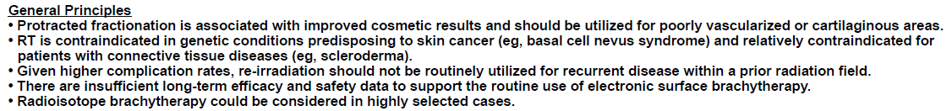
SqCC
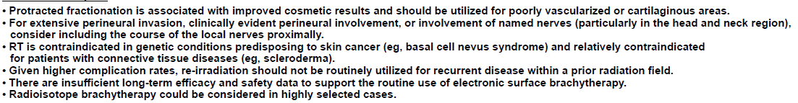
BCC
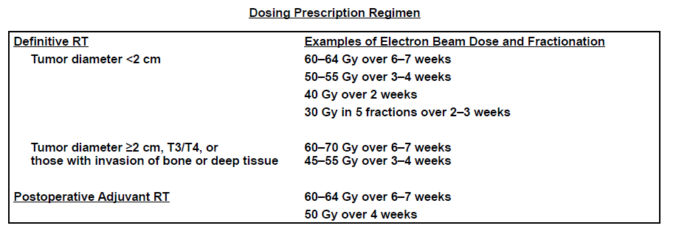
SqCC (T的照法同BCC)
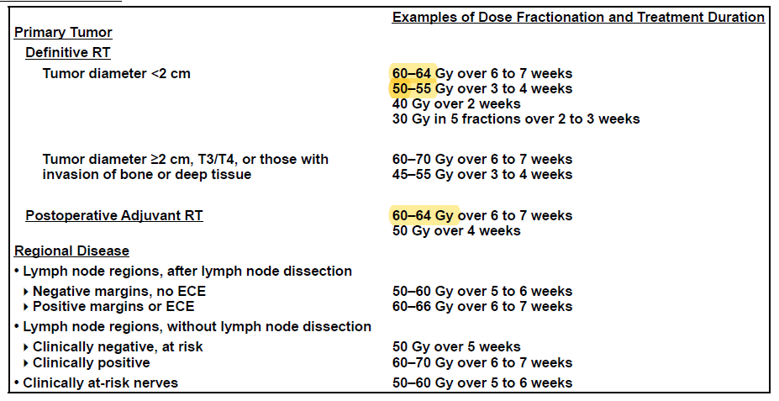

Melanoma:
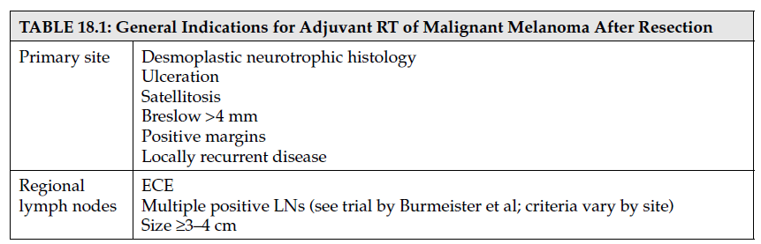
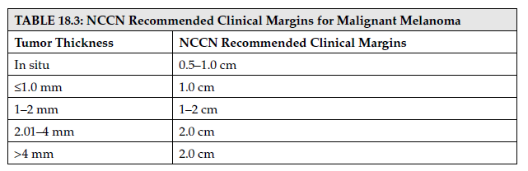
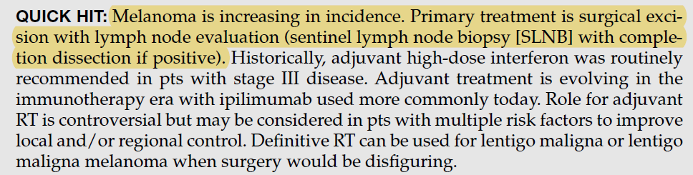

TREATMENT PARADIGM
Surgery: Surgical excision is primary treatment for melanoma. Wide local excision is recommended, with margin requirement based on thickness of tumor. NCCN guidelines outline the following margin requirement based on fi ndings from multiple randomized surgical trials, though these can be modifi ed for individual anatomic or functional needs
Sentinel lymph node status is the most important prognostic factor for recurrence in patients with melanoma. SLNB is recommended for patients with ≥0.75 mm or those with <0.75-mm thickness with any high-risk feature (ulceration, LVSI, or mitotic rate greater than or equal to 1/mm2). Completion lymphadenectomy is recommended for patients with positive SLNB as ~18% of those with +SLN will have additional regional LN.9,10 However, there has been no prospective evidence establishing impact of completion dissection on recurrence and survival for this population; this is being studied in MSLT-II trial. Lymph node dissection is also required for those with clinically node-positive patients (stage III). Adequate dissections require >10 LNs in groin, >15 LNs in axilla and neck.

Systemic therapy
Adjuvant: Multiple randomized trials have demonstrated improved DFS with use of adjuvant high-dose interferon for patients with high-risk melanoma after complete resection. High-dose IFNα continued for 1 year has historically been the standard of care for patients with resected node-positive melanoma (stage III) and should be considered for patients with negative nodes and increased risk of recurrence (stage IIB and
IIC). Side effects include fatigue, headache, nausea, weight loss, myelosuppression, and depression. Role of immunotherapy in adjuvant setting is evolving. NCCN now has ipilimumab (see the following for details) use as category 1 treatment option I adjuvant setting after resection of clinical stage III disease, based on results of EORTC 18071, which demonstrated RFS benefi t with use of adjuvant ipilimumab compared to
Placebo
