2020 陳一瑋CNS
- 26歲女性，left temporal brain tumor (提供MRI)。病人是右撇子，請問可能出現哪種神經問題。
- Brain anatomy：
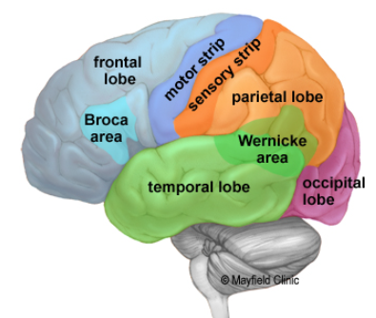
若腫瘤位於temporal lobe及parietal lobe交界，可能會影響Wernicke’s area，造成Wernicke’s aphasia，無法理解語言。病人會語句流利但辭不達意。
- 補充：Broca's area位於frontal lobe，與語言的產生有關。
- 術後CT image (考BCNU polymer wafer?)
- BCNU polymer wafer：含①可生物分解的聚合物及②化療藥物carmustine，覆蓋於surgical bed，carmustine會漸漸被釋放而達到抗癌作用。
- CT 影像 (網路圖片)：BCNU wafer為hyperattenuating (白色箭頭)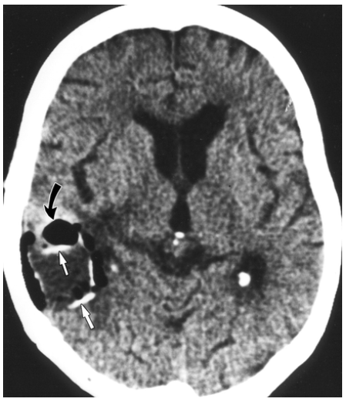
- 術後病理為glioblastoma。解釋一下病理報告為何是glioblastoma ?
答：Diagnosis of a WHO grade IV glioma requires :
① High grade infiltrating glioma with astrocytic differentiation
② Nuclear atypia
③ Pleomorphism
④ Elevated mitotic activity
⑤ Necrosis or microvascular proliferation
Ref: Pathology outlines
- 如何從IHC染色去看MGMT、IDH、ATRX ? 哪個對預後影響大? MGMT有無甲基化的預後差異? (共筆作者：這題目應該有錯，應該是MGMT promoter有無甲基化)
答：
IHC | Interpretation | Note
IDH (-) | IDH wild type | Tumor develops de novo
ATRX (-) | ATRX loss | Consistent with mutation
MGMT (+) | No promoter hypermethylation | Less effective using TMZ
Prognosis:
- IDH1 mutation: MS 27.4 mos for IDH1-mutated vs. 14 mos for IDH1-WT
- MGMT promoter methylation: The median overall survival 18.2 mos for MGMT (-) vs.12.2 mos for MGMT (+)。HR: 0.45
- ATRX (-):
 | MS (year)  (ATRX - vs +) | HR
IDH1 wt | 4.7 vs 1.2 | 0.36
a, b Ref: Essentials Of Clinical Radiation Oncology;
c Ref: doi: 10.1007/s00401-017-1690-1
結論：預後不好 ① IDH wt (所以IHC -) ② ATRX no mutation (所以IHC +) ③ MGMT IHC (+)
- Adjuvant therapy (GBM SOC)
Stupp, EORTC/NCIC (NEJM 2005; Lancet Oncology 2009)
PRT of 573 pts with GBM, ages 18 to 70 with ECOG PS 0-2. All pts received EBRT 60 Gy/30 fx, and were randomized to RT alone or chemoRT with concurrent TMZ 75 mg/m2 then adjuvant TMZ 150 to 200 mg/m2 5-day schedule every 28 days x 6c.
Hegi (NEJM 2005): MGMT status response to TMZ
MGMT promoter methylation CRT vs RT: MS 21.7 vs 15.3 months
No MGMT promoter methylation CRT vs RT : MS 12.7 vs 11.8 months
- TMZ side effect: Nausea and vomiting, bone marrow suppression, fatigue
- RT plan:
NCCN
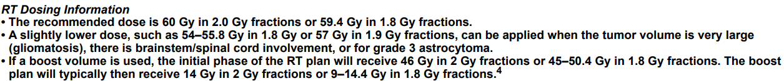
- Alterative fractionation
In poorly performing patients or elderly patients, hypoFx course should be considered.
Roa, Canadian (JCO 2004, PMID 15051755)
100 pts ≥60 y/o randomized to 60 Gy/30 fx vs. 40 Gy/15 fx (no CHT), MS was 5.1 mos for standard vs 5.6 for shorter course RT (p = NS)
- Recurrence：Systemic treatment/Re-resection/Re-irradiation/BNCT
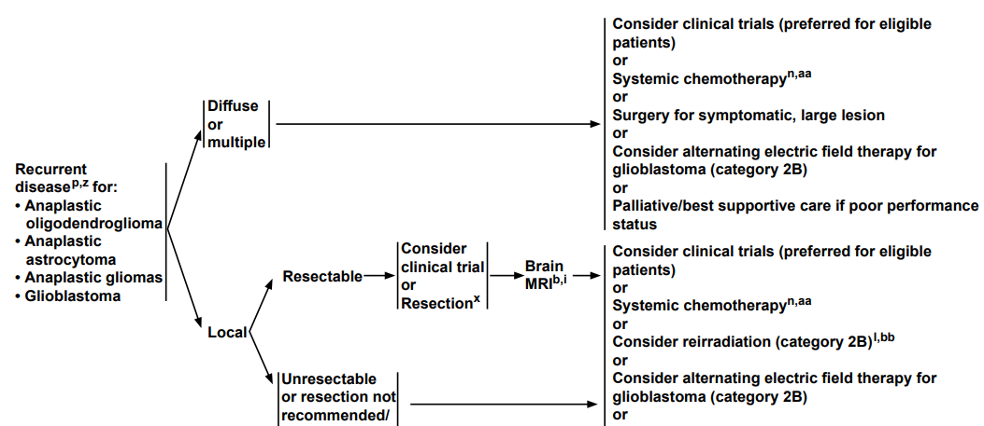
Systemic therapy：Bevacizumab prolonged PFS but not overall survival
Preferred regimens | Other regimens
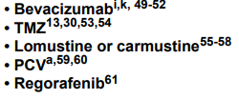 | 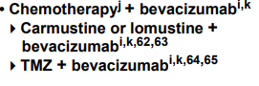

2019 劉岱瑋 CNS
- 39 歲男性，最近有肢體無力的情形，於是在外院做了brain MR，請判讀下列影像?
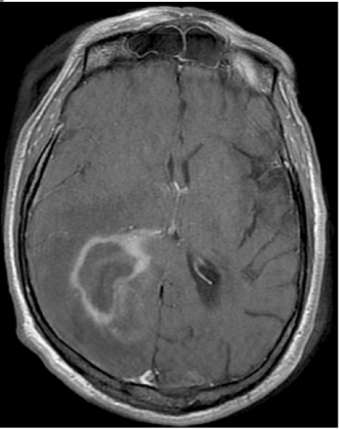
答：solitary periventricular lesion with peripheral ring enhancement. DDx: CNS lymphoma, CNS toxoplasmosis, brain abscess, etc.
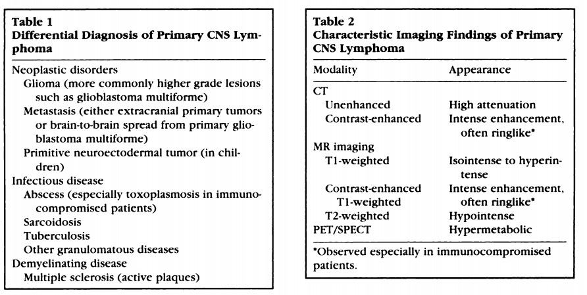
Ref: https://doi.org/10.1148/radiographics.17.6.9397461
2. 接下來的survey
答：(NCCN) 影像學若懷疑是lymphoma，先安排biopsy (DC steroid)。確診後：
① 抽血：LDH、HIV
② 影像：PET、+/- spine MRI
③ 眼科檢查、lumbar puncture
其他可考慮bone marrow biopsy、testicular ultrasound
- Biopsy 結果是 diffuse large B cell lymphoma，no seeding，接下來的治療?
答：
① High dose MTX (3.5–8 g/m2) based chemotherapy.
② CR after MTX
- Chemotherapy + stem cell rescue
- WBRT 23.4 Gy/13 fx
③ PR after MTX: 30-36 Gy WBRT with boost to 45 Gy/25 fx
補充：RT filed前緣要包含後眼球，下緣要包含C1/C2

