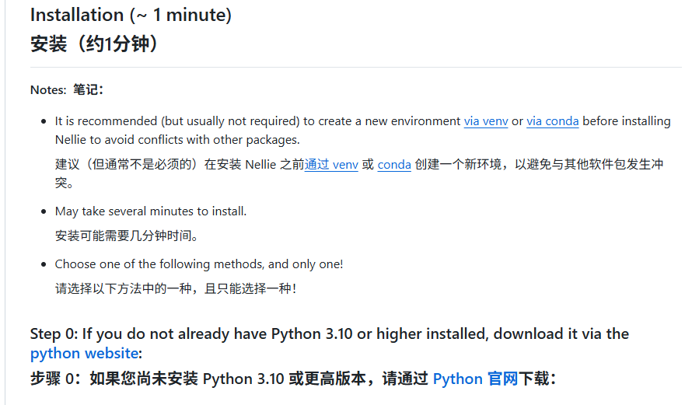

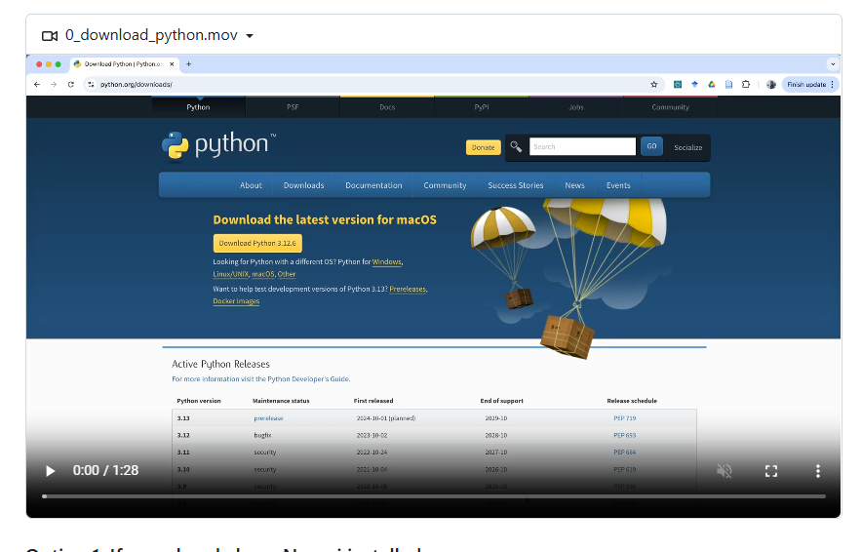

步骤一：图像合并

修改部分：
if __name__ == '__main__':
path = "/data1/fcl/sciAbuchong/FCL-20260508-RAW-3D-SIMFN2__2026-05-08T10_33_41-Measurement 1/Images"
out_path = "/data1/fcl/sciAbuchong/FCL-20260508-RAW-3D-SIMFN2"

步骤二：提取参数

pipeline.load("pipeline_3D-1115.cppipe")

file_list = list(pathlib.Path('/').absolute().glob('data1/fcl/sciAbuchong/FCL-20260508-RAW-3D-SIMFN2-2/*.tiff'))
files = [file.as_uri() for file in file_list]
pipeline.read_file_list(files)

pipeline.modules()[7].setting(10).set_value('Elsewhere...|/data1/fcl/sciAbuchong/FCL-20260508-RAW-3D-SIMFN2-2/overlayimages')
pipeline.modules()[9].setting(10).set_value('Elsewhere...|/data1/fcl/sciAbuchong/FCL-20260508-RAW-3D-SIMFN2-2/overlayimages')
pipeline.modules()[19].setting(10).set_value('Elsewhere...|/data1/fcl/sciAbuchong/FCL-20260508-RAW-3D-SIMFN2-2/overlayimages')
pipeline.modules()[23].setting(8).set_value('Elsewhere...|/data1/fcl/sciAbuchong/FCL-20260508-RAW-3D-SIMFN2-2/CSV')

标红为修改的地方

步骤三： TSNE 降维分析

方法a:3. tsne_welll

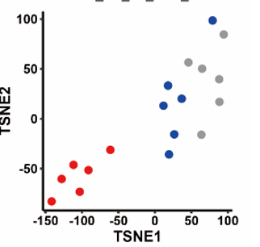
方法2：4. tsne_single cell

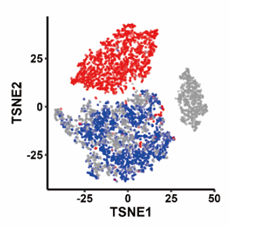

步骤四：PCA综合得分

5. PCA_comprehensive score
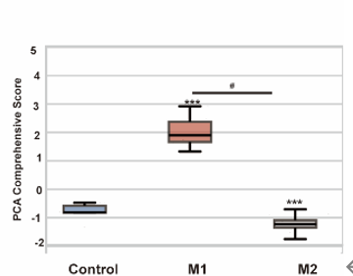

例外补充cellprofiler方法

