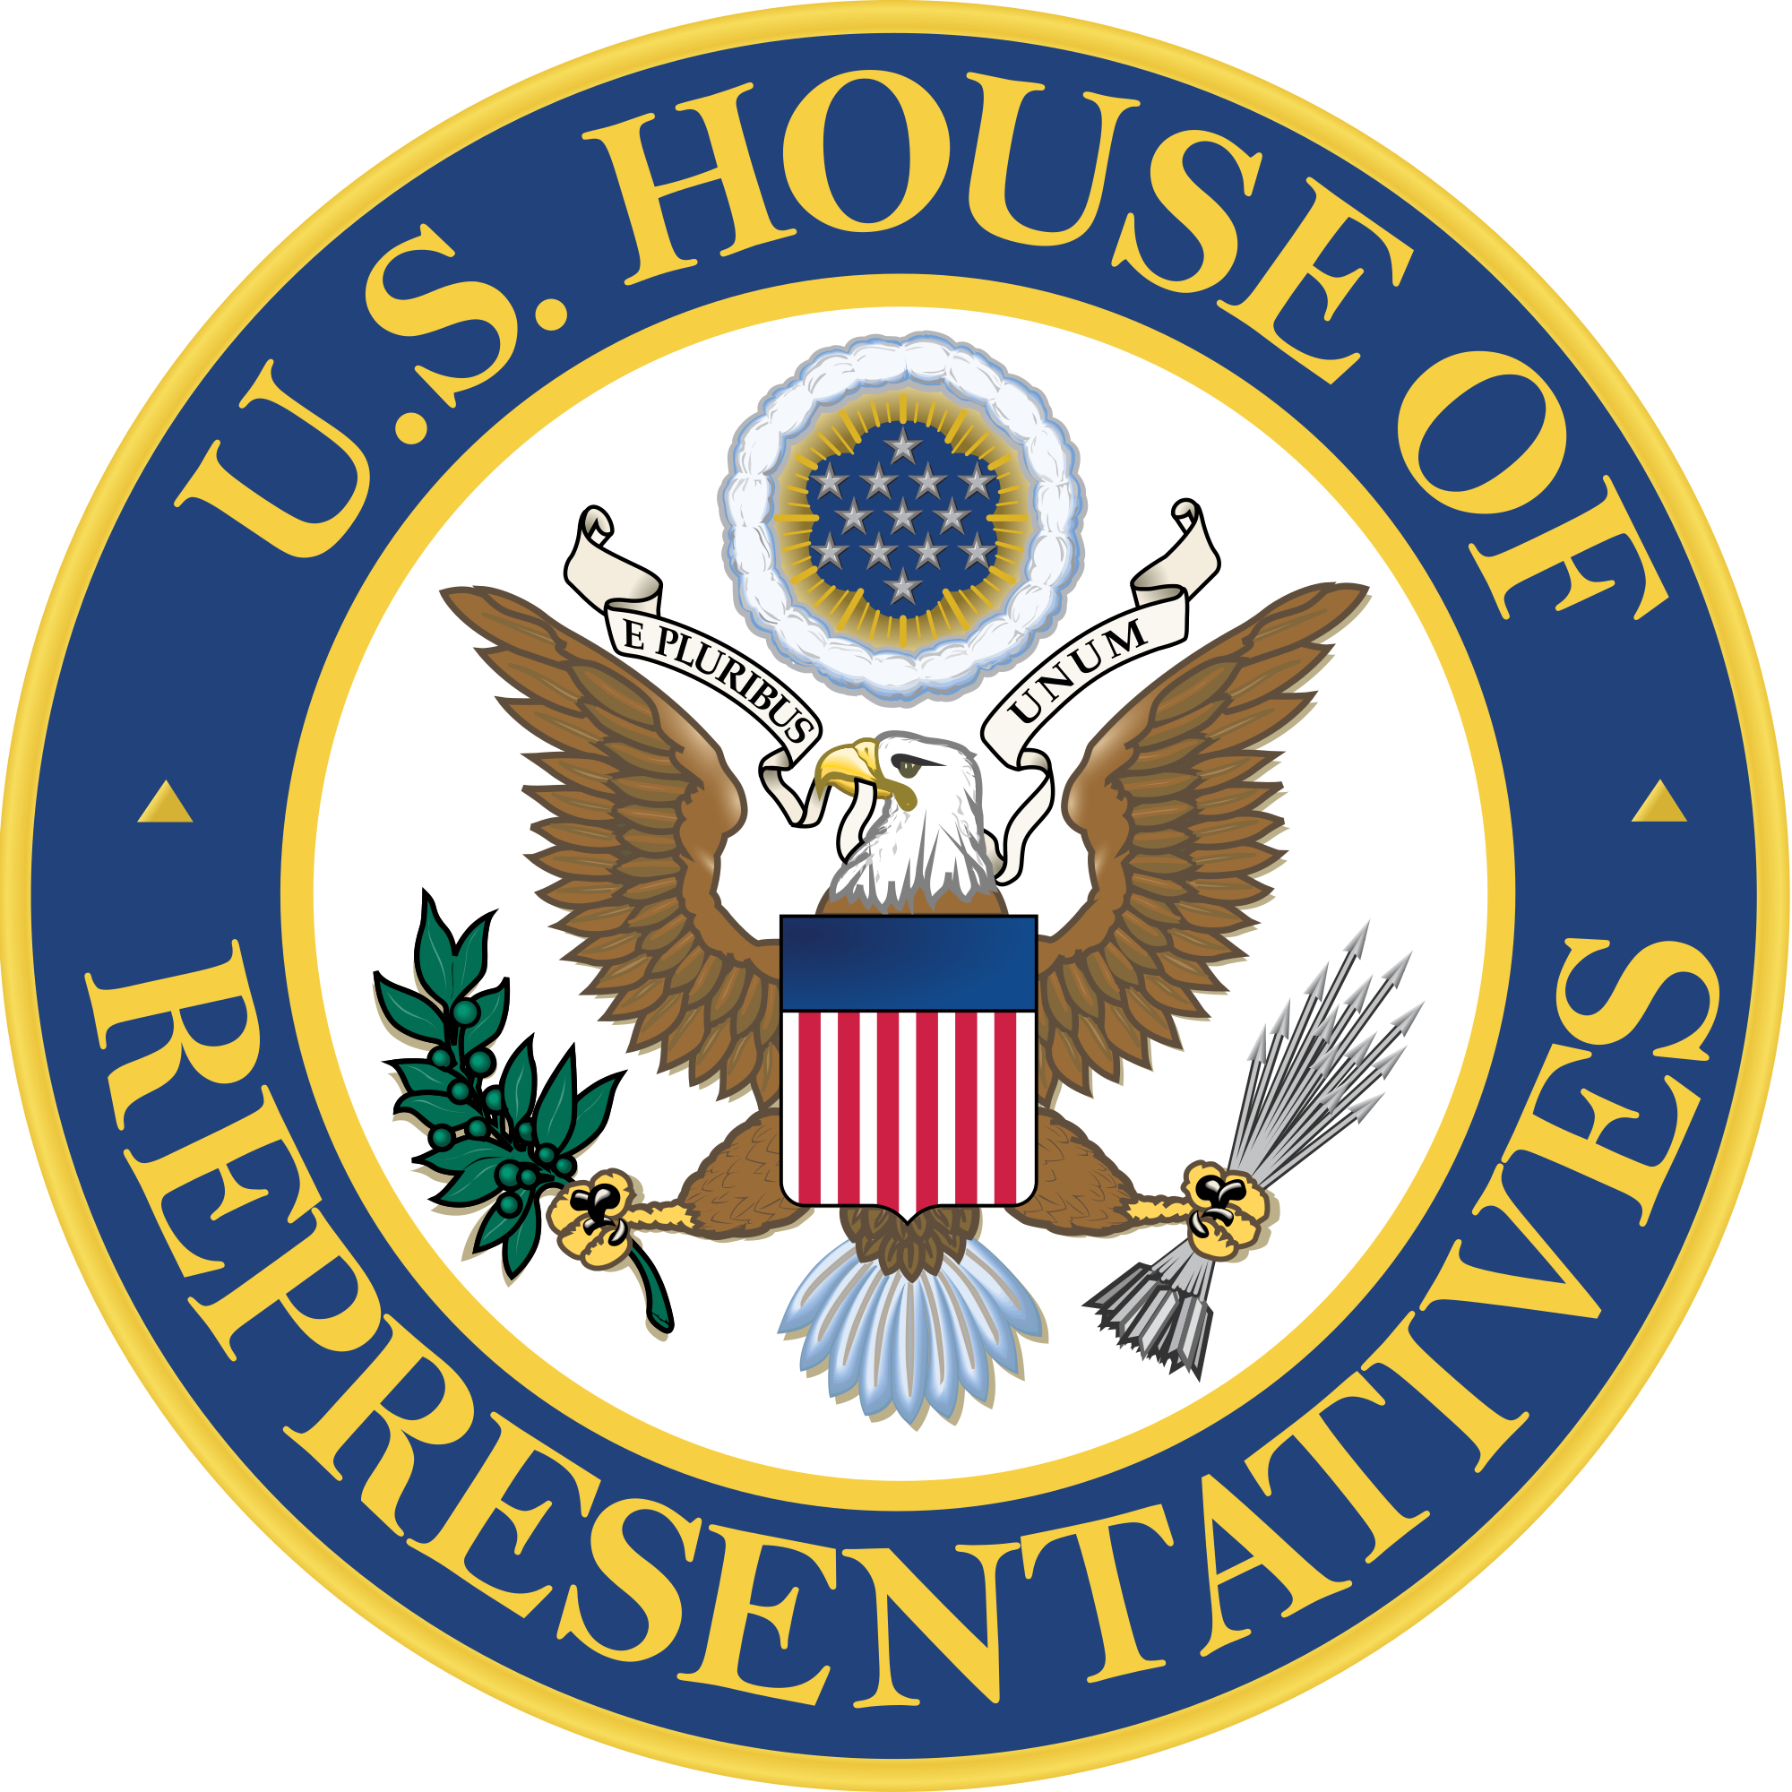
House of Representatives Bill Document
Representative Keshu Yang | H.R. 2035 | Website: https://yangkeshu.github.io/fuel-smart-america-act/
Introduced the following bill:
A Bill to establish the Fuel-Smart Vehicle Rebate and Efficiency Program
Be it enacted by the House of Representatives and the United States Senate in Congress assembled, that:
Purpose & Goals
I chose this topic because people should be able to spend less on gas without being told exactly what kind of car to buy. Even though new vehicles averaged 27.2 miles per gallon in model year 2024, Americans still used about 136.72 billion gallons of gasoline in 2025, and federal clean-vehicle purchase credits ended for vehicles acquired after September 30, 2025. The purpose of this Act is to make fuel-efficient vehicles more affordable through rebates, gradual efficiency standards, and public reporting while still letting drivers choose the vehicle and technology that fit their needs.
Section 1 - Short Title, Findings, and Effective Date
(a) Short title. This Act may be cited as the “Fuel-Smart America Act.”
(b) Findings. Congress finds that improved fuel economy can reduce the amount families spend on fuel, decrease national petroleum demand, and encourage manufacturers to compete through efficiency and innovation.
(c) Consumer choice. Nothing in this Act requires an individual to purchase an electric vehicle, hybrid vehicle, or any other specific technology. A gasoline, diesel, hybrid, plug-in hybrid, fuel-cell, or battery-electric vehicle may qualify if it meets the same efficiency and price requirements.
(d) Effective date. Rulemaking shall begin within 180 days after enactment. Consumer rebates and vehicle fees shall begin on January 1, 2028.
Section 2 - Definitions
(a) Covered vehicle. The term “covered vehicle” means a new passenger car or light-duty truck with a gross vehicle weight rating of not more than 10,000 pounds that is manufactured primarily for use on public streets, roads, and highways.
(b) Qualifying new vehicle. The term means a covered vehicle purchased for personal use, with a manufacturer’s suggested retail price not exceeding $55,000 for a passenger car or $80,000 for a light-duty truck, that achieves at least 40 miles per gallon combined or 90 miles per gallon equivalent for model years 2028-2031, at least 45 mpg or 100 MPGe for model years 2032-2034, and at least 50 mpg or 110 MPGe beginning in model year 2035.
(c) Qualifying used vehicle. The term means a covered vehicle that is at least two model years old, has a sale price not exceeding $25,000, has not previously received a used-vehicle rebate under this Act, and achieves at least 35 mpg combined or 75 MPGe.
(d) Eligible buyer. The term means an individual whose modified adjusted gross income does not exceed $150,000 for a single filer, $225,000 for a head of household, or $300,000 for a joint return. For a used-vehicle rebate, each limit is reduced by one-half.
(e) Low- or moderate-income buyer. The term means an eligible buyer whose modified adjusted gross income does not exceed $75,000 for a single filer, $112,500 for a head of household, or $150,000 for a joint return.
Section 3 - Fuel-Smart Consumer Rebates
(a) New vehicles. The Secretary of the Treasury shall provide an eligible buyer a point-of-sale rebate of $3,500 for a qualifying new vehicle.
(b) Used vehicles. The Secretary shall provide an eligible buyer a point-of-sale rebate equal to the lesser of $2,000 or 20 percent of the sale price of a qualifying used vehicle.
(c) Affordability bonus. A low- or moderate-income buyer shall receive an additional $1,000 rebate. The total rebate may not exceed 30 percent of the vehicle’s sale price.
(d) Point-of-sale administration. A registered dealer shall subtract the rebate from the amount paid by the buyer and shall be reimbursed electronically by the Treasury Department. The dealer must give the buyer a written statement showing the vehicle’s certified efficiency, sale price, and rebate amount.
(e) Guardrails. A taxpayer may receive one new-vehicle rebate and one used-vehicle rebate in any three-year period. A rebated vehicle may not be resold within one year except in cases of death, disability, military reassignment, or other hardship defined by the Secretary.
Section 4 - Gradual National Efficiency Standards
(a) Annual improvement. The National Highway Traffic Safety Administration, in consultation with the Environmental Protection Agency and the Department of Energy, shall set manufacturer fleet standards that improve fuel economy by not less than 2 percent per model year for model years 2028-2031 and not less than 3 percent per model year for model years 2032-2035, measured separately for passenger cars and light trucks.
(b) Practical design. Standards shall use the existing vehicle-footprint system and shall consider safety, technological feasibility, vehicle affordability, and the needs of rural families and small businesses. Manufacturers may use credit banking and trading under existing federal law.
(c) Temporary hardship waiver. NHTSA may grant a manufacturer a waiver of not more than one model year only after a public finding that compliance is temporarily infeasible because of a major supply disruption. The agency shall publish the evidence and a corrective plan.
(d) Enforcement. Existing CAFE reporting and civil-penalty procedures shall apply. Penalty revenue shall be deposited into the Fuel-Smart Vehicle Rebate Account established in Section 5.
Section 5 - Funding, Fairness, and Oversight
(a) Fuel-Smart Vehicle Rebate Account. The Treasury shall establish an account to receive vehicle-efficiency fees and civil penalties and to pay rebates and administrative costs under this Act.
(b) Low-efficiency luxury-vehicle fee. At the first retail sale of a new covered vehicle with a manufacturer’s suggested retail price above $65,000, the Treasury shall collect a $2,500 fee if the vehicle is rated below 18 mpg combined and a $4,000 fee if it is rated below 15 mpg combined.
(c) Exemptions. The fee shall not apply to emergency vehicles; military vehicles; vehicles modified for a person with a disability; or pickup trucks and vans certified for primary use in farming, construction, utility service, or another qualified trade. False certification shall be subject to repayment and a civil penalty.
(d) Authorization. Congress authorizes up to $4.5 billion for each fiscal year 2028-2035 for rebates and administration. Fee and penalty receipts shall offset those appropriations. If demand would exceed available funds, the Treasury shall preserve the full affordability bonus and prorate other rebates prospectively, with public notice.
(e) Transparency. Treasury, NHTSA, EPA, and DOE shall publish one annual report listing participation, average buyer income, vehicle efficiency, estimated fuel savings, administrative cost, fee revenue, and manufacturer compliance. Personally identifying information shall not be published.
(f) Independent review and sunset. The Government Accountability Office shall evaluate the program by December 31, 2031. Rebate and fee authority shall expire on December 31, 2035 unless Congress reauthorizes it after reviewing costs, savings, market effects, and fairness.
Conclusion
I believe this bill is a fair compromise. It helps families pay less for fuel, but it does not ban gasoline vehicles or punish people who need a truck or specialized vehicle for work. Instead, it rewards vehicles that use less fuel, gives manufacturers time to improve, and requires the government to report whether the program is actually working.

