**CSc 1302: Homework 3 (Summer 2017)**

(Due on 11:59 pm, 6/28/2017)

**Program #1**:

Write a program of a game of Tic-Tac-Toe that represents the board by using of 2D Array.

* Play the game 1 time for 2 players;
* Show who the winner is (Player 1, Player 2, or Draw)
* Name the program as TicTac.java, a screen output will be similar to the following.

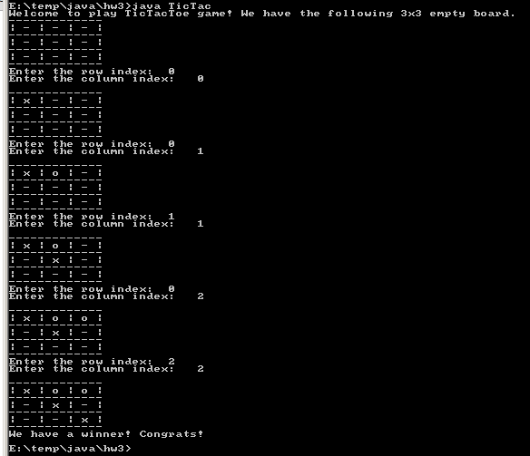

**Program #2**:

Add *divide* method to take another Fraction as the parameter and return a new Fraction that is the division of current Fraction and the Fraction in the parameter. (public Fraction divide(Fraction f)).

* Add *scaleup* and *scaledown* methods to the Fraction class. The *scaleup* method will take a factor as the parameter and multiply the numerator by the factor. The *scaledown* method will take a factor as the parameter and multiply the denominator by the factor.
* Add a *scale* method which will have two parameters: *factor* and *flag*. The *flag* is *boolean*. If *flag* is true, then scale up the fraction; otherwise scale down the fraction.
* Both *scaledown* and *scale* methods must check if the factor is 0. If it is 0, a warning message is printed out and no scaling is operated.
* Add two more constructors. One of the constructors will have no parameters; it initializes the fraction to 0/1. The other constructor will have one parameter, representing the numerator of the fraction; the denominator of the fraction will be 1.
* Write a program named *FractionScale* that prompts the user of a fraction and a scale factor. Here is what the user will see on the screen:

This program performs the scaling operations on a fraction.

Enter a fraction: **3/7**

Scale up or down (1: up, 0: down): **1**

Enter a scale factor: **2**

Scaled fraction is: 6/7

You can assume that the user always enters two integers separated by a slash (/) for the faction. However, the user may enter any number of spaces before and after each integer.

**public** **class** Fraction {

// Instance variables

**private** **int** numerator; // Numerator of fraction

**private** **int** denominator; // Denominator of fraction

// Constructors

**public** Fraction(**int** num, **int** denom) {

numerator = num;

denominator = denom;

}

// Instance methods

**public** **int** getNumerator() {

**return** numerator;

}

**public** **int** getDenominator() {

**return** denominator;

}

**public** Fraction add(Fraction f) {

**int** num = numerator * f.denominator +

f.numerator * denominator;

**int** denom = denominator * f.denominator;

**return** **new** Fraction(num, denom);

}

}

**What to turn in**:

1. Upload all of the .java and the .class files to the CSc1302 dropbox on [http:// icollege.gsu.edu](http://desire2learn.gsu.edu/).

**Note**:

1. For all assignments, always use comments to include the programmer information, date, title of the program and brief description of the program.
2. No copying allowed. If it is found that students copy from each other, all of these programs will get **0**.
3. You must name your file/program as specified. Should you use a different name, you would lose **10%** of what the program is worth.
4. Make sure that both the .java and .class files are uploaded to the ftp server correctly. If the any special package is used in the program. Be sure to upload the package also. Should you use any other subdirectory (whatsoever) your program would not be graded and you will receive a **0 (zero)**.