**CSc 1302: Homework 4 (Summer 2017)**

(Due on 11:59 pm, 7/10/2017)

**Program #1**:

Finish the following programming project. An output picture will be like the following. A scanned copy of the project description is also attached.

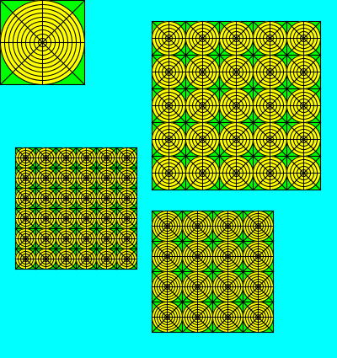

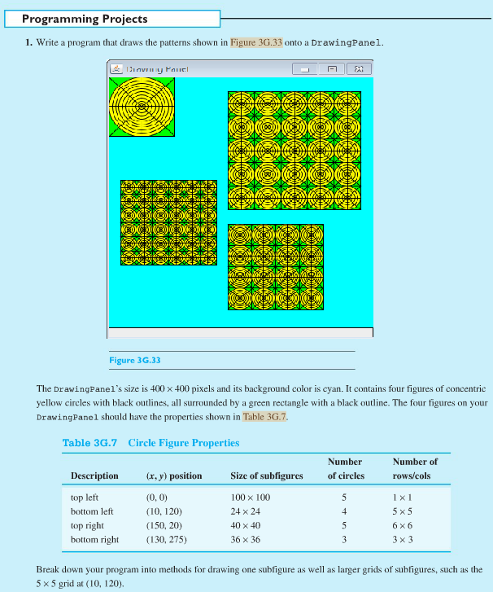

**Program #2**:

Following is a part of the source codes for NBATeam and NBA classes. Finish the programs for both classes to produce an output screen similar to the following figure.

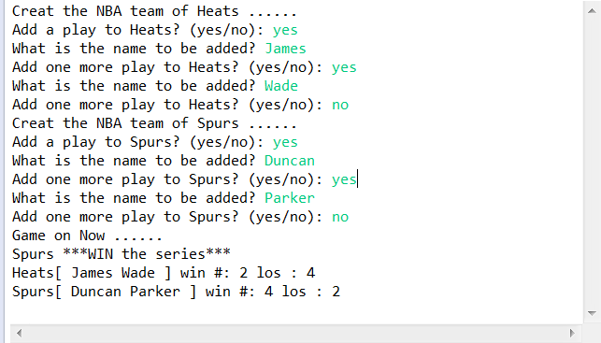

//File NBA.java

**import** java.util.Scanner;

**public** **class** NBA {

**public** **static** **void** main(String[] args) {

Scanner input = **new** Scanner (System.*in*);

String ifAddPlayer;

String playerName;

//construct Team Heat

System.*out*.println("Creat the NBA team of Heats ...... ");

NBATeam heat= **new** NBATeam("Heats");

System.*out*.print("Add a play to Heats? (yes/no): ");

ifAddPlayer= input.next();

**while** (ifAddPlayer.equalsIgnoreCase("yes")){

System.*out*.print("What is the name to be added? ");

playerName=input.next();

heat.addAPlayer(playerName);

System.*out*.print("Add one more play to Heats? (yes/no): ");

ifAddPlayer= input.next();

}

//construct Team spurs

…………………………//Your code here

/*simulate a series of atmost 7 games by generating a random number; if the random number is bigger than 0.5, Heat wins; otherwise Heat losses a game. As soon as team wins 4 games, the series is over. */

…………………………//Your code here

System.*out*.println(heat);

System.*out*.println(spurs);

}

}

//File NBATeam.java

**public** **class** NBATeam {

**private** String sTeamName;

**private** **int** nWin;

**private** **int** nLoss;

**private** String [] playerArray;

…………………………//Your code here

}//end of class definition

**What to turn in**:

1. Upload all of the .java and the .class files to the CSc1302 dropbox on [http:// icollege.gsu.edu](http://desire2learn.gsu.edu/).

**Note**:

1. For all assignments, always use comments to include the programmer information, date, title of the program and brief description of the program.
2. No copying allowed. If it is found that students copy from each other, all of these programs will get **0**.
3. You must name your file/program ase specified. Should you use a different name, you would lose **10%** of what the program is worth.
4. Make sure that both the .java and .class files are uploaded to the ftp server correctly. If the jpb package is used in the program. Be sure to upload the jpb package also. Should you use any other subdirectory (whatsoever) your program would not be graded and you will receive a **0 (zero)**.