**CSc 1302: Homework 1**

(Due on 11:59 pm, 6/14/2017)

**Program #1**:

Write a program named ChrisTree that produces images of Christmas trees as output. It should have a method with two parameters: one for the number of segments in the tree and one for the height of each segment. For example, the tree shown here on the left has three segments of height 4 and the one on the right has two segments of height 5. 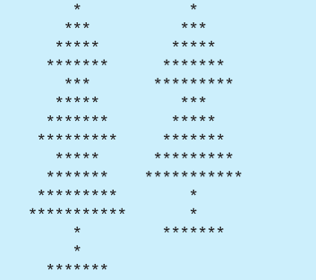

**Program #2**:

Write a program called Swap.java, in the main method, the program first asks user to input a number and call a method swapDigitPairs to swap the number as shown in the following figure. Then, ask the user to input a string of letters/numbers and call a method swapLetterPairs to swap the letters as in the following figure.

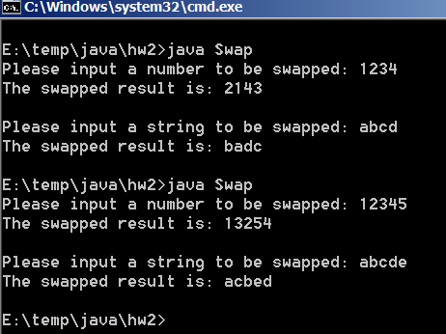

The method swapDigitPairs accepts an integer n as a parameter and returns a new integer whose value is smilar to n’s but with each pair of digits swapped in order. For example, the call of swapDigitPairs(482596) would return 845269. Notice that the 9 and 6 are swapped, as are the 2 and 5, and the 4 and 8. If the number contains an odd number of digits, leave the leftmost digit in its original place. The method swapDigitPairs should not use String class to help the swapping operation.

The method swapLetterPairs will conduct similar swapping operation as swapDigitPairs, but accepts a String as a parameter and return the swapped String. You can use String class in this method.

**What to turn in**:

1. Upload all of the .java and the .class files to the CSc1302 dropbox on [http:// icollege.gsu.edu](http://desire2learn.gsu.edu/).

**Note**:

1. For all assignments, always use comments to include the programmer information, date, title of the program and brief description of the program.
2. No copying allowed. If it is found that students copy from each other, all of these programs will get **0**.
3. You must name your file/program as specified. Should you use a different name, you would lose **10%** of what the program is worth.
4. Make sure that both the .java and .class files are uploaded to the ftp server correctly. If the any special package is used in the program. Be sure to upload the package also. Should you use any other subdirectory (whatsoever) your program would not be graded and you will receive a **0 (zero)**.