**CSc 1302: Homework 5 (Summer 2017)**

(Due on 11:59 pm, 7/17/2017)

**Program #1**:

1. Write a PaypalAccount class to include both *balance* and *accountID* as the instance variables. Make sure each instance of this account will have a **unique** *accountID.* In other words, different account object should have different *accountID* (hint: class variable).
2. Write a Bank class with main method. In the main method, ask the user to input how many accounts (say *numOfAccount*) to be generated in the bank (assuming less than 1000). Then create an array to hold these *numOfAccount* of Account objects. For each Account object, generate a random balance in the range of 0.0-1000.0.
   1. Assume that your GSU campus ID is *abc-de-fghi*;search the array to see if there is an account with *accountID* as *abc* (the first three digits of your campus ID). If there is not an account with *accountID* as *abc*, then set the *accountID* of the last account in the array as *abc;* transfer all the balance of the first account to the account with *accountID* of *abc*
   2. Set the *balance* of the account with *accountID* of *abc* to be *efghi/100.0* (i.e., your last 5 digits of your campus ID divided by 100.0); and print out the information of this account
   3. Find the average account balance of all the accounts in the array and print it out.
   4. Find the account with the largest balance, print out its accountID and balance.
   5. Find the account with the lowest balance, print out its accountID and balance.

Here is an example of the screenshot when running the program:

Enter the number of accounts to generate: **200**

My Pather ID is 141-88-2014; my bank account ID is 141 and balance is: $820.14

The average balance is: $499.5

The account with the largest balance: accountID = 156, balance = 999.9

The account with the lowest balance: accountID = 89, balance = 0.9

**Program #2**:

1. Finish Exercises 5, 6, 7, 8 in the end of Chapter 9 (Page657 and 658). A scanned copy is as the follows.

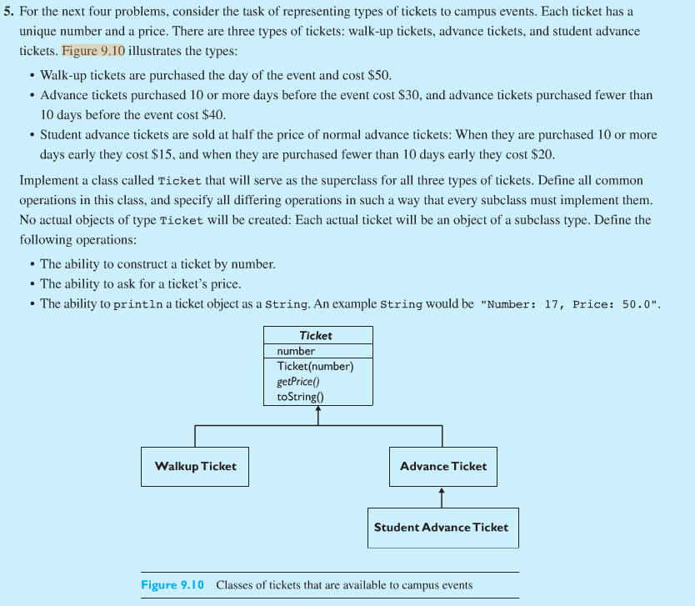

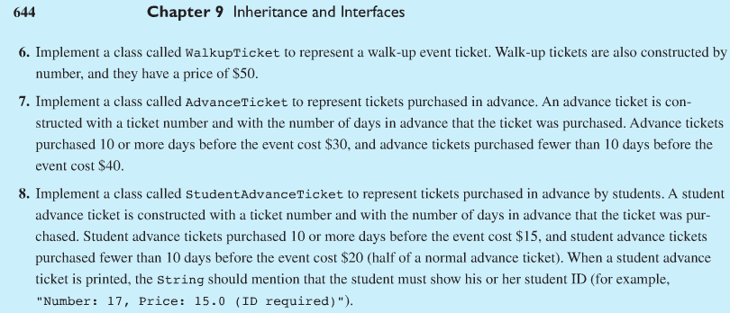

**What to turn in**:

1. Upload all of the .java and the .class files to the CSc1302 dropbox on [http:// icollege.gsu.edu](http://desire2learn.gsu.edu/).

**Note**:

1. For all assignments, always use comments to include the programmer information, date, title of the program and brief description of the program.
2. No copying allowed. If it is found that students copy from each other, all of these programs will get **0**.
3. You must name your file/program ase specified. Should you use a different name, you would lose **10%** of what the program is worth.
4. Make sure that both the .java and .class files are uploaded to the ftp server correctly. If the jpb package is used in the program. Be sure to upload the jpb package also. Should you use any other subdirectory (whatsoever) your program would not be graded and you will receive a **0 (zero)**.