Assignment 3, Implementation of Mobile E-Learning App-Phase 3

In this semester’s assignments, we will focus on the topic and the use case scenarios of a E-learning system or the so called learning management system(LMS). You are asked to develop functions for a mobile E-learning App in the consecutive five assignments, each assignments will have specific requirements.

You can refer to the use cases provided in the article “Applicability of Use-Case Modeling for Virtual Learning Environments” for understanding the business requirements of a mobile e-learning system.

In assignment3, our focus will be on achieving better user experience, to do so you are encouraged to apply multiple android programming techniques such as local data caching, layout transition and optimizing the UI design and etc.

***Requirements:***

The implementation should include but not limited to following optimization, such as,

1. Look in the list of courses

In general, recyclerview is suggested to be used for course list display. We’d like you to add more information and more enchanting layout for the list item display. E.g, providing different viewitem layouts within one recyclerview; adding videos, statistics diagrams in the item view; anything eye catching. Below is a draft of a sampe item view,

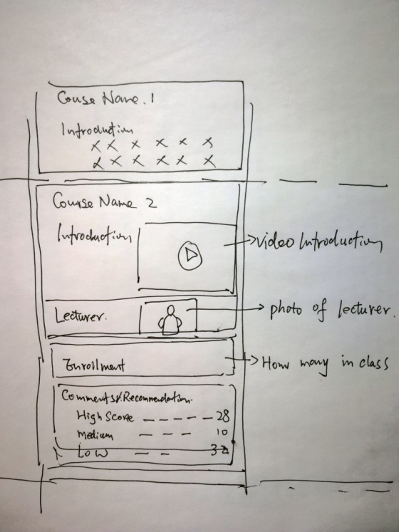

1. Navigating with transition animation.
2. Login to the E-learning platform

User only need to login once, next time open the app, your app will remember the user and recover the UI from user’s last use. To do so, you can use the shared preferences api to store user behavious and run- time status.

4, Caching the user browsed data in local sqllite database/local file cache, so that fetching one data item from internet only takes place once.

5,For long running jobs such as loading/uploading image or video, store in cache file and etc, implmenting with async task or multi thread is necessary.

6, Use broadcast receiver and notification to notify user of server side updates.

***Delivery:***

1, You need to archive the project and prototype running screen capture to github repository.

2, Provide a design document.

3, Hand in due to 2019 -12- 23

Assignment 4 Implementation of Mobile E-Learning App-Phase4

In assignment 4, our focus will be on implementation with MVVM and architecture components.

***Requirements:***

1, You are asked to re write your program, if not all, at least one module using mvvm and use the room api for databae access. You are encouraged to program in Kotlin rather than Java.

2, Add in Introduction slide page to your app.

3, Implementing 3rd party login with your WeChaT/QQ account

4,Share course announcements to WeChat/SMS.

***Delivery:***

1, You need to archive the project and prototype running screen capture to github repository.

2, Provide a design document.

3, Hand in due to 2019 -12- 23

Assignment 5 Implementation of Mobile E-Learning App-Phase5

In assignment 5, our focus will be on unit testing and android android testing framework.

***Requirements:***

1, You are asked to provide complete unit test cases and implementing the android testing for at least one activity module.

***Delivery:***

1, You need to archive the project and prototype running screen capture to github repository.

2, Provide a design document.

3, Hand in due to 2019 -12- 23