**Extreme-value based Emitter Recovery (EVER) version 3 user manual**

The EVER is a method to accurately recover the fluorescent emitters from heterogeneous background. This method is used as the first step in WindSTORM. This method can also be used independently as a pre-processing step to recover fluorescent emitters prior to single molecule localization.

In this implementation (ImageJ plugin), the users should note:

(1) This plugin is designed to remove the nonuniform background for localization microscopy with sCMOS cameras. It cannot achieve the best performance for images acquired by EMCCD cameras.

(2) This plugin is designed to remove nonuniform background with values less than 5000 photons.

The default GUI of EVERv3 is:

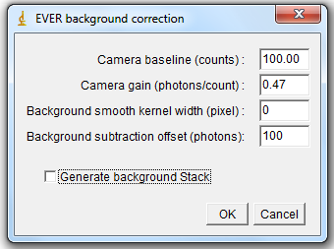

**Camera baseline (counts):** The value is around 100 for most sCMOS cameras. (Important)

**Camera gain (photons/count):** The value is around 0.47 for most sCMOS cameras. (Important)

**Background smooth kernel width (pixel):** Average filter can be used to smooth the estimated background for higher precision. The recommend value is 0 for strong heterogeneous background, 1 for common heterogeneous background, and 2 or 3 for slightly heterogeneous background. (Minor)

**Background subtraction offset (photons):** To avoid the negative values, users can set an offset. Note that, for some localization algorithms (e.g., FALCON, ThunderSTORM), background value is important for emitter finding. In this situation, I recommend the user to set a value that is approximate to the background value for better performance. (Minor)

**Generate background Stack:** Users have the option to generate either the background corrected image stack or the estimated background.

**“test_data.tif”** is the simulated dataset for testing. (Baseline: 100, Gain: 0.47)

Any questions regarding this plugin should be addressed to Dr. Hongqiang Ma ([hongqiang.ma@pitt.edu](mailto:hongqiang.ma@pitt.edu) ).