贵州大学实验报告
学院：大数据与信息工程学院 专业：数据科学与大数据技术 班级：数科181
姓名 |  | 杨露瑶 | 学号 | 1817000346 | 实验组
实验时间 |  | 2021.6.12 | 指导教师 | 何庆 | 成绩
实验项目名称 |  | PoS 算法实现
实验目的 | 通过让学生进行实验，使其对于区块链的内容有一个较为深入的了解和熟悉。最终可以基本使用。
实验要求 | - PoS 算法机制的代码实现，根据持币数量来做股权分配。（编程语言不限）
实验原理 | 根据上课内容及其他网络资料编写PoS 算法机制，根据持币数量来做股权分配。
实验仪器 | 具备上网条件的PC机器
实验步骤 | 按照实验要求的内容逐一完成实验的要求。
实验内容 | - PoS 算法机制的代码实现，根据持币数量来做股权分配。（编程语言不限）
实验数据 | - 实验代码  - import time  - import json  - import threading  - from hashlib import sha256  - from datetime import datetime  - from random import choice  - from queue import Queue, Empty  - from socketserver import BaseRequestHandler, ThreadingTCPServer  - # 需要两个队列  - # 定义变量  - block_chain = []  - temp_blocks = []  - candidate_blocks = Queue() # 创建队列，用于线程间通信  - announcements = Queue()  - validators = {}  - My_Lock = threading.Lock()  - def generate_block(oldblock, bpm, address):  - """  - :param oldblock:  - :param bpm:  - :param address:  - :return:  - """  - newblock = {  - "Index": oldblock["Index"] + 1,  - "BPM": bpm,  - "Timestamp": str(datetime.now()),  - "PrevHash": oldblock["Hash"],  - "Validator": address  - }  - newblock["Hash"] = calculate_hash(newblock)  - return newblock  - def calculate_hash(block):  - record = "".join([  - str(block["Index"]),  - str(block["BPM"]),  - block["Timestamp"],  - block["PrevHash"]  - ])  - return sha256(record.encode()).hexdigest()  - def is_block_valid(newblock, oldblock):  - """  - :param newblock:  - :param oldblock:  - :return:  - """  - if oldblock["Index"] + 1 != newblock["Index"]:  - return False  - if oldblock["Hash"] != newblock["PrevHash"]:  - return False  - if calculate_hash(newblock) != newblock["Hash"]:  - return False  - return True  - def pick_winner(announcements):  - """  - 选择记账人  - :param announcements:  - :return:  - """  - time.sleep(10)  - while True:  - with My_Lock:  - temp = temp_blocks  - lottery_pool = [] #  - if temp:  - for block in temp:  - if block["Validator"] not in lottery_pool:  - set_validators = validators  - k = set_validators.get(block["Validator"])  - if k:  - lottery_pool.append(block["Validator"] for _ in k)  - lottery_winner = choice(lottery_pool)  - # 向区块链添加赢家区块，并让所有其他节点都知道  - for block in temp:  - if block["Validator"] == lottery_winner:  - with My_Lock:  - block_chain.append(block)  - # 在队列中写入消息  - for _ in range(len(validators)):  - msg = "\n:{0} 赢得了记账权利\n".format(lottery_winner)  - announcements.put(msg)  - break  - with My_Lock:  - temp_blocks.clear()  - class HandleConn(BaseRequestHandler):  - def handle(self):  - print("Got connection from", self.client_address)  - while True:  - # todo线程始终将信息同步到客户端  - try:  - msg = announcements.get(block=False)  - self.request.send(msg.encode())  - except Empty:  - pass  - #验证程序地址  - self.request.send(b"Enter token balance:")  - balance = self.request.recv(8192)  - try:  - balance = int(balance)  - except Exception as e:  - print(e)  - break  - t = str(datetime.now())  - address = sha256(t.encode()).hexdigest()  - validators[address] = balance  - print(validators)  - self.request.send(b"\nEnter a new BPM:")  - bpm = self.request.recv(8192)  - # todo线程生成新块  - try:  - bpm = int(bpm)  - except Exception as e:  - print(e)  - del validators[address]  - break  - last_block = block_chain[-1]  - new_block = generate_block(last_block, bpm, address)  - print(new_block, last_block)  - if is_block_valid(new_block, last_block):  - candidate_blocks.put(new_block)  - self.request.send(b"\nEnter a new BPM:")  - # todo线程总是向客户端发送消息  - time.sleep(30)  - with My_Lock:  - output = json.dumps(block_chain)  - self.request.send(output.encode())  - def candidate(candidate_blocks):  - while True:  - try:  - candi = candidate_blocks.get(block=False)  - except Empty:  - time.sleep(3)  - continue  - temp_blocks.append(candi)  - def run():  - # 创建一个genesis块  - t = str(datetime.now())  - genesis_block = {  - "Index": 0,  - "Timestamp": t,  - "BPM": 0,  - "PrevHash": "",  - "Validator": ""  - }  - genesis_block["Hash"] = calculate_hash(genesis_block)  - print(genesis_block)  - block_chain.append(genesis_block)  - # 开始一个tcp服务  - serv = ThreadingTCPServer(('', 9090), HandleConn)  - serv.serve_forever()  - thread_canditate = threading.Thread(target=candidate, args=(candidate_blocks,))  - thread_pick = threading.Thread(target=pick_winner, args=(announcements,))  - thread_canditate.start()  - thread_pick.start()  - if __name__ == '__main__':  - run()  - 代码执行  - 执行blockchain2.py  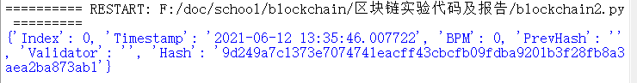  - •打开3个终端分别输入命令：•nc localhost 9090  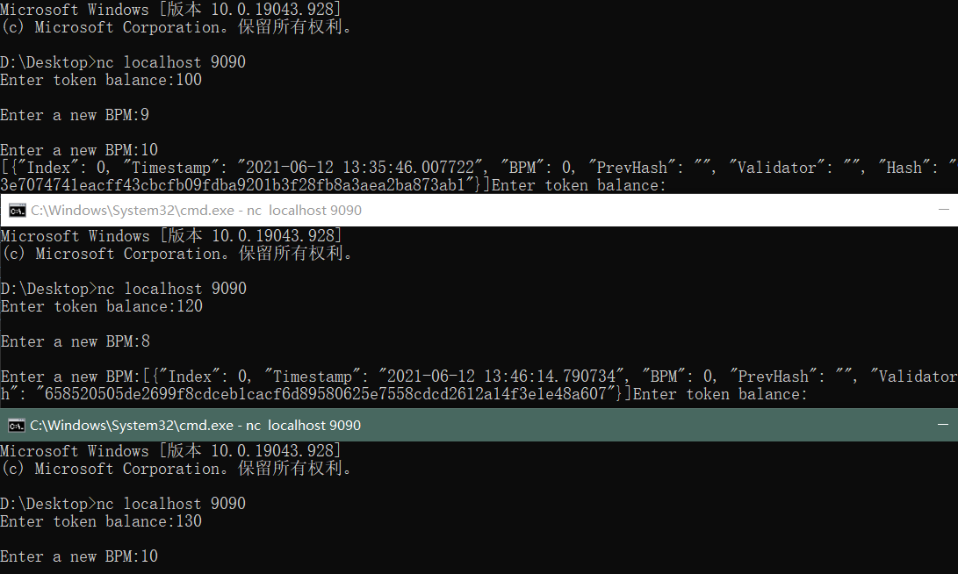  - 获得的3个block信息  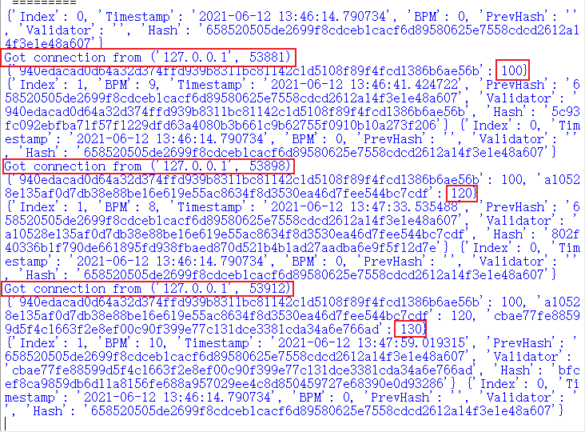
实验总结 | - python中多线程开销比较大，可以改成协程的方式  - TCP建立的长链接是基于TCPServer，是中心化的方式，可以改成P2P对等网络  - 链的信息不够完整  - 系统可以拓展成分布式，让其更健壮
指导教师意见 | 签名： 年 月 日
注：各学院可根据教学需要对以上栏木进行增减。表格内容可根据内容扩充。

