

大数据分析与应用

学 院：大数据与信息工程学院
专 业：数据科学与大数据技术
班 级： 大数据181
指导教师： 杜逆索
学 号： 杨露瑶
姓 名： 1817000346

2021年 6 月 5 日

贵州大学实验报告
目录
一、 python的版本 3
二、 数据读取与写入 3
源代码 3
执行结果： 4
三、 合并数据集 6
源代码 6
执行结果： 9
1） mergeSame.xlsx 9
2） mergeIndex.xlsx 10
3） axialConnection.xlsx 12
四、 数据转换 13
源代码 13
执行结果： 18
1） removeDuplicates.xlsx 18
2） dataConversion.xlsx 19
3） replacement.xlsx 20
4） renameAxisindex.xlsx 21
5） discreteData.xlsx 22
6） detectOutliers.xlsx 22
7） permutation.xlsx 23
8） dummyVariable.xlsx 24

- python的版本
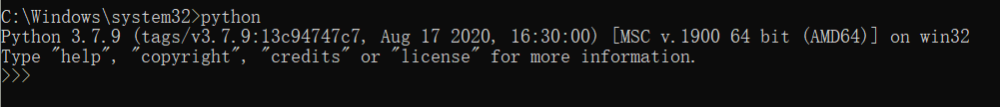
- 数据读取与写入

源代码：
class Read():
#7.1.1读取txt文件
def readTxt(self, filename):
f= open(filename,'r',encoding='UTF-8')
#读取练习.txt文档中的所有行数据
d1=f.readlines()
print(d1)
f.close()

#7.1.2以追加的方式写入txt文件
def writeTxt(self, filename):
f = open(filename,'a+',encoding='UTF-8')
f.write("\ntest file\n")
f.write("hahahha")
f.close()
#再次打开文件查看已写入的内容
self.readTxt(filename)

#7.1.3读取csv文件
def readCsv(self, filename):
#1.read_csv函数
df=pd.read_csv(filename,encoding='GBK')
print('read_csv:')
print(df)
#2.read_table函数
df=pd.read_table(filename,encoding='GBK',sep=',')
print('read_table:')
print(df)
#3.逐块读取文本文件
df=pd.read_table(filename,encoding='GBK',nrows=5)
print('one by one:')
print(df)

def readExcel(self, filename0, filename1):
#7.1.4读取Excel文件
#读取并输出Excel表1
print("excel表1")
a=pd.read_excel(filename0)
print(a)
print("\n")
#读取并输出Excel表2
print("excel表2")
b=pd.read_excel(filename1)
print(b)
print("\n")
#合并两张Excel表的交集部分
print("两张Excel表的交集部分")
c=pd.merge(a,b,on="id")
print(c)
print("\n")
#合并两张Excel表的并集部分
print("两张Excel表的并集部分")
d=pd.merge(a,b,on="id",how="outer")
print(d)

if __name__ == '__main__':
f1 = 'E:\\objects\\python\\data\\test.txt'
f2 = 'E:\\objects\\python\\data\\test.csv'
f3 = 'E:\\objects\\python\\data\\test0.xlsx'
f4 = 'E:\\objects\\python\\data\\test1.xlsx'
r = Read()
r.readTxt(f1)
r.writeTxt(f1)
r.readCsv(f2)
r.readExcel(f3,f4)

执行结果：
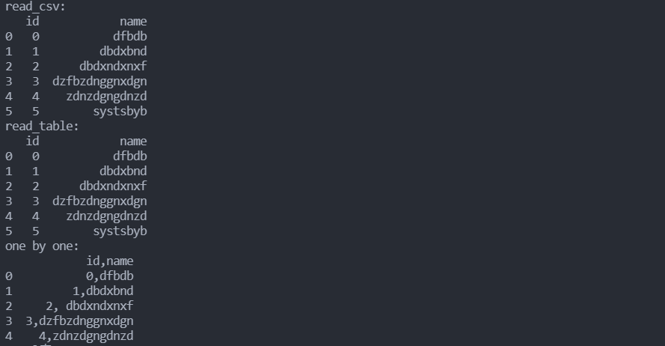
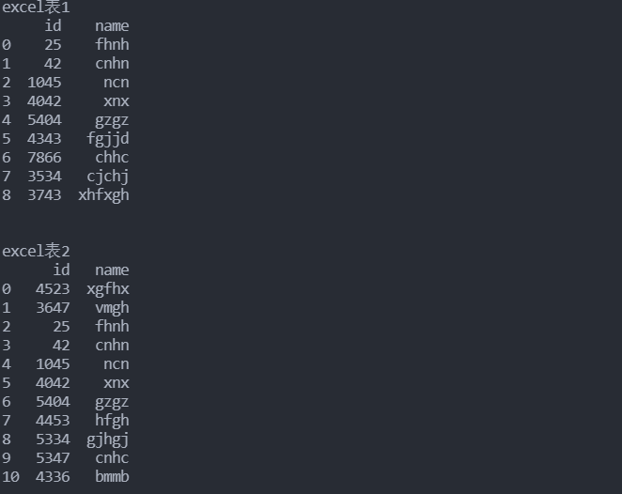
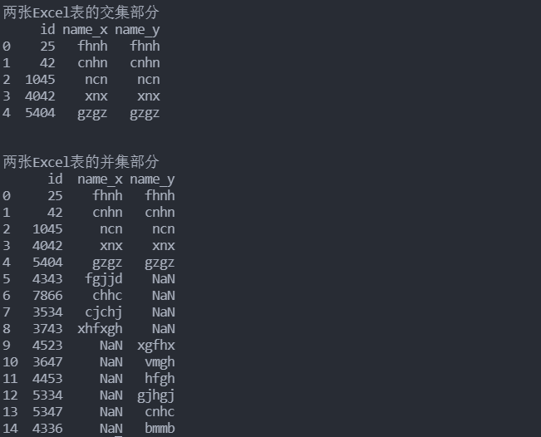

- 合并数据集

源代码：
class Merge():

#8.1 合并数据集
#8.1.1索引上的合并
def mergeIndex(self):
left1 = pd.DataFrame({'key':['a','b','a','a','b','c'],'value':range(6)})
right1 = pd.DataFrame({'group_val':[3.5,7]},index=['a','b'])
left2 = pd.DataFrame([[1.,2.],[3.,4.],[5.,6.]],index=['a','c','e'],columns=['Ohio','Nevada'])
right2 = pd.DataFrame([[7.,8.],[9.,10.],[11.,12.],[13.,14.]],index=['b','c','d','e'],columns=['Missouri','Alabama'])
lefth = pd.DataFrame({'key1':['Ohio','Ohio','Ohio','Nevada','Nevada'],'key2':['2000','2001','2002','2001','2002'],'data':np.arange(5.)})
righth = pd.DataFrame(np.arange(12).reshape((6,2)),index=[['Nevada','Nevada','Ohio','Ohio','Ohio','Ohio'],['2001','2000','2000','2000','2001','2002']],columns=['event1','event2'])

#合并操作
#两张关联表的交集部分
print("两张关联表的交集部分")
d1=pd.merge(left1,right1,left_on='key',right_index=True)
# print(d1)
# print("\n")
#两张关联表的并集部分
print("两张关联表的并集部分")
d2=pd.merge(left1,right1,left_on='key',right_index=True,how='outer')
# print(d2)
# print("\n")
#复合键进行索引
d3=pd.merge(lefth,righth,left_on=['key1','key2'],right_index=True)
# print(d3)
d4=pd.merge(lefth,righth,left_on=['key1','key2'],right_index=True,how='outer')
# print(d4)
#合并双方的索引
d5=pd.merge(left2,right2,left_index=True,right_index=True,how='outer')
# print(d5)
#join函数
d6=left2.join(right2,how='outer')
# print(d6)
#d5与d6输出相同

#将结果写入mergeIndex.xlsx中
filename = 'E:\\objects\\python\\data\\merge\\mergeIndex.xlsx'
writer = pd.ExcelWriter(filename)
d1.to_excel(writer, 'd1', float_format='%.5f')
d2.to_excel(writer, 'd2', float_format='%.5f')
d3.to_excel(writer, 'd3', float_format='%.5f')
d4.to_excel(writer, 'd4', float_format='%.5f')
d5.to_excel(writer, 'd5', float_format='%.5f')
d6.to_excel(writer, 'd6', float_format='%.5f')
writer.save()
writer.close()
print("mergeIndex.xlsx完成")

#8.1.2轴向连接
def axialConnection(self):
arr=np.arange(12).reshape((3,4))
# print(arr)
temp = np.concatenate([arr,arr],axis=1)
d1 = pd.DataFrame(temp)
# print(temp)
# print(d1)
#concat函数
s1=pd.Series([0,1],index=['a','b'])
s2=pd.Series([2,3,4],index=['c','d','e'])
s3=pd.Series([5,6],index=['f','g'])
d2=pd.concat([s1,s2,s3])
# print(d2)
d3=pd.concat([s1,s2,s3],axis=1)
# print(d3)
d4=pd.concat([s1,s3],axis=1)
# print(d4)
d5=pd.concat([s1,s1,s3],keys=['one','two','three'])
# print(d5)
d6=pd.concat([s1,s2,s3],axis=1,keys=['one','two','three'])
# print(d6)

filename = 'E:\\objects\\python\\data\\merge\\axialConnection.xlsx'
writer = pd.ExcelWriter(filename)
d1.to_excel(writer, 'd1')
d2.to_excel(writer, 'd2')
d3.to_excel(writer, 'd3')
d4.to_excel(writer, 'd4')
d5.to_excel(writer, 'd5')
d6.to_excel(writer, 'd6')
writer.save()
writer.close()
print("axialConnection.xlsx完成")

#8.1.3合并重叠数据
def mergeSame(self):
a=pd.Series([np.nan,2.5,np.nan,3.5,4.5,np.nan],index=['f','e','d','c','b','a'])
# print(a)
b=pd.Series(np.arange(len(a),dtype=np.float64),index=['f','e','d','c','b','a'])
b[-1]=np.nan
# print(b)
temp=np.where(pd.isnull(a),b,a)
c = pd.DataFrame(temp)
# print(c)

# #将结果写入mergeSame.xlsx中
filename = 'E:\\objects\\python\\data\\merge\\mergeSame.xlsx'
writer = pd.ExcelWriter(filename)
a.to_excel(writer, 'a')
b.to_excel(writer, 'b')
c.to_excel(writer, 'c')
writer.save()
writer.close()
print("mergeSame.xlsx完成")
if __name__ == '__main__':
m = Merge()
m.mergeIndex()
m.axialConnection()
m.mergeSame()

执行结果：
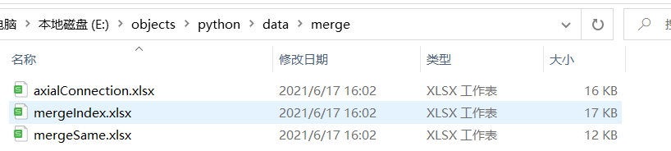
- mergeSame.xlsx
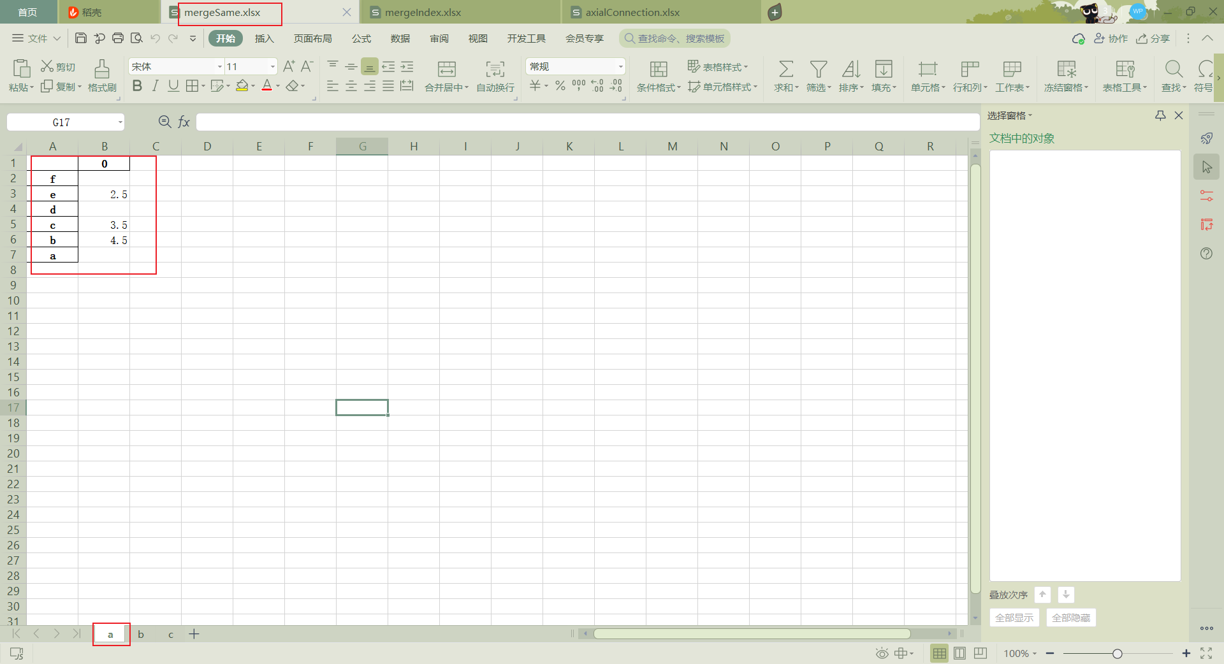
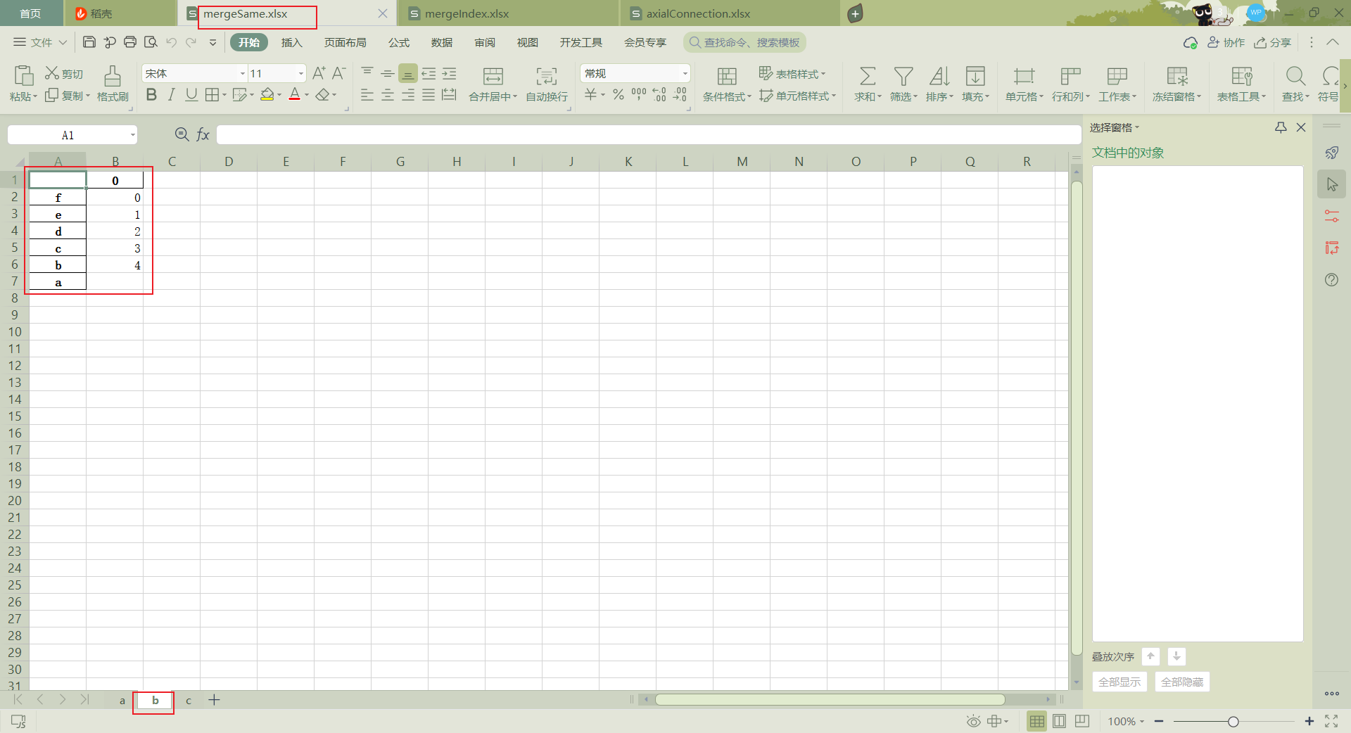
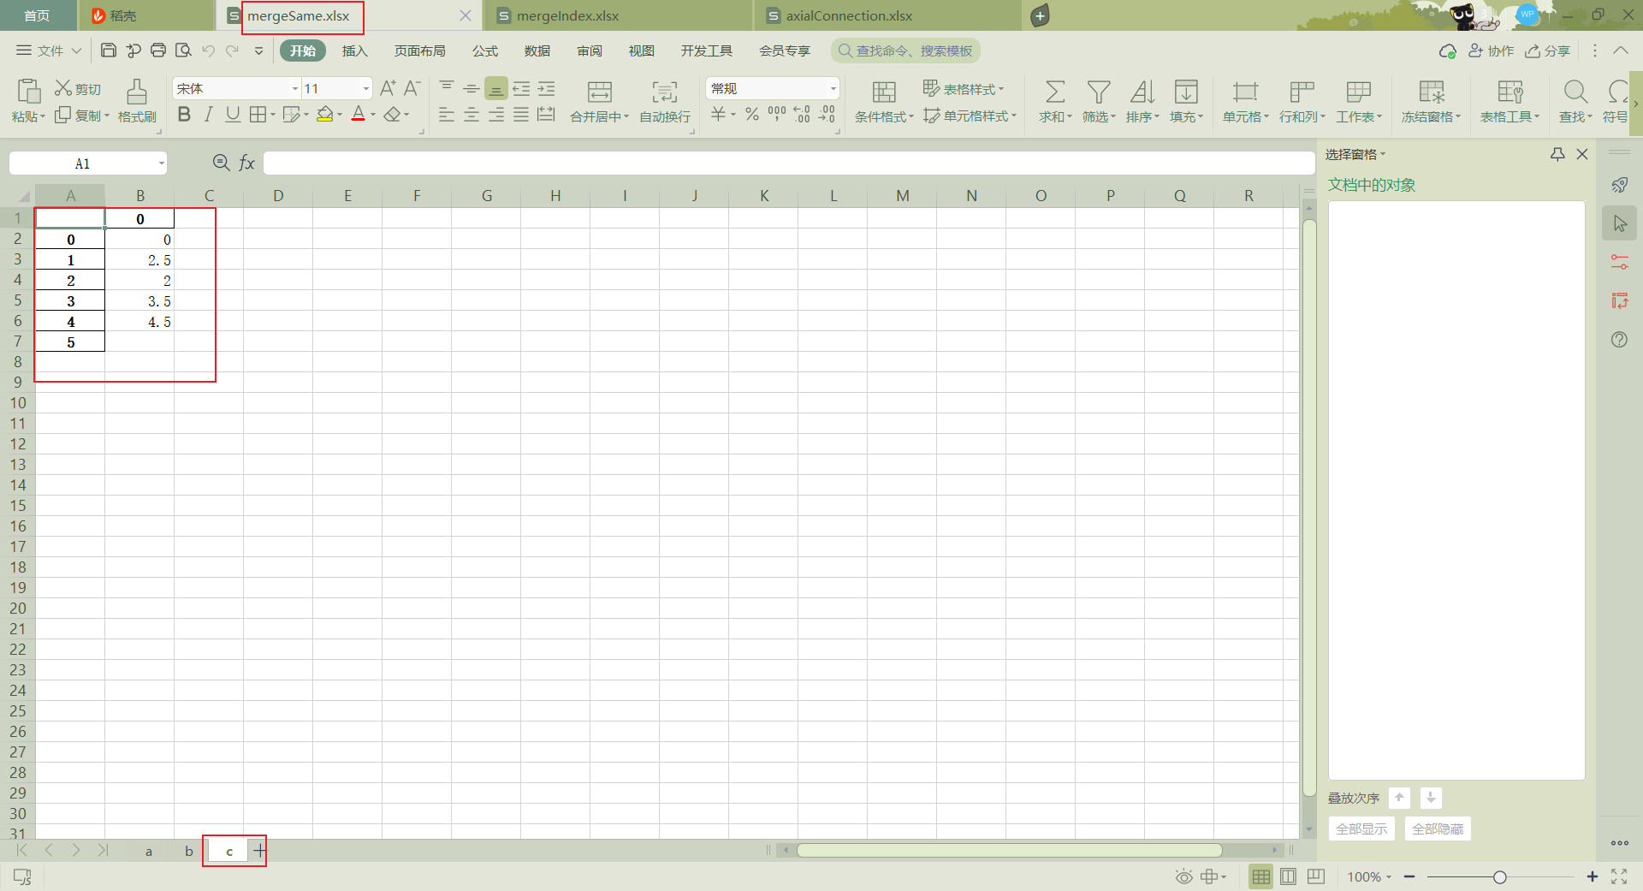
- mergeIndex.xlsx
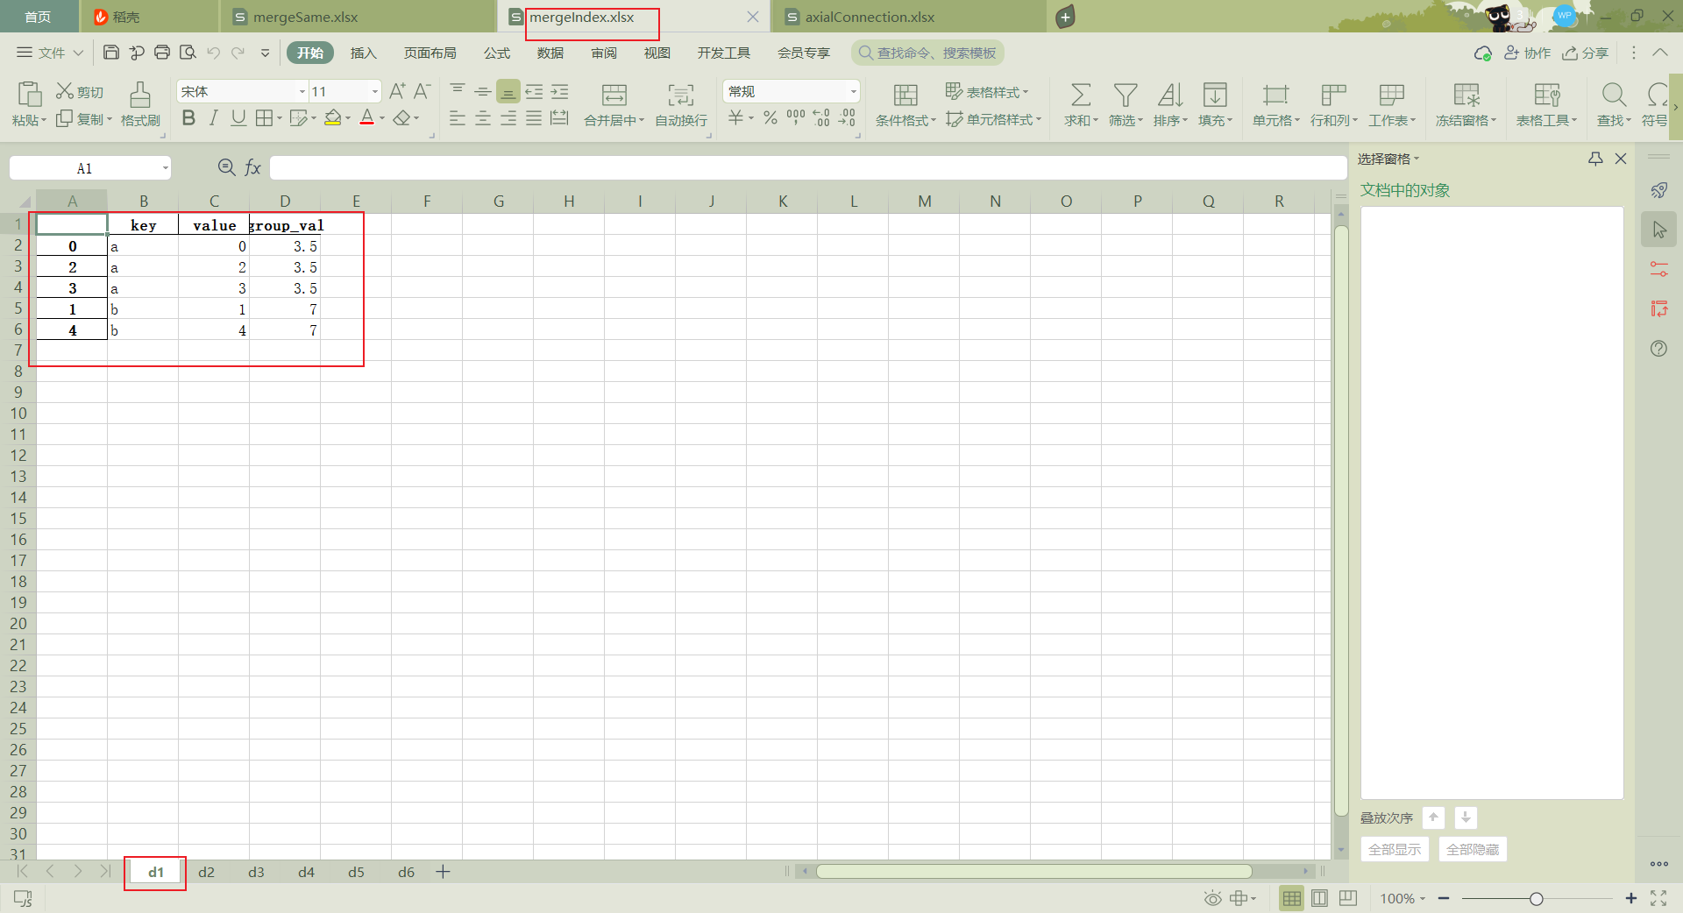
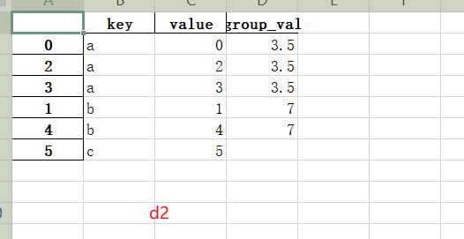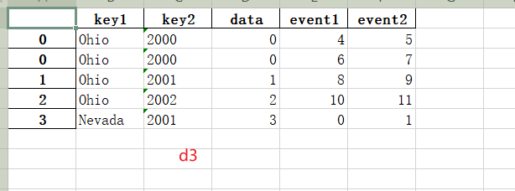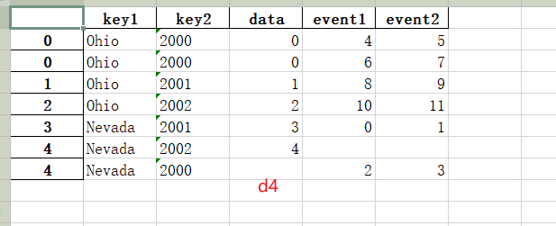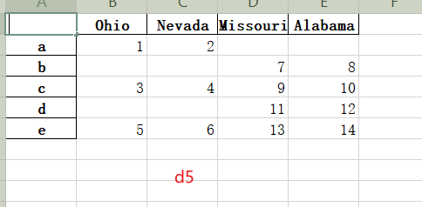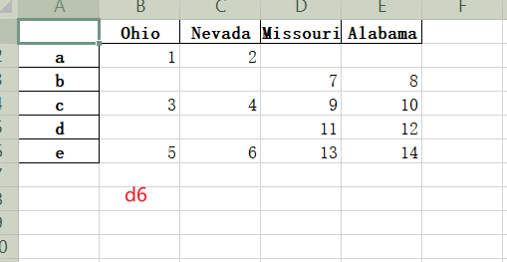
- axialConnection.xlsx
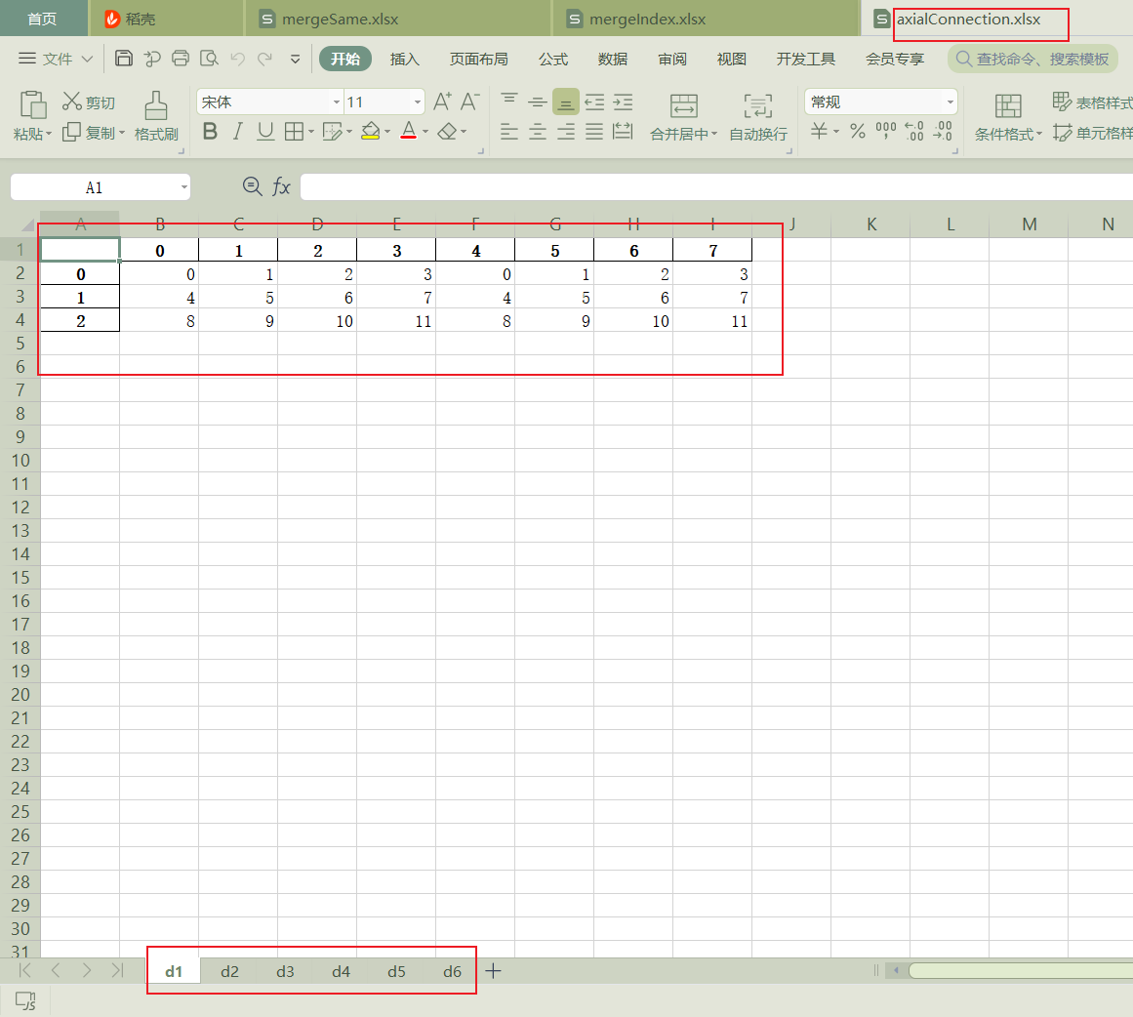
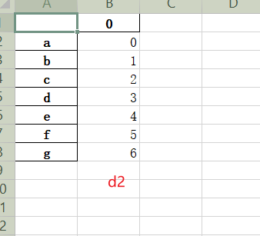
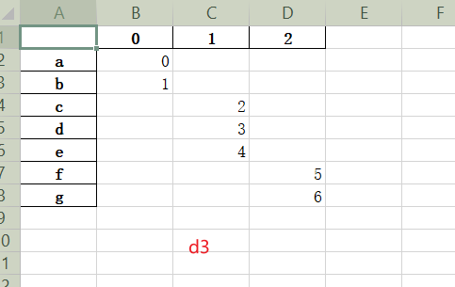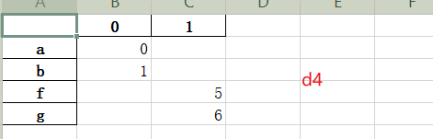
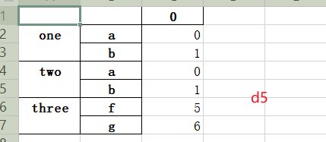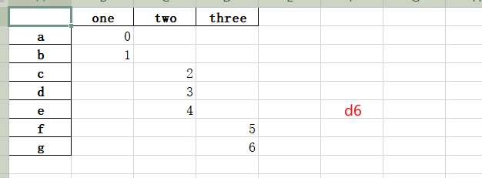
- 数据转换

源代码：
class Convert():
#8.2 数据转换
#8.2.1移除重复数据
def removeDuplicates(self):
data=pd.DataFrame({'k1':['one']*3+['two']*4,'k2':[1,1,2,3,3,4,4]})
# print(data)
# print('/n')
d1=data.duplicated()
# print(d1)
# print('/n')
d2=data.drop_duplicates()
# print(d2)
# print('/n')
data['v1']=range(7)
# print(data)
# print('/n')
# 根据k1移除重复数据
d3=data.drop_duplicates(['k1'])
# print(d3)
# print('/n')
# 根据k1，k2移除重复数据
d4=data.drop_duplicates(['k1','k2'])
# print(d4)
# print('/n')

filename = 'E:\\objects\\python\\data\\convert\\removeDuplicates.xlsx'
writer = pd.ExcelWriter(filename)
data.to_excel(writer, 'data')
d1.to_excel(writer, 'd1')
d2.to_excel(writer, 'd2')
d3.to_excel(writer, 'd3')
d4.to_excel(writer, 'd4')
writer.save()
writer.close()
print("removeDuplicates.xlsx完成")

#8.2.2利用函数进行数据转换
def dataConversion(self):
filename = 'E:\\objects\\python\\data\\convert\\dataConversion.xlsx'
writer = pd.ExcelWriter(filename)
data=pd.DataFrame({'food':['bacon','pulled pork','bacon','Pastrami','corned beef','Bacon','pastrami','honey ham','nova lox'],'ounces':[4,3,12,6,7.5,8,3,5,6]})
# print(data)
data.to_excel(writer, 'data0')
meat_to_animal = {
'bacon':'Pig',
'pulled pork':'pig',
'pastrami':'Cow',
'corned beef':'cow',
'honey ham':'pig',
'nova lox':'almon'
}
data['animal'] = data['food'].map(str.lower).map(meat_to_animal)
# print(data)
data.to_excel(writer, 'data1')
data['food'].map(lambda x: meat_to_animal[x.lower()])
# print(data)
data.to_excel(writer, 'data2')
writer.save()
writer.close()
print("dataConversion.xlsx完成")

#8.2.3替换值
def replacement(self):
data=pd.Series([1.,-999,2.,-999,-1000.,3.])
# print(data)
d1=data.replace(-999,np.nan)
# print(d1)
d2=data.replace([-999,-1000],np.nan)
# print(d2)
d3=data.replace([-999,-1000],[np.nan,0])
# print(d3)
filename = 'E:\\objects\\python\\data\\convert\\replacement.xlsx'
writer = pd.ExcelWriter(filename)
data.to_excel(writer, 'data')
d1.to_excel(writer, 'd1')
d2.to_excel(writer, 'd2')
d3.to_excel(writer, 'd3')
writer.save()
writer.close()
print("replacement.xlsx完成")

#8.2.4重命名轴索引
def renameAxisindex(self):
filename = 'E:\\objects\\python\\data\\convert\\renameAxisindex.xlsx'
writer = pd.ExcelWriter(filename)
data=pd.DataFrame(np.arange(12).reshape((3,4)),index=['Ohio','Colorado','New York'],columns=['one','two','three','four'])
data.index.map(str.upper)
# print(data)
data.to_excel(writer, 'data0')
data.index=data.index.map(str.upper)
# print(data)
data.to_excel(writer, 'data1')
d1=data.rename(index=str.title,columns=str.upper)
# print(d1)
d2=d1.rename(index={'Ohio':'INDIANA'},columns={'three':'peekaboo'})
# print(d2)
_=d1.rename(index={'Ohio':'INDIANA'},inplace=True)
# print(d1)
d1.to_excel(writer, 'd1')
d2.to_excel(writer, 'd2')
writer.save()
writer.close()
print("renameAxisindex.xlsx完成")

#8.2.5离散化数据
def discreteData(self):
ages=[20,22,25,27,21,23,37,31,61,45,41,32]
bins=[18,25,35,60,100]
cats=pd.cut(ages,bins)
d1 = pd.DataFrame(cats)
# print(cats)
filename = 'E:\\objects\\python\\data\\convert\\discreteData.xlsx'
writer = pd.ExcelWriter(filename)
d1.to_excel(writer, 'cats')
writer.save()
writer.close()
print("discreteData.xlsx完成")

#8.2.6检测异常值
def detectOutliers(self):
filename = 'E:\\objects\\python\\data\\convert\\detectOutliers.xlsx'
writer = pd.ExcelWriter(filename)
np.random.seed(12345)
data=pd.DataFrame(np.random.randn(1000,4))
data.to_excel(writer, 'data0')
# print(data)
col=data[3]
d1=col[np.abs(col)>3]
# print(d1)
d2=data[(np.abs(data)>3).any(1)]
# print(d2)
data[np.abs(data)>3]=np.sign(data)*3
# print(data)
data.to_excel(writer, 'data')
d1.to_excel(writer, 'd1')
d2.to_excel(writer, 'd2')
data.to_excel(writer, 'data')
writer.save()
writer.close()
print("detectOutliers.xlsx完成")

#8.2.7排列和随机采样
def permutation(self):
filename = 'E:\\objects\\python\\data\\convert\\permutation.xlsx'
writer = pd.ExcelWriter(filename)
df=pd.DataFrame(np.arange(5*4).reshape(5,4))
# print(df)
df.to_excel(writer, 'df')
sampler=np.random.permutation(5)
temp = pd.DataFrame(sampler)
temp.to_excel(writer, 'sampler')
# print(sampler)
d1=df.take(sampler)
temp = pd.DataFrame(d1)
temp.to_excel(writer, 'd1')
# print(d1)
d2=df.take(np.random.permutation(len(df))[:3])
temp = pd.DataFrame(d2)
temp.to_excel(writer, 'd2')
# print(d2)
bag=np.array([5,7,-1,6,4])
sampler =np.random.randint(0,len(bag),size=10)
temp = pd.DataFrame(sampler)
temp.to_excel(writer, 'sampler')
# print(sampler)
draws=bag.take(sampler)
temp = pd.DataFrame(draws)
temp.to_excel(writer, 'draws')
# print(draws)
writer.save()
writer.close()
print("permutation.xlsx完成")

#8.2.8哑变量
def dummyVariable(self):
filename = 'E:\\objects\\python\\data\\convert\\dummyVariable.xlsx'
writer = pd.ExcelWriter(filename)
df=pd.DataFrame({'key':['b','b','a','c','a','b'],'data1':range(6)})
d1=pd.get_dummies(df['key'])
d1.to_excel(writer, 'd1')
# print(d1)
dummies=pd.get_dummies(df['key'],prefix='key')
df_with_dummy=df[['data1']].join(dummies)
temp=pd.DataFrame(df_with_dummy)
temp.to_excel(writer, 'df_with_dummy')
# print(df_with_dummy)
mnames=['movie_id','title','genres']
movies=pd.read_table('E:\objects\python\data\movies.dat',sep='::',header=None,names=mnames)
# movies[:10]
temp = pd.DataFrame(movies[:10])
temp.to_excel(writer, 'movies')
# print(movies)
writer.save()
writer.close()
print("dummyVariable.xlsx完成")
if __name__ == '__main__':
c = Convert()
c.removeDuplicates()
c.dataConversion()
c.replacement()
c.renameAxisindex()
c.discreteData()
c.detectOutliers()
c.permutation()
c.dummyVariable()

执行结果：
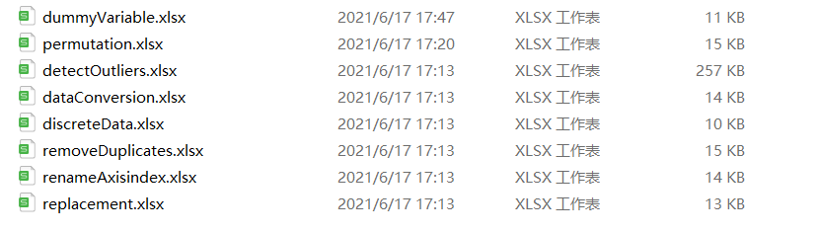
- removeDuplicates.xlsx
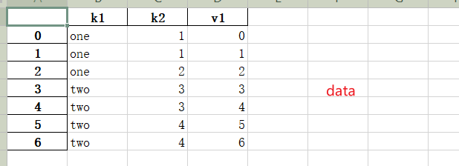
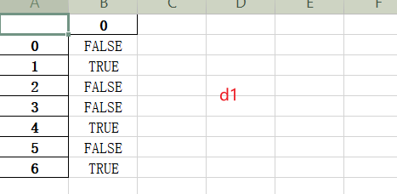
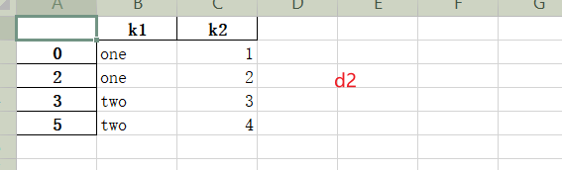
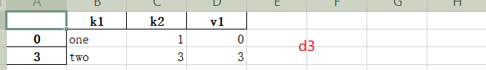
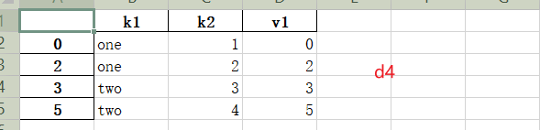
- dataConversion.xlsx
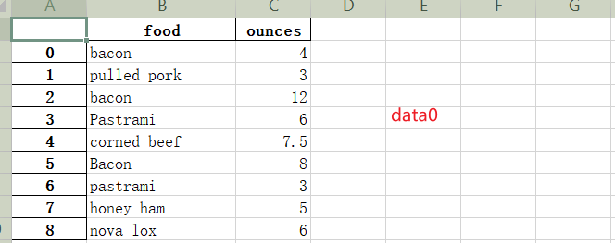
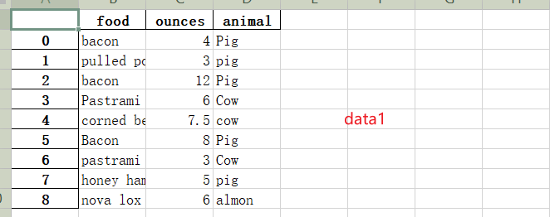
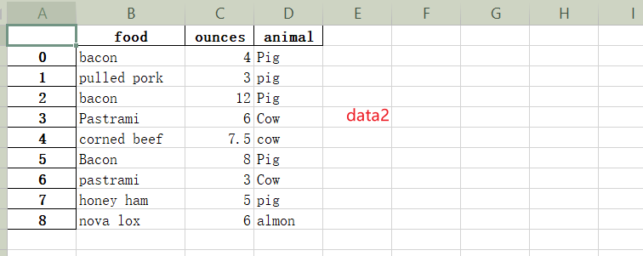
- replacement.xlsx
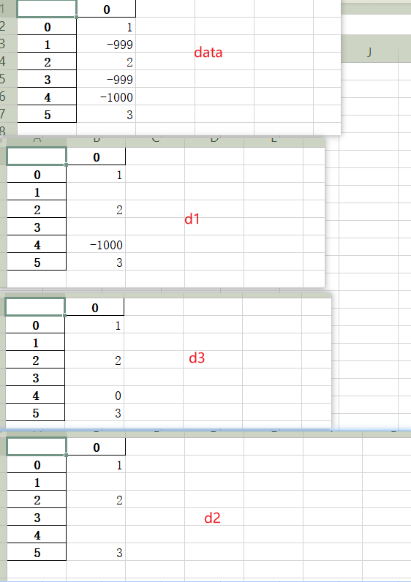
- renameAxisindex.xlsx
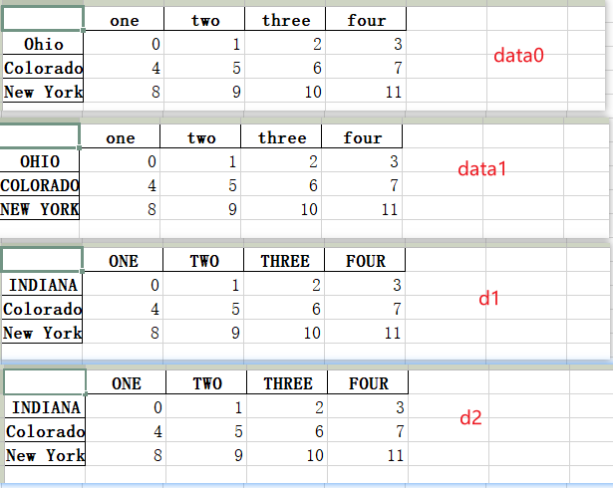
- discreteData.xlsx
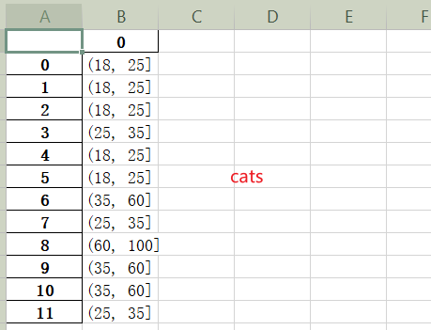
- detectOutliers.xlsx
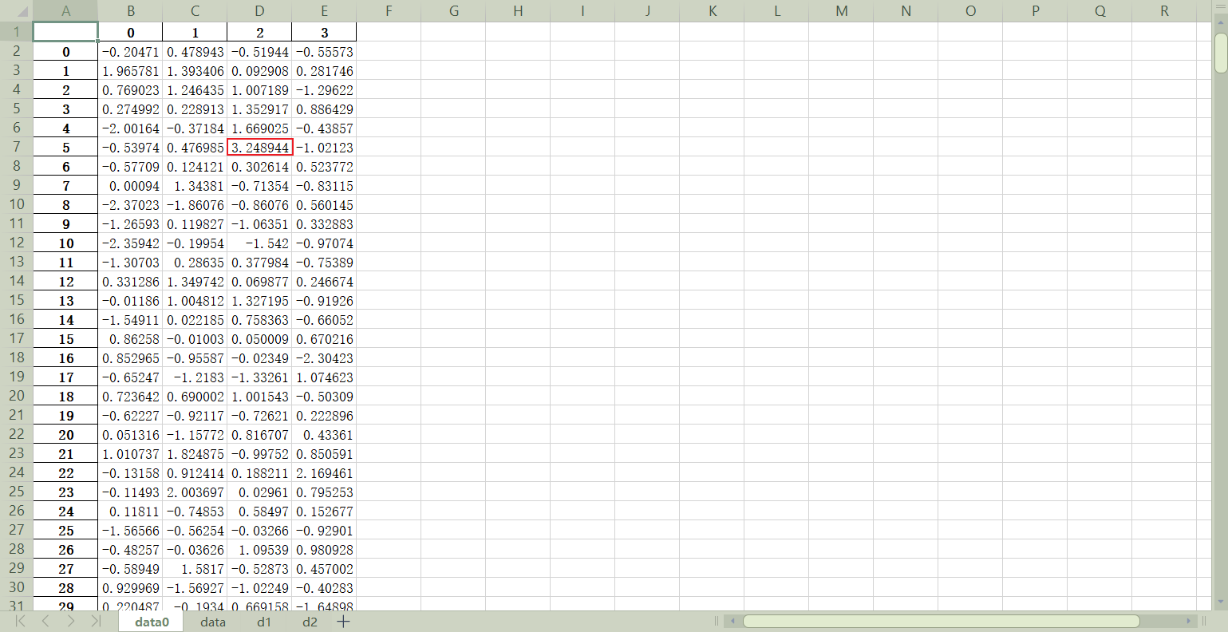
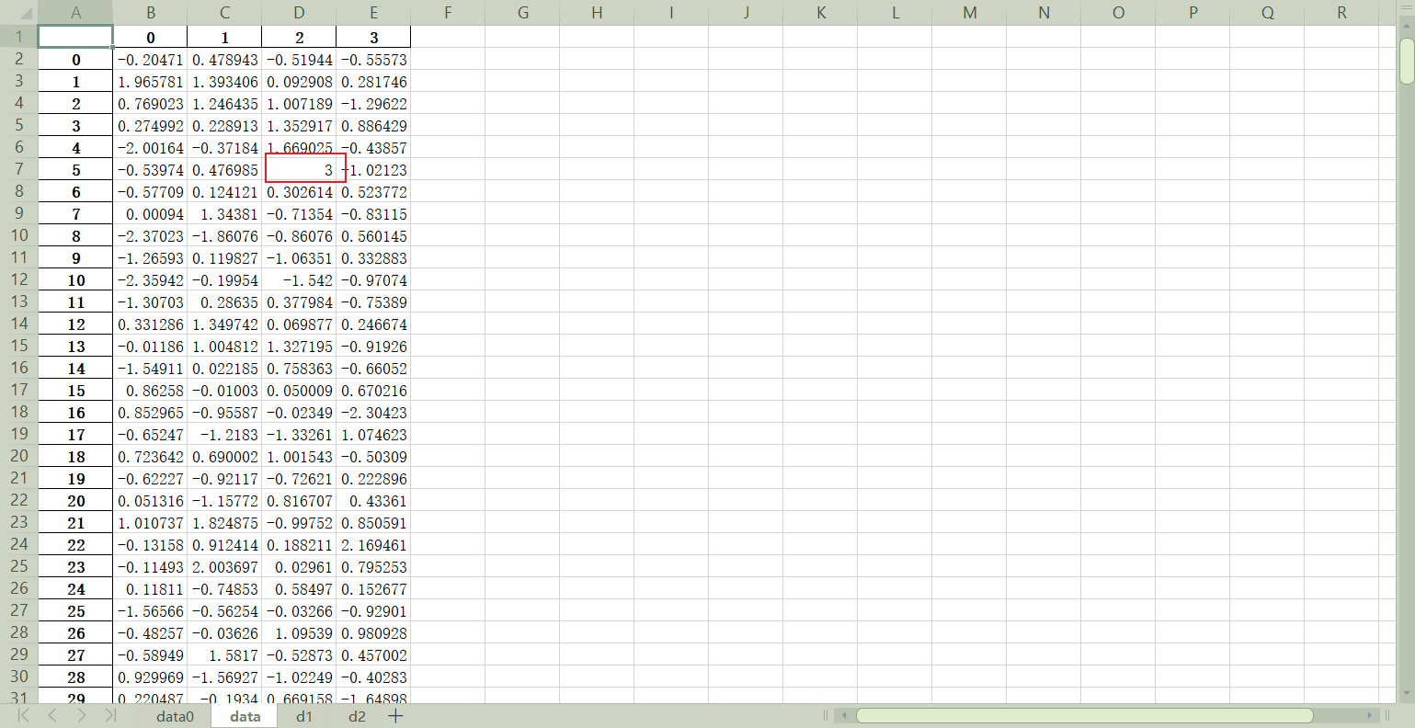
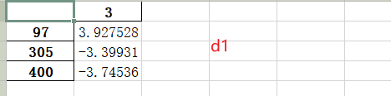
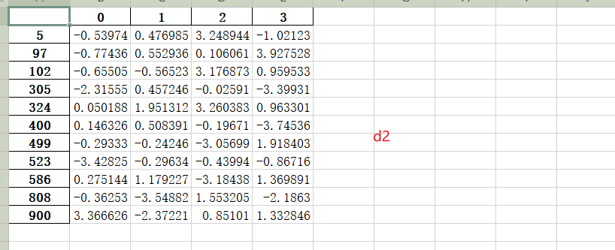
- permutation.xlsx
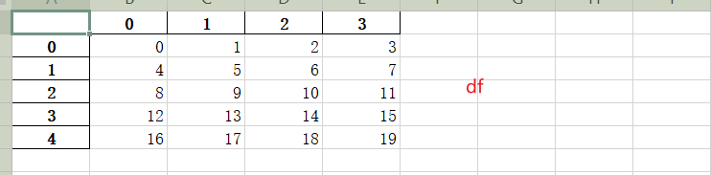
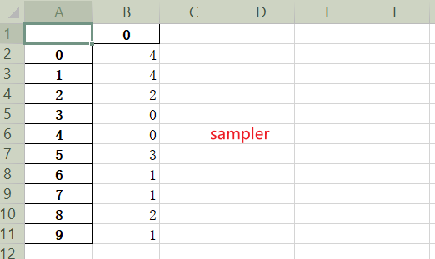
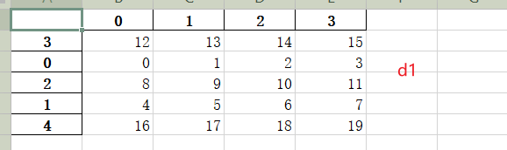
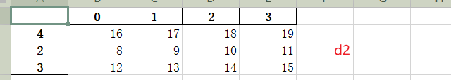
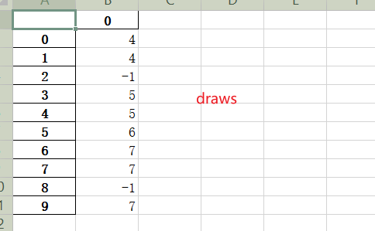
- dummyVariable.xlsx
