

K-Means 算法

学 院：大数据与信息工程学院
专 业：数据科学与大数据技术
班 级： 大数据181
指导教师： 涂歆
学 号： 杨露瑶
姓 名： 1817000346

2021年 6 月 18 日

贵州大学实验报告
- 代码
- kmeans_base.py
from collections import defaultdict
import time

from sklearn.cluster import KMeans
from sklearn import datasets

import numpy as np

from misc_utils import distance, check_random_state, sortLabel

class KMeansBase(object):
def __init__(self, n_clusters = 8, init = "random", max_iter = 300, random_state = None, n_init = 10, tol = 1e-4):
self.k = n_clusters # 聚类个数
self.init = init # 输出化方式
self.max_iter = max_iter # 最大迭代次数
self.random_state = check_random_state(random_state) #随机数
self.n_init = n_init # 进行多次聚类，选择最好的一次
self.tol = tol # 停止聚类的阈值

# fit对train建立模型
def fit(self, dataset):
self.tol = self._tolerance(dataset, self.tol)
bestError = None
bestCenters = None
bestLabels = None
for i in range(self.n_init):
labels, centers, error = self._kmeans(dataset)
if bestError == None or error < bestError:
bestError = error
bestCenters = centers
bestLabels = labels
self.centers = bestCenters
return bestLabels, bestCenters, bestError

# predict根据训练好的模型预测新的数据
def predict(self, X):
return self.update_labels_error(X, self.centers)[0]

# 合并fit和predict
def fit_predict(self, dataset):
self.fit(dataset)
return self.predict(dataset)

# kmeans的主要方法，完成一次聚类的过程
def _kmeans(self, dataset):
self.dataset = np.array(dataset)
bestError = None
bestCenters = None
bestLabels = None
centerShiftTotal = 0
centers = self._init_centroids(dataset)

for i in range(self.max_iter):
oldCenters = centers.copy()
labels, error = self.update_labels_error(dataset, centers)
centers = self.update_centers(dataset, labels)

if bestError == None or error < bestError:
bestLabels = labels.copy()
bestCenters = centers.copy()
bestError = error

## oldCenters和centers的偏移量
centerShiftTotal = np.linalg.norm(oldCenters - centers) ** 2
if centerShiftTotal <= self.tol:
Break

#由于上面的循环，最后一步更新了centers，所以如果和旧的centers不一样的话，再更新一次labels，error
if centerShiftTotal > 0:
bestLabels, bestError = self.update_labels_error(dataset, bestCenters)

return bestLabels, bestCenters, bestError

# k个数据点，随机生成
def _init_centroids(self, dataset):
n_samples = dataset.shape[0]
centers = []
if self.init == "random":
seeds = self.random_state.permutation(n_samples)[:self.k]
centers = dataset[seeds]
elif self.init == "k-means++":
pass
return np.array(centers)

# 把tol和dataset相关联
def _tolerance(self, dataset, tol):
variances = np.var(dataset, axis=0)
return np.mean(variances) * tol

# 更新每个点的标签，和计算误差
def update_labels_error(self, dataset, centers):
labels = self.assign_points(dataset, centers)
new_means = defaultdict(list)
error = 0
for assignment, point in zip(labels, dataset):
new_means[assignment].append(point)

for points in new_means.values():
newCenter = np.mean(points, axis=0)
error += np.sqrt(np.sum(np.square(points - newCenter)))

return labels, error

# 更新中心点
def update_centers(self, dataset, labels):
new_means = defaultdict(list)
centers = []
for assignment, point in zip(labels, dataset):
new_means[assignment].append(point)

for points in new_means.values():
newCenter = np.mean(points, axis=0)
centers.append(newCenter)

return np.array(centers)

# 分配每个点到最近的center
def assign_points(self, dataset, centers):
labels = []
for point in dataset:
shortest = float("inf") # 正无穷
shortest_index = 0
for i in range(len(centers)):
val = distance(point[np.newaxis], centers[i])
if val < shortest:
shortest = val
shortest_index = i
labels.append(shortest_index)
return labels
- kmeans_plus.py
import time

from sklearn.cluster import KMeans
from sklearn import datasets

import numpy as np

from misc_utils import distance, sortLabel
from kmeans_base import KMeansBase

class KMeansPlusPlus(KMeansBase):

def __init__(self, n_clusters = 8, init="random", max_iter = 300, random_state = None, n_init = 10, tol = 1e-4):
super(KMeansPlusPlus, self).__init__(
n_clusters=n_clusters, init=init, max_iter=max_iter,
random_state=random_state, tol=tol, n_init=n_init)

def _init_centroids(self, dataset):
n_samples = dataset.shape[0]
centers = []
if self.init == "random":
seeds = self.random_state.permutation(n_samples)[:self.k]
centers = dataset[seeds]
elif self.init == "k-means++":
centers = self._k_means_plus_plus(dataset)
return np.array(centers)

# kmeans++的初始化方式，加速聚类速度
def _k_means_plus_plus(self, dataset):
n_samples, n_features = dataset.shape
centers = np.empty((self.k, n_features))
# n_local_trials是每次选择候选点个数
n_local_trials = None
if n_local_trials is None:
n_local_trials = 2 + int(np.log(self.k))

# 第一个随机点
center_id = self.random_state.randint(n_samples)
centers[0] = dataset[center_id]

# closest_dist_sq是每个样本，到所有中心点最近距离
# 假设现在有3个中心点，closest_dist_sq = [min(样本1到3个中心距离),min(样本2到3个中心距离),...min(样本n到3个中心距离)]
closest_dist_sq = distance(centers[0, np.newaxis], dataset)

# current_pot所有最短距离的和
current_pot = closest_dist_sq.sum()

for c in range(1, self.k):
# 选出n_local_trials随机址，并映射到current_pot的长度
rand_vals = self.random_state.random_sample(n_local_trials) * current_pot
# np.cumsum([1,2,3,4]) = [1, 3, 6, 10]，就是累加当前索引前面的值
# np.searchsorted搜索随机出的rand_vals落在np.cumsum(closest_dist_sq)中的位置。
# candidate_ids候选节点的索引
candidate_ids = np.searchsorted(np.cumsum(closest_dist_sq), rand_vals)

# best_candidate最好的候选节点
# best_pot最好的候选节点计算出的距离和
# best_dist_sq最好的候选节点计算出的距离列表
best_candidate = None
best_pot = None
best_dist_sq = None
for trial in range(n_local_trials):
# 计算每个样本到候选节点的欧式距离
distance_to_candidate = distance(dataset[candidate_ids[trial], np.newaxis], dataset)

# 计算每个候选节点的距离序列new_dist_sq， 距离总和new_pot
new_dist_sq = np.minimum(closest_dist_sq, distance_to_candidate)
new_pot = new_dist_sq.sum()

# 选择最小的new_pot
if (best_candidate is None) or (new_pot < best_pot):
best_candidate = candidate_ids[trial]
best_pot = new_pot
best_dist_sq = new_dist_sq

centers[c] = dataset[best_candidate]
current_pot = best_pot
closest_dist_sq = best_dist_sq

return centers

- misc_utils.py
import numpy as np
import numbers
from scipy.stats import multivariate_normal

def distance(point1, point2):
return np.sqrt(np.sum(np.square(point1 - point2), axis=1))

def check_random_state(seed):
if seed is None or seed is np.random:
return np.random.mtrand._rand
if isinstance(seed, (numbers.Integral, np.integer)):
return np.random.RandomState(seed)
if isinstance(seed, np.random.RandomState):
return seed
raise ValueError('%r cannot be used to seed a numpy.random.RandomState'
' instance' % seed)

def sortLabel(label):
label = np.array(label)
labelOld = []
labelNum = len(list(set(label)))
for i in label:
if i not in labelOld:
labelOld.append(i)
if len(labelOld) == labelNum:
break
labelNew = sorted(labelOld)
for i, old in enumerate(labelOld):
label[label == old] = labelNew[i] + 10000
return label - 10000

def prob(x, mu, cov):
norm = multivariate_normal(mean=mu, cov=cov)
return norm.pdf(x)

def log_prob(x, mu, cov):
norm = multivariate_normal(mean=mu, cov=cov)
return norm.logpdf(x)

def log_weight_prob(x, alpha, mu, cov):
N = x.shape[0]
return np.mat(np.log(alpha) + log_prob(x, mu, cov)).reshape([N, 1])

- 主函数：kmeans.py
import sys
import os
searchPath=os.path.abspath('..')
sys.path.append(searchPath)

from kmeans_base import KMeansBase
from kmeans_plus import KMeansPlusPlus
import time

from sklearn.cluster import KMeans
from sklearn.manifold import TSNE
from sklearn import datasets

import numpy as np

from misc_utils import distance, sortLabel
from kmeans_base import KMeansBase

import matplotlib.pyplot as plt

allData = {"iris":datasets.load_iris().data,
"boston":datasets.load_boston().data,
"digits":datasets.load_digits().data}
models = {"KmeansBase":KMeansBase,
"kmeans++":KMeansPlusPlus,
"sklearnKmeans":KMeans}

for dataName, value in allData.items():
n_clusters = 3
init = "k-means++"
if dataName == "digits":
n_clusters = 10
#降维\n",
tsne = TSNE(n_components=2, init='pca', random_state=0)
X_tsne = tsne.fit_transform(value)
for modelName, model in models.items():
startTime = time.time()
init = "k-means++"
if modelName == "KmeansBase":
init = "random"
labels = model(n_clusters = n_clusters, init = init).fit_predict(value)
takeTime = time.time() - startTime
print("dataset=%s model=%s takeTime=%s"%(dataName, modelName, round(takeTime, 5)))
plt.scatter(X_tsne[:, 0],X_tsne[:, 1], c=labels)
plt.show()\

print("-" * 100)
- 执行结果
- dataset = iris
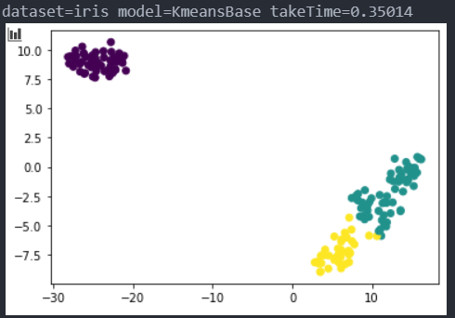
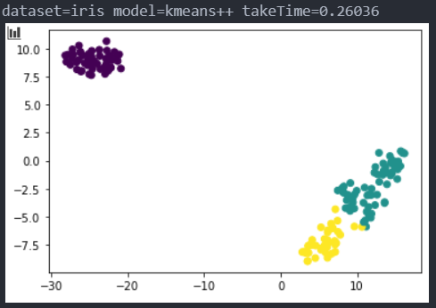
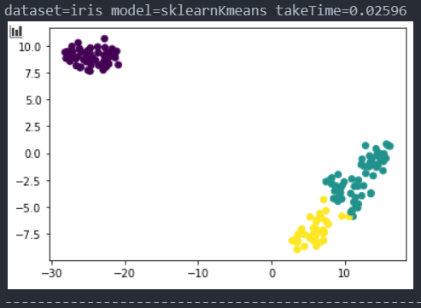

- dataset = boston
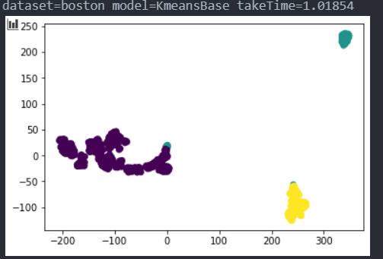
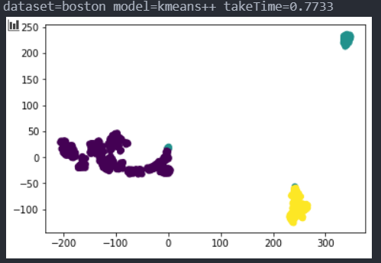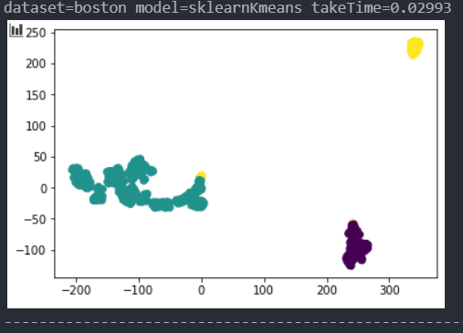

- dataset = digits
