贵州大学课程报告
学院：大数据与信息工程学院 专业：数据科学与大数据技术 班级：数科181
姓名 |  | 杨露瑶 | 学号 | 1817000346 | 实验组
实验时间 |  | 7.10 | 指导教师 | 何庆 | 成绩
实验项目名称 |  | 反弹球消砖游戏
实验描述 | 通过C++在终端中实现反弹球消砖游戏：  - 窗口的展现  - 砖块的实现  - 挡板的实现  - 小球的实现  - 键盘监听的实现
输入输出测试(结果展示) | 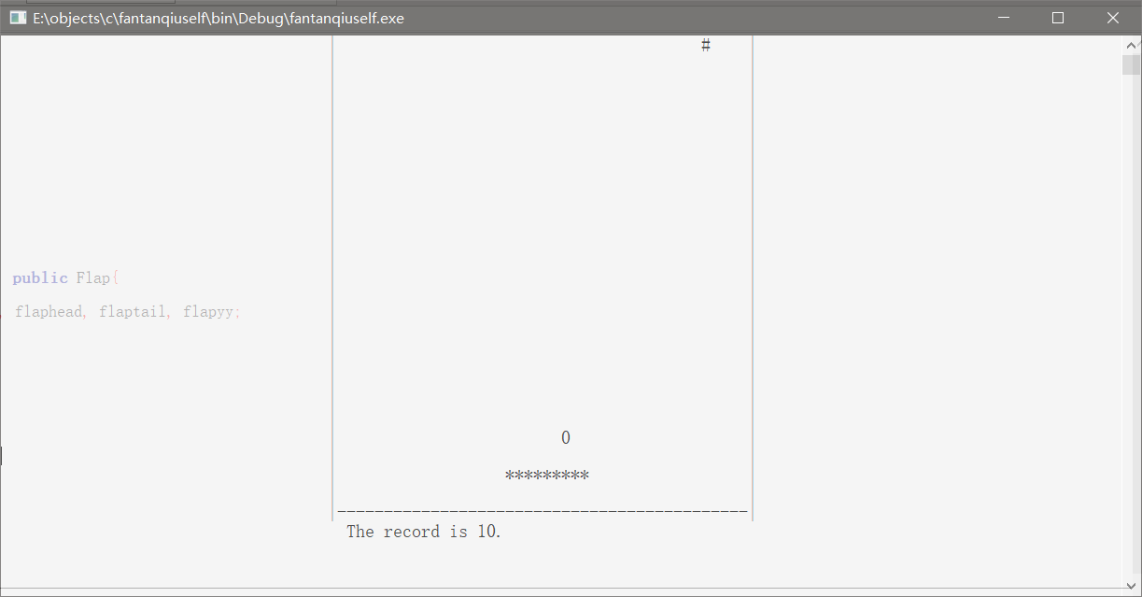
实验步骤 | - 实现坐标的跳转  - void gotoxy(int x, int y){  - HANDLE handle = GetStdHandle(STD_OUTPUT_HANDLE); //获取屏幕尺寸  - COORD pos = {x,y}; //设置坐标  - SetConsoleCursorPosition(handle,pos);  - //在获取到的屏幕中将光标移动到指定的位置  - }  - 完成各模块类的定义  - 窗口类的定义  - struct Window{  - private:  - int left, width, hight;  - public:  - void initWindow(){  - left = LEFT;  - width = WIDTH;  - hight = HIGHT;  - for(int y=0; y<=hight; y++){  - gotoxy(left,y);  - cout << "|" << endl;  - }  - for(int y=0; y<=hight; y++){  - gotoxy(left+width,y);  - cout << "|" << endl;  - }  - for(int x=36; x<left+width; x++){  - gotoxy(x,hight);  - cout << "-" << endl;  - }  - }  - };  - 砖块类的定义  - struct Block{  - private:  - int blockx, blocky;  - public:  - Block(){  - blockx = 37;  - blocky = 0;  - gotoxy(blockx,blocky);  - cout<<"#"<<endl;  - }  - int getBlockx(){  - return blockx;  - }  - int getBlocky(){  - return blocky;  - }  - void setBlock(int tmp){  - blockx = tmp;  - //cout<<blockx<<endl;  - blocky = 0;  - gotoxy(blockx,blocky);  - cout<<"#"<<endl;  - }  - void clearBlock(int blockx, int blocky){  - gotoxy(blockx,blocky);  - cout<<" "<<endl;  - }  - };  - 小球类的定义  - struct Ball{  - private:  - int ballx, bally;  - public:  - Ball(){  - ballx = 45;  - bally = 10;  - gotoxy(ballx,bally);  - cout<<"0"<<endl;  - }  - int getBallx(){  - return ballx;  - }  - int getBally(){  - return bally;  - }  - void clearBall(int ballx, int bally){  - gotoxy(ballx,bally);  - cout<<" "<<endl;  - }  - };  - 挡板类的定义  - struct Flap{  - private:  - int head, tail, flapy;  - public:  - Flap(){  - head = 54;  - tail = 62;  - flapy = 23;  - gotoxy(head, flapy);  - cout<<"*********"<<endl;  - }  - int getHead(){  - return head;  - }  - int getTail(){  - return tail;  - }  - int getFlapy(){  - return flapy;  - }  - void clearOne(int tmpx, int tmpy){  - gotoxy(tmpx,tmpy);  - cout<<" "<<endl;  - }  - void addOne(int tmpx, int tmpy){  - gotoxy(tmpx,tmpy);  - cout<<"*"<<endl;  - }  - void clearLine(int tmpx, int tmpy){  - gotoxy(tmpx,tmpy);  - cout<<" "<<endl;  - }  - void addLine(int tmpx, int tmpy){  - gotoxy(tmpx,tmpy);  - cout<<"*********"<<endl;  - }  - };  - 游戏窗口的展示  - void showWindow(){  - Window myWindow;  - myWindow.initWindow();  - }  - 动态过程的封装  - struct Hit : public Block, public Ball, public Flap{  - private:  - int blockxx, blockyy, ballxx, ballyy, flaphead, flaptail, flapyy;  - int ballvx = -1;  - int ballvy = -1;  - public:  - int record = 0;  - int judge = 1;  - Hit(){  - blockxx = Block::getBlockx();  - blockyy = Block::getBlocky();  - ballxx = Ball::getBallx();  - ballyy = Ball::getBally();  - flaphead = Flap::getHead();  - flaptail = Flap::getTail();  - flapyy = Flap::getFlapy();  - }  - void showText(){  - gotoxy(37,26);  - cout<<"The record is 0 ."<<endl;  - }  - void showRecord(){  - gotoxy(51,26);  - cout<<record;  - }  - void sportBall(){  - clearBall(ballxx,ballyy);  - ballxx = ballxx+ballvx;  - ballyy = ballyy+ballvy;  - gotoxy(ballxx,ballyy);  - cout<<"0"<<endl;  - Sleep(110);  - }  - void updateWithInput(){ // 与用户输入有关的更新  - char input;  - if(_kbhit() ) // 判断是否有输入  - {  - input = getch(); // 根据用户的不同输入来移动，不必输入回车  - if (input == 'a')  - {  - clearOne(flaptail,flapyy);  - flaptail = flaptail-1;  - flaphead = flaphead-1;  - addOne(flaphead,flapyy);  - }  - if (input == 'd')  - {  - clearOne(flaphead,flapyy);  - flaptail = flaptail+1;  - flaphead = flaphead+1;  - addOne(flaptail,flapyy);  - }if (input == 'w')  - {  - clearLine(flaphead,flapyy);  - flapyy = flapyy-1;  - addLine(flaphead,flapyy);  - }  - if (input == 's')  - {  - clearLine(flaphead,flapyy);  - flapyy = flapyy+1;  - addLine(flaphead,flapyy);  - }  - }  - }  - void judgeDirection(){  - if (ballxx==36||ballxx==79){  - ballvx = -ballvx;  - }  - if (ballyy==0){  - if (ballxx==blockxx){  - int tmp;  - if (record == 0) tmp=75;  - else if (record == 10) tmp=63;  - else if (record == 20) tmp=45;  - else tmp=(rand()%(WIDTH))+35;  - Block::setBlock(tmp);  - blockxx = Block::getBlockx();  - blockyy = Block::getBlocky();  - record = record+10;  - }  - ballvy = -ballvy;  - }  - if (ballyy==flapyy-1){  - if(flaphead<=ballxx&&ballxx<=flaptail){  - ballvy = -ballvy;  - //cout<<ballxx<<","<<ballyy<<endl;  - //cout<<"游戏结束"<<endl;  - }  - else{  - gotoxy(37,27);  - cout<<"游戏结束!!"<<endl;  - judge = -1;  - }  - }  - showRecord();  - }  - };  - 游戏的实现  - int main()  - {  - showWindow();  - Hit hit;  - hit.showText();  - while(1){  - hit.updateWithInput();  - if (hit.judge<0)break;  - else{  - hit.judgeDirection();  - hit.sportBall();  - }  - }  - getchar();  - return 0;  - }
代码截图 | - 头文件  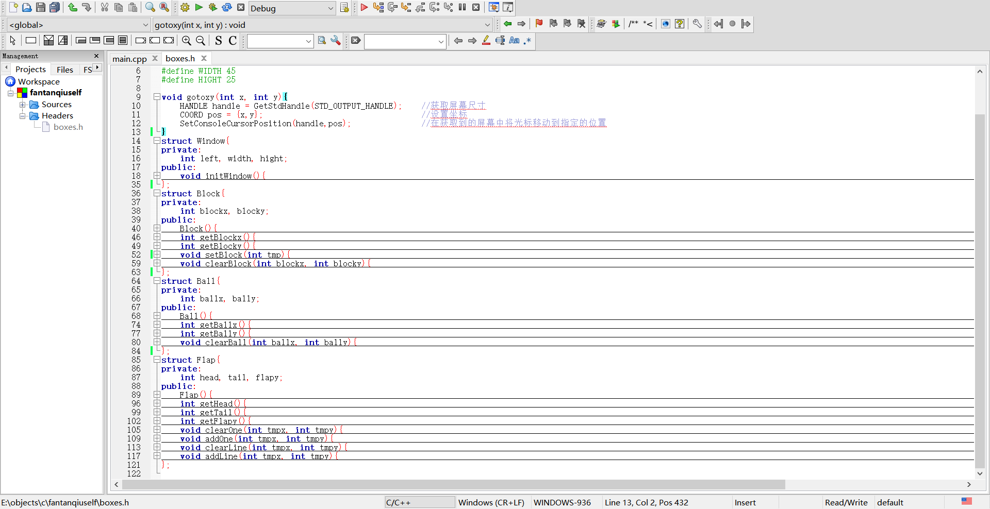  - 主函数  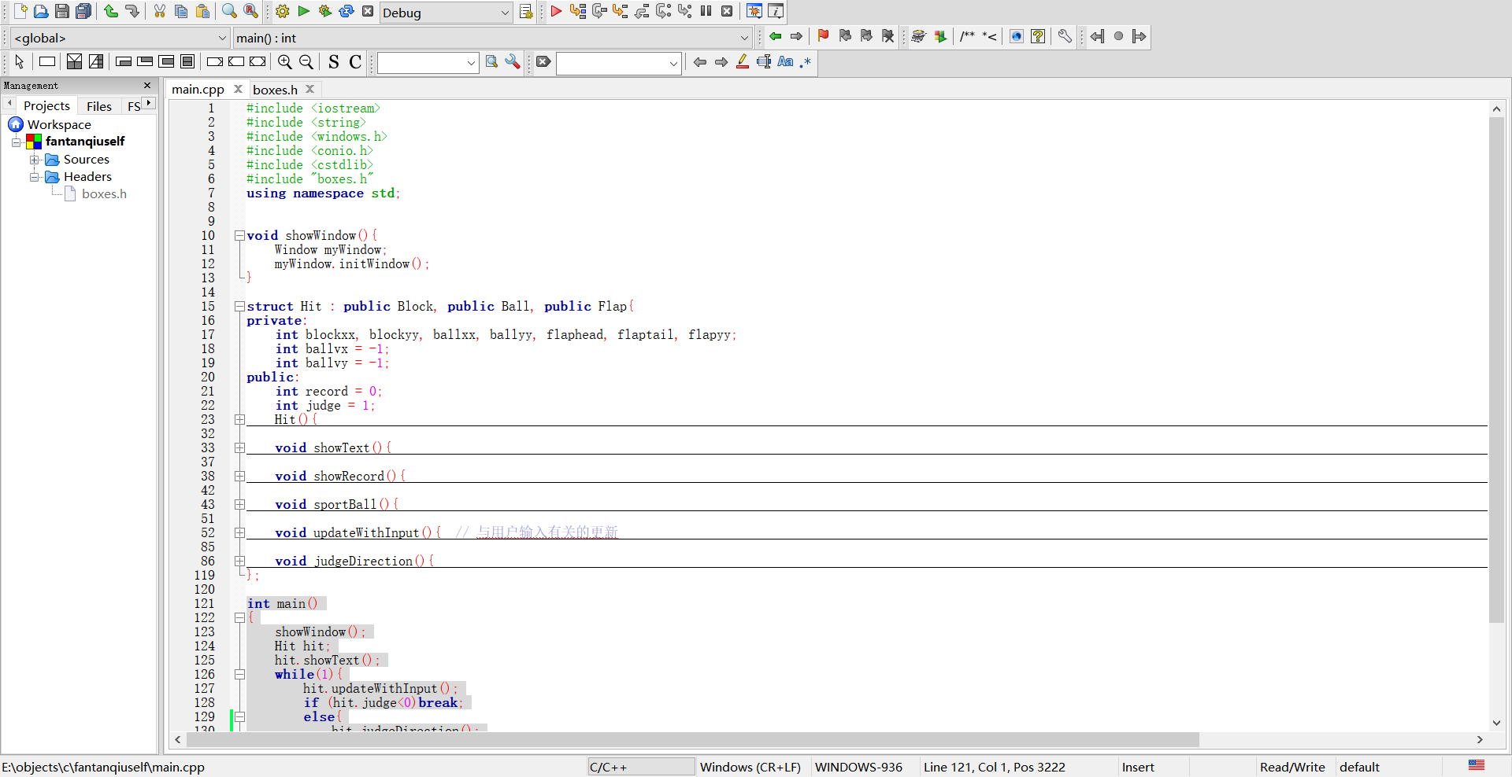
指导教师意见 | 签名： 年 月 日

