学生姓名：杨孟衡 学号：8002118240 班级：软工1809

1. 布局基本应用：

实现效果：

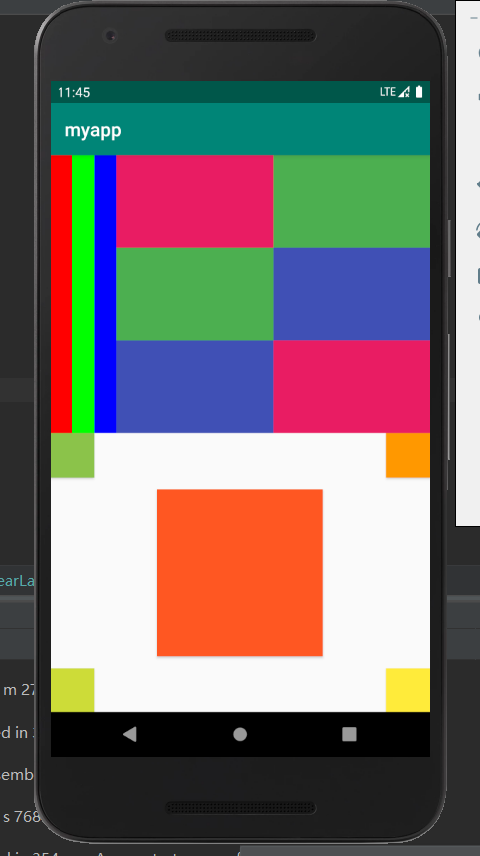

源代码：

<?xml version="1.0" encoding="utf-8"?>

<androidx.constraintlayout.widget.ConstraintLayout xmlns:android="http://schemas.android.com/apk/res/android"

    xmlns:app="http://schemas.android.com/apk/res-auto"

    xmlns:tools="http://schemas.android.com/tools"

    android:layout_width="match_parent"

    android:layout_height="match_parent"

    tools:context=".MainActivity">

    <LinearLayout

        android:layout_width="match_parent"

        android:layout_height="match_parent"

        android:orientation="vertical">

        <LinearLayout

            android:layout_width="match_parent"

            android:layout_height="match_parent"

            android:layout_weight="0.5">

            <LinearLayout

                android:layout_width="match_parent"

                android:layout_height="match_parent"

                android:layout_weight="0.95"

                android:orientation="horizontal">

                <Button

                    android:id="@+id/ulred"

                    android:layout_width="wrap_content"

                    android:layout_height="match_parent"

                    android:layout_weight="0.33"

                    android:background="#FF0000" />

                <Button

                    android:id="@+id/ulgreen"

                    android:layout_width="wrap_content"

                    android:layout_height="match_parent"

                    android:layout_weight="0.33"

                    android:background="#00FF00" />

                <Button

                    android:id="@+id/ulblue"

                    android:layout_width="wrap_content"

                    android:layout_height="match_parent"

                    android:layout_weight="0.33"

                    android:background="#0000FF" />

            </LinearLayout>

            <LinearLayout

                android:layout_width="match_parent"

                android:layout_height="match_parent"

                android:layout_weight="0.2"

                android:orientation="horizontal">

                <LinearLayout

                    android:layout_width="match_parent"

                    android:layout_height="match_parent"

                    android:layout_weight="0.5"

                    android:orientation="vertical">

                    <Button

                        android:id="@+id/urred1"

                        android:layout_width="match_parent"

                        android:layout_height="wrap_content"

                        android:layout_weight="0.33"

                        android:background="#E91E63" />

                    <Button

                        android:id="@+id/urgreen1"

                        android:layout_width="match_parent"

                        android:layout_height="wrap_content"

                        android:layout_weight="0.33"

                        android:background="#4CAF50" />

                    <Button

                        android:id="@+id/urblue1"

                        android:layout_width="match_parent"

                        android:layout_height="wrap_content"

                        android:layout_weight="0.33"

                        android:background="#3F51B5" />

                </LinearLayout>

                <LinearLayout

                    android:layout_width="match_parent"

                    android:layout_height="match_parent"

                    android:layout_weight="0.5"

                    android:orientation="vertical">

                    <Button

                        android:id="@+id/urgreen2"

                        android:layout_width="match_parent"

                        android:layout_height="wrap_content"

                        android:layout_weight="0.33"

                        android:background="#4CAF50" />

                    <Button

                        android:id="@+id/urblue2"

                        android:layout_width="match_parent"

                        android:layout_height="wrap_content"

                        android:layout_weight="0.33"

                        android:background="#3F51B5" />

                    <Button

                        android:id="@+id/urred2"

                        android:layout_width="match_parent"

                        android:layout_height="wrap_content"

                        android:layout_weight="0.33"

                        android:background="#E91E63" />

                </LinearLayout>

            </LinearLayout>

        </LinearLayout>

        <LinearLayout

            android:layout_width="match_parent"

            android:layout_height="match_parent"

            android:layout_weight="0.5"

            android:orientation="horizontal">

            <RelativeLayout

                android:layout_width="match_parent"

                android:layout_height="match_parent">

                <Button

                    android:id="@+id/button15"

                    android:layout_width="wrap_content"

                    android:layout_height="wrap_content"

                    android:layout_alignParentBottom="true"

                    android:background="#CDDC39"

                    android:minWidth="48dip" />

                <Button

                    android:id="@+id/button14"

                    android:layout_width="wrap_content"

                    android:layout_height="wrap_content"

                    android:layout_alignParentLeft="true"

                    android:background="#8BC34A"

                    android:minWidth="48dip" />

                <Button

                    android:id="@+id/button13"

                    android:layout_width="wrap_content"

                    android:layout_height="wrap_content"

                    android:layout_alignParentLeft="false"

                    android:layout_alignParentRight="true"

                    android:layout_alignParentBottom="true"

                    android:background="#FFEB3B"

                    android:minWidth="48dip" />

                <Button

                    android:id="@+id/button12"

                    android:layout_width="wrap_content"

                    android:layout_height="wrap_content"

                    android:layout_alignParentLeft="false"

                    android:layout_alignParentRight="true"

                    android:background="#FF9800"

                    android:minWidth="48dip" />

                <Button

                    android:id="@+id/button11"

                    android:layout_width="180dp"

                    android:layout_height="180dp"

                    android:layout_centerInParent="true"

                    android:background="#FF5722" />

            </RelativeLayout>

        </LinearLayout>

    </LinearLayout>

</androidx.constraintlayout.widget.ConstraintLayout>

1. 计算器布局应用：

实现效果：

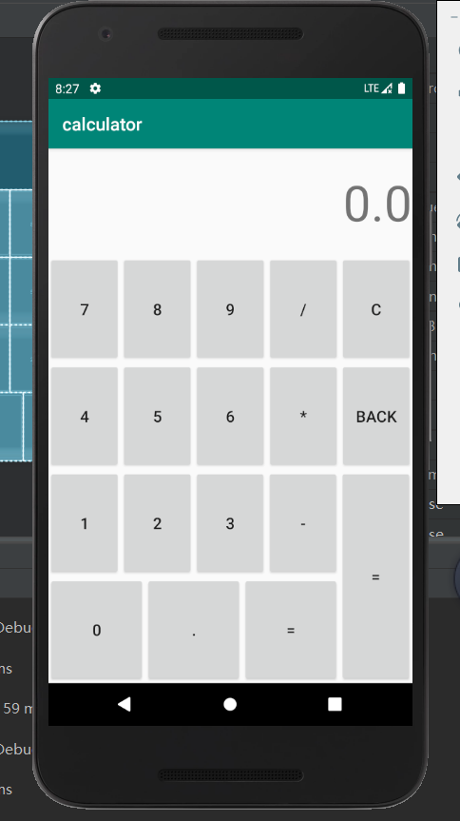

源代码：

<?xml version="1.0" encoding="utf-8"?>

<androidx.constraintlayout.widget.ConstraintLayout xmlns:android="http://schemas.android.com/apk/res/android"

    xmlns:app="http://schemas.android.com/apk/res-auto"

    xmlns:tools="http://schemas.android.com/tools"

    android:layout_width="match_parent"

    android:layout_height="match_parent"

    tools:context=".MainActivity">

    <LinearLayout

        android:layout_width="match_parent"

        android:layout_height="match_parent"

        android:orientation="vertical">

        <LinearLayout

            android:layout_width="match_parent"

            android:layout_height="match_parent"

            android:layout_weight="0.4"

            android:gravity="center|right"

            android:orientation="horizontal">

            <TextView

                android:id="@+id/textView"

                android:layout_width="wrap_content"

                android:layout_height="wrap_content"

                android:text="0.0"

                android:textSize="56sp" />

        </LinearLayout>

        <LinearLayout

            android:layout_width="match_parent"

            android:layout_height="match_parent"

            android:layout_weight="0.3"

            android:orientation="vertical">

            <LinearLayout

                android:layout_width="match_parent"

                android:layout_height="match_parent"

                android:layout_weight="0.5"

                android:orientation="horizontal">

                <Button

                    android:id="@+id/button7"

                    android:layout_width="wrap_content"

                    android:layout_height="match_parent"

                    android:layout_weight="0.2"

                    android:text="7"

                    android:textSize="18sp" />

                <Button

                    android:id="@+id/button4"

                    android:layout_width="wrap_content"

                    android:layout_height="match_parent"

                    android:layout_weight="0.2"

                    android:text="8"

                    android:textSize="18sp" />

                <Button

                    android:id="@+id/button5"

                    android:layout_width="wrap_content"

                    android:layout_height="match_parent"

                    android:layout_weight="0.2"

                    android:text="9"

                    android:textSize="18sp" />

                <Button

                    android:id="@+id/button6"

                    android:layout_width="wrap_content"

                    android:layout_height="match_parent"

                    android:layout_weight="0.2"

                    android:text="/"

                    android:textSize="18sp" />

                <Button

                    android:id="@+id/button8"

                    android:layout_width="wrap_content"

                    android:layout_height="match_parent"

                    android:layout_weight="0.2"

                    android:text="C"

                    android:textSize="18sp" />

            </LinearLayout>

            <LinearLayout

                android:layout_width="match_parent"

                android:layout_height="match_parent"

                android:layout_weight="0.5"

                android:orientation="horizontal">

                <Button

                    android:id="@+id/button9"

                    android:layout_width="wrap_content"

                    android:layout_height="match_parent"

                    android:layout_weight="0.2"

                    android:text="4"

                    android:textSize="18sp" />

                <Button

                    android:id="@+id/button11"

                    android:layout_width="wrap_content"

                    android:layout_height="match_parent"

                    android:layout_weight="0.2"

                    android:text="5"

                    android:textSize="18sp" />

                <Button

                    android:id="@+id/button12"

                    android:layout_width="wrap_content"

                    android:layout_height="match_parent"

                    android:layout_weight="0.2"

                    android:text="6"

                    android:textSize="18sp" />

                <Button

                    android:id="@+id/button10"

                    android:layout_width="wrap_content"

                    android:layout_height="match_parent"

                    android:layout_weight="0.2"

                    android:text="*"

                    android:textSize="18sp" />

                <Button

                    android:id="@+id/button13"

                    android:layout_width="wrap_content"

                    android:layout_height="match_parent"

                    android:layout_weight="0.2"

                    android:text="BACK"

                    android:textSize="18sp" />

            </LinearLayout>

        </LinearLayout>

        <LinearLayout

            android:layout_width="match_parent"

            android:layout_height="match_parent"

            android:layout_weight="0.3"

            android:orientation="horizontal">

            <LinearLayout

                android:layout_width="match_parent"

                android:layout_height="match_parent"

                android:layout_weight="0.1"

                android:orientation="vertical">

                <LinearLayout

                    android:layout_width="match_parent"

                    android:layout_height="match_parent"

                    android:layout_weight="0.5"

                    android:orientation="horizontal">

                    <Button

                        android:id="@+id/button15"

                        android:layout_width="wrap_content"

                        android:layout_height="match_parent"

                        android:layout_weight="0.25"

                        android:text="1"

                        android:textSize="18sp" />

                    <Button

                        android:id="@+id/button16"

                        android:layout_width="wrap_content"

                        android:layout_height="match_parent"

                        android:layout_weight="0.25"

                        android:text="2"

                        android:textSize="18sp" />

                    <Button

                        android:id="@+id/button17"

                        android:layout_width="wrap_content"

                        android:layout_height="match_parent"

                        android:layout_weight="0.25"

                        android:text="3"

                        android:textSize="18sp" />

                    <Button

                        android:id="@+id/button18"

                        android:layout_width="wrap_content"

                        android:layout_height="match_parent"

                        android:layout_weight="0.25"

                        android:text="-"

                        android:textSize="18sp" />

                </LinearLayout>

                <LinearLayout

                    android:layout_width="match_parent"

                    android:layout_height="match_parent"

                    android:layout_weight="0.5"

                    android:orientation="horizontal">

                    <Button

                        android:id="@+id/button19"

                        android:layout_width="wrap_content"

                        android:layout_height="match_parent"

                        android:layout_weight="0.3"

                        android:text="0"

                        android:textSize="18sp" />

                    <Button

                        android:id="@+id/button20"

                        android:layout_width="wrap_content"

                        android:layout_height="match_parent"

                        android:layout_weight="0.3"

                        android:text="."

                        android:textSize="18sp" />

                    <Button

                        android:id="@+id/button21"

                        android:layout_width="wrap_content"

                        android:layout_height="match_parent"

                        android:layout_weight="0.3"

                        android:text="="

                        android:textSize="18sp" />

                </LinearLayout>

            </LinearLayout>

            <LinearLayout

                android:layout_width="match_parent"

                android:layout_height="match_parent"

                android:layout_weight="0.4"

                android:orientation="horizontal">

                <Button

                    android:id="@+id/button14"

                    android:layout_width="match_parent"

                    android:layout_height="match_parent"

                    android:layout_weight="1"

                    android:text="="

                    android:textSize="18sp" />

            </LinearLayout>

        </LinearLayout>

    </LinearLayout>

</androidx.constraintlayout.widget.ConstraintLayout>