**Ex 1:**

estimated_mu = -0.134996 0.038464

estimated_mu = -1.1334 -0.9527

1.0370 1.2020

estimated_mu = -1.6271 -1.5975

1.0370 1.2020

-0.7385 -0.4368

By increasing the number of clusters to 2, 3，the points can only classified into two categories mostly.

**Ex 2:**

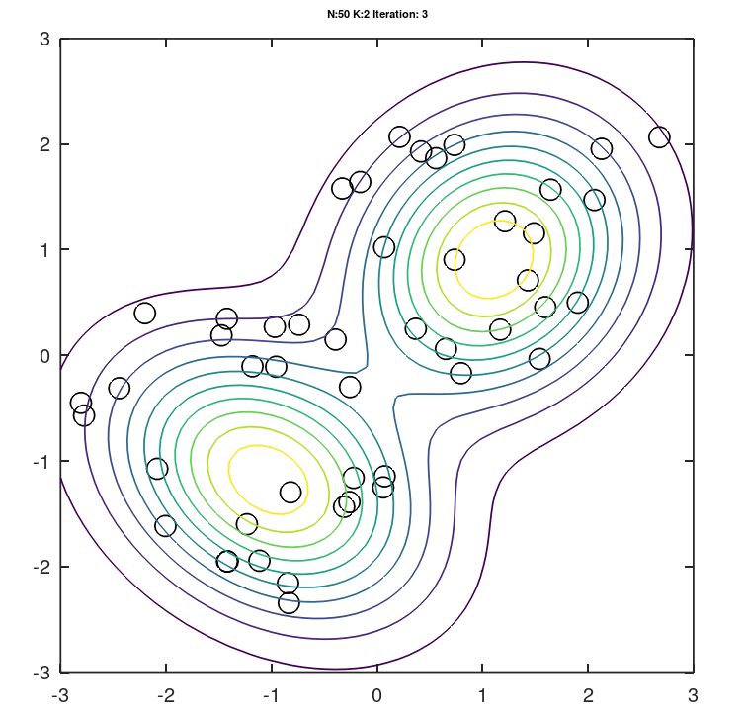

Alpha are mixture weights.

Mu are weighted means.

Sigma are weighted covariance matrices.

w contains posterior probabilities for class labels.

They look relevant.

n=50, mu1=[-2 2], mu2=[-2 2]

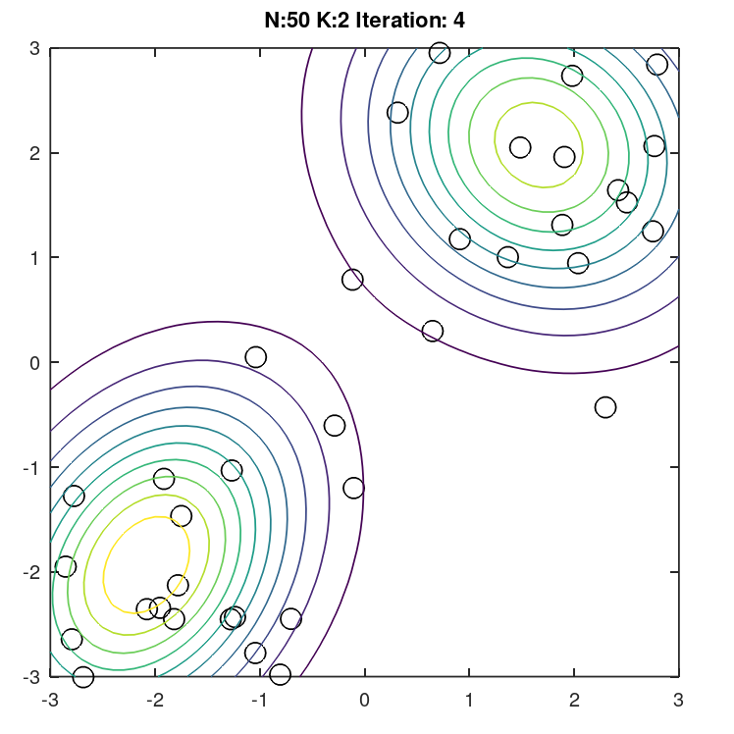

**Ex 3:**

**Speed : EM is faster.**

K-means: 0.011646 seconds.

EM: 0.066735 seconds

**Accuracy:**

**Mean:**

K-means: -1.9357 -2.0852

2.0719 1.6602

EM: -1.9341 -2.0831

2.0734 1.6609

**Variance:**

K-means:

EM: 1.1147 0.2971

0.2971 0.8882

1.0433 -0.1480

-0.1480 1.1230