I am referencing the Kinesis Advantage 2. Kinesis Advantage 360 allows for roll angle but it has too few keys and who wants the extra hassle of a split keyboard?
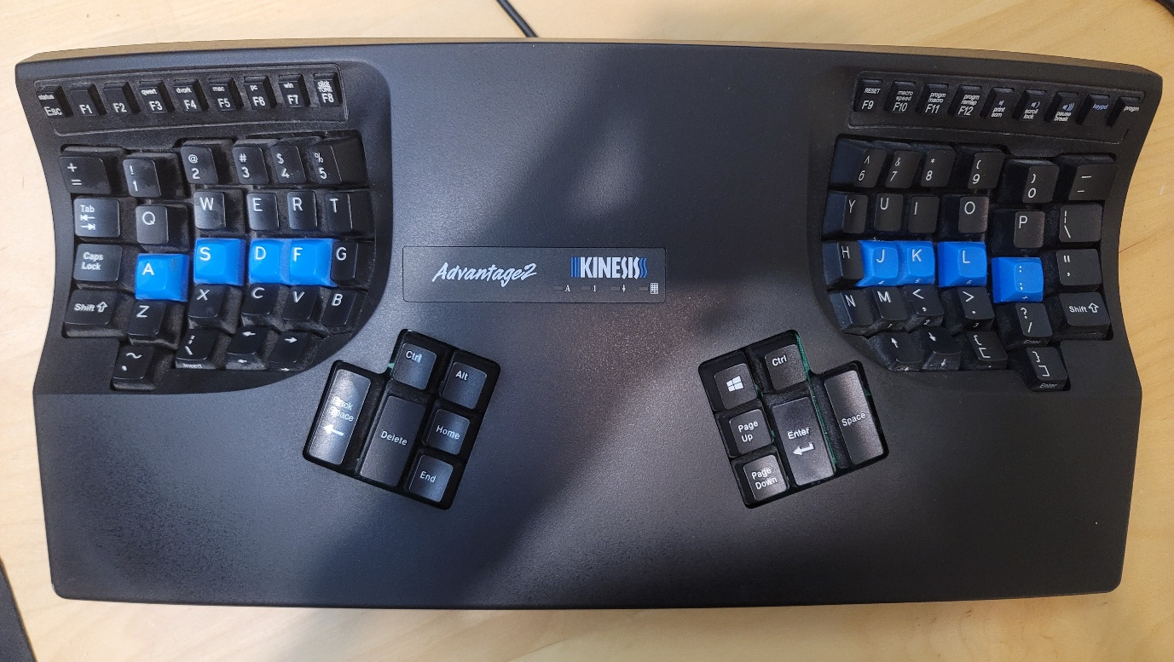
ECK should resemble the Kinesis Advantage 2 but tilted more and with more keys.
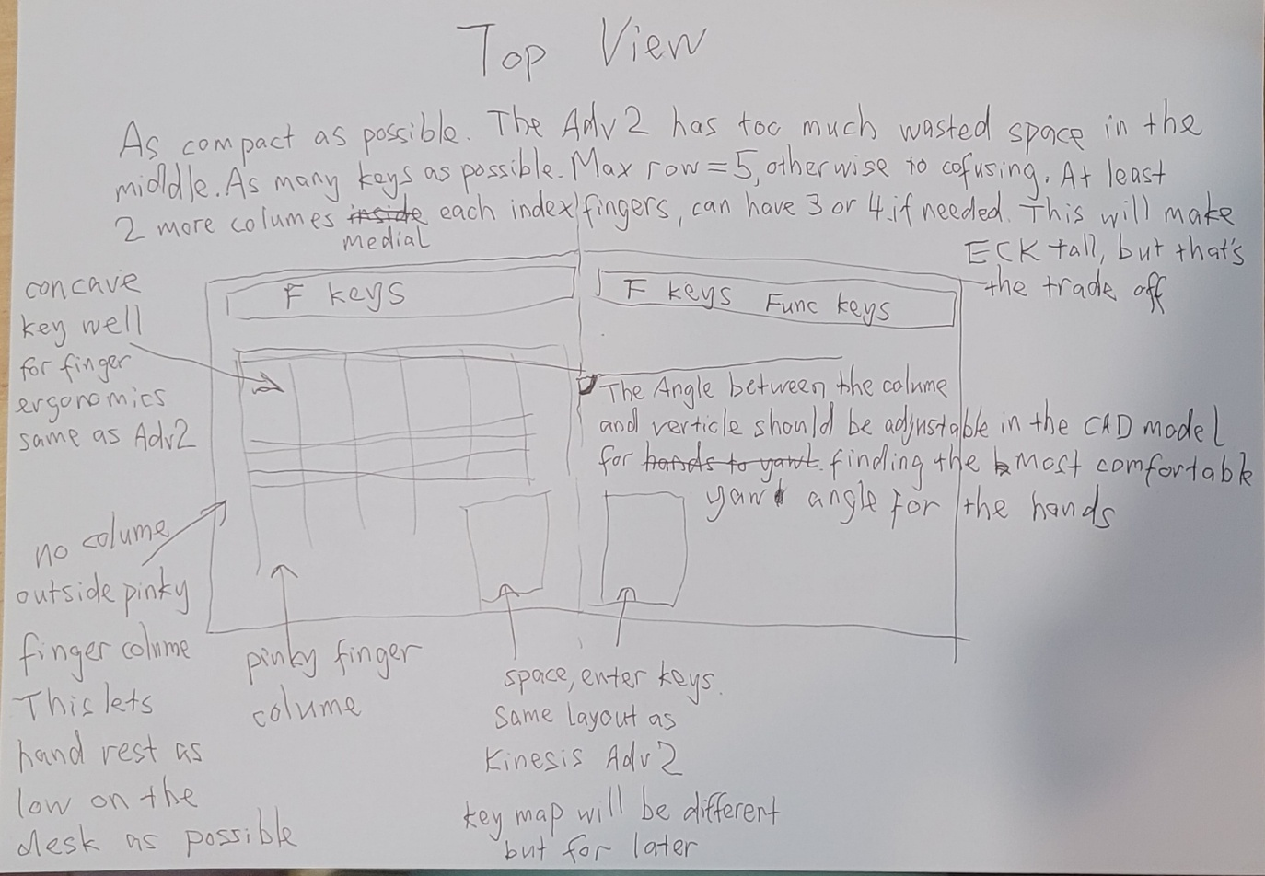
In addition to what’s written on the sheet of paper
. parametric so that other people can contribute adjust tolerances to fit their 3D printer (especially the switch holes)
. in parts to minimize 3D printing support structure
. standard keycaps
. hot swappable keys
. hard xor soft PCB depending on design
