https://github.com/YangPiCui/ProjectIdeas/blob/main/rainbowpiano.png

Create an Android app similar to PerfectPiano, or make a real piano/digital keyboard, but with evenly spaced keys

https://music.stackexchange.com/questions/16704/is-there-such-thing-as-a-piano-like-keyboard-with-all-whole-tones-between-two-ad

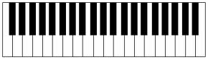

The visible spectrum of light spans from 400–790 TeraHz,

so, color the 12 keys with this repeated pattern: CDEFGAB

