**Rainbow Piano**

Use Python+Kivy(Preferred) to Code a Evenly Spaced Colored Keyboard

. source code available for compilation on windows/mac/android

(<https://github.com/YangPiCui/ProjectIdeas/blob/main/RainbowPiano.docx>)

If you know someone who wants to build a digital keyboard like the Yamaha Reface CP, or a physical one, please contact me.

Someone else had a similar idea: https://music.stackexchange.com/questions/16704/is-there-such-thing-as-a-piano-like-keyboard-with-all-whole-tones-between-two-ad

**Features Compared to the Perfect Piano Android APP**

**Home**

. only the keyboard

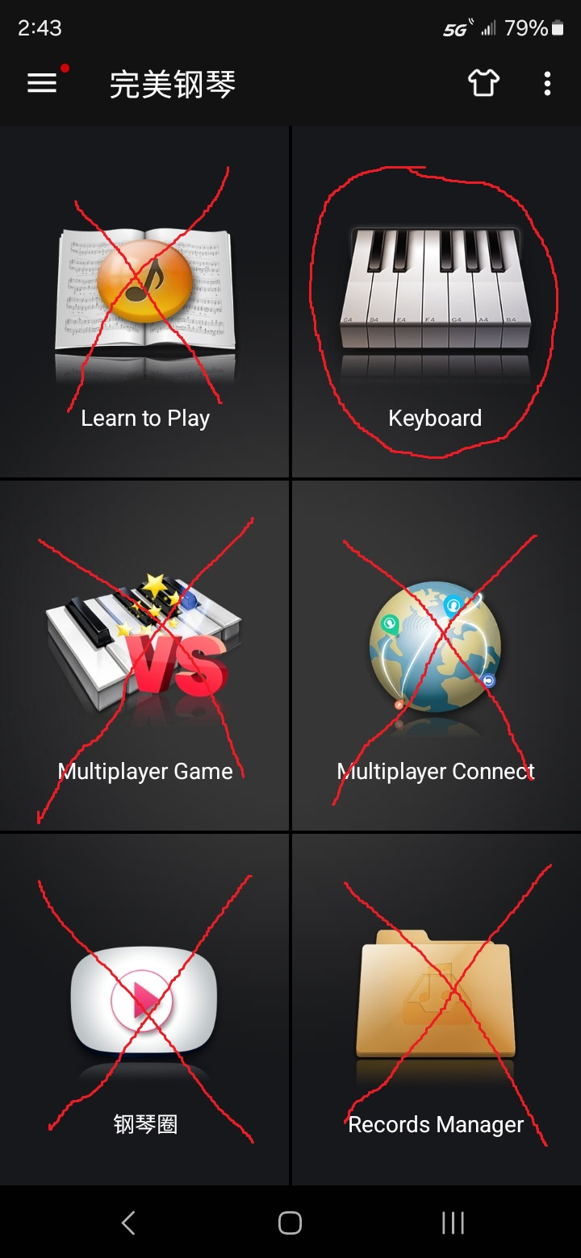

**Keyboard**

. (no) metronome, recording

. please make sure there is concurrency for simultaneous key-pressing (no sound lagging/collision)

. (yes) sustain, FX, layout, instrument selector, menu home

. (new) menu to select key color pattern

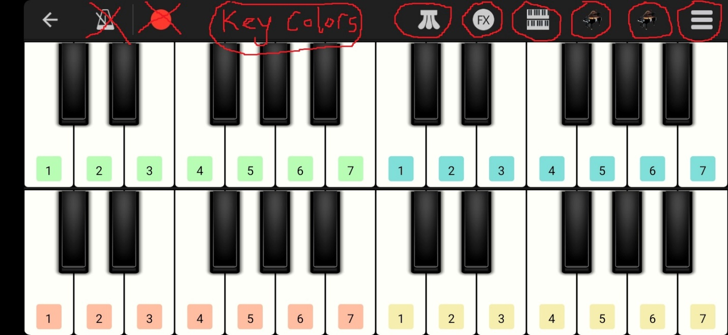

**(new) Key Colors**

. user can change R,G,B,a values for each key on the menu (<https://405nm.com/wavelength-to-color/>). Please mark the default settings in the source code.

|  |  |  |  |  |  |
| --- | --- | --- | --- | --- | --- |
| notes | Wavelength(nm) | R | G | B | a |
| C | 808 | 98 | 0 | 0 | 1 |
| C# | 769 | 139 | 0 | 0 | 1 |
| D | 730 | 177 | 0 | 0 | 1 |
| D# | 691 | 213 | 0 | 0 | 1 |
| E | 652 | 248 | 0 | 0 | 1 |
| F | 613 | 255 | 145 | 0 | 1 |
| F# | 575 | 240 | 255 | 0 | 1 |
| G | 536 | 115 | 255 | 0 | 1 |
| G# | 497 | 0 | 255 | 181 | 1 |
| A | 458 | 0 | 113 | 255 | 1 |
| A# | 419 | 109 | 0 | 251 | 1 |
| B | 380 | 97 | 0 | 97 | 1 |

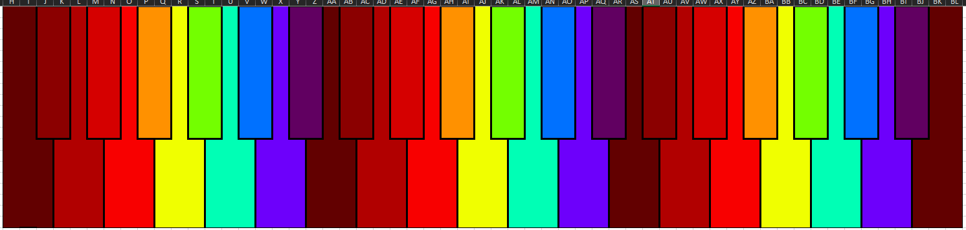

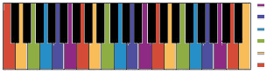

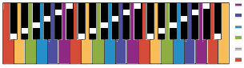

(example effects)

**Menu Home –> rename to settings**

. (no) fx, sustain control, vibrate

. (move) visible keys, keyboard lock, to “Layout”

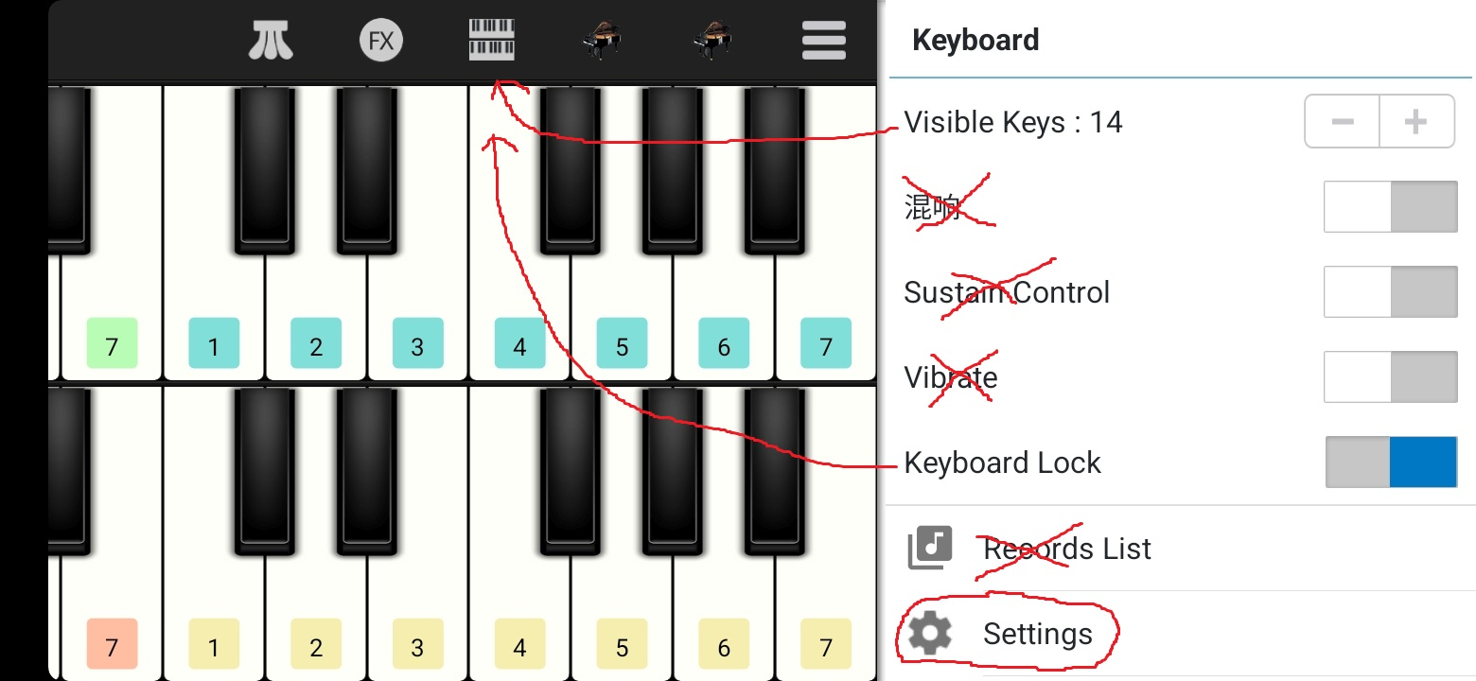

**Layout**

. (moved) visible keys, keyboard lock

. (new) can generate as many rows as one wants

. (new) option for evenly spaced black keys

. (new) option for white keys only; white notes bear all the 12 notes like a xylophone:

'1C', '1C#', '1D', '1D#', '1E', '1F', '1F#', '1G', '1G#', '1A', '1A#', '1B',  
'2C', '2C#', '2D', '2D#', '2E', '2F', '2F#', '2G', '2G#', '2A', '2A#', '2B',

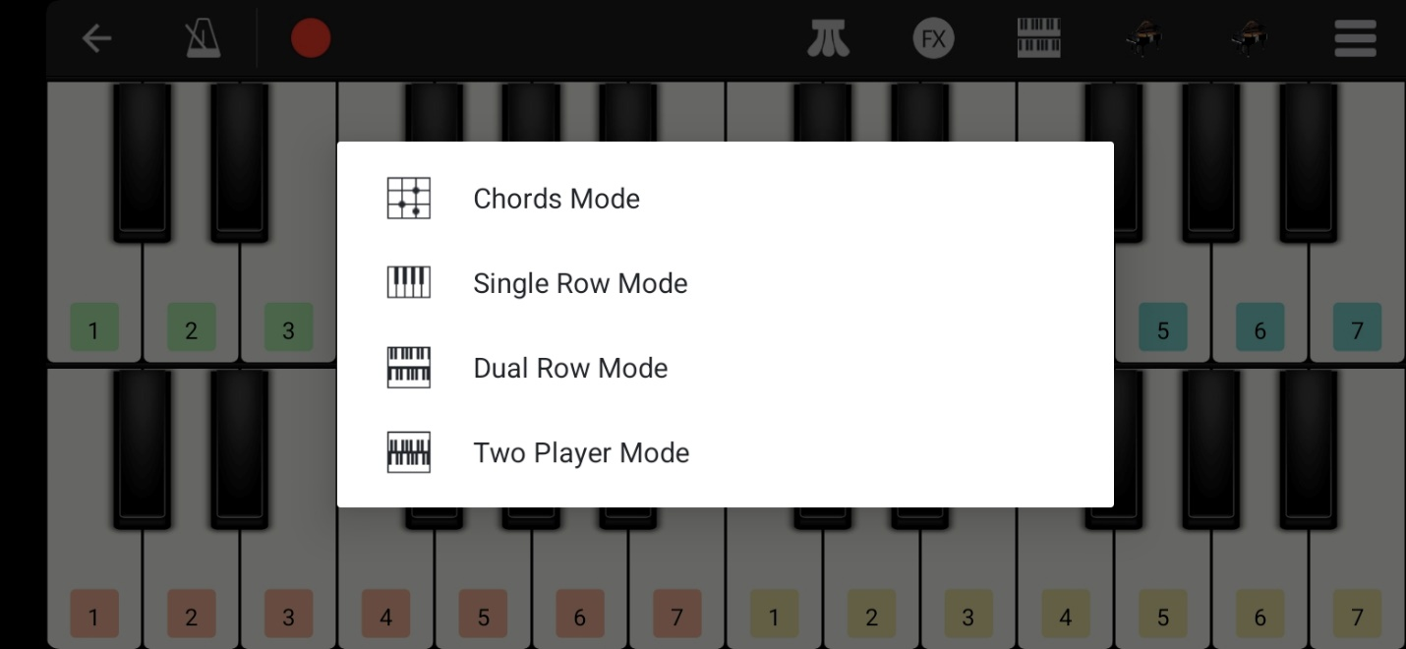

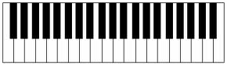

(evenly spaced black keys)

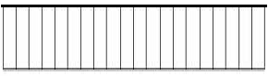

(white keys only)

**FX**

. (no) distortion

. (new) 10 point logarithmically incrementing equalizer from 20Hz to 20 kHz (indicate in the source code how to add more points on the equalizer)

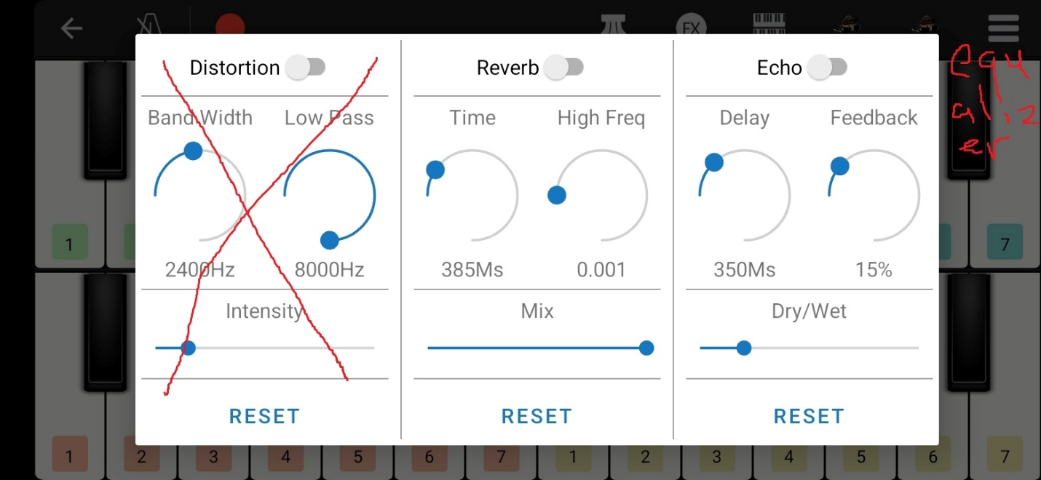

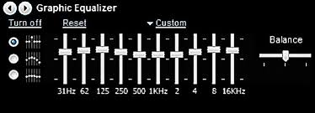

(just an example, does not have to look like this)

**Instrument**

. at least concert piano; please also indicate how to add more sounds in the source code

. (new) option to add custom sounds files on the menu

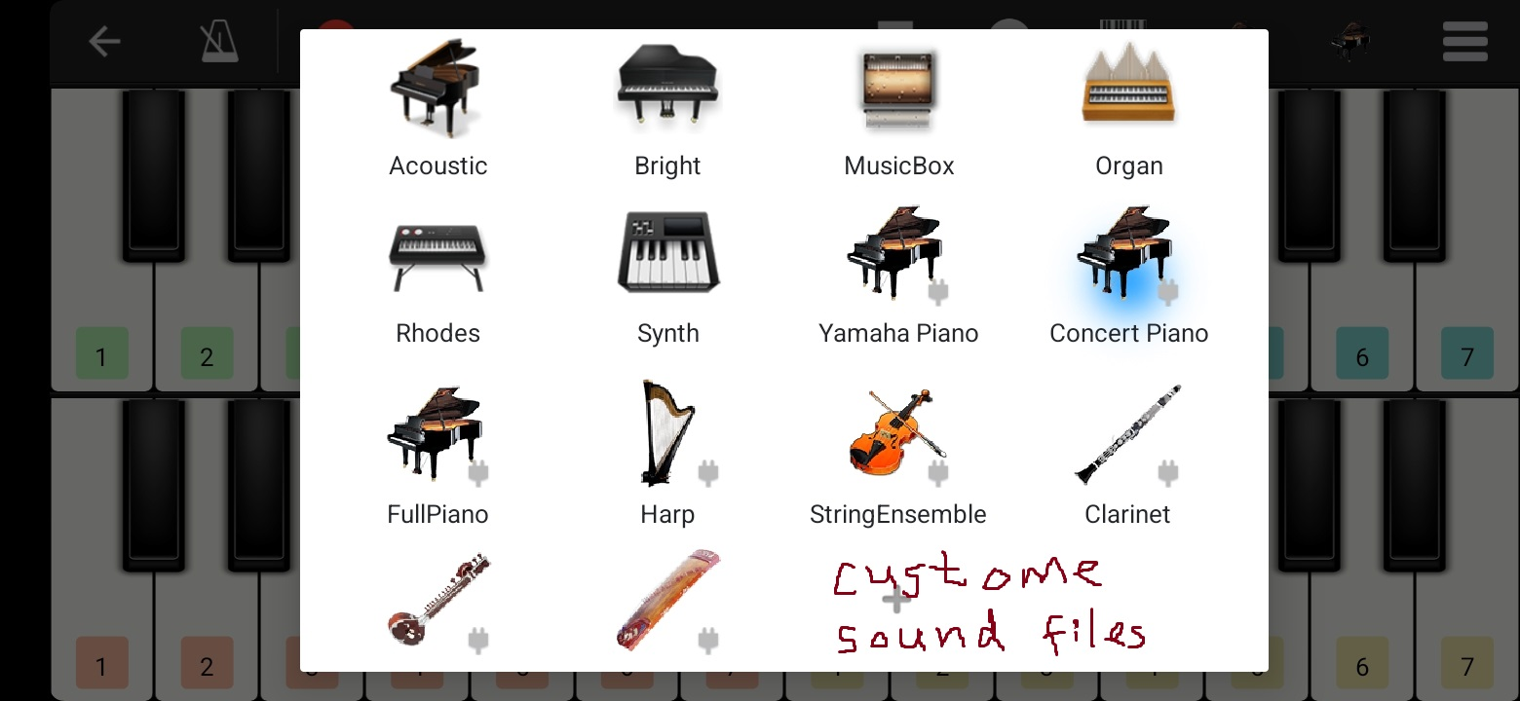

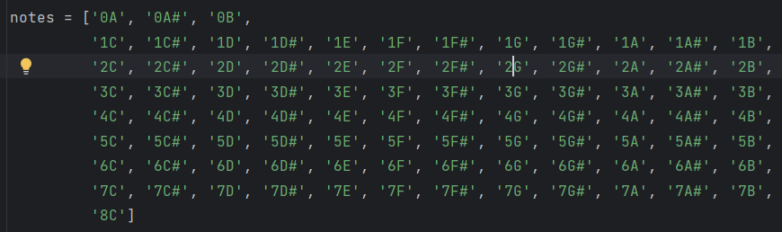

(please use this naming convention in the source file)

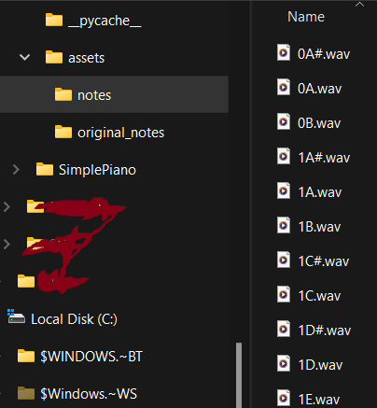

**Settings**

. (no) pre-count, metronome, FX (move appropriately, I like clean UI), white keys displayed, learn to play

. (new) user can customize key labels such as “a,b,c,d,e,f,g,h,i,j,k,l”

. (new) user can export and import all of his settings in a .json file (or another common file format) onto another phone

. (new) show credits to your team, link to my Github page and a BSV donation address. (please show me how to modify this in the source code)

