Members | Task Details
Nguyễn Dương Phúc | All tasks (Work - 100%)

Name | ID
Nguyễn Dương Phúc | 24521386

OTHER EVALUATIONS (*):
TASK ASSIGNMENT TABLE:
Content | Result
Average total time to complete the lab (1) | 9 hours
Video Link (2)
(if any)
Feedback (3) (if any)
+ Challenges
+ Suggestions …
Self-Assessment Score (4) | 9/10
(*): Sections (1) and (4) are mandatory.

Teacher: Phan Trung Phát
Group: CS4283.Q12.CTTT
COMPUTER NETWORKS
2

Question 1

Evidence:
Figure 1. HTTP version and server version

Explanation:
The browser is using HTTP version 1.1 (496 GET /24521395.html HTTP /1.1)
The server is using HTTP version 1.1 (634 HTTP/1.1 200 OK (text/html)).

Question 2

Evidence:
Figure 2. IP addresses of client and server

Explanation:
My computer’s IP address: 192.168.228.54 (Source)
The web server’s IP address: 192.168.228.86 (Destination).

Question 3

Evidence:
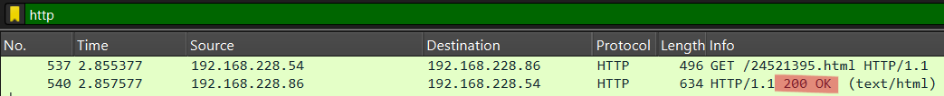
Figure 3. HTTP response status code

Explanation:
The status code: 200 OK.

Question 4

Evidence:
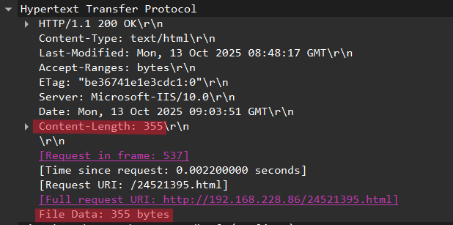
Figure 4. Content length returned by server

Explanation:
The server returned 355 bytes of content to the browser.

Question 5

Evidence:
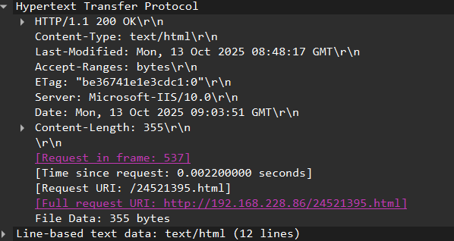
Figure 5. First HTTP GET contents (IF-MODIFIED-SINCE)

Explanation:
No, the first HTTP GET request does not contain the line “IF-MODIFIED-SINCE”.

Question 6

Evidence:
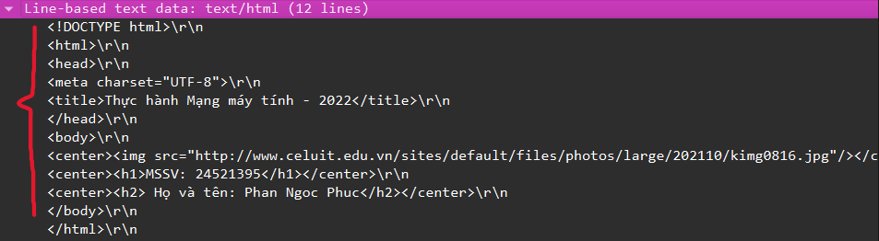
Figure 6. Server response content (HTML file?)

Explanation:
Yes, because Wireshark includes a section “Line-based text data” showing what the server sent back to the browser — the HTML code of the page, as shown in the figure above.

Question 7

Evidence:
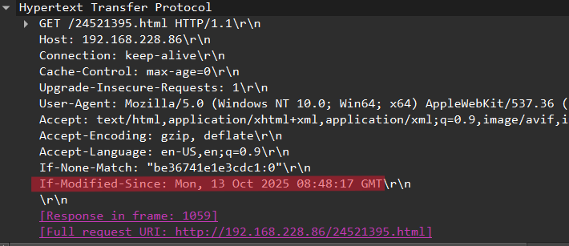
Figure 7. Second HTTP GET (IF-MODIFIED-SINCE value)

Explanation:
Yes, the second HTTP GET contains the line “If-Modified-Since: Mon, 13 Oct 2025 08:48:17 GMT”.

Question 8

Evidence:
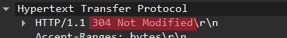
Figure 8. HTTP status code of second GET

Explanation:
The HTTP status code returned from the server: 304 Not Modified (HTTP/1.1 304 Not Modified) .
It means: the requested file has not been changed since the last request
The server does not resend the file contents
Because the browser already has a cached copy of the HTML file from the first HTTP GET and loads the page from its cache instead.

Question 9

Evidence:
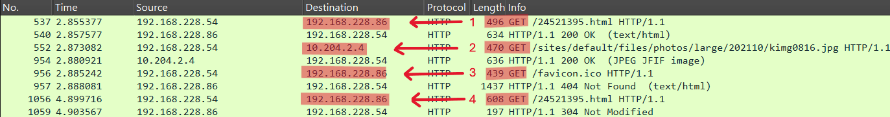
Figure 9. Browser HTTP GETs and IP addresses

Explanation:
The browser sent 4 HTTP GET requests:
• 496 GET /24521395.html → 192.168.228.86
• 470 GET /sites/default/files/photos/large/202110/kimg0816.jpg → 10.204.2.4
• 439 GET /favicon.ico → 192.168.228.86
• 608 GET /24521395.html → 192.168.228.86

Question 10

Evidence:
Figure 10. Browser HTTP GET requests
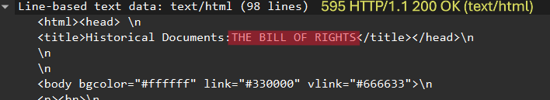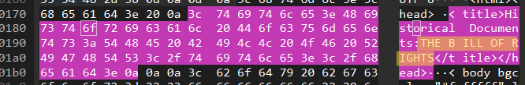
Figure 11. Response packet containing "THE BILL OF RIGHTS

Explanation:
The browser sent 2 HTTP GET requests: frame 2183 (549 GET) and frame 2288 (495 GET).
The line “THE BILL OF RIGHTS” is contained in the first response frame 2263 (595 HTTP/1.1 200 OK, text/html).

Question 11

Evidence:
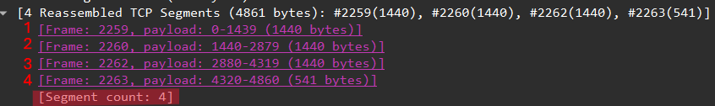
Figure 12. TCP segments carrying "The Bill of Rights"

Explanation:
There are 4 TCP segments to carry the entire HTTP response and the content of "The Bill of Rights".

Question 12

Evidence:
Figure 13. Status code of first HTTP GET

Explanation:
The status code in the first HTTP GET: 401 Unauthorized.
This means the page cannot be accessed until the correct username and password are provided.

Question 13

Evidence:
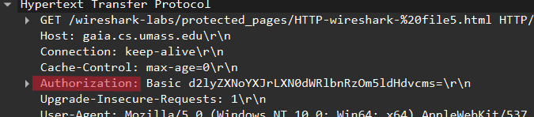
Figure 14. Authorization field in second HTTP GET

Explanation:
The new field that appears in the second HTTP GET: the Authorization field.

END

