Members | Task Details
Nguyễn Dương Phúc | Question 1, 2, 3 ,4 ,5 ,6 ,7 ,8 ,9, expand (Work - 100%)

Name | ID
Nguyễn Dương Phúc | 24521386

OTHER EVALUATIONS (*):
TASK ASSIGNMENT TABLE:
Content | Result
Average total time to complete the lab (1) | 8 hours
Video Link (2)
(if any)
Feedback (3) (if any)
+ Challenges
+ Suggestions …
Self-Assessment Score (4) | 9/10
(*): Sections (1) and (4) are mandatory.

Teacher: Phan Trung Phát
Group: CS4283.Q12.CTTT
COMPUTER NETWORKS
1

Question 1

Evidence:
Exercise 1:
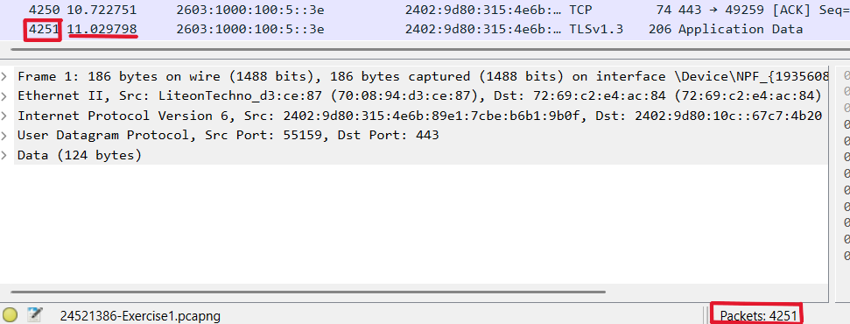
Exercise 2:
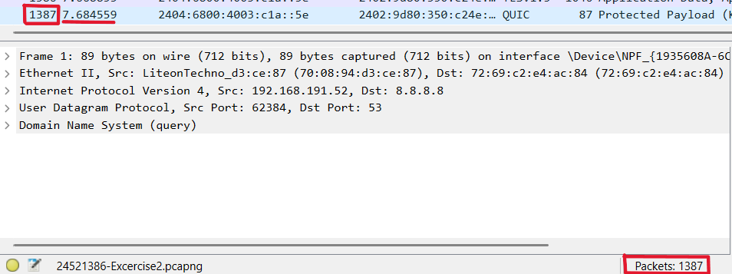

Explanation:
Exercise 1:
Total packet capture time: 11.029798 (s)
Total number of packets captured: 4251 (packets)
Exercise 2:
Total packet capture time: 7.684559 (s)
Total number of packets captured: 1387 (packets)

Question 2

Evidence:

Exercise 1:
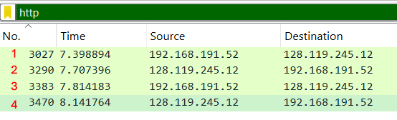
Exercise 2:
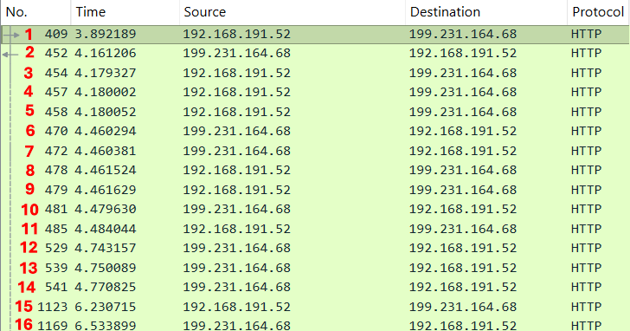

Explanation:
Exercise 1:
There are 4 packets belonging to the HTTP protocol (No. 3027, 3290, 3383, and 3470).
Exercise 2:
There are 16 packets belonging to the HTTP protocol. (No. 409, 452, 454, 457, 458, 470, 472, 478, 479, 481, 485, 529, 539, 541, 1123, and 1169)

Question 3

Evidence:
Exercise 1:
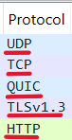
Exercise 2:
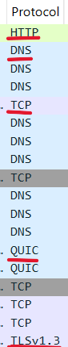

Explanation:
Exercise 1: 5 protocols
- UDP
- TCP
- QUIC
- TLS
- HTTP
Exercise 2: 5 protocols
- HTTP
- DNS
- TCP
- QUIC
- TLS
Main function of those protocols
UDP: A connectionless transport protocol used for fast data transmission where reliability is less critical, such as DNS or video streaming.
TCP: A connection-oriented and reliable transport protocol that ensures accurate data delivery between client and server, commonly used in HTTP and HTTPS.
QUIC: A modern transport protocol developed by Google, built on top of UDP and integrating TLS encryption to provide faster and more reliable connections (used in HTTP/3).
TLS: A cryptographic protocol that provides secure communication over a computer network, used to encrypt data in HTTPS connections.
HTTP: An application-layer protocol used for transferring web content such as HTML pages, images, and other resources between the browser and the web server.
DNS: An application-layer protocol that translates domain names into IP addresses so devices can locate each other on the Internet. It is often used over UDP (port 53) for fast queries, and sometimes over TCP for tasks like zone transfers.

Question 4

Evidence:
Exercise 1:
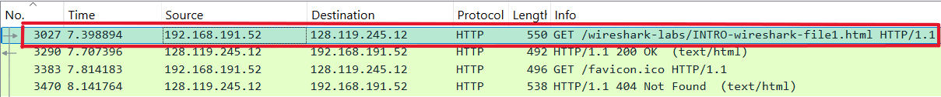
Exercise 2:

Explanation:
Exercise 1:
The first HTTP GET packet is No. 3027 (appears before others and requests the main HTML page from the server)
Exercise 2:
The first HTTP GET packet is No. 409
The basic purpose of an HTTP GET packet: to retrieve data from a server using a specified URI (Uniform Resource Identifier). It requests a resource without modifying any data on the server. For example, when a user accesses a webpage, the browser sends a GET request to download the page content.

Question 5

Evidence:

Exercise 1:
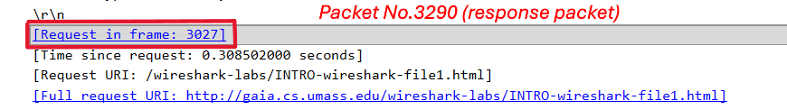
Exercise 2:

Explanation:
Exercise 1:
The response packet corresponding to the first HTTP GET is No.3290 (In the Hypertext Transfer Protocol section of packet 3290, it shows “Request in frame 3027”, and in packet 3027, it shows “Response in frame 3290”.)
Exercise 2:
The response packet corresponding to the first HTTP GET is No.452 (In the Hypertext Transfer Protocol section of packet 452, it shows “Request in frame 409”, and in packet 409, it shows “Response in frame 452”.)

Question 6

Evidence:
Exercise 1:
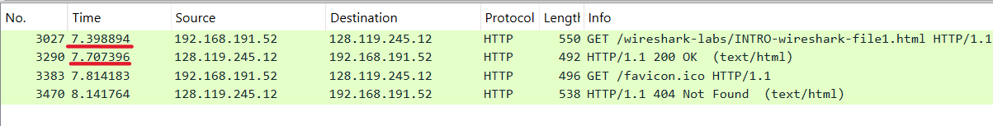
Exercise 2:
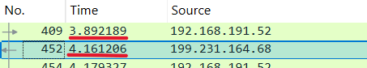

Explanation:
Exercise 1:
Time of GET packet (No. 3027): 7.398894 (s)
Time of 200 OK packet (No. 3290): 7.707396 (s)
- The total response time is 7.707396 – 7.398894 = 0.308502 (s)
Exercise 2:
Time of GET packet (No. 409): 3.892189 (s)
Time of 200 OK packet (No. 452): 4.161206 (s)
- The total response time is 4.161206 – 3.892189 = 0.269017 (s)

Question 7

Evidence:
Exercise 1:
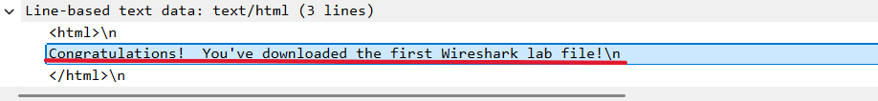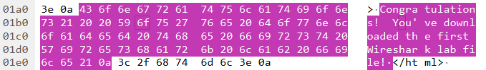

Explanation:
Exercise 1:
Yes, it can be found under the “Line-based text data” section of the HTTP 200 OK response packet (No.3290).
It can also be seen in the Packet Contents window, where it is displayed in both ASCII and hexadecimal formats.

Question 8

Evidence:

Exercise 1:
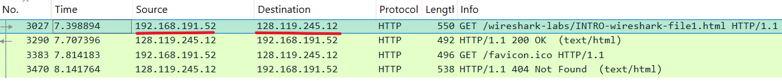
Exercise 2:

Explanation:
Exercise 1:
Source: 192.168.191.52 (IP address of computer)
Destination: 128.119.245.12 (IP address of the website gaia.cs.umass.edu)
Exercise 2:
Source: 192.168.191.52 (IP address of computer)
Destination: 199.231.164.68 (IP address of the website www.faqs.org)

Question 9

Evidence:
Exercise 2:
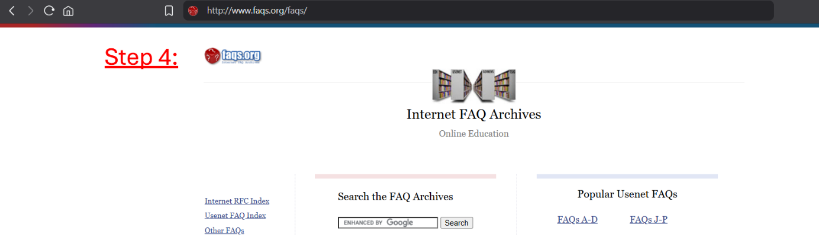

Explanation:
Step 1 – Send GET request:
- The computer sends a packet with the HTTP GET method to the server to request the web page content.
Step 2 – Server processing:
- The server receives the request and processes it.
Step 3 – Return HTTP Response:
- The server sends back an HTTP Response packet.
- If the page is loaded successfully, the status code is 200.
Step 4 – Display the web page:
- At this point, the user can view the web page.
Step 5 – Load additional objects:
- The browser continues to send GET requests for additional objects such as images, CSS, and JavaScript files.
- The server returns HTTP Responses for each object, and this process continues until all objects are loaded.

Expand

Evidence:
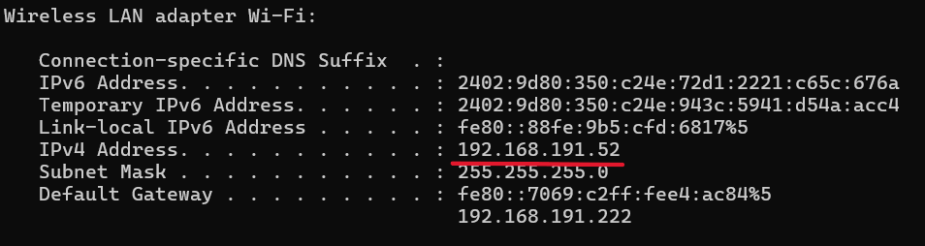
Exercise 1:
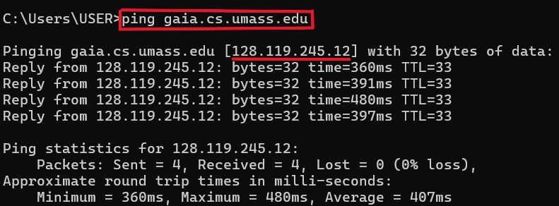
Exercise 2:
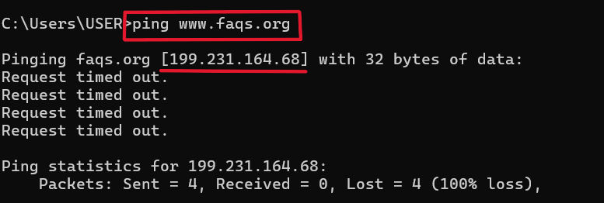

Explanation:
IP address use for:
- Device Identification and Location: Each device on a network has a unique IP address to distinguish it from others. Acts like a digital mailing address, ensuring data reaches the correct device.
- Data Transmission and Routing: Routers use IP addresses to route packets across networks to the correct destination. Supports two-way communication, ensuring data is sent and received accurately.
- Network Configuration and Management: IP addresses help configure firewalls, VPNs, and DHCP, enhancing network management and security. Allow administrators to monitor, control, and block unauthorized access.
- Domain Name Resolution (DNS): IP addresses work with DNS to map human-readable domain names (e.g., google.com) to numerical IPs, allowing devices to locate websites and services.
Check the IP address of computer:
- Open Command Prompt (CMD).
- Type the command: “ipconfig”
- Press Enter.
- Look for the line “IPv4 Address” – this shows the IP address of computer.
Check the IP address of a website
- Open Command Prompt (CMD).
- Type the command: “ping <domain name>”
- Press Enter.
- The response shows the IP address of the website in square brackets

END

