Members | Task Details
Nguyễn Dương Phúc | Task 1- 13 (Work - 100%)

Name | ID
Nguyễn Dương Phúc | 24521386

OTHER EVALUATIONS (*):
TASK ASSIGNMENT TABLE:
Content | Result
Average total time to complete the lab (1) | 10 Hours
Video Link (2)
(if any)
Feedback (3) (if any)
+ Challenges
+ Suggestions …
Self-Assessment Score (4) | 9/10
(*): Sections (1) and (4) are mandatory.

Teacher: Phan Trung Phát
Group: CS4283.Q12.CTTT
COMPUTER NETWORKS
3

Question 1

Evidence:
UDP:
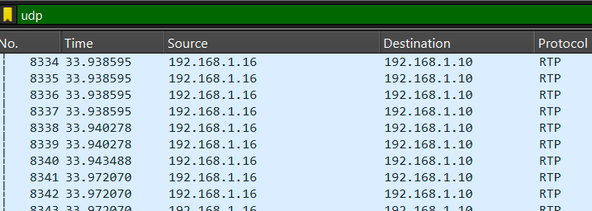
TCP:
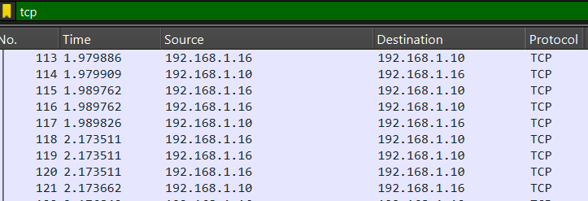
Q6:
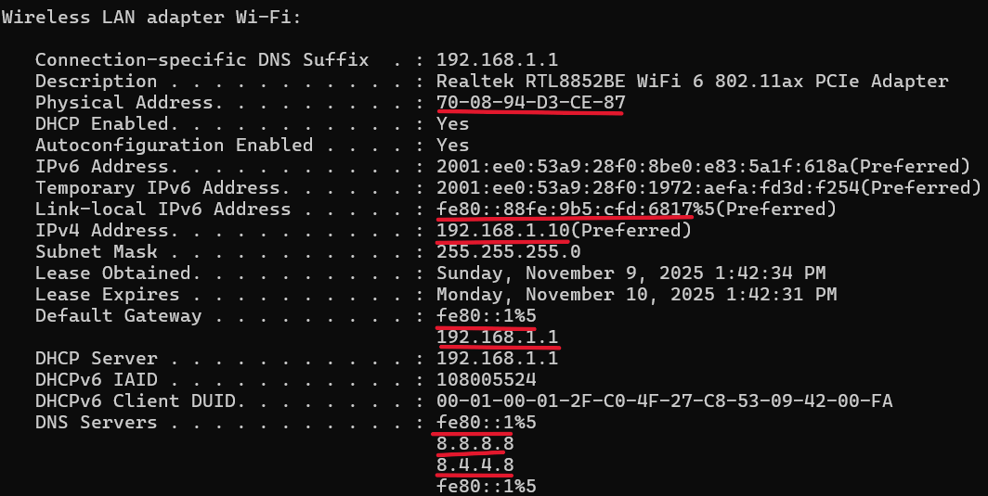

Explanation:
Question | UDP (Attempt 1 – RTSP Streaming) | TCP (Attempt 2 – HTTP Streaming)
Q1 | The video started very fast with almost no delay, but sometimes the image was not smooth, or a few frames were missing. | The video was smooth and clear, but it took a few seconds to start because of buffering.
Q2 | Wireshark showed packets with the UDP protocol. | Wireshark showed packets with the TCP protocol.
Q3 | The video had low delay (fast response) but sometimes small glitches appeared. | The video had no glitches but there was a short delay before it played.
Q4 | The streaming used UDP, which sends data fast but does not check for lost packets. | The streaming used TCP, which checks and resends lost packets for reliable delivery.
Q5 | UDP: Faster and better for real-time video but can lose data. | TCP: Slower but more reliable and stable for streaming.

Q6:
IPv4  Link-local IPv6 address | 192.168.1.10  fe80::88fe:9b5:cfd:6817
MAC address | 70-08-94-D3-CE-87
Default gateway | fe80::1  192.168.1.1
DNS Servers | fe80::1  8.8.8.8, 8.4.4.8

Question 2

Evidence:

Explanation:
The query for uit.edu.vn is in packet 1365.

Question 3

Evidence:
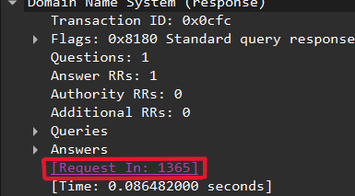

Explanation:
The response packet to the above query is packet 1423. It can be identified by "Standard query response" in the Info column, and in the Domain Name System section, it shows "Request In: 1365", indicating that it is a response to the query in packet 1365.

Question 4

Evidence:
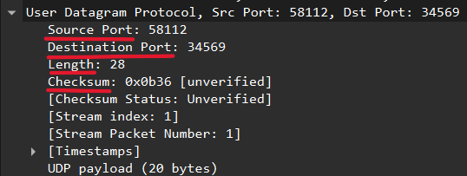

Explanation:
Packet 3. The fields in the UDP header are:
- Source Port (2 bytes): 16-bit number identifying the port from which the packet is sent.
- Destination Port (2 bytes): 16-bit number identifying the port to which the packet is sent.
- Length (2 bytes): 16-bit number indicating the total length of the UDP packet, including header and data. Minimum length is 8 bytes (header only).
- Checksum (2 bytes): 16-bit number used to verify the integrity of the packet. If the checksum is incorrect, the packet is discarded.

Question 5

Evidence:
Source Port:
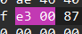
Destination Port:
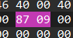
Length:
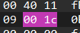
Checksum:
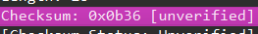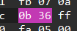

Explanation:
When we click on each field in Wireshark, the corresponding bytes are highlighted in the Hexadecimal view. Each of the four UDP header fields (Source Port, Destination Port, Length, Checksum) occupies 2 bytes, so 2 hex cells are highlighted for each field.

Question 6

Evidence:
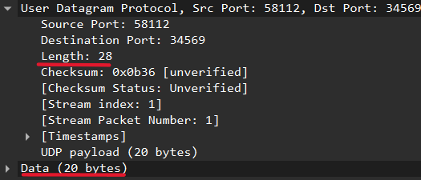

Explanation:
The Length field represents the total length of the UDP datagram, including header and data.
Length = Header (8 bytes) + Data (20 bytes) = 28 bytes, which matches the Length field (28 bytes).

Question 7

Evidence:
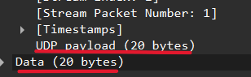

Explanation:
UDP Payload max = 2^16 − 1 − 20 (IP header) − 8 (UDP header) = 65,507 bytes.
In the captured packet, the Data section is 20 bytes, so the UDP payload is 20 bytes, since the payload represents the original data excluding the UDP and IP headers.

Question 8

Evidence:

Explanation:
The Source Port field in the UDP header is 16 bits long.
A 16-bit field can represent values from 0 to 2¹⁶ − 1 = 65,535.
Source Port max = 2^16 − 1 = 65,535

Question 9

Evidence:
The sent packet
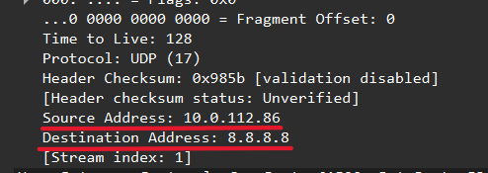
The response packet:
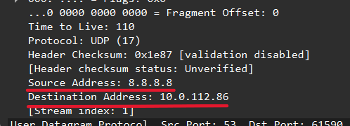

Explanation:
The packet sent by the computer and the response packet have opposite Source and Destination IP addresses and ports.
- For the sent packet:
- Source: 10.0.112.86
- Destination: 8.8.8.8
- For the response packet:
- Source: 8.8.8.8
- Destination: 10.0.112.86
This occurs because each UDP packet contains both a source and a destination IP and port. This ensures that the sender knows where to send the packet and the receiver knows where it came from, allowing communication to reach the correct host and service.

Question 10

Evidence:
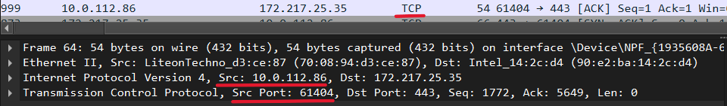

Explanation:
Client IP: 10.0.112.86
Client TCP port: 61404

Question 11

Evidence:
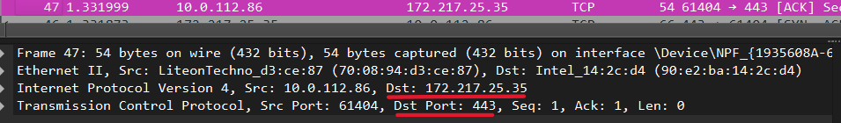

Explanation:
Server IP: 172.217.25.35
Server TCP Port: 443

Question 12

Evidence:
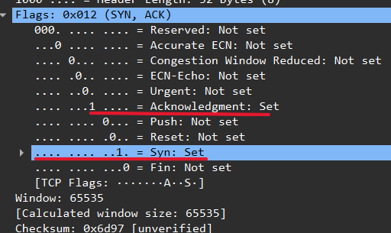

Explanation:
The TCP SYN segment that initiates the connection between the client and the server has a SYN flag set (SYN = 1) and ACK = 0. The Sequence Number is the client’s Initial Sequence Number (ISN), which can be any number, not necessarily 0.
The component that indicates it is a SYN segment is the Flags field in the TCP header.

Question 13

Evidence:
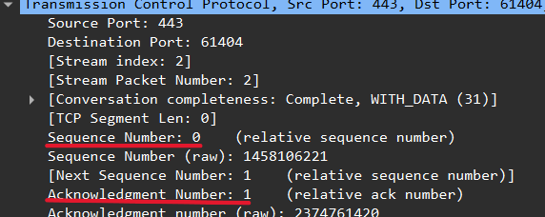

Explanation:
- Sequence Number of the SYN/ACK segment: server's Initial Sequence Number (ISN)
- Acknowledgement Number: client's ISN + 1
- How server determines ACK: by reading the Sequence Number of the received SYN segment from the client
- Component indicating SYN/ACK: the Flags field in the TCP header (SYN = 1, ACK = 1).

