Members | Task Details
Nguyễn Dương Phúc | Task 1, 2, 3 (Work - 100%)

Name | ID
Nguyễn Dương Phúc | 24521386

OTHER EVALUATIONS (*):
TASK ASSIGNMENT TABLE:
Content | Result
Average total time to complete the lab (1) | 9 Hours
Video Link (2)
(if any)
Feedback (3) (if any)
+ Challenges
+ Suggestions …
Self-Assessment Score (4) | 10/10
(*): Sections (1) and (4) are mandatory.

Teacher: Phan Trung Phát
Group: CS4283.Q12.CTTT
CONFIGURING NETWORK DEVICES
5

Question 1

Evidence:
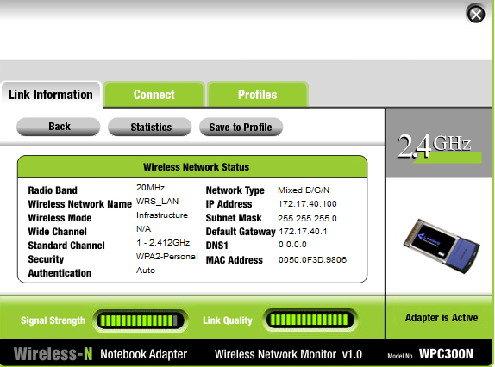
Figure 1. Detailed IP Address Configuration

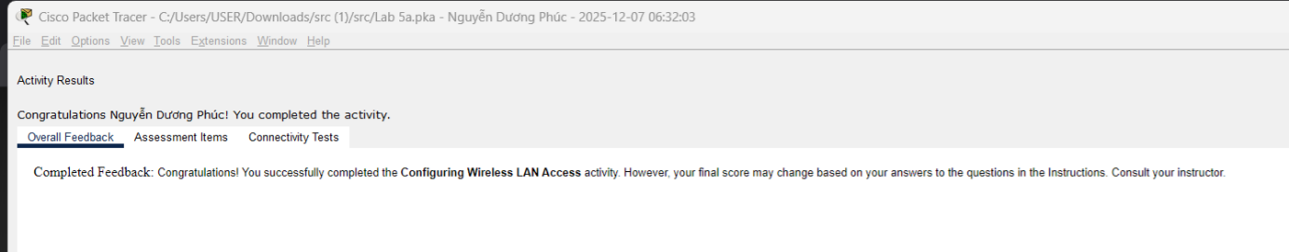
Figure 2. Overall Results Task 1

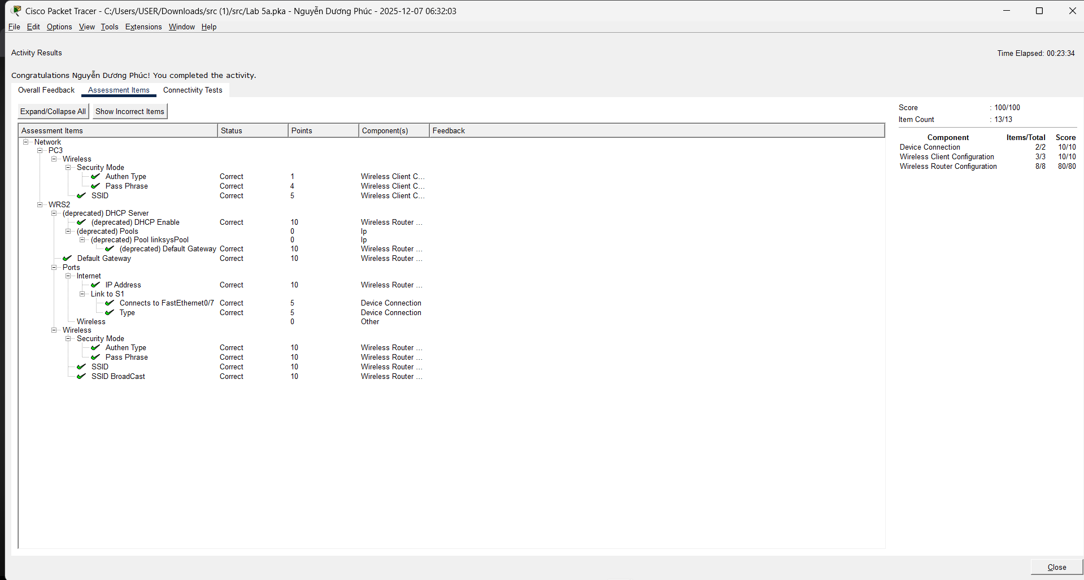
Figure 3. Detailed Results Task 1

Question 2

Evidence:
- The configurations of router R1:
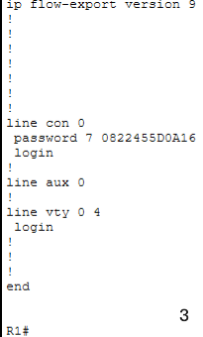
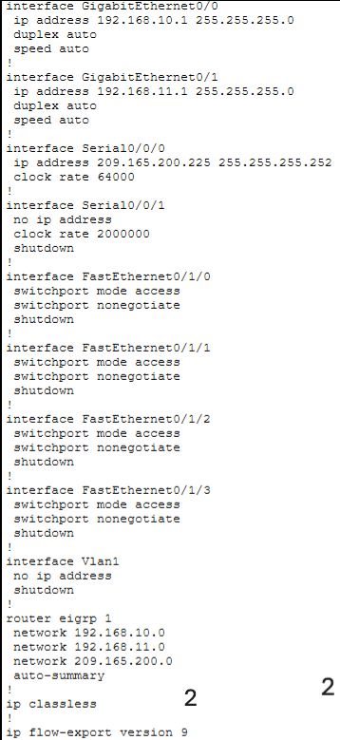
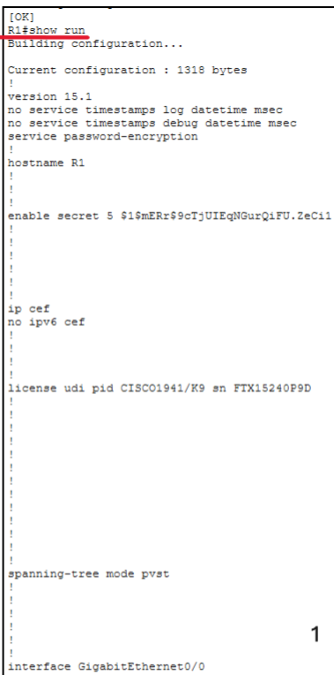

Figure 4. R1 - Show run Command
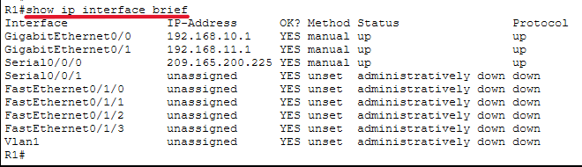
Figure 5. R1 - Show IP interface brief Command

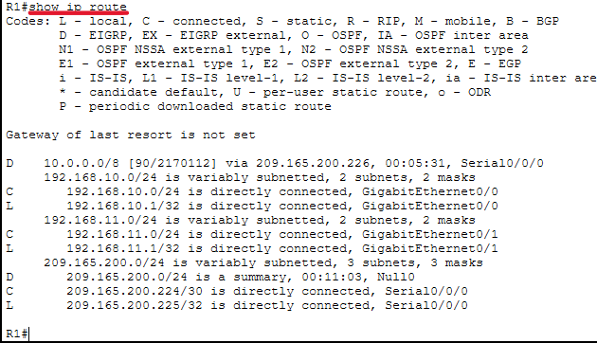
Figure 6. R1 - Show IP route Command

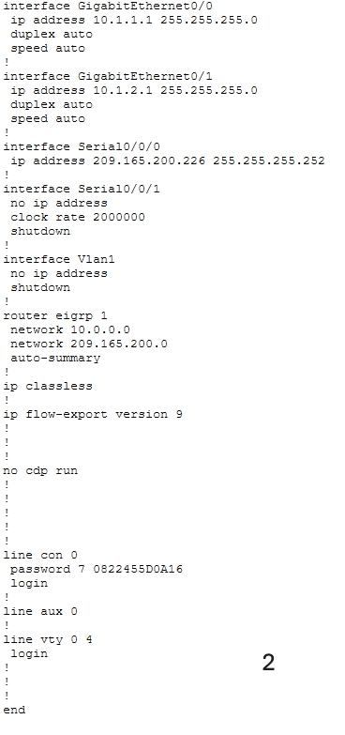
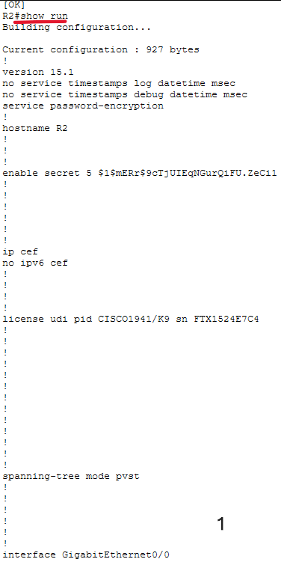
- The configurations of router R2:

Figure 7. R2 - Show run Command

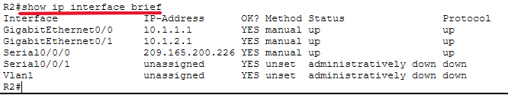
Figure 8. R2 - Show IP interface brief Command

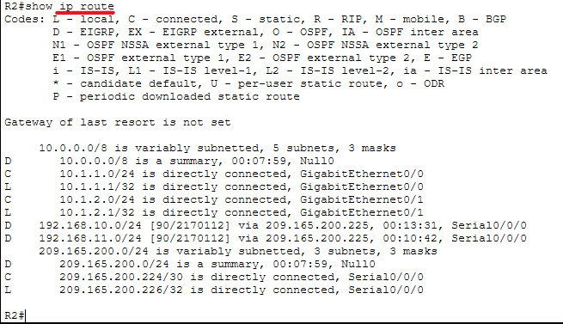
Figure 9. R2 - Show IP route Command

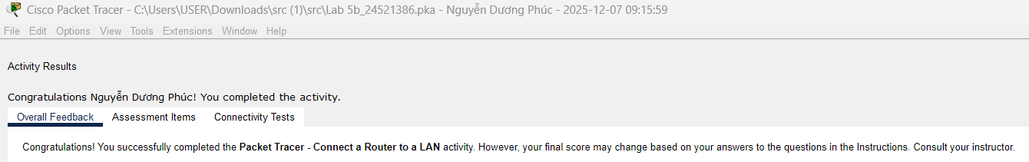
Figure 10. Overall Results Task 2

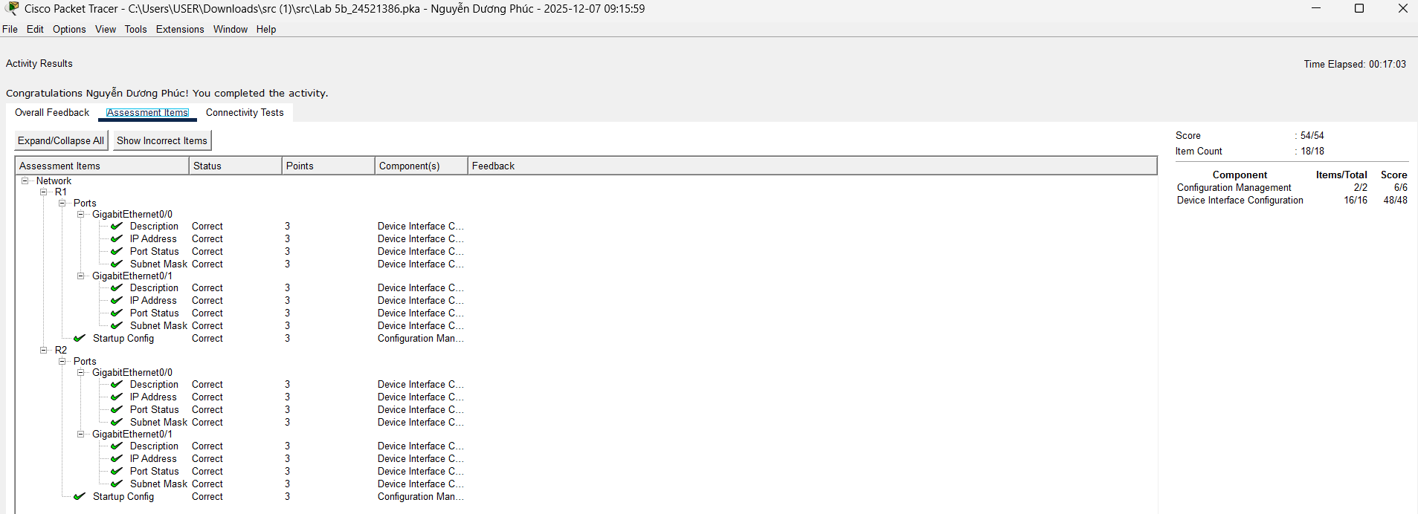
Figure 11. Detailed Results Task 2

Explanation:
- Show run:
Displays the entire running configuration of the router.
Used to check IP settings, passwords, interface status, routing protocols, hostname, and other active configurations.
- Shows the device’s current configuration.
- Show IP interface brief:
Shows a summary of all interfaces, including IP address, status (up/down), and protocol state.
- Used to quickly verify whether interfaces have correct IPs and are operational.
- Show IP route:
Displays the router’s routing table.
Shows known networks, how routes were learned (C, S, R), next-hop information, and selected paths.
- Used to confirm routing and troubleshoot connectivity issues.

Question 3

Evidence:
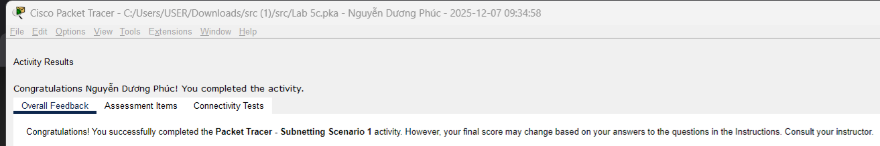
Figure 12. Overall Results Task 3
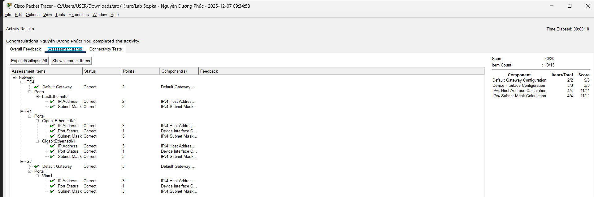
Figure 13. Detailed Results Task 3

Explanation:
No. | Network Address | Starting Host Address | Ending Host Address | Broadcast Address
0 | 192.168.100.0 | 192.168.100.1 | 192.168.100.30 | 192.168.100.31
1 | 192.168.100.32 | 192.168.100.33 | 192.168.100.62 | 192.168.100.63
2 | 192.168.100.64 | 192.168.100.65 | 192.168.100.94 | 192.168.100.95
3 | 192.168.100.96 | 192.168.100.97 | 192.168.100.126 | 192.168.100.127
4 | 192.168.100.128 | 192.168.100.129 | 192.168.100.158 | 192.168.100.159
5 | 192.168.100.160 | 192.168.100.161 | 192.168.100.190 | 192.168.100.191
6 | 192.168.100.192 | 192.168.100.193 | 192.168.100.222 | 192.168.100.223
7 | 192.168.100.224 | 192.168.100.225 | 192.168.100.254 | 192.168.100.255

Device | Interface | IP Address | Subnet Mask | Default Gateway
R1 | G0/0 | 192.168.100.1 | 255.255.255.244 | N/A
 | G0/1 | 192.168.100.33 | 255.255.255.244 | N/A
 | S0/0/0 | 192.168.100.129 | 255.255.255.244 | N/A
R2 | G0/0 | 192.168.100.65 | 255.255.255.244 | N/A
 | G0/1 | 192.168.100.97 | 255.255.255.244 | N/A
 | S0/0/0 | 192.168.100.158 | 255.255.255.244 | N/A
S1 | VLAN 1 | 192.168.100.2 | 255.255.255.244 | 192.168.100.1
S2 | VLAN 1 | 192.168.100.34 | 255.255.255.244 | 192.168.100.33
S3 | VLAN 1 | 192.168.100.66 | 255.255.255.244 | 192.168.100.65
S4 | VLAN 1 | 192.168.100.98 | 255.255.255.244 | 192.168.100.97
PC1 | NIC | 192.168.100.30 | 255.255.255.244 | 192.168.100.1
PC2 | NIC | 192.168.100.62 | 255.255.255.244 | 192.168.100.33
PC3 | NIC | 192.168.100.94 | 255.255.255.244 | 192.168.100.65
PC4 | NIC | 192.168.100.126 | 255.255.255.244 | 192.168.100.97

END

