LAB 1: JAVA BASICS
Link download IntelliJ: https://www.jetbrains.com/idea/download/
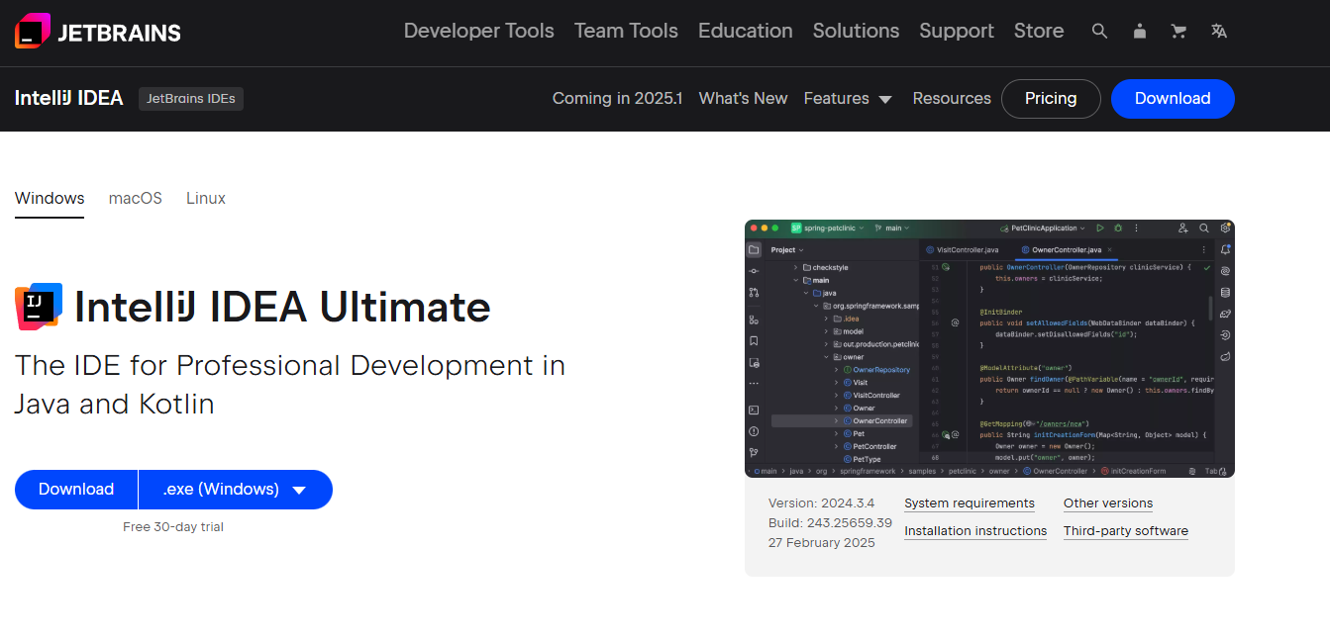
Create new project
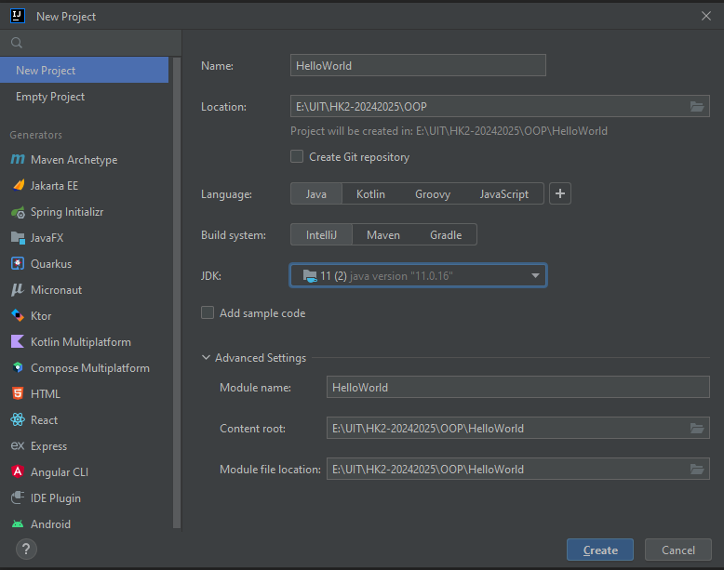

Create new class:
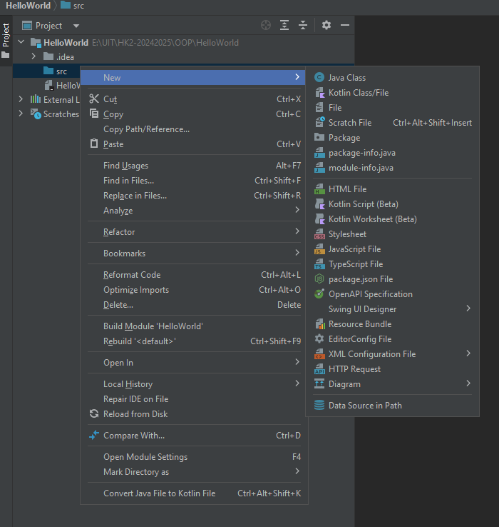
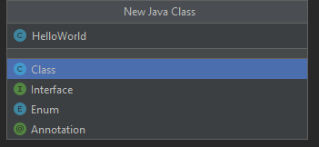

Class HelloWorld:
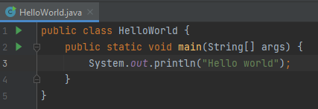
Run “HelloWorld.main()”:
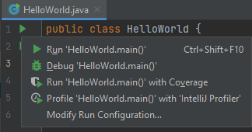
Result:
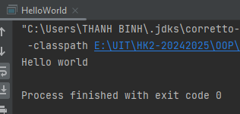
1. Java Variables
Variables store data in Java. There are different types of variables, such as:
- int (integer numbers)
- double (decimal numbers)
- char (single characters)
- String (text)
- boolean (true/false)
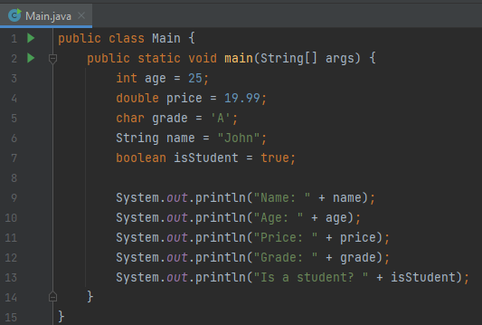
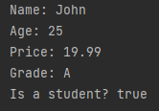
2. Java If-Else Statement
The if-else statement is used to make decisions in a program.
Example: If-Else Condition
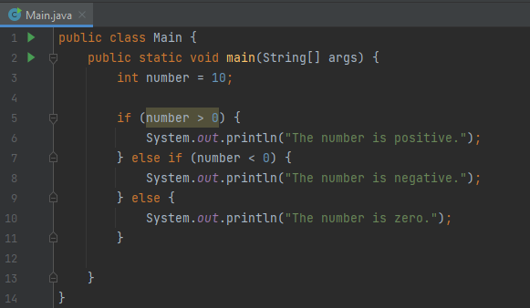
3. Java Loops
Loops help execute a block of code multiple times.
Example: For Loop
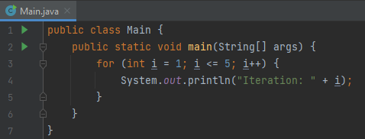
Example: While Loop
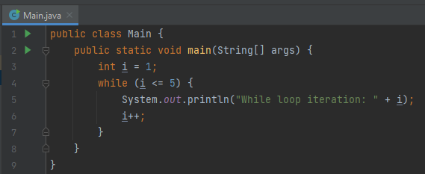
4. Exercise
Exercise 1:
Problem:
Write a Java program that:
- Takes an integer n as input.
- Uses a loop to print all numbers from 1 to n.
- If a number is even, print "Even", otherwise print "Odd".
Expected Output Example (if n = 10):
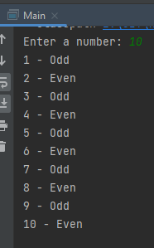
Exercise 2: Find the Largest Number
Problem:
Write a Java program that:
- Takes three integer numbers as input.
- Uses an if-else statement to determine the largest number.
- Prints the largest number.
Expected Output Example: 10 – 25 - 30
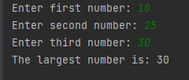
Exercise 3: Sum of Digits
Problem:
Write a Java program that:
- Takes an integer input from the user.
- Calculates the sum of its digits using a loop.
- Prints the sum.
Example Output:
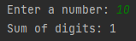
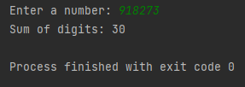
Exercise 4: Reverse a String
Problem:
Write a Java program that:
- Takes a string as input.
- Reverses the string using a loop.
- Prints the reversed string.
Example Output:
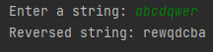
Exercise 5: Multiplication Table
Problem:
Write a Java program that:
- Takes an integer n as input.
- Prints the multiplication table of n up to 10.
Example Output:
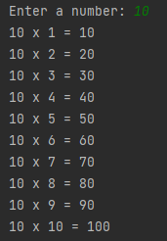
Exercise 6: Find an Element in an Array
Problem:
Write a Java program that:
- Takes an integer n as input, representing the number of elements in an array.
- Reads n integers into an array.
- Takes another integer x as input, representing the number to search for in the array.
- Checks whether x exists in the array.
- If x is found, prints the index of its first occurrence. If not found, prints -1.
Example Output:
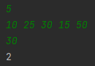
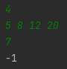

Exercise 7: Merge Two Sorted Arrays
Problem:
Write a Java program that:
- Takes an integer n, representing the number of elements in the first sorted array.
- Reads n integers into the first sorted array.
- Takes an integer m, representing the number of elements in the second sorted array.
- Reads m integers into the second sorted array.
- Merges the two sorted arrays into one sorted array (in ascending order).
- Prints the merged sorted array.
Example Output:
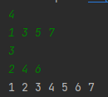
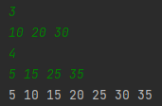
Exercise Bristleback's Quill Spray Damage Calculation:
Bristleback is a very annoying hero in Dota with a well-synergized skill set and is extremely hard to kill. One of his main damage-dealing abilities is Quill Spray. This ability shoots sharp quills from Bristleback's back in all directions, making it impossible for enemy heroes to evade.
Although the initial damage of Quill Spray is not high, the ability leaves sharp quills embedded in enemy heroes. On the next cast, these existing quills will deal additional damage. Each quill exists independently, cannot be removed, and will only disappear after a certain period.
Task
Given the times when a hero is hit by Bristleback’s Quill Spray, determine the total amount of damage the hero has received.
Notes
- If a hero gets hit by Quill Spray at the exact moment when a quill is about to disappear, the additional damage from that quill still applies before it disappears.
- For precise calculations, real numbers should be stored using the double data type.
Input Format
- The first line contains an integer n (n < 10,000), the number of times the hero is hit by Quill Spray.
- The second line contains n real numbers, representing the timestamps when the hero is hit by Quill Spray, in chronological order.
- The third line contains a real number x, the base damage of a Quill Spray hit.
- The fourth line contains a real number y, the additional damage dealt by each quill already embedded when Quill Spray is cast again.
- The last line contains a real number z, the duration after which a quill disappears.
Output Format
- Print the total damage received by the hero.

Input | Output
5  4.9 12.6 19.1 22.9 46.2  65  51  15.0 | 580
13  4.9 12.6 19.1 22.9 26.2 32.7 34.6 44.3  44.6 50.5 59.8 66.2 72.1  65  51  15.0 | 2120

Example Calculation of Total Damage
- At second 4.9, the hero is hit by Quill Spray for the first time, receiving 65 damage and getting 1 embedded quill.
- At second 12.6, the hero is hit again, receiving 65 damage. Since there is 1 quill already embedded, they take an additional 51 damage. Now, the hero has 2 embedded quills.
- At second 19.1, the hero is hit again, receiving 65 damage. Since there are 2 embedded quills, they take an additional 102 damage. Now, the hero has 3 embedded quills.
- At second 22.9, the quill from second 4.9 has expired, leaving the hero with 2 quills. The hero is hit again, receiving 65 damage. Since there are 2 embedded quills, they take an additional 102 damage. Now, the hero has 3 embedded quills.
- At second 46.2, all quills have expired. The hero is hit again, receiving 65 damage.

