Name: Nguyễn Dương Phúc
Student ID: 24521386
Class: CS4323.Q12.CTTT

OS
LAB 1

CHECKLIST
1. Homework
 | 1 | 2 | 3 | 4 | 5
Explanation
Your code
Results and discussions

Mark: 10/10 (self-scrores)

*Notice: Export PDF file, name format:
<MSSV>_LAB1.pdf
2. Lab 1
1. Execute, google, and explain usage of all commands in this section
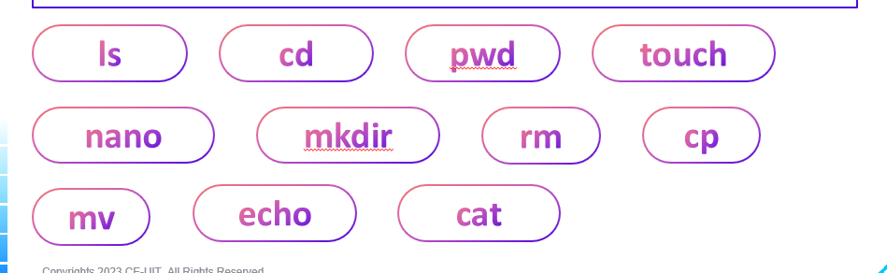
Answer:
- Syntax: ls [options] [path]
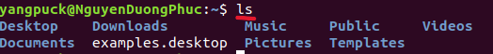
Function: Lists files and directories in the current directory or a specified path.
- Syntax: cd [path]
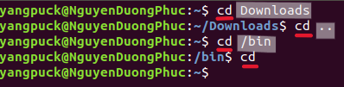
Function: Changes the current working directory.
- cd Downloads: Go into the Downloads folder (move into a subdirectory).
- cd .. : Go up one directory level (to the parent folder).
- cd /bin : Go directly to the /bin directory (absolute path from root).
- cd : Go to your home directory (~).
- Syntax: pwd
Function: Displays the full path of the current directory.
- Syntax: touch filename
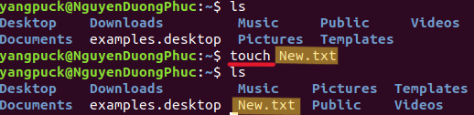
Function: Creates an empty file or updates the timestamp if the file already exists.
- Syntax: nano filename
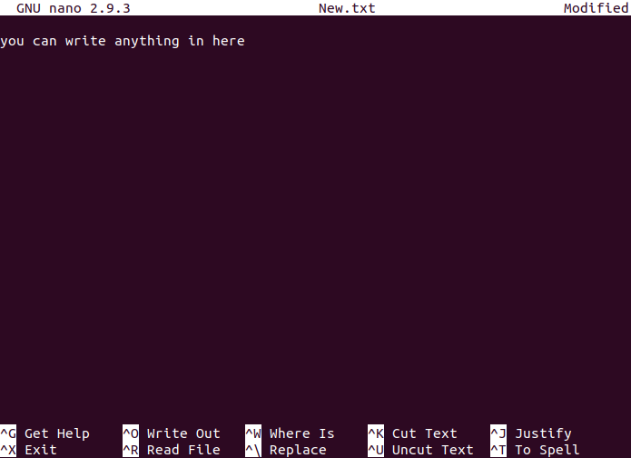
Function: Opens a terminal-based text editor to edit or create a text file.
- Syntax: mkdir [options] directory_name
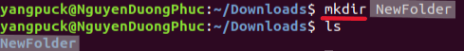
Function: Creates new directories.
- Syntax: rm [options] filename_or_directory
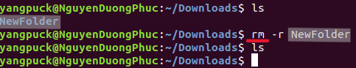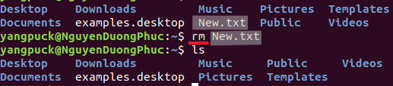
Function: Deletes files or directories.
- r → recursive (for directories)
- f → force (no confirmation)
- Syntax: cp [options] source destination
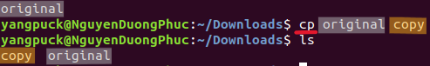
Function: Copies files or directories.
- Syntax: mv source destination
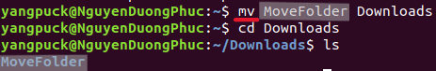
Function: Moves files/directories or renames them.
- Syntax: echo [text]
Function: Prints text or variables to the terminal.
- Syntax: cat [file]
Function: Displays the content of files in the terminal or combines files.
2. Create a folder tree like image below:
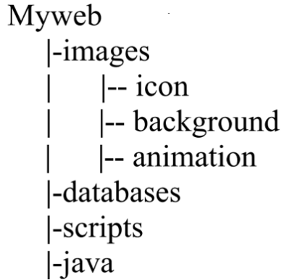
Answer:
Step 1: Create Myweb and enter it
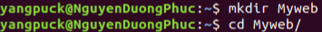
Step 2: Create main subfolders and enter images
Step 3: Create subfolders inside images
Result:
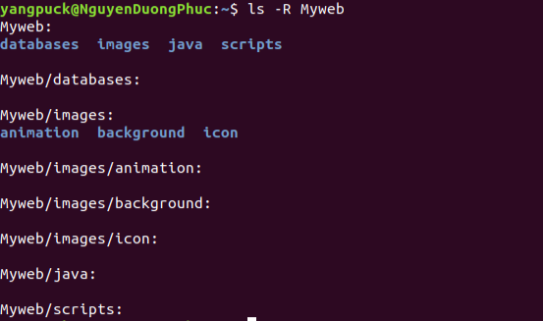
3. Google how to find files with the “.html” extension in your entire system. Copy one of them to Myweb.
Answer:
Step 1: Type the following command to find all .html files:
- Find: the command used to search for files or directories
- /: the starting directory for the search (root directory, i.e., the whole system)
- -name: option to specify that you are searching by file name
- "*.html": pattern to match file names ending with .html
Step 2: Choose any file path from the search results. For example:
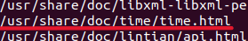
Step 3: Use the cp command to copy the file into Myweb folder:
4. Remove the directory Myweb/scripts.
Answer:
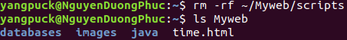
- rm: the command used to remove files or directories
- -r: option to remove directories recursively (including all files and subdirectories)
- ~/Myweb/scripts: the path of the directory to be deleted
5. Set the permission for Myweb/databases as below:
- The owner has all permissions
- Other users have no permission
Answer:

- Chmod: the command used to change file or directory permissions
- 700: permission code where:
  - 7 = read, write, and execute for the owner
  - 0 = no permissions for the group
  - 0 = no permissions for others
- ~/Myweb/databases: the path of the directory to set permissions
- ls: list files and directories
- -l: use long listing format to show detailed information
- ~/Myweb: the directory whose contents you want to check
Result:
- drwx------: permission string
  - d: directory
  - rwx: owner (user) has read, write, execute
  - ---: group has no permission
  - ---: others have no permission
- 2: number of links
- yangpuck: owner name
- yangpuck: group name
- 4096: size in bytes
- Oct 26 07:32: last modified date and time
- /home/yangpuck/Myweb/databases: directory name

