Name: Nguyễn Dương Phúc
Student ID: 24521386
Class: CS4323.Q12.CTTT

OS
LAB 2

CHECKLIST
1. Homework
 | 1 | 2 | 3 | 4
Explanation
Your code
Results and discussions

Mark: 10/10 (self-scrores)

*Notice: Export PDF file, name format:
<MSSV>_LAB2.pdf
2. Lab 2
1. List the contents of your /etc directory, including the ownership and permissions, and redirect the output to a file called report_<studentID>.txt within your home directory.
Answer:
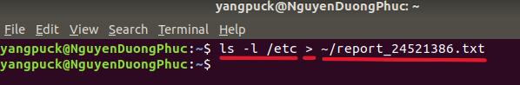
- ls -l /etc
- Lists the detailed contents of the /etc directory (showing permissions, ownership, size, modification date, file names, etc.).
- >
- Output redirection operator: writes the command’s result into a file instead of printing it on the screen.
- ~/report_24521386.txt
- ~: refers to the current user’s home directory.
- The output file will be saved as /home/yangpuck/report_24521386.txt.
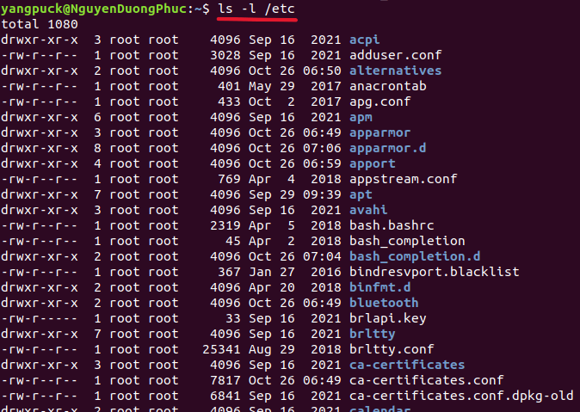
The file report_24521386.txt contains a detailed listing of the /etc directory.
Each line from ls -l /etc includes:
- Column 1: File type and permissions (e.g., drwxr-xr-x).
- Column 2: Number of hard links.
- Column 3: File owner (usually root).
- Column 4: Group owner (usually root).
- Column 5: File size in bytes.
- Columns 6–8: Last modification date and time.
- Column 9: File or directory name.

2. Sort the contents of the report_<studentID>.txt file from your current directory and append it to the end of a new file named report-sorted.txt.
Answer:
- sort: Sorts the contents of a file alphabetically or numerically based on the text in each line.
- ~/report_24521386.txt: A file in the user's home directory that contains the unsorted list of files from /etc.
- >> report-sorted.txt: Appends the sorted output to report-sorted.txt without overwriting the file.
After sorted
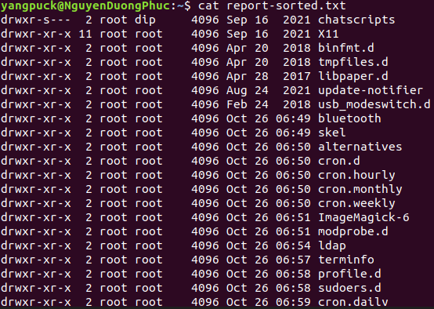

3. Count the number of words within the report_<studentID>.txt file and append the output to the end of a file field2.txt in your home directory. You will need to use both input and output redirection.
Answer:
- wc -w: Counts the number of words in a file.
- < ~/report_24521386.txt: Input redirection. Makes wc read the file from standard input, so the output shows only the word count, without the file name.
- >> ~/field2.txt: Appends the output (word count) to field2.txt in the home directory without overwriting existing content.
- Use cat ~/field2.txt to display the result.
- 1958: The word count of report_24521386.txt

4. Using the previously created report_<studentID>.txt file, count the number of characters of the last 9 lines.
Answer:
- tail -n 9 ~/report_24521386.txt
- tail displays the last few lines of a file.
- -n 9 specifies the number of lines to display (the last 9 lines).
- ~/report_24521386.txt is the input file in the home directory.
- | (pipe)
- Sends the output from tail as input to the next command (wc -m).
- Allows multiple operations on the data without creating temporary files.
- wc -m
- wc counts lines, words, or characters.
- -m counts the number of characters, including spaces and newline characters, in the input received from the pipe.
- 531 is the total number of characters in the last 9 lines of report_24521386.txt.

