Name: Nguyễn Dương Phúc
Student ID: 24521386
Class: CS4323.Q12.CTTT

OS
LAB 3

CHECKLIST
1. Homework
 | 1 | 2 | 3
Explanation
Your code
Results and discussions

Mark: 10/10 (self-scrores)

*Notice: Export PDF file, name format:
<MSSV>_LAB3.pdf
2. Lab 3
1. Given the file gradebook.csv which contain grades of a class. Research how to use IFS to read csv file. Use shell script to:
- Read Student ID from command line
- Use Student ID to find and print name, original grade, and letter-based grade of corresponding student

Answer:
Step 1: Create a new shell script file
Step 2: Write the script with comments explaining each step:
- Prompt the user for Student ID
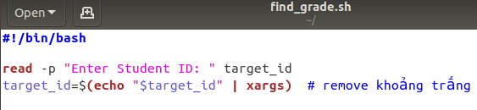

- Check if the CSV file exists
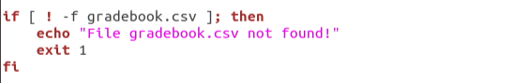

- Read the CSV file line by line using a loop
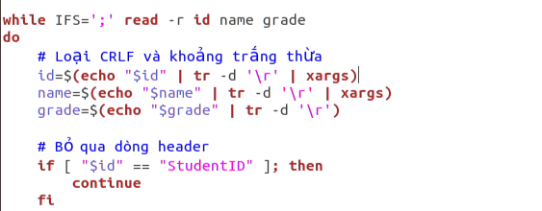

- Compare the input ID with the current line
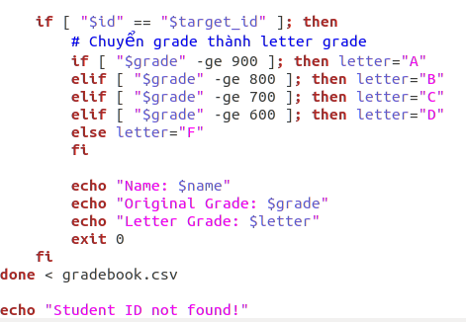

Notes / Explanation:
- IFS=';' is used to split each line into columns.
- tr -d '\r' removes Windows carriage return characters (^M).
- The script skips the header line, then compares the input ID with each line.
- If a match is found, it prints the student’s name, original numeric grade, and letter grade.
- If no match is found, it prints "Student ID not found!"
Step 3: Give execution permission to the script
Step 4: Run the script
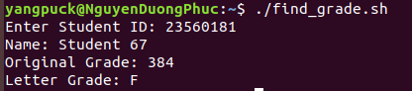
2. Write a shell script to let user input their age, then:
- Check if input is a number and its value is between 0 and 100.
- If input is less than 12 Print “You are a child”
- If input is from 12 – 18 Print “You are a teenager”
- If input is greater than 18 Print “You are an adult”

Answer:
Step 1: Create a new shell script file
Step 2: Write the script with comments explaining each step:
- Prompt the user to enter their age
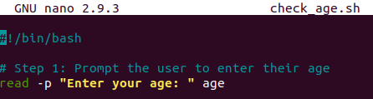

- Check if the input is a valid number
- Use regex to ensure only digits
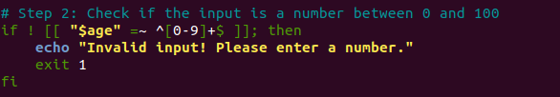

- Check if the age is between 0 and 100
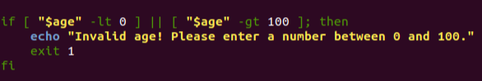

- Determine age category:
Age less than 12 → child
Age between 12 and 18 → teenager
Age greater than 18 → adult
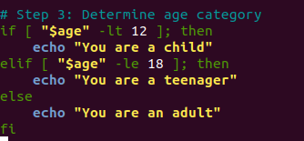
Step 3: Give execution permission

Step 4: Run the script (test case)
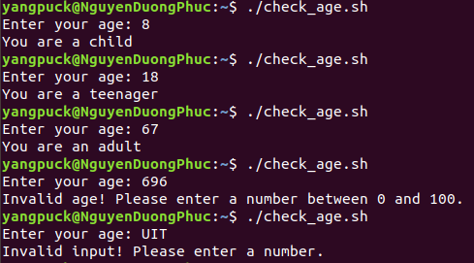
3. Write a program that read 02 arguments from command line: first argument is a string while second argument is a path.
Check if that string exists in any text file (for example, test.txt) in the provided path. Print the line containing the string.

Answer:
Step 1: Create the script file
Step 2: Write the script with comments explaining each step:
- Check if two arguments are provided: The script first checks if exactly two arguments (a string and a directory path) are provided. If not, it prints a usage message showing the correct format and exits.
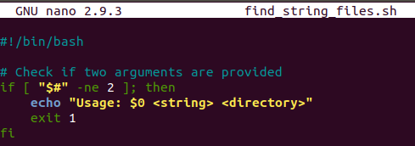
- Assign arguments to variables:
- The first argument ($1) is assigned to 'search_string' (the string to search for).
- The second argument ($2) is assigned to 'search_dir' (the directory to search in).
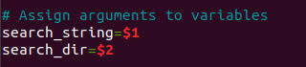

- Check if the directory exists: The script verifies whether the provided directory exists using '-d'. If the directory does not exist, it prints an error message and exits.
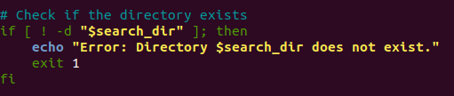

- Search for the string in text files: 'find' lists all .txt files in the given directory: For each file, the script uses 'grep -q' to check silently if the string exists. If the string is found, it prints the file name and the line(s) containing the string. The 'found' variable is set to 1 to indicate at least one match was found.
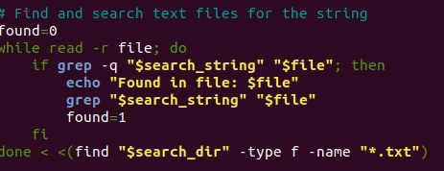

- Handle the case where no matches are found: After checking all .txt files, if 'found' is still 0, the script prints a message indicating that the search string was not found in any file in the directory.
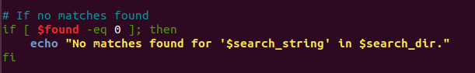
Step 3: Give execution permission
Step 4: Prepare test data
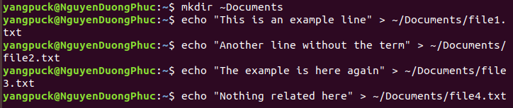
Step 5: Run the script
