Name: Nguyễn Dương Phúc
Student ID: 24521386
Class: CS4323.Q12.CTTT

OS
LAB 4

CHECKLIST
1. Homework
 | 1 | 2
Explanation
Your code
Results and discussions

Mark: 10/10 (self-scored)

*Notice: Export PDF file, name format:
<MSSV>_LAB4.pdf
2. Lab 4
1. Write a program time.cpp that measures the execution time of a shell command. The program will be executed with the syntax ./time <command> where <command> is the shell command you want to measure the execution time for. Example:
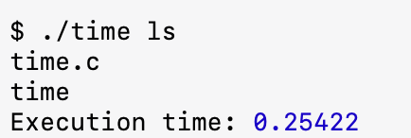
Answer:
Step 1: Enter Recovery Mode
- Restart Ubuntu virtual machine.
- When the Ubuntu logo appears, press:
  - Left Shift (VirtualBox)
- The GRUB menu will appear.
- Select: Advanced options for Ubuntu
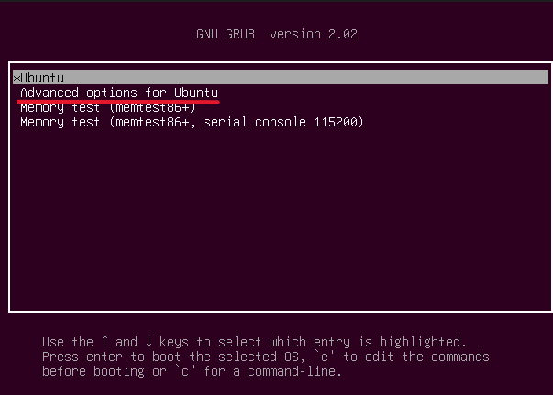

- Select the line that ends with: (recovery mode)
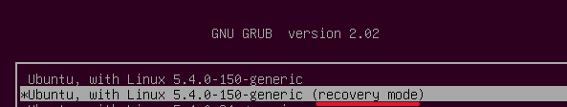

Step 2: Drop to root shell
In the Recovery Menu, choose:
root - Drop to root shell prompt
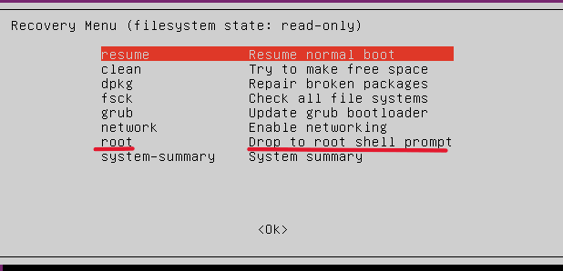

Step 3: Remount the filesystem as read-write
- Type: mount -o rw,remount /
- Explanation:
In recovery mode, the filesystem is read-only.
We need read-write access to modify user permissions.

Step 4: Add your user to the sudo group
- My username is yangpuck, run:
usermod -aG sudo yangpuck
- Explanation:
- usermod: modify a user
- -aG: append to a group
- sudo: group with admin rights

Step 5: Reboot
reboot

Step 6: Install g++
Open a normal terminal and run:
sudo apt update
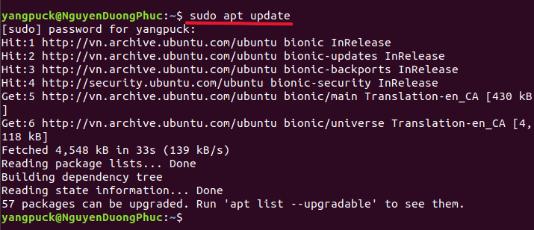

sudo apt install g++

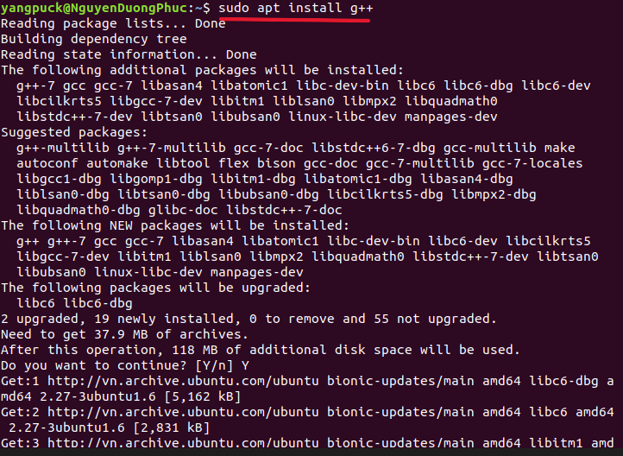
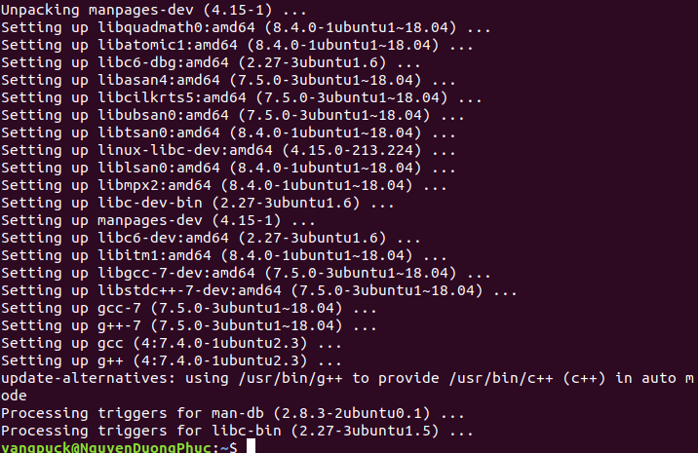

Step 7: Create the C++ file using nano
- Open nano editor:
nano time.cpp
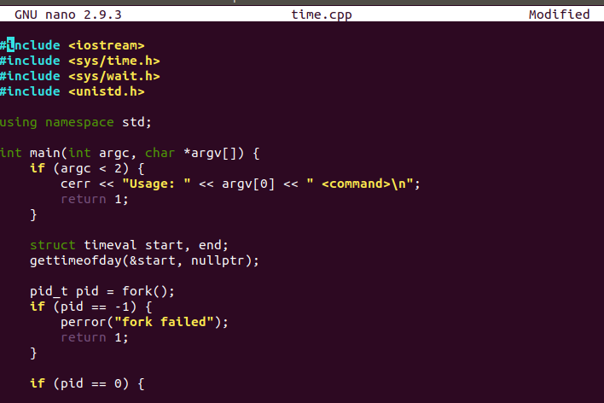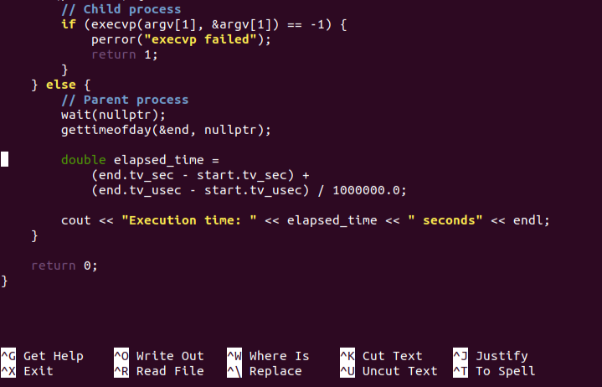
- Explanation:
- The program measures the execution time of a shell command provided by the user.
- It first checks whether the user entered a command; if not, it prints the correct usage message.
- The program records the start time using gettimeofday().
- It creates a new process using fork().
- Child process:
- Calls execvp() to execute the shell command.
- If execvp() fails, it prints an error and exits.
- Parent process:
- Waits for the child process to finish using wait().
- Records the end time after the command has completed.
- The program calculates the execution time by subtracting the start and end timestamps (seconds + microseconds).
- It then prints the total execution time in seconds.
- Summary: fork() creates a child → child runs the command with execvp() → parent waits → parent measures and prints the execution time.

Save and exit nano
Press Ctrl + O → save
Press Ctrl + X → exit
Step 8: Compile the program
g++ time.cpp -o time
Explanation:
- g++ = C++ compiler
- time.cpp = the source file
- -o time = output executable named time

Step 9: Run the program
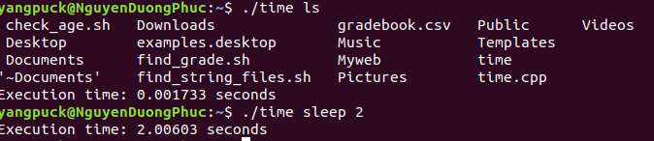
- Example 1:
./time ls
Output:
- First: the result of ls (file list)
- Last line:
Execution time: 0.001733 seconds
- Example 2 (longer command):
./time sleep 2
Output:
Execution time: 2.00603 seconds

2. Design a file-copying program named filecopy.cpp using ordinary pipes. This program will be passed two parameters: the name of the file to be copied and the name of the destination file. The program will then create an ordinary pipe and write the contents of the file to be copied to the pipe. The child process will read this file from the pipe and write it to the destination file. For example, if we invoke the program as follows:
./filecopy input.txt copy.txt
The file input.txt will be written to the pipe. The child process will read the contents of this file and write it to the destination file copy.txt.
Answer:

1. Create the source file with nano
- Command
nano filecopy.cpp
- Code
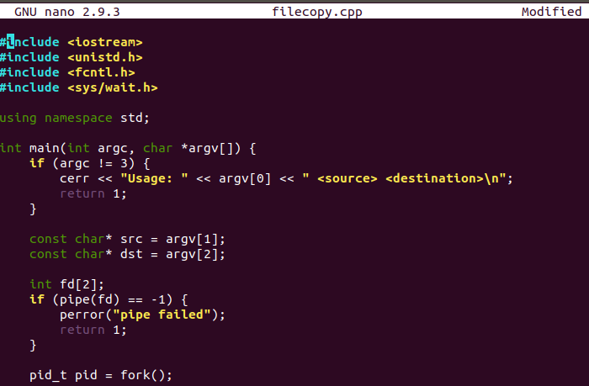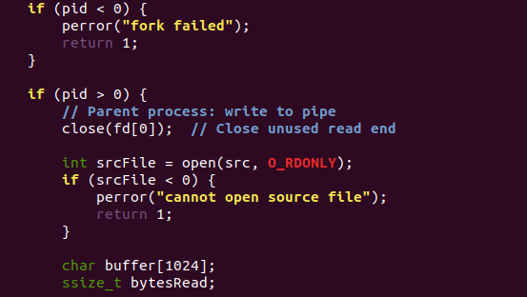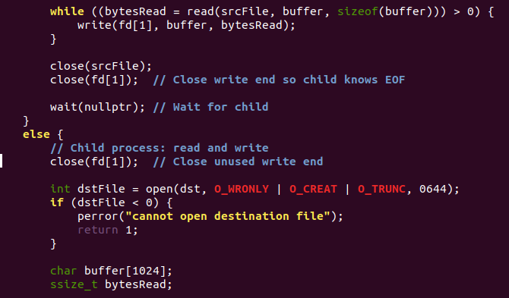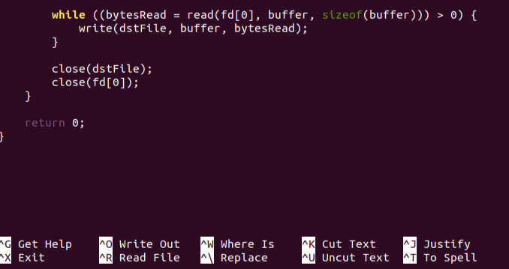
- Explanation
  - Check arguments
- if (argc != 3)
→ Checks that exactly two parameters are provided: the source file and the destination file.
- Store filenames
- const char* src = argv[1];
- const char* dst = argv[2];
→ Stores the names of the source and destination files.
- Create a pipe
- int fd[2];
- pipe(fd);
→ Creates a pipe with two ends:
  - fd[0] = read end
  - fd[1] = write end
- Fork
- pid_t pid = fork();
→ Creates a child process.
- Parent process block (pid > 0)
Close unused pipe end
- close(fd[0]);
→ Parent does not read from the pipe.
Open source file
- open(src, O_RDONLY);
→ Opens the input file for reading.
Read from source file
- read(srcFile, buffer, sizeof(buffer));
→ Reads chunks of data into the buffer.
Write to pipe
- write(fd[1], buffer, bytesRead);
→ Sends the data through the pipe to the child process.
Close descriptors
- close(srcFile);
- close(fd[1]);
→ Closes the file and the write end of the pipe (signals EOF to the child).
Wait for child
- wait(nullptr);
→ Waits for the child process to finish.
- Child process block (pid == 0)
Close unused pipe end
- close(fd[1]);
→ Child does not write to the pipe.
Open destination file
- open(dst, O_WRONLY | O_CREAT | O_TRUNC, 0644);
→ Opens (or creates) the destination file.
Read from pipe
- read(fd[0], buffer, sizeof(buffer));
→ Reads the data sent by the parent.
Write to destination file
- write(dstFile, buffer, bytesRead);
→ Writes the data into the output file.
Close descriptors
- close(dstFile);
- close(fd[0]);
- End of program
- return 0;

Save & exit
- Press Ctrl + O → Enter (save)
- Press Ctrl + X (exit)

- Compile with g++
- Command
g++ filecopy.cpp -o filecopy
- Explanation
- g++ is the GNU C++ compiler.
- filecopy.cpp is the input source file.
- -o filecopy tells the compiler to write the executable named filecopy.
- On success you get an executable ./filecopy.

- Create input.txt quickly using cat and redirection
  - Command
cat > input.txt
hello world
24521386
[Ctrl + D] (exit)
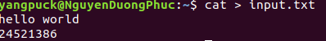
- Explanation
- cat > input.txt makes the shell redirect standard input into input.txt.
- Type lines (e.g., hello world and 24521386), then press Ctrl + D to send EOF and finish.
- input.txt is created containing the lines you typed.

- Run the program to copy the file using an ordinary pipe
- Command
./filecopy input.txt copy.txt
- Explanation
- Runs your program filecopy with two arguments:
  - input.txt = source file to copy
  - copy.txt = destination file to create
- Parent process reads input.txt and writes bytes into a pipe.
- Child process reads from the pipe and writes to copy.txt.

- Verify the copied file with cat
- Command
cat copy.txt
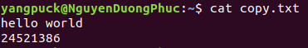
- Explanation
- Prints the contents of copy.txt to the terminal so you can visually verify the copy.
- If it matches input.txt, the program worked.

