Name: Nguyễn Dương Phúc
Student ID: 24521386
Class: CS4323.Q12.CTTT

OS
LAB 5

CHECKLIST
1. Homework
 | 1 | 2 | 3
Explanation
Your code
Results and discussions

Mark: 10/10 (self-scored)

*Notice: Export PDF file, name format:
<MSSV>_LAB5.pdf
2. Lab 5
1. Implement the consume and produce
sells <= products <= sells + <4 last digit of SID>
Answer:
Step 1: Create the source file
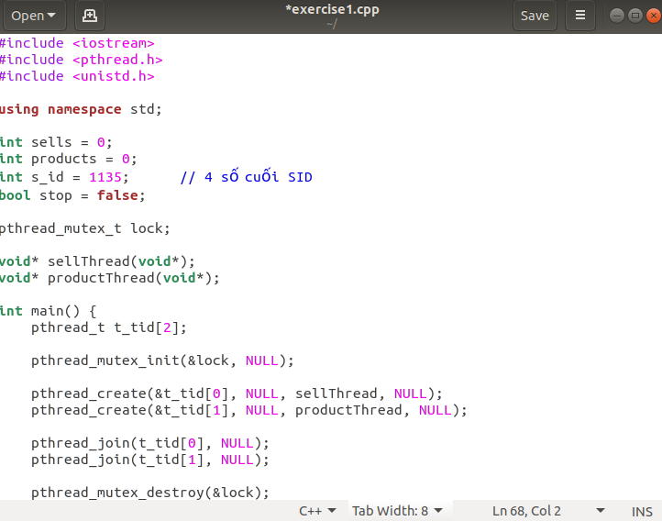
Step 2: C++ implementation (pthread + semaphore)

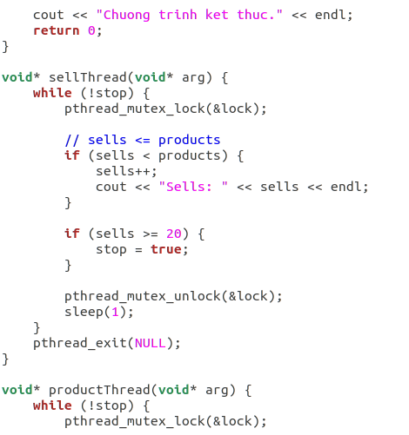

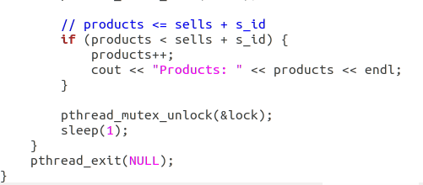

Explanation:
- The program uses two threads:
- productThread (Producer)
- sellThread (Consumer)
- products represents the number of produced items.
- sells represents the number of consumed items.
- The producer increases products only if:
products < sells + SID
- The consumer increases sells only if:
sells < products
- A mutex lock is used to protect shared variables and prevent race conditions.
- The program stops when sells reaches 20.
- The sleep() function is used to avoid busy waiting and reduce CPU usage.
Step 3: Compile the program
Step 4: Run the program and observe the output
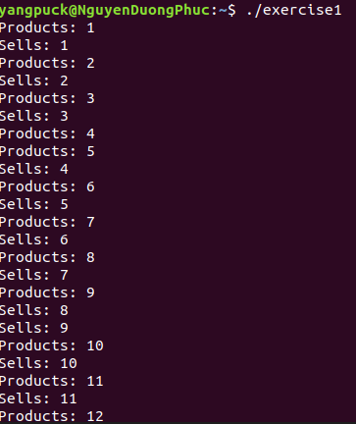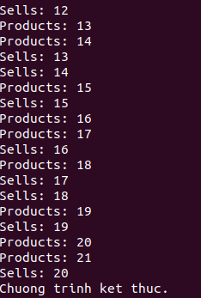

2. Given 4 threads T1, T2, T3, T4, whose jobs are print their name, running simultaneously. Let’s implement the process/thread synchronization for these 4 threads using the diagram beside.
Answer:
Step 1: Create the source file

Step 2: C++ implementation (pthread + semaphore)
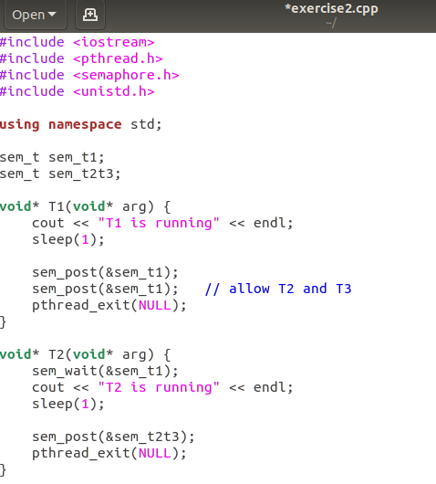
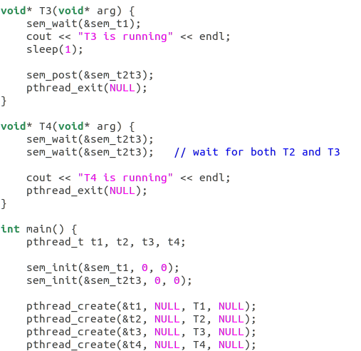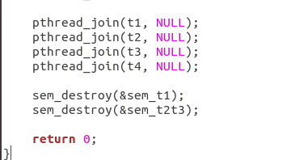
Explanation:
- Four threads are created and run concurrently.
- Semaphore sem_t1 ensures that T2 and T3 start only after T1 finishes.
- Semaphore sem_t2t3 ensures that T4 starts only after both T2 and T3 finish.
- T2 and T3 signal completion independently.
- T4 waits for two signals before executing.
- Semaphores are used to enforce the required execution order.
Step 3: Compile the program
Step 4: Run the program and observe the output
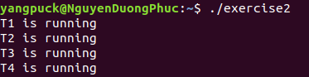

3. Given an array a declared as an integer array with n elements, a is declared as a global variable. Write a program that includes 2 threads running concurrently:
Thread 1: performs the task of generating random integers, then adding them to array a. After adding, it counts and outputs the number of elements in a immediately after insertion
Thread 2: takes an element from array a (any element, depending on the implementation), then counts and outputs the number of elements in a immediately after removal. If there are no elements left in a, it should display “Nothing in array a”.
Answer:
Step 1: Create the source file
Step 2: C++ implementation (pthread + semaphore)
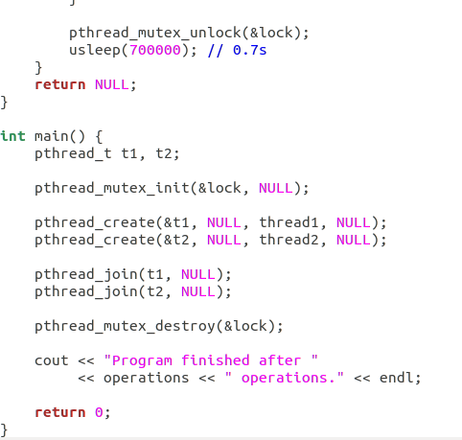
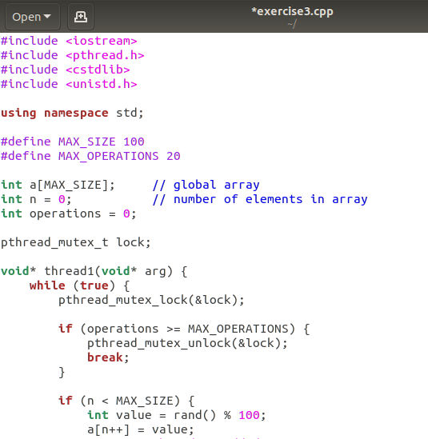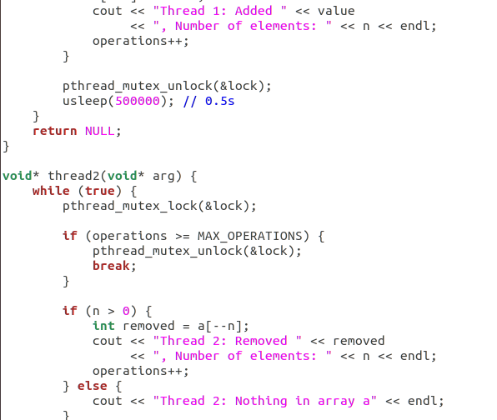
Explanation:
- The program creates two concurrent threads using POSIX threads.
- A global array a is shared between the threads.
- The variable n stores the current number of elements in the array.
- A mutex is used to synchronize access to the shared array.
Thread 1 (Producer):
- Generates random integers.
- Inserts elements into the array.
- Prints the number of elements after insertion.
Thread 2 (Consumer):
- Removes elements from the array.
- Prints the number of elements after removal.
- Prints “Nothing in array a” if the array is empty.
Main Thread:
- Initializes the mutex.
- Creates and joins the two threads.
- Destroys the mutex before program termination.
- The mutex prevents race conditions and ensures correct synchronization.
Step 3: Compile the program

Step 4: Run the program and observe the output
