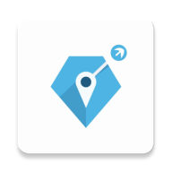
Release documentation
Totem User Manual
Experimental Smartphone GNSS Positioning Software
Software | Totem
Release date | August 23, 2026
Build date | Aug23-2026
App version | 2026.08.23-guest
Android package | com.sleepy.totem.guest
APK | totem-release-aug23-2026.apk
Author / Affiliation | Yang Jiang, Department of Geomatics Engineering, University of Calgary
Prepared for public field testing, dataset replay, and support review.
Not for safety-critical navigation.

Chapter Outline
- 1. Scope and toolbox concept
- 2. Installation, permissions, and first launch
- 3. Main screen and global navigation
- 4. Map page controls and overlays
- 5. Control page: collect, solve, and monitor device status
- 6. Solution and satellites pages
- 7. Engine Options and map settings
- 8. Dataset Log, replay, export, and delete
- 9. Post-process Dataset workflow
- 10. Export packages, public files, and masked diagnostics
- 11. Recommended field workflows and troubleshooting
- Appendix. Processing concepts used in Totem

1. Scope and Toolbox Concept
Totem is experimental smartphone GNSS positioning software for Android field use. It is designed as a deployable toolbox that connects Android raw GNSS collection, correction handling, native-engine SPP/RTK processing, map-based monitoring, local replay, and exportable session packages.
The current design follows a four-layer toolbox model: the Android app layer owns field interaction; the native bridge transfers observations, corrections, presets, and solution streams; the embedded RTK engine performs GNSS processing; and the session package stores measurements, solutions, configuration, and diagnostics for later review.
Workflow area | What Totem provides
Real-time field use | Collect Android raw GNSS data, monitor the phone solution, and run the embedded SPP/RTK engine.
Replay | Replay datasets recorded by this app for repeated processing checks and training runs.
Post-processing | Process a selected local dataset with the available settings and export generated results.
Export | Package public measurement and solution files together with masked internal diagnostics.

2. Installation, Permissions, and First Launch
- Install the APK from the release package or with ADB: adb install -r totem-release-aug23-2026.apk.
- Open Totem and allow location permission while using the app.
- If Android asks for battery optimization or related special access, allow it for stable long-running GNSS collection.
- Wait for the Map page to appear. If Google Play Services is unavailable, use the map provider selector to switch to AMap or OSM.
- Move outdoors and wait for the phone position marker before starting a field session.
Requirement | Recommendation
Android version | Android 10 or newer is recommended.
GNSS hardware | Raw GNSS measurement support is required. Dual-frequency GNSS is recommended for RTK tests.
Permissions | Location permission must be granted. Network access is needed for online maps and corrections.
Environment | Start tests outdoors with clear sky visibility whenever possible.

3. Main Screen and Global Navigation
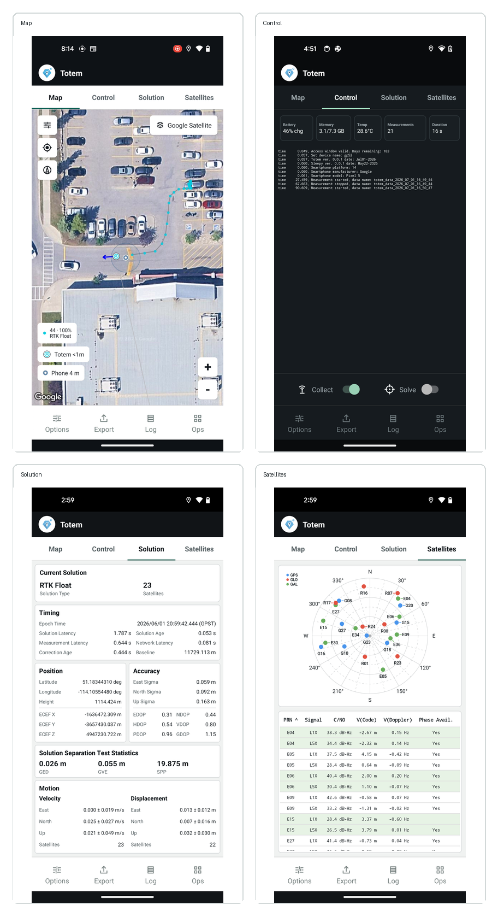
Representative Totem Android workflow screens.
Control | Action
Map tab | Shows the phone solution, Totem solution, map provider, legend, and recenter/zoom controls.
Control tab | Starts and stops measurement collection and engine solving.
Solution tab | Displays solution status, timing, position, accuracy, and motion values.
Satellites tab | Shows satellite skyplot and signal/status tables.
Options | Opens Engine Options and map/display settings.
Export | Exports the current or selected session when export is available.
Log | Opens Dataset Log for recorded sessions, replay, export, and delete actions.
Ops | Opens additional operations such as import/post-process entry points available in the current release.

4. Map Page Controls and Overlays
The Map page is the primary field monitoring view. It can display the Android phone solution and the Totem engine solution at the same time. When Totem processing is not running, Totem-specific legends are hidden so the map stays uncluttered.
Map item | Purpose
Phone marker and label | Displays the Android device positioning solution and the phone-reported accuracy. Accuracy below 1 m is shown as <1 m.
Totem marker and label | Displays the Totem solution. When prediction is enabled, the displayed marker follows the predicted Totem position.
Legend | Explains phone and Totem marker colors and shows solution-type counts/percentages for nonzero Totem solution types.
Provider selector | Switches map provider and style, including Google, AMap, OSM, and satellite styles when supported.
Recenter | Centers the camera on the Totem predicted solution when Totem is running; otherwise centers on the phone solution.
Zoom + / - | Changes the map zoom level. User zoom interaction temporarily suppresses automatic prediction/animation interference.
Compass / rotate reset | Returns the map bearing to north-up when rotation has been changed.
Map Options | Controls prediction animation, general animation, map provider, satellite map style, and display preferences.

5. Control Page: Collect, Solve, and Monitor Device Status
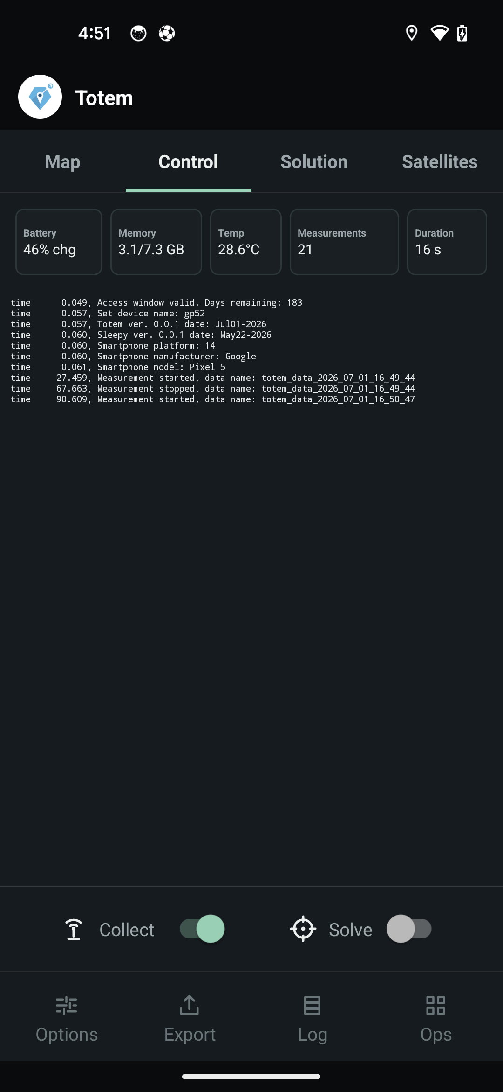
Current Control page with device status, measurement count, and session duration.
The Control page is intentionally compact for field use. It shows phone status, current GNSS measurement availability, and session duration directly above the console.
Control page item | Meaning
Battery | Battery level and compact charging state, for example 46% chg.
Memory | Approximate used/total RAM.
Temp | Battery temperature reported by Android.
Measurements | Number of measurements in the latest Android GNSS measurement epoch. The value resets to -- when collection stops.
Duration | Elapsed time for the current collection session. It updates every second during the first minute and then updates by minute.
Collect switch | Starts/stops Android raw GNSS collection and local session recording.
Solve switch | Starts/stops the embedded engine. It is enabled only after collection is running.
Console | Shows short operator-facing messages. Detailed internal diagnostics are saved in the masked diagnostic log.

Recommended real-time sequence
- Open Control and check Battery, Memory, Temp, Measurements, and Duration.
- Turn Collect on. Confirm the console prints the measurement-start message and Duration starts at 0 s.
- Wait until Measurements is nonzero and stable enough for the test environment.
- Turn Solve on. Wait for engine initialization and then monitor Map and Solution.
- To stop, turn Solve off first, then turn Collect off. Export the session if needed.

6. Solution and Satellites Pages
The Solution page is arranged for quick inspection while moving. It uses compact cards rather than long scrolling tables.
Solution item | Displayed information
Current solution | Solution type, satellite count, and AR ratio when ambiguity-resolution information applies.
Timing | Epoch time, solution latency, solution age, measurement latency, and network latency.
Geometry | Correction age and baseline length.
Position | Latitude, longitude, ellipsoid height, and ECEF coordinates.
Accuracy | East/North/Up sigma and DOP values. TDOP is omitted for the compact display.
Solution separation test statistics | GED, GVE, SPP, and IAR statistics when enabled by configuration.
Motion | Velocity East/North/Up and displacement East/North/Up, each shown as value plus sigma where available.

The Satellites page shows a skyplot and per-satellite details. Constellation colors are used consistently in the skyplot legend.

7. Engine Options and Map Settings
Open Options from the bottom navigation bar. Engine Options uses professional grouped controls for positioning mode, estimator, base/correction handling, sensors, quality control, and logging.
Setting group | Typical controls
Mode | SPP/RTK processing mode and solution behavior.
Estimator | GLSF-based estimator settings and stochastic model parameters.
Base / corrections | RTCM3 or correction source options, segmented IP/port entry, and correction connection settings.
Sensors | GNSS, inertial, camera, and sensor-fusion availability. Public Totem disables camera/sensor fusion controls.
SPP / RTK / GED / GVE | Processing thresholds and quality-control options. GED refers to inter-epoch GNSS error detection and repair; GVE refers to GNSS velocity-estimation checks.
Ambiguity resolution | Public Totem exposes only Try Ambiguity Resolution. Advanced IAR controls are not exposed in this release.
Map settings | Prediction animation, general animation, provider, satellite style, legend behavior, compass/rotation behavior, and recenter behavior.
Logging | Operator console verbosity and internal diagnostic logging. Full diagnostic detail is written to masked logs rather than printed in the console.

8. Dataset Log, Replay, Export, and Delete
Dataset Log lists sessions recorded by the app. The list header shows the total number of local datasets, and each row provides dataset metadata and available actions.
Action | Purpose
Replay | Replays a dataset recorded by this app. Replay uses the stored measurements and settings available for the public release.
Export | Creates a ZIP package for sharing, archiving, or desktop review.
Delete | Removes the selected local dataset from the phone.
Refresh | Reloads the local dataset list.

9. Post-process Dataset Workflow
Post-process Dataset is used for solving a selected local dataset outside the real-time field session. Public Totem supports post-processing/replay of datasets recorded by this app; external import is disabled in the public release.
Post-process control | Action
Select dataset | Choose a local recorded dataset package.
Process | Starts post-processing with the selected/current options.
Options | Opens the available processing options for the replay/post-process run.
Use current options | Uses the current Engine Options values instead of changing replay-specific options.
Export | Exports processed outputs after the run finishes.
Console output | Shows a concise status stream. Verbose engine detail is stored in the masked diagnostic log.

10. Export Packages, Public Files, and Masked Diagnostics
Export creates a standard ZIP package. Measurement text files and solution files are intentionally left readable for public use and external analysis. Internal diagnostic files are binary-masked so they can be decoded for support/debugging without cluttering normal user packages.
File type | Export behavior
Measurement text files | Readable public files.
Solution files | Readable public files.
Configuration/session metadata | Stored with the package for reproducible replay where supported.
Internal diagnostic logs | Masked binary files for support/debugging.
Decoder | Use the local Totem diagnostic decoder script when a support package needs to be inspected.

11. Recommended Field Workflows and Troubleshooting

Real-time RTK/SPP field workflow
- Open Map and confirm the phone position marker appears.
- Open Options and confirm correction source, map provider, prediction/animation, and ambiguity-resolution preference.
- Open Control, start Collect, and wait for nonzero Measurements.
- Start Solve and monitor Map, Solution, and Satellites.
- Stop Solve, stop Collect, then export the session.

Common issues
Issue | Check
No map | Switch provider, check network access, or use AMap/OSM when Google Play Services is unavailable.
No phone solution | Confirm location permission and test outdoors.
No Totem solution | Confirm Collect is on, Measurements is nonzero, correction source is configured, and the engine is running.
Engine stalls | The app watchdog starts after engine initialization and stops the engine if no solution is produced for an extended period.
Export fails | Check storage and retry after stopping collection/processing.
Unsupported device | The phone may not expose Android raw GNSS measurements required by Totem.

Appendix. Processing Concepts Used in Totem
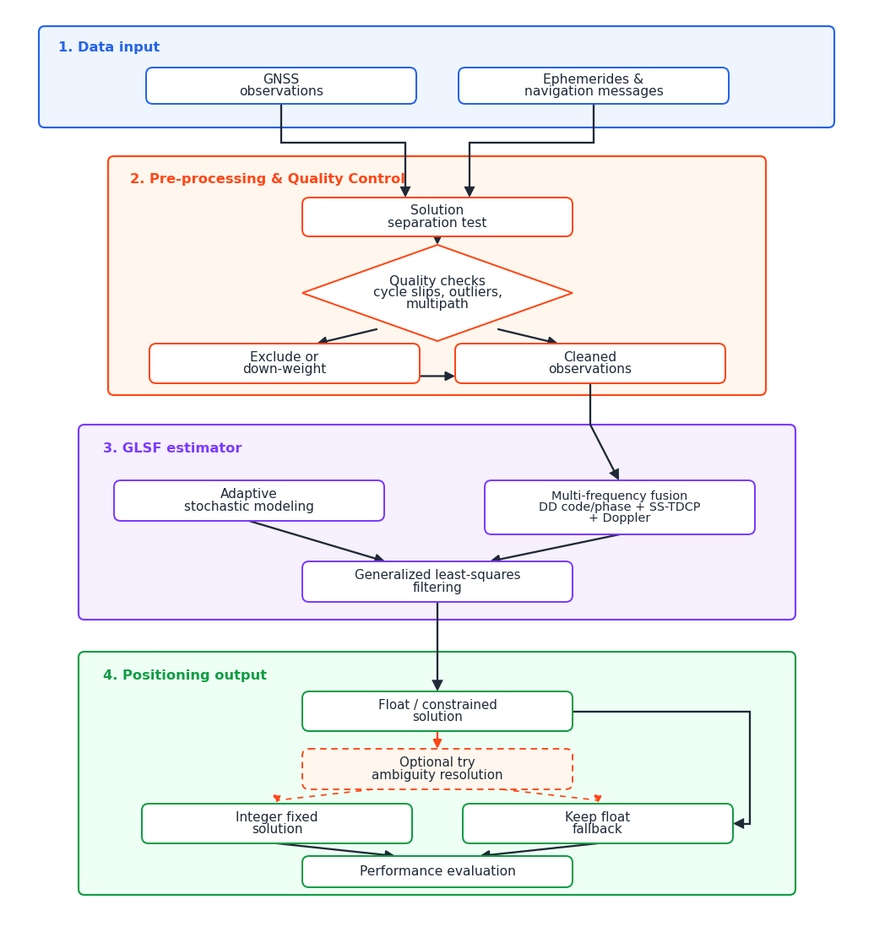
RTK processing pipeline used by the embedded engine.
The embedded processing configuration is designed for smartphone GNSS observations, where carrier-phase cycle slips, pseudorange noise, multipath, and duty-cycle behavior require careful quality control.
Term | Meaning in Totem
SPP | Single Point Positioning using the phone observations and broadcast/correction information.
RTK | Real-Time Kinematic positioning using rover and base/correction information.
GLSF | The generalized least-squares filtering estimator used by the embedded engine configuration.
TDCP | Time-differenced carrier phase, useful for inter-epoch displacement information over continuous arcs.
GED | GNSS error detection/repair controls for cycle slips and observation consistency.
GVE | GNSS velocity-estimation checks based on ALS thresholds and related controls.
IAR | Integer ambiguity resolution. The public release exposes a simplified Try Ambiguity Resolution control.
RTCM3 | Correction/base data format used by many network or local correction sources.

