

**Capstone Design (2)**

**Spring, 2019**

**School of Software, CAU**

**Final Report**

**Team Name**

YANG JONG GOOK

**Team list**

20166282 Yang Tae Seong

20165770 Kim Byoung Gook

20166319 Yoon Jong Yeop

**Index**

**1. Project Introduction** **3**

1.1 Introduction 3

1.2 Motivation & Goals 3

1.3 Difference of other program 4

1.4 Team roles and Project schedule 5

1.4.1 Project Schedule 5

1.4.2 Team roles and Individual Schedule 5

1.5 Algorithm Introduction 6

1.6 Development Environments 7

**2. Function Implement** **8**

2.1 Project outline 8

2.2 Development progress 10

**3. Project Result** **12**

3.1 Version Check(Github) 12

3.2 Review 12

# **1.** **Project Introduction**

## **1.1 Introduction**

The heat of education in our country is in the hands of the whole world. Because of this kind of education, the upper class gets expensive money and private education, but the lower class does not. In addition, some students receive expensive consulting services at the academy. We, too, did not know all the type at the time of university entrance and relied solely on school teachers. When I entered the university, I noticed that there were a lot of type in college, and I had a lot of regrets that I did not know these kinds of admission properly. For these reasons, we have created a college admissions consulting site to help many students.

## **1.2 Motivation & Goals**

There are many universities in our country. And many universities are recruiting students with many different types. We do not know all these examples and we can’t find them all. Therefore, students are required to pay a high price for university consulting, seek out private institutes, and students who live in the provinces are hardly able to obtain such opportunities.

Our goal is to be a site for all students, but especially to inform students about the different types of universities for students who are away from private tutoring and to let them know how to best suit their needs.

## **1.3 Difference of other program**

Our programs have these strengths compared to websites that analyze students' grades and determine which colleges they can go to.

* This program is available for all students in grades one through three of high school.

: Unlike other programs that offer consulting services to high school students in the third grade, our program can analyze data by entering their grades and specifications even if they are not in the third grade.

Through early consulting, students can develop a more systematic examination strategy.

* By comparing the passing handwriting with the specification of the user, it is possible to establish the accuracy of the consulting and to facilitate the setting of the user's future admission strategy

: It is not easy to establish the credibility of the user even though other programs can refer to college admissions. It is also difficult for users to set up an admission strategy and plan only with the college information provided by other programs. We not only extract information from college admissions colleges based on user specifications, but also compare the passing handwriting with the user's specifications. So we get the credibility from the user and the ease with which the user sets up the admission strategy later.

* Free program

: The cost of consulting, whether offline or online, is a burden on students. The representative sites of college entrance examination, the College of Education, and the Uwaya Fly, are part-pay systems. However, our program is free, minimizing the burden on the user. In addition, since it is a free program, the user can conduct consulting at all times, so that he or she can systematically and consistently set the direction that should be taken for the admission of the university of the target.

## **1.4 Team roles and Project schedule**

### **1.4.1 Project Schedule**

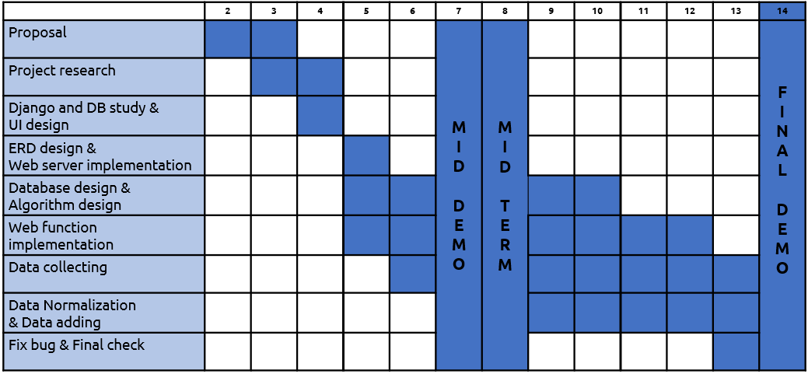

### 

### **1.4.2 Team roles and Individual Schedule**

* Yang Tae Seong : Database design and Algorithm design

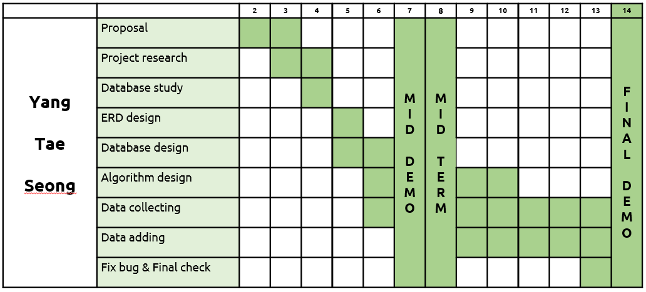

* Kim Byung Gook : Database design, Data normalization

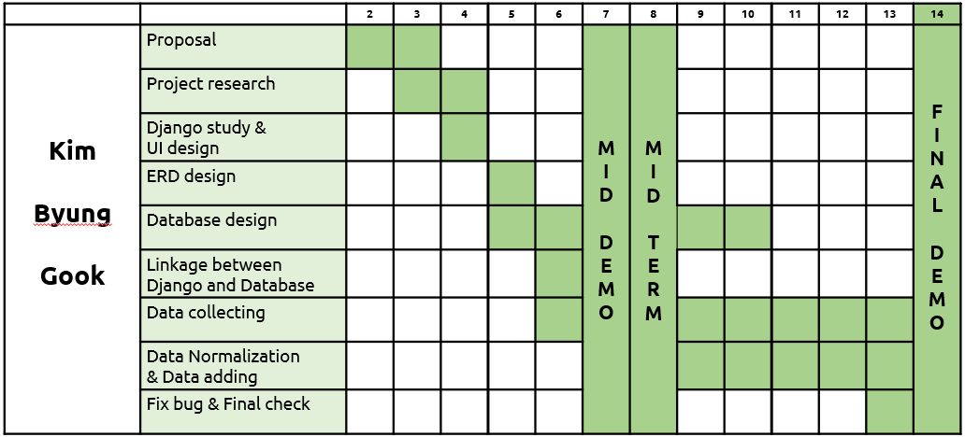

* Yoon Jong Yeop: Web function and Server implementation

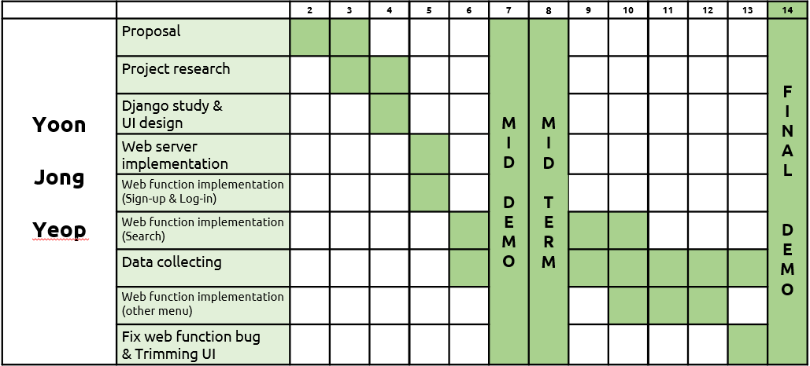

## **1.5 Algorithm Introduction**

First, the user inputs data. Input data includes the grade, service time, student council officer activity, and reading volume. The input data is compared with the typical data of each university in the server to calculate which data is insufficient. Let's take an example of output data accordingly. 'X' is missing from the 'D' specification at the university. Prepare 'Y' because the 'D' and 'E' specifications at the university are not enough. Please note that the high school students can get the entrance examination guideline.

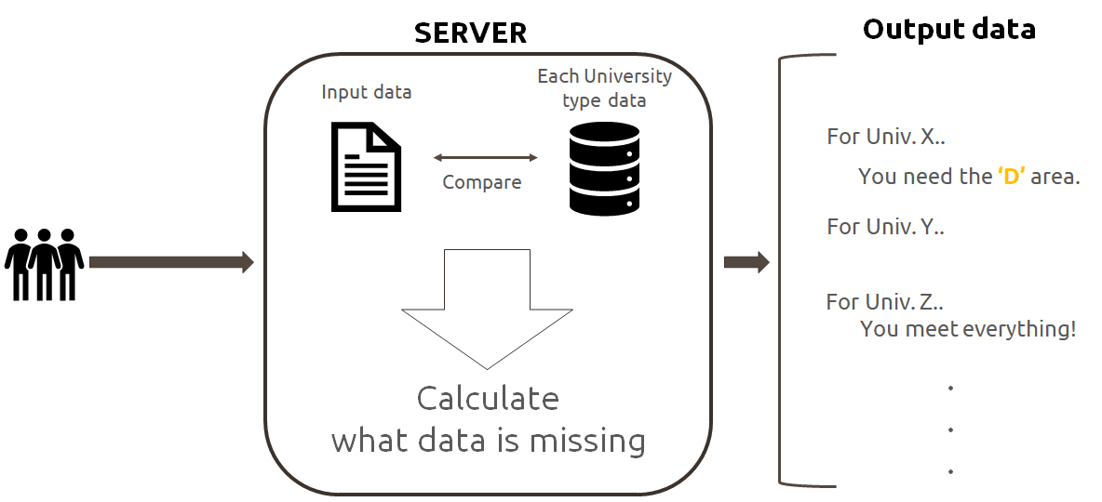

## **1.6 Development Environments**

The overall internal environment is as follows. Django as the backend, web languages such as HTML, CSS, and JS as the front end, AWS as the web hosting server, and sqlite as the database.

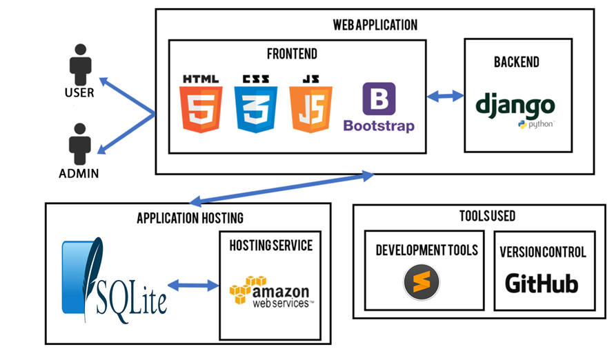

Use nginx (1.10.3) and uwsgi (2.0.18) for AWS ec2 for stable web server deployment in addition to the above environment.

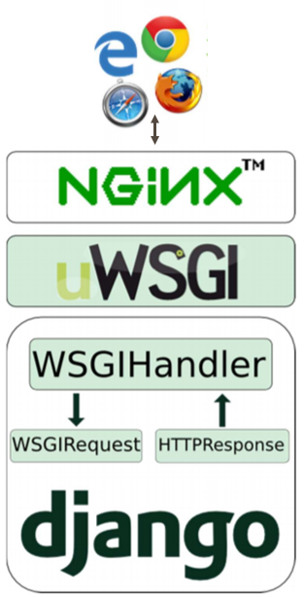

# **2.** **Function Implement**

## **2.1 Project outline**

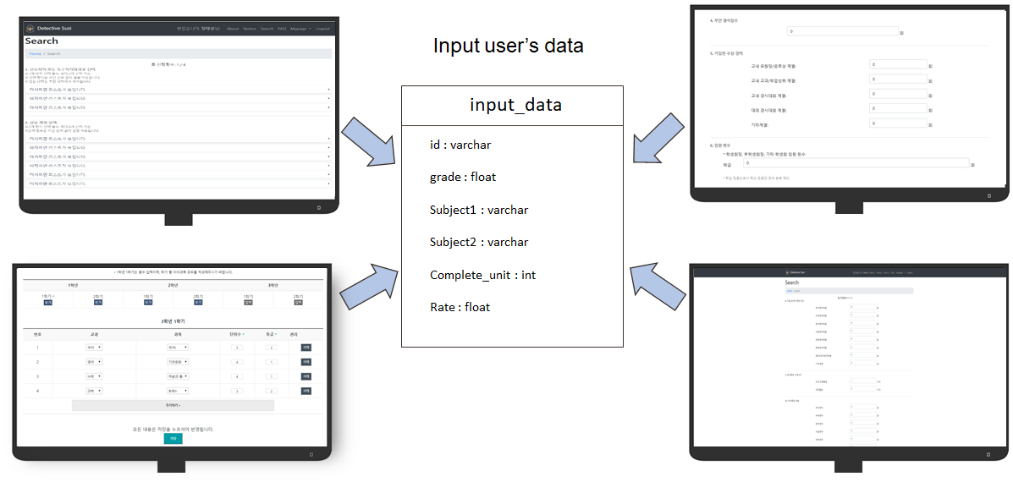

The user inputs his / her grades and specifications.

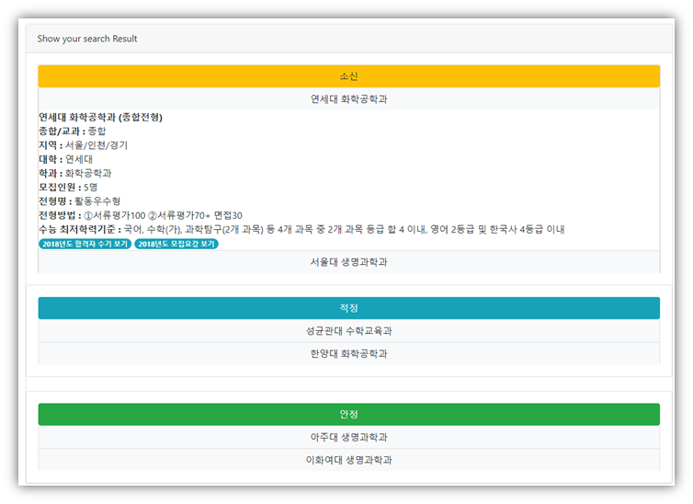

Analyze the user's data and output the school, department, and model suitable for the user's challenge.

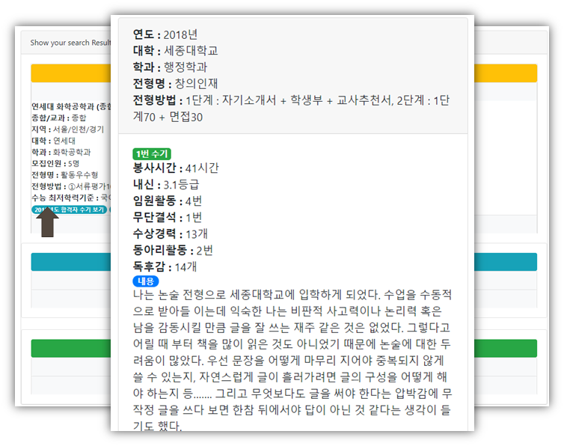

Detailed function of output data: View the last successful applicant of the item

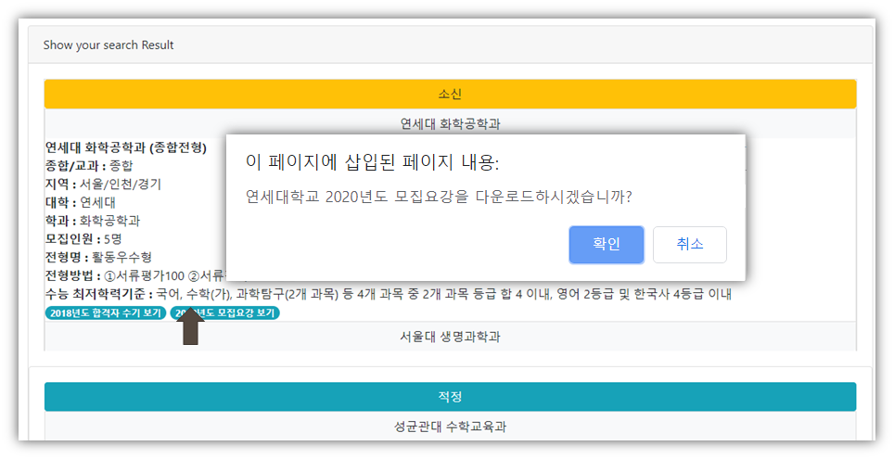

Detailed function of output data: Downloading this year's application summary of the item concerned

## **2.2 Development progress**

UI Design

* (Web surver implementation)

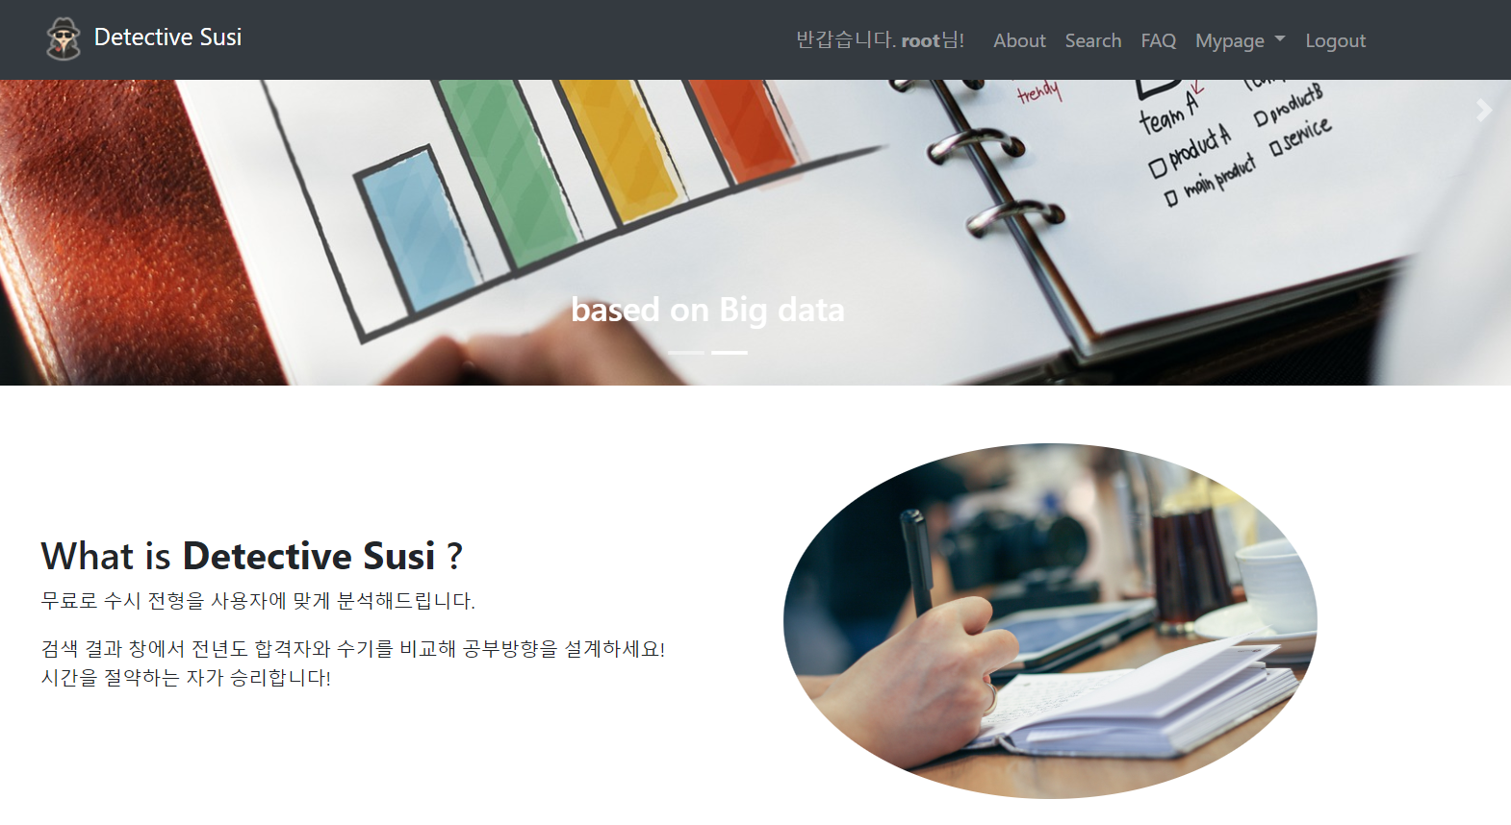

Database Design

* (ERD design, Algorithm design)

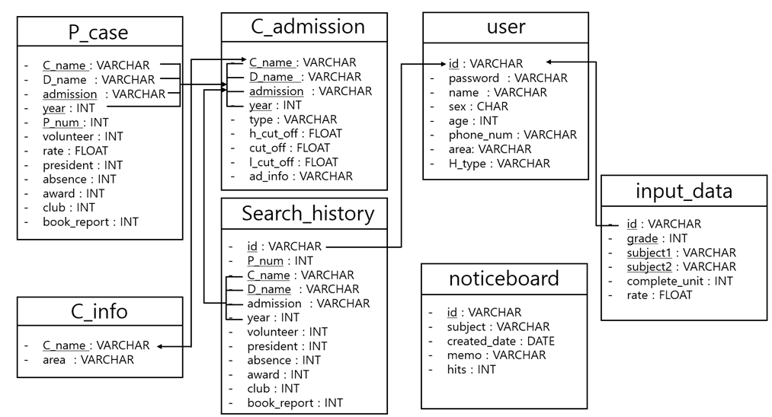

Each web function implementation

# 

Data Collecting & Adding

* (Data normalization)

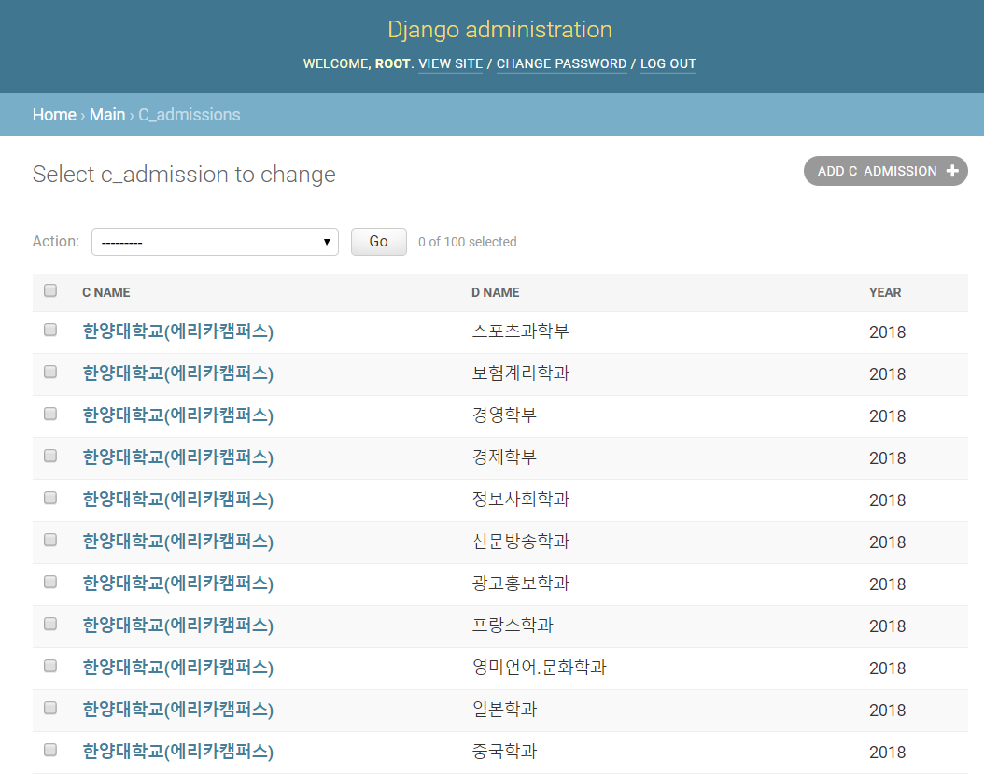

# 

# **3.** **Project Result**

## **3.1 Version Check(Github)**

As described in the above development environment, the project version check used Github. Github URL : <https://github.com/rlaqudrnr810/CapsYJG>

## **3.2 Review**

* **Yang Tae Seong**

I was in charge of backend with Kim Byung Kook. I've put a lot of emphasis on the database and algorithms. This was the first time to implement a database that would run on a real website.I had a lot of unexpected errors, but I took a lot of time and effort to overcome them one by one.At the time, the process seemed to be very difficult, but the most memorable part of the project was the hard work.The next time I run a similar project, I have the courage and confidence to work more efficiently.

And I am very grateful to the team members.

Every time I did a team project, there was a big and small friction with the team members. But I was able to work in a pleasant atmosphere in this project.I felt that teamwork was a very important part of finishing the team project.

Finally, I would like to thank the same classmates, assistant professor, and professor who helped us make our team project a better result through questions and advice.

* **Kim Byung Gook**

I was responsible for the overall algorithm design of the database and the program.

This is the first time for me to link the database with the web, so I worked on the project while studying that part.

In the course of study and connection, django basically supports sqlite3 and we wanted to study MariaDB, so we tried to do it by connecting with MariaDB, but there were too many errors.

Still, we tried to connect to the database by overcoming such errors one by one, and we also collected and added data.

The most memorable error was that when django and MariaDB were linked, the tables of sqlite3 that were in django were copied over to MariaDB, but the data inside was not passed over. it took the most time to resolve this error.

But as I went through these processes, I thought I could do better next time I did it again.

In addition, django provides the function of obtaining results set by accessing the DB by changing the ORM code to the sql query statement without directly writing the sql query statement.

But we decided to use the sql queries we learned at school, and with our short knowledge, there were queries that were not accessible from django to sql queries, and eventually had to use ORM. This process also remains a painful memory.

However, the team members worked together and worked hard on the project and finished the project well.

It was the first time I'd done a team project for so long, and through Capstone design I realized how important communication and atmosphere between team members was.

I think I am getting a lot through Capstone Design overall.

* **Yoon Jong Yeop**

I was responsible for and implemented the overall web functionality. I first came across the Django framework, and I became clear about the benefits of Django that I learned from the pre-development environment research. The more I understand the web development, the more I can see why django uses MVC, and how to use django's functions in the functions to be implemented. Regarding the algorithm application, we changed the existing RAW SQL to ORM SQL query. It is not easy to understand about ORM and it is unusual to use ORM. It is an opportunity that I do not have many opportunities to share with the team members during one semester each week and share what I have been working on for a week. I took advantage of this opportunity to know what the team project is and how to proceed.