# Simulation of JadePix1

In this article, JadePix1 is a monolithic chip designed by Ying Zhang and Allpix2 is used as the simulation software.

## Structure of JadePix1

The JadePix1 chip contains two sensor matrices. The pixel size in sensor matrix 1 is 33\*33μm2, and the pixel size in sensor matrix 2 is 16\*16μm2. Each sensor matrix has 16 source followers to select the sensor for output. There are 24 function blocks in sensor matrix 1 and sensor matrix 2, but there are 8 function blocks in sensor matrix 1 used as preamplifiers, and others used as probe signals, function blocks in sensor matrix 2 are mainly used for testing. This paper simulates a sensor in the sensor matrix 1 which is used to detect signal, that is, the function block indicated by the red box in Figure 1‑1. In the digitization process, eight function blocks used as preamplifiers are considered.

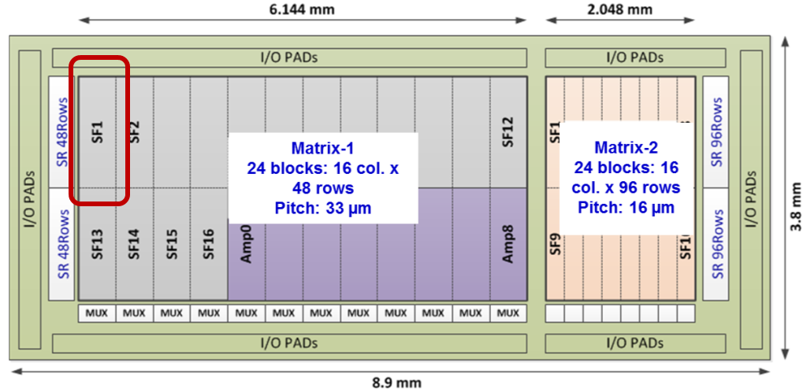

Figure 1‑1 JadePix1 structure

### Structure of JadePix1 sensor

The sensor in JadePix1 is composed of 48\*16 pixels. The size of each pixel is 33\*33μm2, and the thickness of the sensor is 15μm. Figure 1‑2 shows the structure of the sensor.

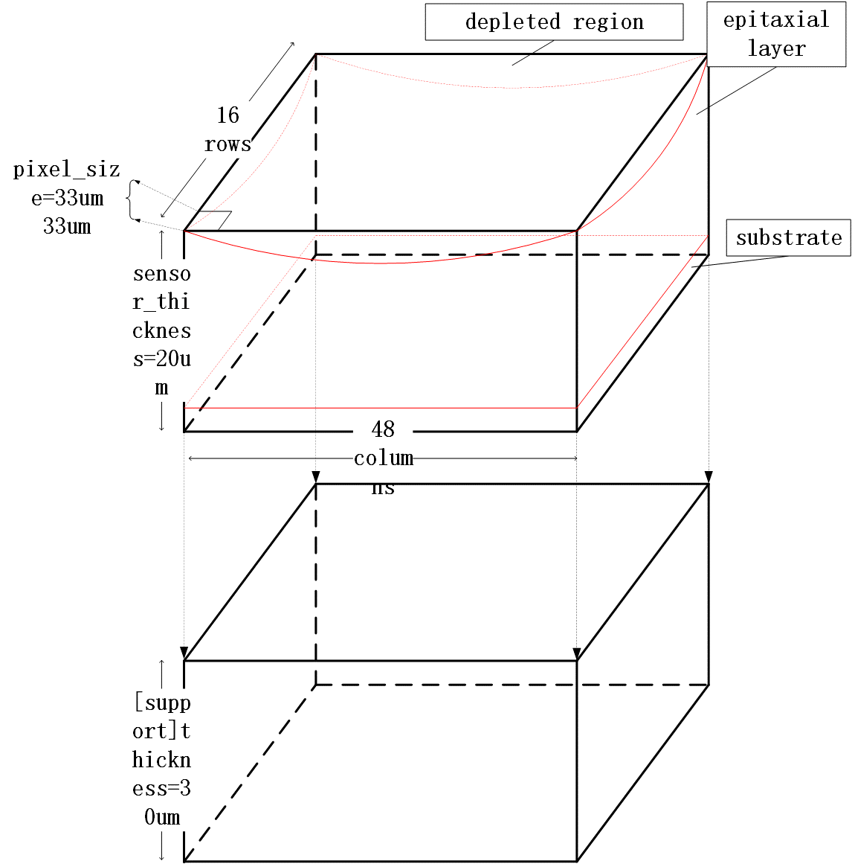

Figure 1‑2 Structure of the JadePix1 sensor

The sensor defined by Allpix2 is just a block of material. The addition of an electric field adds the depletion layer, the epitaxial layer and the substrate to the sensor as well. When the depletion layer electric field is introduced, the way collector collects the charges is also introduced.

### JadePix1 sensor placement in AllPix2

Allpix2 defaults to the body center of the detector as the origin point when placing the detector. The plane where pixels are arranged is the xy plane, and the direction of positive direction of z-axis can be seen in Figure 1‑3.

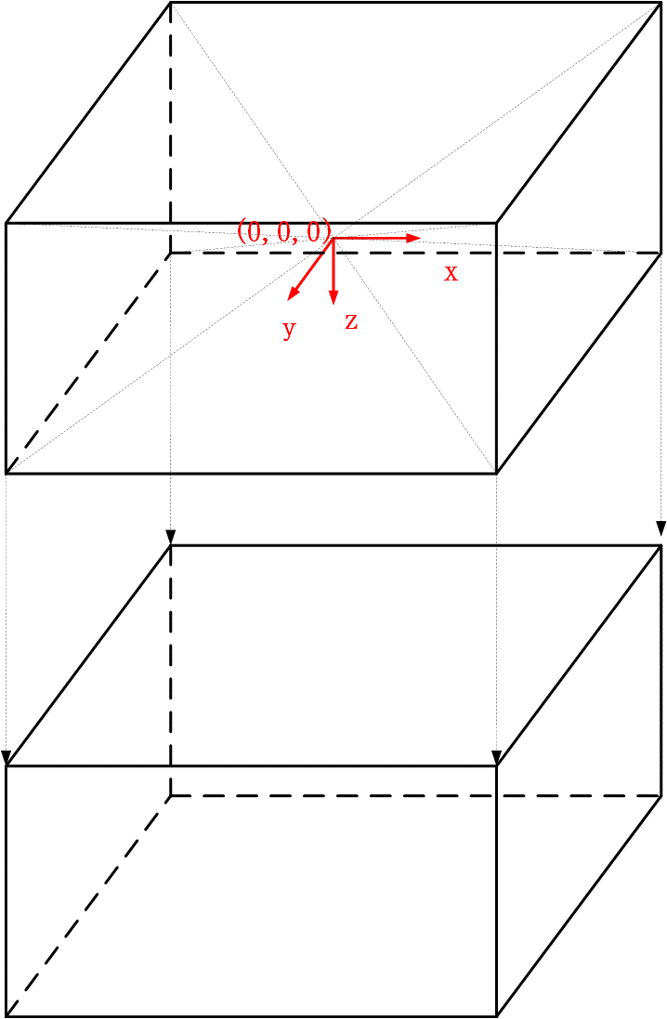

Figure 1‑3 JadePix1 sensor placement in AllPix2

## Settings for JadePix1 parameters in AllPix2

### Detector configuration file and detector modules configuration file

The detector configuration file defines the placement of the sensor, as shown in Figure 1.3. Since AllPix2 does not have a JadePix1 sensor as the detector module, users need to define the detector module. The parameters of the detector are as shown in Figure 1.2. The specific configuration file is:

* type="monolithic" (define the type of detector)
* number\_of\_pixels = 48\*16
* pixel\_size = 33μm 33μm
* sensor\_thickness = 20. μm
* sensor\_material = “Silicon”
* [support](support layer definition)
  + thickness = 30μm
  + size = 1584μm 528μm
  + location = “sensor”(support layer follows the sensor)
  + material = “Aluminum”

### Setting of parameters in main configuration file

When the AllPix2 is simulating a silicon detector, the various functions of the silicon pixel detector are divided into several different functional modules. Each functional module has its own unique parameters. The parameters are set differently to simulate the unique performance of different detectors. Specific to JadePix1 sensor, the settings of various function module parameters are as follows:

* [Allpix] (global variable)
  + log\_level = "INFO" (output redundancy degree of log file)
  + log\_format = "DEFAULT" (log information output form)
  + detectors\_file = "jadepix1\_detector.conf" (invoke the JadePix1 detector configuration file)
  + number\_of\_events = 10000 (total number of events)
  + model\_paths = "mymodels/" (where the detector model configuration file is stored)
* [DepositionGeant4]
  + physics\_list = FTFP\_BERT\_EMY (particle reaction processes defined in Geant4)
  + particle\_type = "gamma"
  + beam\_energy = 5.89keV
  + beam\_position = 0 0 -5mm
  + beam\_size = 231μm  
    Beam\_size refers to a circle with a diameter of 231 μm centered on the particle source. The distribution of photon numbers in each diameter satisfies a Gaussian distribution with a width of 231 μm. Figure 1‑4 shows this description.  
     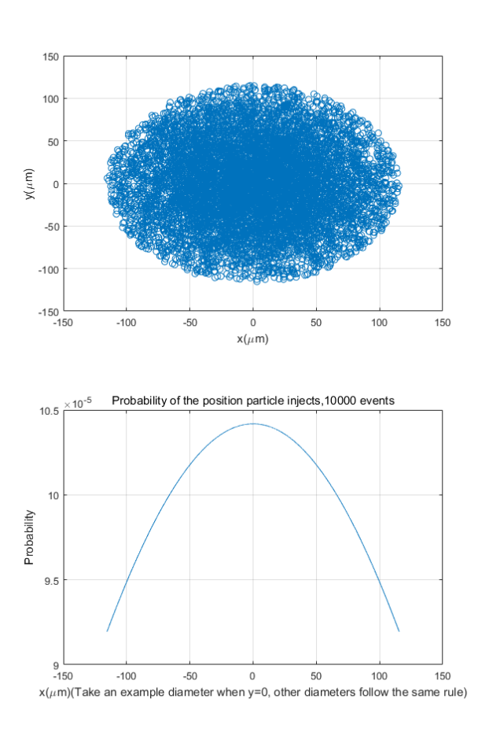

Figure 1‑4 The distribution of incident photons

* + beam\_diraction = 0 0 1(represents the unit vector of the direction)
  + number\_of\_particles = 1(particles in one event)
  + max\_step\_length = 1μm(the maximum length of each step in each sensitive device simulated by Geant4)

[ElectricFieldReader]  
In this part some explanations have to be made. First of all, there are two sets of coordinate systems in AllPix2. The first one is global coordinate system, and the second one is local coordinate system. When you put the detector, the coordinate system refers to the global coordinate system, as well as when you talk about particle injection, the coordinate system can be seen in the picture below  
 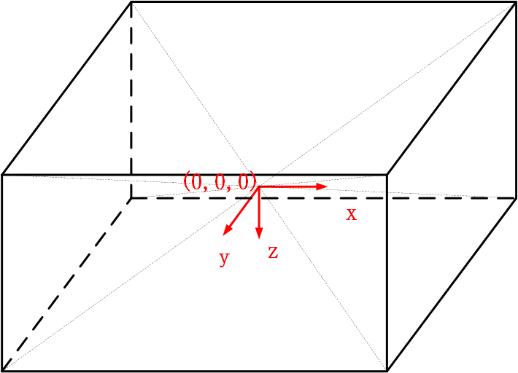  
 Figure 1‑5Global coordinate system  
and when you talk about local coordinate system, you are dealing with the detector components, the coordinate system is shown in the picture below  
 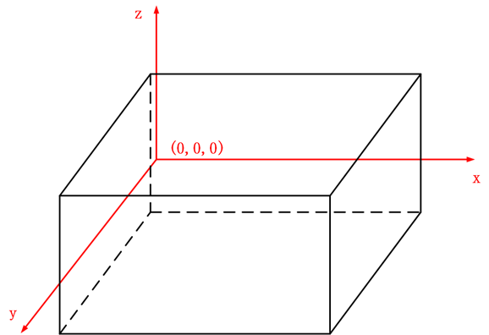  
 Figure 1‑6Local coordinate system  
The transform from local coordinate system to global coordinate system can be seen in $PATH-TO-ALLPIX/src/core/geometry/Detector.cpp. For linear electric field, you can draw 2D projection in xy plane, xz plane and yz plane as being shown below  
 electric field magnitude 
0.5 
0.4 
0.3 
0.2 
0.5 
120 
100 
80 
60 
40 
20 
1.5 
x (mm)   
 Figure 1‑72D projection in xy plane  
 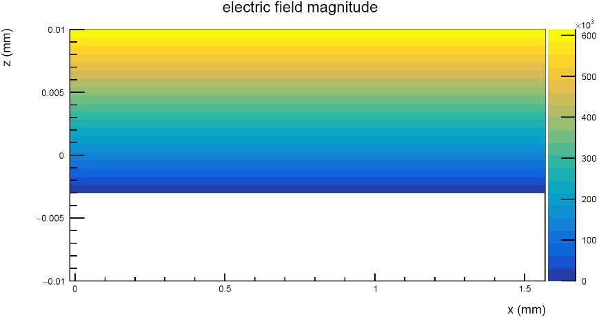  
 Figure 1‑82D projection in xz plane  
 electric field magnitude 
0.01 
0.005 
-0.005 
_0.01 
0.2 
0.3 
0.4 
600 
500 
400 
300 
200 
100 
0.5 
Y (mm)   
 Figure 1‑92D projection in yz plane  
and the electric field strength is also plotted in z axis  
 o 
3 
0 
-500 
-1000 
-0.01 
-0.005 
electric field (z-component) 
0 
0.005 
0.01 
z (mm)   
 Figure 1‑10Electric field strength in z axis

* + model = "linear" (add a linear electric field)
  + bias\_voltage = -400V (bias voltage applied to the device)
  + depletion\_depth = 13μm(depletion layer depth in a linear electric field)
* [GenericPropagation]
  + temperature = 293K
  + charge\_per\_step = 100 (maximum number of charge carriers traveling together, dividing the total number of charge carriers generated at a particular point into a collection of these charge carriers and a set of residual charge carriers)
* [SimpleTransfer]
  + max\_depth\_distance = 5μm (the maximum distance in depth, propagation charge will take this factor into account)  
    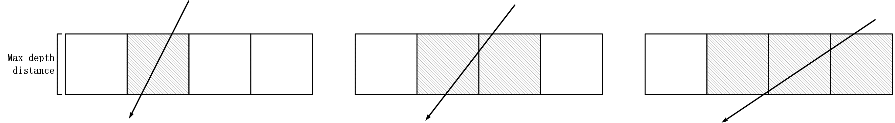

Figure 1‑11 max\_depth\_distance in the sensor

* [DefaultDigitizer]
  + electric\_noise = 30e (mainly include shot noise and thermal noise)
  + gain = 8 (preamplifier gain)
  + threshold = 0e (as long as the collected charge exceeds this threshold, it will be considered as a hit)
  + threshold\_smearing =0e (width of Gaussian distribution of uncertainty of threshold)
  + adc\_resolution = 16 (A/D converter, ADC, the number of binary digits)
  + adc\_smearing = 0e (the width of the Gaussian noise during ADC conversion after passing the threshold)
  + adc\_slope = 3.8e  
    from





we can derive



In the formula, is the voltage amplitude gain per unit electron, here, the experimentally measured value is 0.032mV/e; is the energy of the incident particles, in this simulation, 5.89keV is used; is the average energy needed to generate an electron-hole pair, which is 3.6eV for silicon; n is the ADC's number of binary digits, ie, adc\_resolution; is the maximum voltage amplitude that the ADC can convert, and is set to be 8V in this simulation.

## AllPix2 Simulation Results

The above parameters are applied to the compiled allpix binary file. The simulated photon deposition energy spectrum is shown in Figure 1‑6.

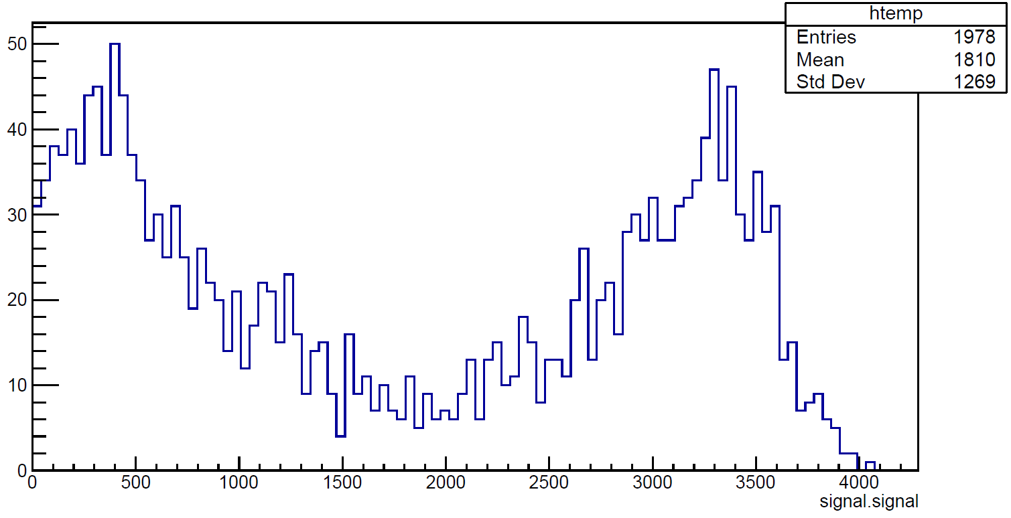

Figure 1‑12 Photon deposition energy spectra of AllPix2 simulated JadePix1 sensors

An electron-hole pair generated by the deposition of photon energy in the detector will have a characteristic peak if it is completely collected by the collector. If an electron-hole pair lose its energy in the collection process, a main peak will appear and the peak position of the main peak will be obviously below the characteristic peak. There is a characteristic peak near 3500 and a main peak near 500 in figure 1.6. The peak position of the characteristic peak is similar to the theoretical peak value calculated by equation

, which is about 3450 ADCs. The obtained characteristic peaks are very similar to the theoretical calculations, which indicates that the simulation results of AllPix2 are reliable.

The result of AllPix2 simulation adopts the data storage structure of TRef, which is not conducive to future analysis. Therefore, the TRef structure needs to be converted into TTree structure in the way described in AllPix2 manual(Thanks for Xin’s help). Figure 1‑7 shows this process.

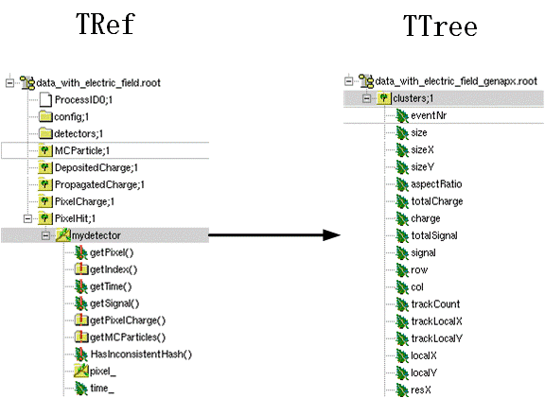

Figure 1‑13 Conversion of TRef to Ttree

# Data analysis

## Data structure

Data structure is shown in Figure 2‑1. There is a branch named ‘clusters’ in root file and also a leaf named ‘signal’ in ‘clusters’ branch. Every entry represents one cluster signal for ‘signal’ leaf. The number of adc depends on cluster size and size distribution could be find in ‘size’ leaf.

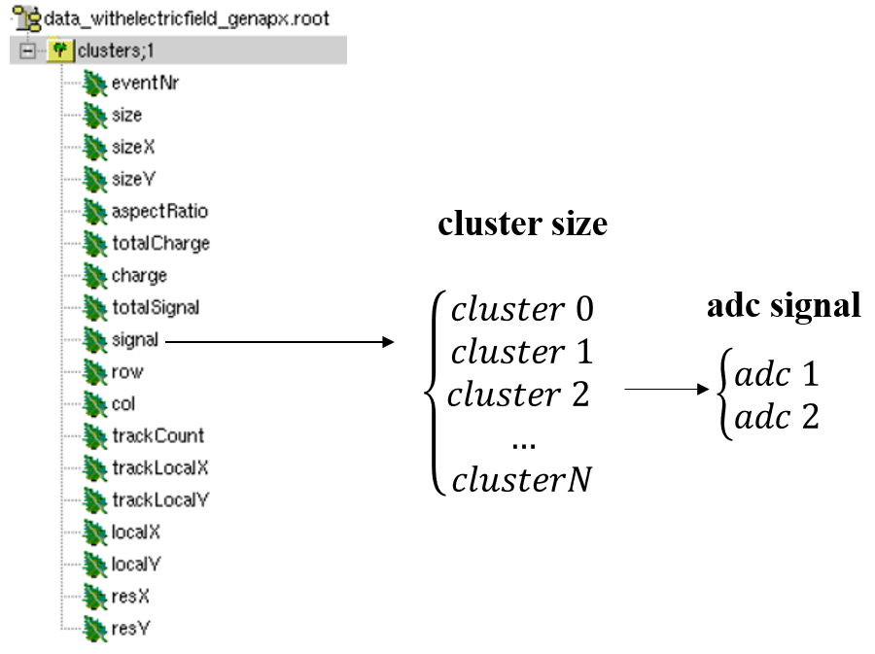

Figure 2‑1 data structure

## linear electric fields configuration

Single photon and linear electric fields are implanted in this version. The setting of parameters in main configuration file is below:

[DepositionGeant4]

number\_of\_particles = 1

[ElectricFieldReader]

model = "linear" (add a linear electric field)

bias\_voltage = -400V (bias voltage applied to the device)

depletion\_depth = 13μm(depletion layer depth in a linear electric field)

others are default value (see 1.2.2)

### linear electric fields

For linear electric fields in Allpix2, the field has a constant slope determined by the bias voltage

and the depletion voltage. The sensor is always depleted from the implant side, the direction of the electric field depends on the sign of the bias voltage (with negative bias voltage the electric field vector points towards the backplane and vice versa). The electric field is calculated using the formula(see Allpix2 manual P71)



Where  is the thickness of the sensor, and , are the depletion and bias voltages, respectively. This formula bases on **prototype** **one-sided step p-n junction** and **over-depletion condition**.

**The following derivation is general and applies under any bias condition:**

For a one-sided step p-n junction, the physical diagram is below:

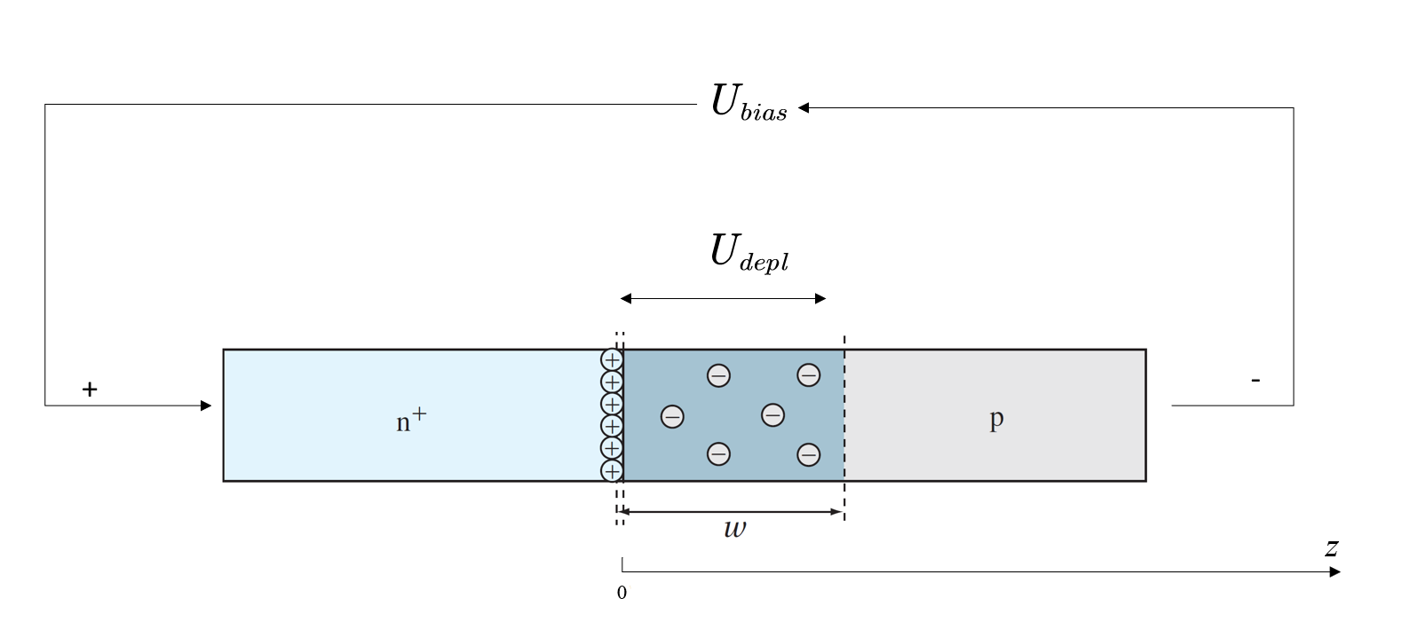

Figure 2‑2 one-sided step p-n junction

To find the electric field, need to solve Poisson’s equation:



The charge density  is the charge per unit volume at a given position , and ε is the permittivity of the semiconductor. On the p-type side, where ,



 is ionized acceptors concentration since the ionized acceptors are negatively charged. Assume that  is zero and thus  outside the depletion region .Using these expressions in Equation , on the p side for :



The result is



Now find the functional form of , the voltage distribution. Use the expression



On the p side, we integrate V from  to  and find:



or



When ,, then



so



When  ( is full depletion voltage),  results to



with mobility , resistivity  and . Depend on equation , if ,  (over depleted), PN junction could be considered as capacitor.



### CCE calculate

Charge collection efficiency is defined by



where



### CCE analysis

…