Understanding Airbnb Listing Performance through Spatial Semantics and Urban Amenities: Evidence from LLMs and XAI

Yang Wang¹, Joseph Shingleton² and Jing Yao³
Summary
This paper explores how the way hosts describe nearby places in Airbnb listings works alongside actual local amenities to influence listing performance. Using multi-year data for Edinburgh, we extract spatial semantics from listing descriptions with large language models (LLMs) and combine them with information on nearby amenities. With explainable artificial intelligence (XAI) approaches, it is found that both descriptive spatial cues and real-world amenities help explain why some listings attract more reviews, especially when used together. Interactively, spatial semantics matters more in areas with fewer nearby amenities, while adding less benefit in more vibrant neighbourhoods.
KEYWORDS: Airbnb; Spatial Semantics; LLMs; Machine Learning; XAI

Introduction

Digital short-term rental platform, Airbnb, reshapes urban housing, tourism, and neighbourhood dynamics (De Jong et al. 2024), yet the determinants of listing performance remain only partially understood from a spatial perspective (Panahandeh et al. 2025).

Existing studies rely on structural attributes, neighbourhood indicators, or POI densities (Chen and Xie 2017, Gyódi and Nawaro 2021), to capture characteristics of places which however overlook the spatial semantic information embedded in listing descriptions. Recent advances in large language models (LLMs) enable the extraction of narrative spatial cues, ranging from specific places to vague references to accessibility or neighbourhood characteristics (Östh et al. 2025, Panahandeh et al. 2025). Their relationships remain understudied.

This paper takes LLM-derived spatial semantics with objective amenity measures to evaluate their independent and joint contributions to Airbnb performance, proxied by the number of reviews, as an indicator of realised demand. Using Explainable Artificial Intelligence (XAI), we demonstrate how semantic and physical spatial attributes complement each other and interact in shaping listing outcomes, which offers new insight into how place descriptions and the built environment influence digital platform behaviour.

Data

2.1 Airbnb listings descriptions

The data comes from InsideAirbnb for Edinburgh, 2021-2025. Each monthly snapshot contains listing descriptions, structural characteristics, host policies, review content and ratings, and booking calendar information. For LLM-based semantic extraction, we use 19,514 unique listings associated with 37,528 listing descriptions. For performance analysis, we focus on 4,880 listings, with their cumulative reviews observed in September 2025.

2.2 Feature construction

Number of reviews is the response variable. Due to strong right skewness, they are trimmed at the ninety-fifth percentile and then log-transformed. Listings with missing host activity or availability information are removed.

For performance modeling, we construct a total of 24 features capturing property structural characteristics, hosting policies, and service history, together with host gender inferred using a combined rule-based and computer vision approach, as well as review sentiment derived using VADER, following the existing literature (Camatti et al. 2024, Delgado 2023). Full details of feature construction are provided in Appendix 1. Price is excluded from the model due to collinearity.

Our analysis focuses on two key features. One is the number of spatial semantics, e.g. unique specific places or landmarks and vague amenities like pubs or shops, mentioned in listing descriptions. The other is the number of points of interest (POIs) within an 800m walking distance. While the former reflects how hosts semantically frame spatial information, the latter captures real-world amenities. We deliberately exclude precise geographic coordinates and neighbourhood-level indicators to avoid over-representation of locational fixed effects

Figure 1 illustrates the spatial distributions of key features aggregated to H3 hexagons (1.11 km²). Listings, reviews, and POIs show overlapping hotspots in the city centre, while spatial semantics extends more broadly beyond the central core.
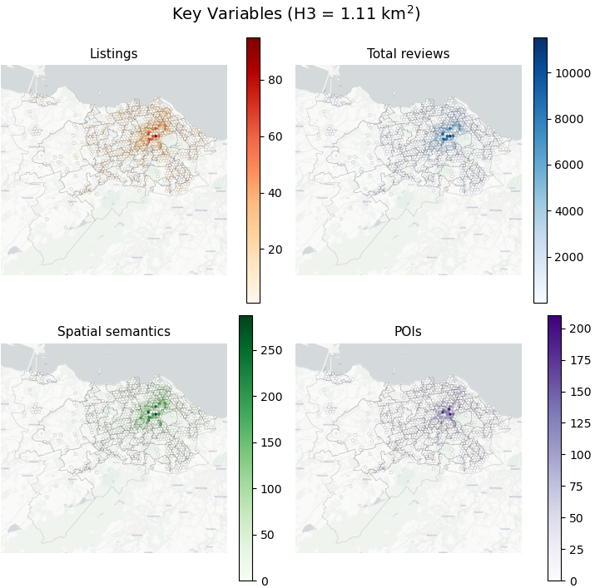
Figure 1 Spatial distribution of key features.

Method

3.1 LLM for extracting spatial semantics

Following Shingleton and Basiri (2025), LLMs are adopted to extract spatial semantics from Airbnb listing descriptions. A knowledge distillation framework is employed to transfer a high-capacity teacher model to a smaller student model for scalable inference. The teacher model, Llama-3.3-70B-Instruct quantised to 4-bit (Jin et al. 2024) with Unsloth (Han 2023), reaches an F1 score of 0.869 and is trained on 9,201 descriptions from the multi-period corpus.

As the teacher-model inference requires substantial computation on an NVIDIA RTX A6000 GPU, a 4-bit Meta-Llama-3.1-8B-Instruct model was taught on an NVIDIA A30 GPU, which was then used to process the rest of the listing descriptions.

The extracted spatial semantics, generated from the prompt in Appendix 2, fall into two categories, specific places and general places. After cleaning with JSON-Repair, both categories are used to calculate the total number of spatial semantics for each listing.

3.2 XAI for predicting listing performance

As mentioned above, the number of reviews is used as a performance indicator, that is, the outcome of the prediction modelling. The missing values are obtained with the method that produces the lowest out-of-sample error from K-nearest neighbour, Bayesian iterative, and random forest imputation.

A number of common machine learning (ML) models are employed in this research, including Bayesian Ridge Regression, Elastic Net, Random Forests, XGBoost, and neural network models (ANN and BNN). The lowest root mean squared error (RMSE) is used for model assessment after hyperparameter tuning, and the one with the lowest RMSE is selected for further SHAP analysis.

The TreeSHAP values allow assessment of the relative contribution of each feature, with a focus on spatial semantics and POIs. SHAP interaction values are used for evaluating the joint effect and interactions of the two features.

4. Result
4.1 Model selection

Across all candidate models, XGBoost produces the lowest prediction error with an RMSE of 0.835 and is selected for further analysis (Table 2). Nonlinear trees (RF, XGBoost) adapt better to this task.
Table 2. Model Selection
Model | RMSE
XGBoost | 0.835
Random Forest (Frequentist) | 0.845
Bayesian Neural Network (BNN) | 1.041
Artificial Neural Network (ANN) | 1.175
Bayesian Ridge Regression | 1.311
Elastic Net OLS | 1.322

4.2 Joint and independent contributions of spatial semantics and POIs

Models that include either feature each improve the prediction relative to the baseline, reducing RMSE by 4.46% and 1.29%, respectively. The combined model shows a larger improvement of 5.27% which indicates complementary interaction between the two key features in improving prediction accuracy.
Table 3 Model Performance on key variable settings
Spatial semantics | POIs | RMSE | % RMSE improvement
FALSE | FALSE | 0.825 | Baseline
FALSE | TRUE | 0.788 | -4.46%
TRUE | FALSE | 0.814 | -1.29%
TRUE | TRUE | 0.781 | -5.27%

4.3. Comparing feature importance

Examining individual contributions (Figure 2), the spatial semantics and POIs emerge as consistently influential predictors, each showing strong marginal effects. In the combined model, their SHAP patterns confirm complementary contributions. They jointly alter the relative importance of listing-level attributes, which indicates an interaction that enhances the model’s ability to explain Airbnb listing performance.

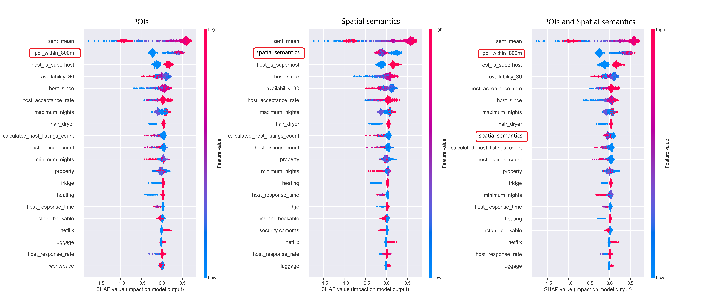
Figure 2 SHAP global summary plot

4.4 Interaction effects

The interaction plot (Figure 3) shows that the effect of spatial semantics on predicted performances shifts with nearby POIs using LOWESS-estimated SHAP interaction rends. It enhances the prediction in low-POI areas (blue) but reverses in amenity-dense neighbourhoods (red). A threshold of around five spatial references indicates that additional semantics no longer contribute predictive value in high-amenity settings.

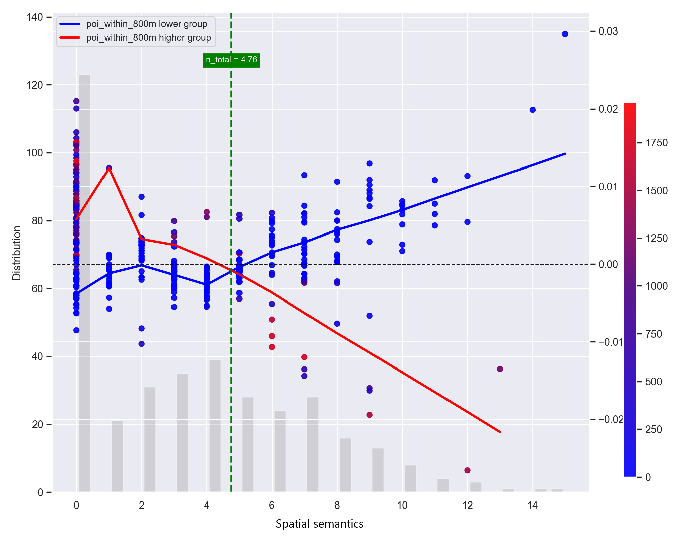
Figure 3 SHAP interaction values between spatial semantics and POIs.

4.5 Cross-dataset validation
Using September 2024 data, consistent results is confirmed. Although the standalone effect of spatial semantics is weaker in the best-performed XGBoost model, it continues to enhance performance when combined with POIs, ranks high in SHAP, and exhibits the same interaction pattern with a threshold of around three spatial semantics (results available upon request).

5. Conclusions
This paper assesses the Airbnb listing performance with ML and SHAP-based interpretation, with a focus on the role of LLM-derived spatial semantics, including specific places and general amenities, and real-world urban amenities on Airbnb listing performance. The results indicate that both of them provide distinct as well as complementary signals. Importantly, the effect of spatial semantics interacts with the surrounding amenity environment. Semantics play a larger role where amenity density is low, whereas in amenity-rich areas, additional spatial descriptions offer limited marginal value and do not improve performance on the platform.

References

Camatti, N., di Tollo, G., Filograsso, G. and Ghilardi, S. (2024) Predicting airbnb pricing: A comparative analysis of artificial intelligence and traditional approaches. Computational Management Science, 21(1), pp. 30.

Chen, Y. and Xie, K. (2017) Consumer valuation of airbnb listings: A hedonic pricing approach. International Journal of Contemporary Hospitality Management, 29(9), pp. 2405-2424.

De Jong, M., Joss, S. and Taeihagh, A. (2024) Smart cities as spatial manifestations of 21st century capitalism. Technological Forecasting and Social Change, 202, pp. 123299.

Delgado, J. e. J. e. (2023) Econometrics meets ai: Predicting airbnb prices using machine learning. Unpublished Bachelor Degree in Economics, University Carlos III de Madrid.

Gyódi, K. and Nawaro, Ł. (2021) Determinants of airbnb prices in european cities: A spatial econometrics approach. Tourism management, 86, pp. 104319.

Han, D., Team; (2023) Unsloth package. in,http://github.com/unslothai/unsloth.

Jin, R., Du, J., Huang, W., Liu, W., Luan, J., Wang, B. and Xiong, D. (2024) A comprehensive evaluation of quantization strategies for large language models. in Findings of the Association for Computational Linguistics ACL 2024. pp. 12186-12215.

Östh, J., Türk, U., Kourtit, K. and Nijkamp, P. (2025) Hedonic price models, social media data and ai–an application to the airbnb sector in us cities. Computers, Environment and Urban Systems, 120, pp. 102303.

Panahandeh, A., Rabiei-Dastjerdi, H., Goktas, P. and McArdle, G. (2025) Answering new urban questions: Using explainable ai-driven analysis to identify determinants of airbnb price in dublin. Expert Systems with Applications, 260, pp. 125360.

Shingleton, J. and Basiri, A. (2025) How close is" close"? An analysis of the spatial characteristics of perceived proximity using large language models. AGILE: GIScience Series, 6, pp. 11.

Biographies

Yang Wang is a Lecturer in Urban Analytics in the Urban Studies & Social Policy subject area at the University of Glasgow.

Joseph Shingleton is a Research Software Engineer in c.

Jing Yao is a Professor of Urban Analytics in the Urban Studies & Social Policy subject area at the University of Glasgow.

Appendix 1 Table A1. Features and cleaning process

Data (Inside Airbnb) | Operation | Purpose | Model Features | Feature type
Reviews (Target) | Remove missing values, trim above 95th percentile, log-transform | Reduce skewness and outlier influence | Number of Reviews | log(Number of Reviews)
Price | Remove missing values, trim above 95th percentile, log-transform | Reduce skewness and outlier influence | not included, due to high correlations | N/A
Service activity | Create inactive indicator from reviews per month and impute missing review rates as zero | Distinguish inactive listings | inactive | Binary
Room type | Map room categories to numeric codes: 'Private room', 'Entire home/apt', 'Shared room', 'Hotel room' | Standardise listing types | room_type | Categorical
Accommodates | Derive max. number of guests | Capture hosting and property characteristics | accommodates | Integer
Availability | Clean availability set within 30 days | Measure hosting availability | availability_30 | Integer (days)
Bathrooms | Clean bathroom text descriptions, extract numeric count | Capture key structural property | bathrooms | Integer
Bedrooms | Clean bedroom descriptions | Capture key structural property | bedrooms | Integer
Beds | Clean beds available | Capture key structural property | beds | Integer
Property type | Encode property, such as Private room, Entire home, categories as factors | Capture key property characteristics | property | Categorical
Hosting history | Drop listings with missing host_since or maximum nights requirements fields | Remove inactive or incomplete listings | host_since | Integer(days)
Host response time | Map host response time categories: none, 'within an hour', 'within a few hours', 'within a day', 'a few days or more'. | Capture host engagement | host_response_time | Categorical
Host response rate | Clean host response rate | Capture hosting rules | host_response_rate | Integer (%)
Host acceptance rate | Clean host acceptance rate | Capture hosting rules | host_acceptance_rate | Integer (%)
Professionalization | Aggregated number of listings hosted | Capture the degree of professional services | host_listings_count | Integer
Professionalization | Derived matrix based on listings managed by host - <68% correlation with host_listings_count | Measure portfolio | Calculated_host_listing_count | Interger
Host gender (name) | Infer gender from host name using gender_gusser | Capture demographic information | gender_final | Categorical
Host gender (CV) | Apply deepface model for missing cases | Increase gender coverage | gender_final | Categorical
Host gender (cleanup) | Manual correction and assign categories: female =0, male=1 couple =0 | Impute demographic groups | gender_final | Categorical
Platform attributes | Binary encode availability, instant booking, verification, superhost and host identities | Capture hosting policies | has_availability', 'instant_bookable', 'host_has_profile_pic',  'host_is_superhost', 'host_identity_verified' | Binary
Hosting policy | Clean minimum and maximum service period | Measure hosting and availability settings | minimum_nights;maximum_nights | Integer (days)
Amenities | One-hot encode selected amenities, such as tv, air_conditioning, coffee, luggage, from text | Capture service quality-relevant features | tv, netflix,gym,elevator,fridge,heating,hair_dryer,air_conditioning,hot_tub,oven,bbq,security cameras,workspace,coffee, backyard, outdoor_dining, greets, pool, beachfront, patio, luggage, furniture | Binary
Reviews (text) | Filter non-Latin and non-English reviews | Ensure sentiment comparability | sent_mean | Float
Review Sentiment | Compute and aggregate sentiment mean per listing using VADER Sentiment Analysis | Capture guest experience | sent_mean | Float
Number of spatial terms mentioned (focused predictor) | Derived spatial semantics by LLM from descriptions | Capture semantic spatial expressions | Spatial Semantics | Integer
Number of POIs within 800m walking distance (focused predictor) | POIs within 800m walking distance, derived from OS POI (https://www.ordnancesurvey.co.uk/products/points-of-interest), classifications 'Accommodation' (0101), 'Eating and Drinking': ('0102'), 'Attractions':('03'), 'Sport and entertainment':('0421','0423','0424','0425'),'Education':('0531','0532'),'Health': ('0528'),'Retail': ('09'), 'Transport':('1053','10570731','10570756','10570738','10570761','10590732','10590759') | Represent geographic locations of POIs | POIs | Integer

Appendix 2 The prompt used for the LLMs
You will be given a short description from an Airbnb listing in Edinburgh. It may describe either:
- the property itself, or
- the surrounding neighbourhood.

Your task is to identify **places or locations described as being near** the property — for example, anything mentioned as a short walk away, close by, or nearby.

You should categorise all such places into three groups:

1. `specific_locations` — locations that are **named and mappable**, such as landmarks, parks, venues, or neighbourhood features (e.g. "The Meadows", "Ocean Terminal").
2. `general_locations` — vague or generic references to places that **are not named or are too broad to geocode**, such as "train station", "shops", or "city centre".
3. `parent_locations` — the neighbourhood or area where the property is located (e.g. "Marchmont", "Leith"). Do not include these in the other two categories unless the location is explicitly described as a separate nearby place.

Correct minor spelling mistakes for named places (e.g. "Murayfield" -> "Murrayfield Stadium") so they match real map locations.

For `general_locations`, strip out descriptive words and articles (e.g. "the lively bars" -> "bars", "local shops" -> "shops")..

If a vague reference clearly refers to a specific place, correct it (e.g. "the castle" -> "Edinburgh Castle"). But only do this when the reference is **unambiguous**. For example, "the station" may refer to multiple locations and should remain general unless disambiguated in the text.

If a location is mentioned more than once, list it only once in the appropriate category.

Return your output in the following JSON format, marked "<|startofjson|>" and "<|endofjson|>" before and after the JSON block:

```
{
"specific_locations": [...],
"general_locations": [...],
"parent_locations": [...],
}
```

Here are some examples of inputs and expected outputs.

Example 1: Vague reference to specific location, reference to parent location.
Description:
"This bright flat in Marchmont is just a few minutes from the Meadows and near the university."

Output:
```
{
"specific_locations": ["The Meadows", "University of Edinburgh"],
"general_locations": [],
"parent_locations": ["Marchmont"]
}
```
Example 2: Vague reference to specific location, reference to parent location, spelling mistake (Lieth -> Leith).
Description:
"A cosy studio located in Lieth, just steps from The Shore and right beside Ocean Terminal. You're also a short bus ride from the city centre, and less than 30 mins from the airport by tram."

Output:
```
{
"specific_locations": ["The Shore", "Ocean Terminal", "Edinburgh International Airport"],
"general_locations": ["city centre"],
"parent_locations":["Leith"]
}
```

Example 3: Vague references and adjectives.
Description:
"This cosy apartment is a few minutes’ walk from the station, is handy for local shops and has a great view of the castle."

Output:
```
{
"specific_locations": ["Edinburgh Castle"],
"general_locations": ["train station", "shops"],
"parent_locations": []
}
```

Example 4: spelling mistake (Princess -> Princes), parent location, ambiguous wording, abbreviation (St -> Street).
Description:
"Located on Market St, We're just a few minutes' walk from Princess Street, and handy for both the new and old town."

Output:
```
{
"specific_locations": ["Princes Street", "New Town", "Old Town"],
"general_locations": [],
"parent_locations": ["Market Street"]
}
```

Example 5: No locations present.
Description:
“This conveniently located apartment features high ceilings, modern decor, and a fully equipped kitchen.”

Output:
```
{
"specific_locations": [],
"general_locations": [],
"parent_locations": []
}
```

If you must reason, do so briefly, but always output **only a single JSON object and nothing else**.

Now try with the following property description:

yang.wang@glasgow.ac.uk
joseph.shingleton@glasgow.ac.uk
jing.yao@glasgow.ac.uk
https://www.ordnancesurvey.co.uk/products/points-of-interest
https://huggingface.co/ywang-gla/ProxiLlama-3.1-8b

