Q1 :
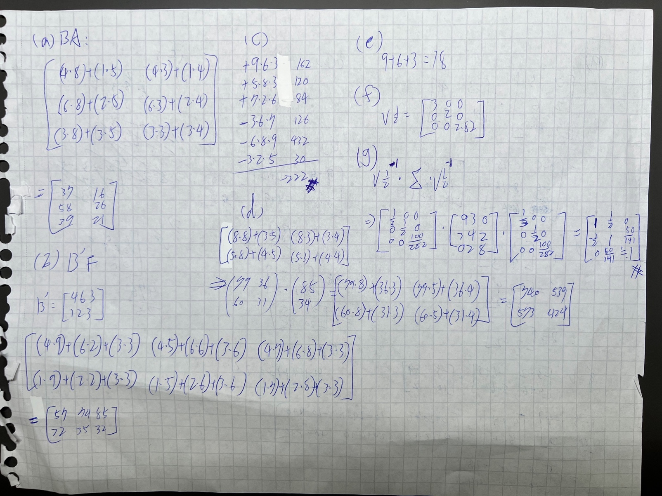
g)
the correlation matrix (ρ) of Sigma Σ
> SigmaCor = diag(x = sqrt(diag(sigma)), nrow = nrow(sigma), ncol = ncol(sigma))
> SigmaCor # Standard deviation matrix
[,1] [,2] [,3]
[1,] 3 0 0.000000
[2,] 0 2 0.000000
[3,] 0 0 2.828427
> SigmaCor_inv = solve(SigmaCor)
>
> rho = SigmaCor_inv %*% sigma %*% SigmaCor_inv
> rho
[,1] [,2] [,3]
[1,] 1.0 0.5000000 0.0000000
[2,] 0.5 1.0000000 0.3535534
[3,] 0.0 0.3535534 1.0000000

h)
determinant of matrix Sigma Σ.
> det(sigma)
[1] 180

i)
a singular matrix I must be a square matrix whose determinant is zero, which means that the matrix does not have an inverse. singular matrix
provide your reasoning for each. Σ. :
> det(m_A)
[1] 17
> det(m_F)
[1] -222
> det(sigma)
[1] 180

Matrix A, F, Sigma are square matrix and can be solved by determinant, therefore they are not singular matrix.
Matrix B is not square matrix, so it is not a singular matrix.

Q2
a)
I removed index, Date,Time type columns, because they are not contribute much to our model.

missing values are 0
> check =nrow(AQ) - nrow(AQ_r_m)
> check
[1] 0

Outliner:
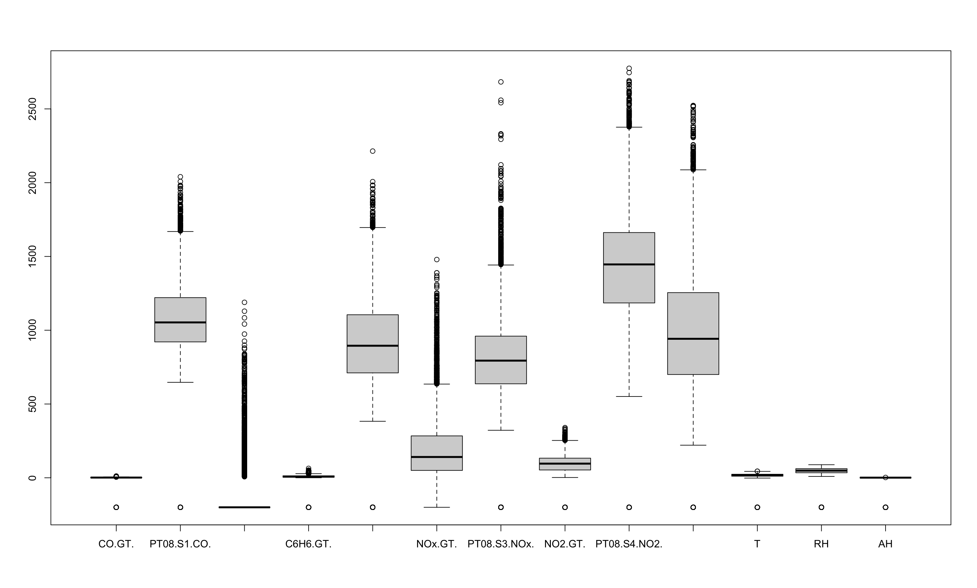

> AQ = AQ[AQ[,7]<2000,]
> AQ = AQ[AQ[,5]<2000,]
> AQ = AQ[AQ[,6]<1250,]
> AQ = AQ[AQ[,3]<1000,]
> AQ = AQ[AQ[,2]<2000,]
> for(i in c(1,2,4,5,7:13)){
+ AQ = AQ[AQ[,i]>-200,]
+ }
I decided to remove the values that is extremely higher than Fourth quartile,
And the values that are blow 0.

b-1)
In none rotate I would choose 4 dims

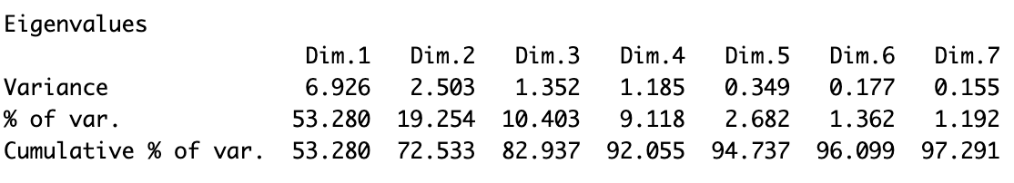

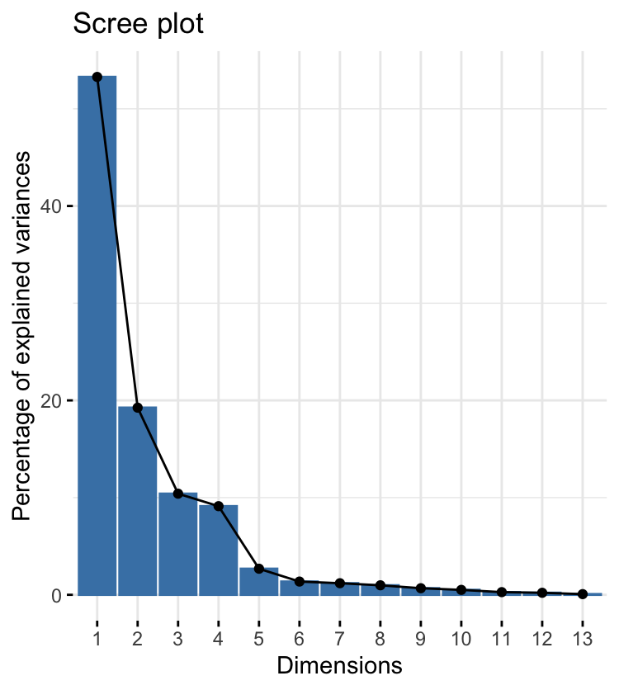
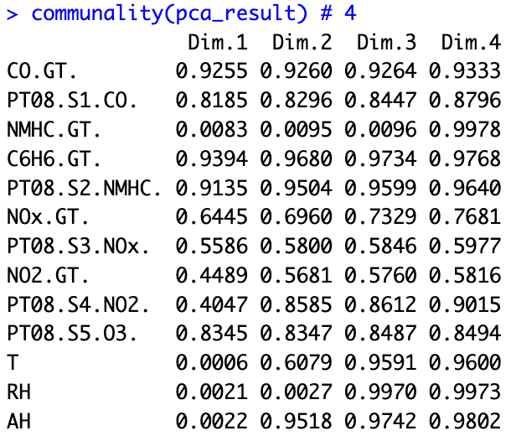
Because

- Eigenvalue Criterion: select dim 1~4, because dim 6 eigenvalue is below 1.
- Proportion of Variance Explained: select dim 1~4, because dim 6 cumulative% is between 65% ~ 85%.
- Screeplot Criterion : select dim 1~4, because after dim 4 it has significant leveling
- Minimum Communality Criterion : select dim 1~4, because before dim 6 every variable has a communality of at least 50%.
b-2)
CO.GT. 0.9621, C6H6(GT) 0.9692 and PT08.S5(O3) 0.9558 in dim1.
Variables may correspond to the same underlying factors. And there may be a strong correlation between them (multicollinearity). It might decrease explanatory, and we could remove one of them and observe if it is better or using rotation to improve model.

b-3)
1. each of variables have more explanatory than the none rotate model.

2. there’s no overlapping loadings in varimax rotate model.
None varimax
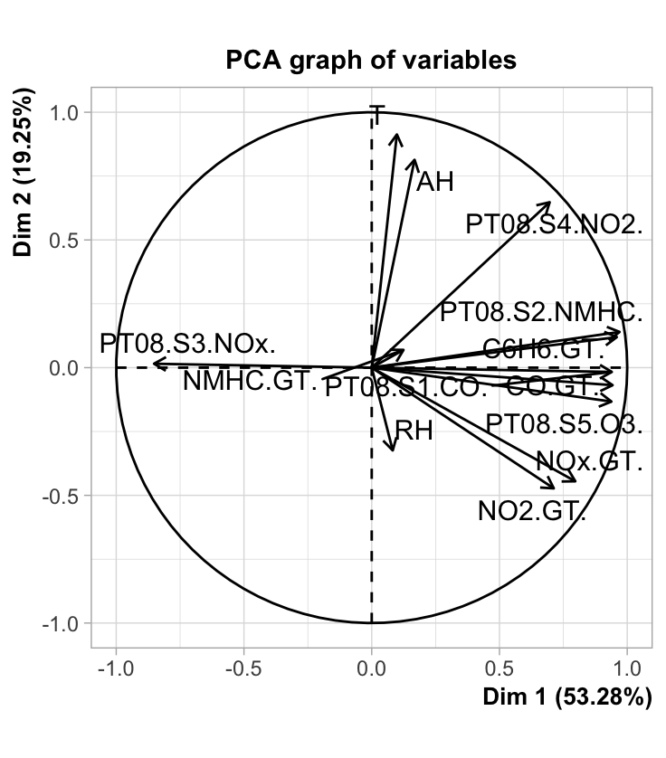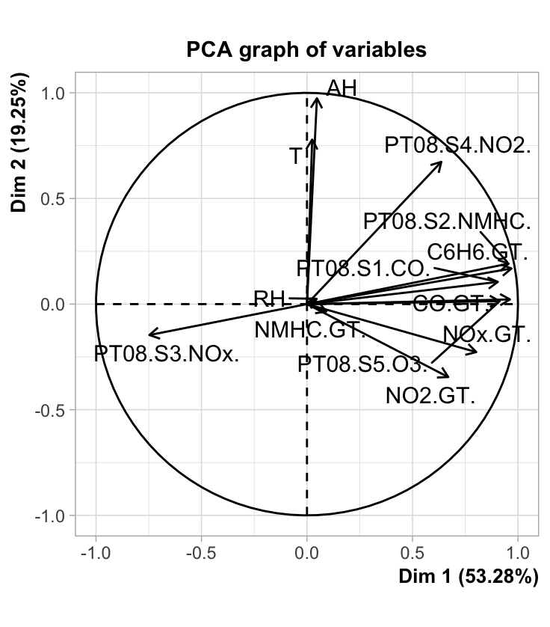

3. Yes, it is more better. As both chart shows the varimax model is more clear than none rotate model.

4.
In Correlation analysis if the value is higher than 0.7, which means they are high related, it might have some issue. First explanatory decreasing, because they may cover similar information. Second, it is hard to figure out the meaning of each principal component.

In this case, the value that dim 1 have correlated with dim 2 and dim3 are beyond 0.7, which means they may cover similar information.

Code:
the first observation:
> # compute values for each PCA dimension
> AQ.final= as.matrix(AQ) %*% as.matrix(pca_result$var$coord[,1:4]) #compute AQ %*% pca dim 1~4
> AQ.final
Dim.1 Dim.2 Dim.3 Dim.4
- 3914.9753 1279.4866 116.65904779 923.7268

Correlation analysis:
> loadings.pcarot= varimax(pca_result$var$coord)$loadings
> pca_result$var$coord = loadings.pcarot
> cor(AQ.final, use="pairwise.complete.obs")
Dim.1 Dim.2 Dim.3 Dim.4
Dim.1 1.0000000 0.7531869 0.782694719 0.371135044
Dim.2 0.7531869 1.0000000 0.240911082 0.600214441
Dim.3 0.7826947 0.2409111 1.000000000 0.009370955
Dim.4 0.3711350 0.6002144 0.009370955 1.000000000
Q3:
(a)
First, I removed the columns that is “character” or “id” type.

Remove column: "X", "ID", "Name", "Photo", "Nationality", "Flag", "Club" , "Club.Logo", "Work.Rate", "Body.Type", "Real.Face", "Position" Joined", "Loaned.From", "Contract.Valid.Until".

And clean the columns.

XX+X(i.e: LS = 88+2) type to number, “Money type” (i.e: value = €110.5M) to just numbers,
Foot/inchs type (i.e: Height = 5'7) to centermeter, LBS type (i.e: weight = 159lbs) to just numbers.

Second, because of high correlation between columns will affect the explaination, I removed some columns with high correlation number(>0.7), and combined extremely high correlation(>0.9) columns (add all the values together and divide by the total number).

Remove column: "Special", ShortPassing, "Volleys", "Dribbling", "Curve", "BallControl".

Combine "LS", "ST", "RS", "LW", "LF", "CF", "RF", "RW", "LAM", "CAM", "RAM", "LM", "RM" to one column,
Combine "LCM", "CM", "RCM" to one column,
Combine "LWB", "LDM", "CDM", "RDM", "RWB", "LB", "LCB", "CB", "RCB", "RB" to one column.

And removed the columns which have high Uniquenesses.

Remove column: "Value", "Weak.Foot", "Jersey.Number"

(b)
> f = factanal(FF_rm,factors=6, rotation="promax")
> print(f,cutoff=.4)
Call:
factanal(x = FF_rm, factors = 6, rotation = "promax")

Uniquenesses:
Age Overall Potential Wage International.Reputation Skill.Moves Height Weight LS~LM,RM
0.005 0.023 0.154 0.633 0.726 0.271 0.197 0.298 0.005
LCM~RCM LWB~RB Crossing Finishing HeadingAccuracy FKAccuracy LongPassing Acceleration
0.005 0.157 0.217 0.085 0.259 0.288 0.103 0.332
Loadings:
Factor1 Factor2 Factor3 Factor4 Factor5 Factor6
Age 1.000
Overall 0.819
Potential 0.862
Wage 0.544
International.Reputation 0.435
Skill.Moves 0.677
Height 0.965
Weight 0.861
LS~LM,RM 0.915
LCM~RCM 0.764
LWB~RB 0.848
Crossing 0.682
Finishing 0.857
HeadingAccuracy 0.972 -0.481
FKAccuracy 0.716
LongPassing 0.722 0.543
Acceleration 0.465 -0.429

Factor1 Factor2 Factor3 Factor4 Factor5 Factor6
SS loadings 3.881 2.076 2.041 1.861 1.460 1.304
Proportion Var 0.228 0.122 0.120 0.109 0.086 0.077
Cumulative Var 0.228 0.350 0.470 0.580 0.666 0.742

Factor Correlations:
Factor1 Factor2 Factor3 Factor4 Factor5 Factor6
Factor1 1.000 -0.1040 0.3222 -0.434 0.4431 -0.0120
Factor2 -0.104 1.0000 -0.3108 0.194 -0.0854 0.2465
Factor3 0.322 -0.3108 1.0000 -0.212 0.1643 -0.0753
Factor4 -0.434 0.1943 -0.2120 1.000 -0.4562 -0.3850
Factor5 0.443 -0.0854 0.1643 -0.456 1.0000 0.4918
Factor6 -0.012 0.2465 -0.0753 -0.385 0.4918 1.0000

Test of the hypothesis that 6 factors are sufficient.
The chi square statistic is 24383.43 on 49 degrees of freedom.
The p-value is 0
(c)
Varimax rotation reduces the correlation between components, making the rotated factors more independent and the weights of the components simpler to interpret.

Promax rotation allows a higher correlation between factors and rotation of the components, making it simpler to identify correlations between the components after rotation.

In this case, I choose Promax(oblique rotation), because it gives a better loadings values and SS loadings. We also see the correlation between factor and factor.

Call:
factanal(x = FF_rm, factors = 6, rotation = "varimax")
Factor1 Factor2 Factor3 Factor4 Factor5 Factor6
Age 0.960
Overall 0.870
Potential 0.810
Wage 0.565
International.Reputation 0.463
Skill.Moves 0.704
Height -0.863
Weight -0.797
LS~LM,RM 0.448 0.822
LCM~RCM 0.474 0.706 0.437
LWB~RB 0.822
Crossing 0.712
Finishing 0.786
HeadingAccuracy 0.759
FKAccuracy 0.701
LongPassing 0.692 0.547
Acceleration 0.556 0.519

Factor1 Factor2 Factor3 Factor4 Factor5 Factor6
SS loadings 3.798 2.803 2.177 1.716 1.458 1.291
Proportion Var 0.223 0.165 0.128 0.101 0.086 0.076
Cumulative Var 0.223 0.388 0.516 0.617 0.703 0.779

Call:
factanal(x = FF_rm, factors = 6, rotation = "promax")
Loadings:
Factor1 Factor2 Factor3 Factor4 Factor5 Factor6
Age 1.000
Overall 0.819
Potential 0.862
Wage 0.544
International.Reputation 0.435
Skill.Moves 0.677
Height 0.965
Weight 0.861
LS~LM,RM 0.915
LCM~RCM 0.764
LWB~RB 0.848
Crossing 0.682
Finishing 0.857
HeadingAccuracy 0.972 -0.481
FKAccuracy 0.716
LongPassing 0.722 0.543
Acceleration 0.465 -0.429

Factor1 Factor2 Factor3 Factor4 Factor5 Factor6
SS loadings 3.881 2.076 2.041 1.861 1.460 1.304
Proportion Var 0.228 0.122 0.120 0.109 0.086 0.077
Cumulative Var 0.228 0.350 0.470 0.580 0.666 0.742

Factor Correlations:
Factor1 Factor2 Factor3 Factor4 Factor5 Factor6
Factor1 1.000 -0.1040 0.3222 -0.434 0.4431 -0.0120
Factor2 -0.104 1.0000 -0.3108 0.194 -0.0854 0.2465
Factor3 0.322 -0.3108 1.0000 -0.212 0.1643 -0.0753
Factor4 -0.434 0.1943 -0.2120 1.000 -0.4562 -0.3850
Factor5 0.443 -0.0854 0.1643 -0.456 1.0000 0.4918
Factor6 -0.012 0.2465 -0.0753 -0.385 0.4918 1.0000

(d)
Code:
Loadings:
Factor1 Factor2 Factor3 Factor4 Factor5 Factor6
Age 1.000
Overall 0.819
Potential 0.862
Wage 0.544
International.Reputation
Skill.Moves 0.677
Height 0.965
Weight 0.861
LS~LM,RM 0.915
LCM~RCM 0.764
LWB~RB 0.848
Crossing 0.682
Finishing 0.857
HeadingAccuracy 0.972
FKAccuracy 0.716
LongPassing 0.722 0.543

Factor 1 : skill [Skill.Moves, Crossing, Finishing, HeadingAccuracy, FKAccuracy, LongPassing, Acceleration]

Factor 2 : value [Overall, Potential, Wage, International.Reputation]

Factor 3 : body [Weight, Height]

Factor 4 : index_LS_LCM [LS,LCM]

Factor 5 : index_ LWB [LWB]

Factor 6 : age [Age]

(e)
Factor Correlations: ( > 0.7 may have Multicollinearity )
Factor1 Factor2 Factor3 Factor4 Factor5 Factor6
Factor1 1.000 -0.1040 0.3222 -0.434 0.4431 -0.0120
Factor2 -0.104 1.0000 -0.3108 0.194 -0.0854 0.2465
Factor3 0.322 -0.3108 1.0000 -0.212 0.1643 -0.0753
Factor4 -0.434 0.1943 -0.2120 1.000 -0.4562 -0.3850
Factor5 0.443 -0.0854 0.1643 -0.456 1.0000 0.4918
Factor6 -0.012 0.2465 -0.0753 -0.385 0.4918 1.0000

If there is a strong correlation between variables, multicollinearity may exist. This means that two or more elements partially measure the same component.
In this case, there has no values above 0.5 in this factors correlation matric, so it is acceptable.

(f)
(g)
- Loadings:
In right dataset:
Crossing, Finishing, HeadingAccuracy, FKAccuracy, LongPassing, Acceleration are more related in “right dataset” than the “left dataset”.

In Left dataset:
FKAccuracy is more isolated with Crossing, Finishing, HeadingAccuracy, LongPassing, Acceleration.

- proportion of variance explained ( The higher the explained variance, the more variance the factor model can explain, which indicates a better fit of the model to the data. ) :
In right dataset:
HeadingAccuracy and Acceleration are greater than left dataset.

In left dataset:
LCM~RCM and LWB~RB are greater than right dataset.

To sum up, when we looking at right foot player we can be more focus on HeadingAccuracy and Acceleration values. In the other hand, when we looking at left foot player we can be more focus on LCM, RCM, LWB…etc values.

Factor analysis :
Right
Call:
factanal(x = FF_R, factors = 6, rotation = "varimax")

Uniquenesses:
Age Overall Potential Wage International.Reputation
0.005 0.023 0.153 0.632 0.726
Skill.Moves Height LS~LM,RM LCM~RCM LWB~RB
0.259 0.202 0.298 0.005 0.005
LWB Crossing Finishing HeadingAccuracy FKAccuracy
0.140 0.201 0.073 0.231 0.273
LongPassing Acceleration
0.103 0.321

Loadings:
Factor1 Factor2 Factor3 Factor4 Factor5 Factor6
Age 0.961
Overall 0.867
Potential 0.821
Wage 0.562
International.Reputation
Skill.Moves 0.727
Height -0.853
LS~LM,RM -0.792
LCM~RCM 0.839
LWB~RB 0.718
LWB 0.829
Crossing 0.732
Finishing 0.809
HeadingAccuracy 0.785
FKAccuracy 0.719
LongPassing 0.694 0.547
Acceleration 0.587

Factor1 Factor2 Factor3 Factor4 Factor5 Factor6
SS loadings 3.996 2.765 2.102 1.737 1.466 1.286
Proportion Var 0.235 0.163 0.124 0.102 0.086 0.076
Cumulative Var 0.235 0.398 0.521 0.624 0.710 0.785

Test of the hypothesis that 6 factors are sufficient.
The chi square statistic is 17937.23 on 49 degrees of freedom.
The p-value is 0
LEFT:
Call:
factanal(x = FF_L, factors = 6, rotation = "varimax")
Uniquenesses:
Age Overall Potential Wage International.Reputation
0.005 0.027 0.157 0.626 0.714
Skill.Moves Height LS~LM,RM LCM~RCM LWB~RB
0.333 0.187 0.302 0.005 0.005
LWB Crossing Finishing HeadingAccuracy FKAccuracy
0.209 0.280 0.118 0.383 0.345
LongPassing Acceleration
0.117 0.406

Loadings:
Factor1 Factor2 Factor3 Factor4 Factor5 Factor6
Age 0.952
Overall 0.865
Potential 0.760
Wage 0.580
International.Reputation
Skill.Moves 0.654
Height 0.867
LS~LM,RM 0.794
LCM~RCM 0.783 0.512
LWB~RB 0.633 0.525 0.510
LWB 0.779
Crossing 0.613
Finishing 0.866
HeadingAccuracy 0.711
FKAccuracy 0.700
LongPassing 0.586 0.605
Acceleration -0.578

Factor1 Factor2 Factor3 Factor4 Factor5 Factor6
SS loadings 3.847 2.877 2.191 1.584 1.317 0.966
Proportion Var 0.226 0.169 0.129 0.093 0.077 0.057
Cumulative Var 0.226 0.396 0.524 0.618 0.695 0.752

Test of the hypothesis that 6 factors are sufficient.
The chi square statistic is 6286.63 on 49 degrees of freedom.
The p-value is 0
proportion of variance explained :
> var_exp(FVR$correlation)
Age Overall Potential Wage International.Reputation
0.02964898 0.07074171 0.04615629 0.04595379 0.04053130
Skill.Moves Height LS~LM,RM LCM~RCM LWB~RB
0.07984906 0.04641037 0.04041720 0.06774965 0.07339796
LWB Crossing Finishing HeadingAccuracy FKAccuracy
0.03923011 0.08542189 0.07433156 0.04394749 0.07816933
LongPassing Acceleration
0.07689656 0.06114676
> var_exp(FVL$correlation)
Age Overall Potential Wage International.Reputation
0.03216275 0.07889136 0.04832107 0.04739456 0.04224088
Skill.Moves Height LS~LM,RM LCM~RCM LWB~RB
0.07425621 0.04346222 0.03943043 0.08560037 0.08933000
LWB Crossing Finishing HeadingAccuracy FKAccuracy
0.04214899 0.07763942 0.06773133 0.03273091 0.07169778
LongPassing Acceleration
0.07606425 0.05089747

Q4

(a) Provide a summary of this data. Your summary should include the types of data (that
are essential for this analysis), interesting summary measures and appropriate box plots.
Consider outliers and missing values.

Exclude following columns, other columns have value to analysis.

column EmployeeID : is not a related data.
EmployeeCount, Over18, StandardHours : all rows of those columns have same data .

Boxplot :
Even monthlyincome has several outliner, but all of them are Continuous.
Therefore, I decide not to removed them.
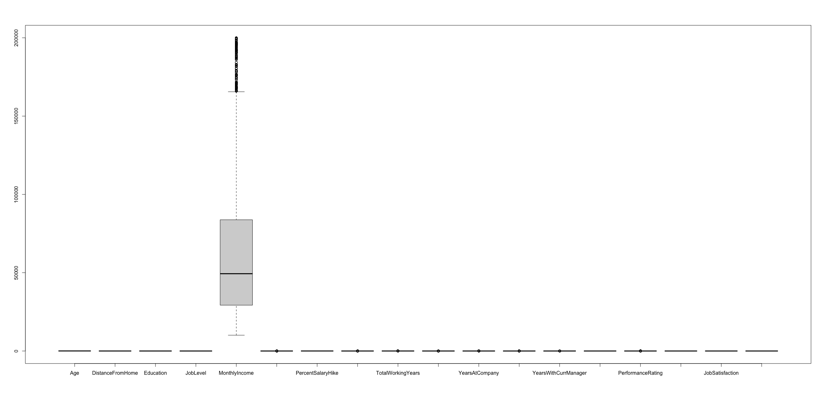

Missing values :
This dataset has 110 mssing data, and I decide to removed them.,
> f_r_m=f_df[complete.cases(f_df),]
> check =nrow(f_df) - nrow(f_r_m)
> check
[1] 110

(b) Determine and list any columns that are not needed in a first “full” model. Explain why
you removed those columns
based on variable.importance I decide to removed
- JobSatisfaction
- JobLevel
- PerformanceRating
- Gender
- JobInvolvement
Because after removed those columns, according to Confusion Matrix, the accuracy become higher.
> cfit$variable.importance
TotalWorkingYears MonthlyIncome JobRole Age EducationField YearsAtCompany NumCompaniesWorked
69.353753 59.813167 53.819918 52.729209 30.129933 29.527372 24.742428
DistanceFromHome YearsWithCurrManager PercentSalaryHike Education StockOptionLevel MaritalStatus TrainingTimesLastYear
24.421628 23.365590 20.516252 20.141450 18.049111 16.262948 14.758063
BusinessTravel Department YearsSinceLastPromotion EnvironmentSatisfaction WorkLifeBalance JobSatisfaction JobLevel
12.765076 11.379484 10.559093 9.994369 7.780563 7.592392 6.105254
PerformanceRating Gender JobInvolvement
5.735006 3.258317 2.872810

(c) Using two algorithms C5.0 and Conditional Inference. Develop a full model decision tree
to analyze the attrition.

Output :
f = as.formula('Attrition ~ TotalWorkingYears+MonthlyIncome+JobRole+ Age +EducationField+ YearsAtCompany+NumCompaniesWorked +DistanceFromHome + YearsWithCurrManager+ PercentSalaryHike+ Education+ StockOptionLevel+MaritalStatus+TrainingTimesLastYear +BusinessTravel+ Department +YearsSinceLastPromotion+EnvironmentSatisfaction ' )
> #develop decision tree against training set using CTree Method--
> output.tree <- ctree( f, data = trainf_df_ctree)
>
> # summary(output.tree)
> #Alternatively you can plot
> testf_df_ctree$predict = predict(output.tree, newdata=testf_df_ctree, type='response')
>
> #Counts
> tab = table(testf_df_ctree$Attrition, testf_df_ctree$predict)
> tab
No Yes
No 1555 96
Yes 224 92
> #Predict Table as Pct
> pcttab <- rbind(tab[1, ]/sum(tab[1, ]), tab[2, ]/sum(tab[2, ]))
> print(round(pcttab, 3))
No Yes
[1,] 0.942 0.058
[2,] 0.709 0.291

> library(C50)
> # Now use the C50 Algorithm --
> ruleModel <- C5.0(Attrition ~ ., data = trainf_df_c50)
> #summary(ruleModel)
> #Alternatively you can plot
> testf_df_c50$predict = predict(ruleModel, newdata=testf_df_c50, type='class')
>
> #Counts
> tab = table(testf_df_c50$Attrition, testf_df_c50$predict)
> tab

No Yes
No 1601 50
Yes 84 232
> #Predict Table as Pct
> pcttab <- rbind(tab[1, ]/sum(tab[1, ]), tab[2, ]/sum(tab[2, ]))
> print(round(pcttab, 3))
No Yes
[1,] 0.970 0.030
[2,] 0.266 0.734

(d) From your full model, develop a more appropriate model (lower variables) that will provide
an ”attrition” prediction. What was the formula of your final model , in the C5.0 and
conditional inference algorithm.
'Attrition ~ TotalWorkingYears+MonthlyIncome+JobRole+ Age +EducationField+ YearsAtCompany+NumCompaniesWorked +DistanceFromHome + YearsWithCurrManager+ PercentSalaryHike+ Education+ StockOptionLevel+MaritalStatus+TrainingTimesLastYear +BusinessTravel+ Department +YearsSinceLastPromotion+EnvironmentSatisfaction '

(e) Compare the methods based on appropriate measures of accuracy.
Based on Confusion Matrix, C50 algorithm is more precise.
ctree
> #Predict Table as Pct
> pcttab <- rbind(tab[1, ]/sum(tab[1, ]), tab[2, ]/sum(tab[2, ]))
> print(round(pcttab, 3))
No Yes
[1,] 0.962 0.038
[2,] 0.698 0.302

c50
No Yes
[1,] 0.961 0.039
[2,] 0.352 0.648
(f) Provide the charts from each algorithm of your final model.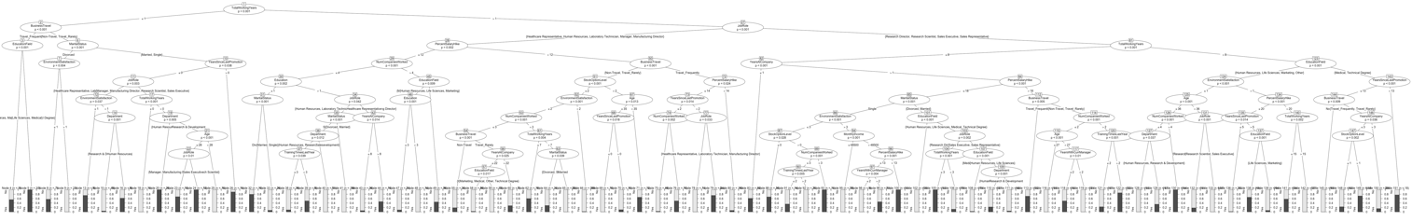

Q5
(a) Explain why the covariance matrix is important for analysis. Additionally, explain what
the eigenvectors and eigenvalues are and why they are important.

Covariance matrix are used for analyzing the correlations between variables. A strong covariance between two variables indicates that they tend to vary in the same direction. In contrast, a low or negative covariance between two variables indicates that they tend to vary in opposing ways. But it is only working when the variables are linear relationship.

(b) In machine learning, explain the importance of splitting up the dataset. What are the
different ways to split and how should an analyst split the data.

This helps us to determine whether the model is overfitting or underfitting, and to adjust the optimal values of the model parameters.

- Simple random sampling : A portion of the entire data set is randomly selected as the training set and the remaining portion as the test set. generally, a training set of between 60% and 80% is a more common choice.

- Stratified Sampling : The overall population is separated into various levels according to certain characteristics, and then samples are selected from each level individually according to a certain percentage, such that the proportion of samples in each level is the similar to the proportion of the overall population.

(c) What are the differences and similarities between factor analysis and PCA. Focus on the
equations that are produced.

- Differences: Factor analysis has more detail for explanation than PCA, Because of the ε’s

  - PCA works to find orthogonal linear combinations for descriptive purposes and the creation of components.

  - Factor analysis presents a deeper analysis since the focus is on the latent factors relationship to the individual variables.

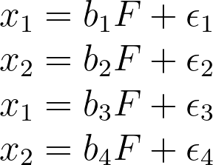

(d) What are some of the challenges with k-NN. How would you advise someone who decides
to use k-NN?

- If the data size is huge or dimension is very high, the KNN algorithm becomes very ineffective.

- If the dataset is little or no prior information about a dataset's distribution data, or when an analyst just want to explore new data

(e) What is the difference between orthogonal rotation and oblique rotations. When would
we choose either, or neither.

Orthogonal:
orthogonal rotation enables a clearer view of the factor loadings. But it will not keep correlation between factors and factors.

Oblique:
oblique rotation are rotations that retain the correlation between two variables, the axes are not kept perpendicular.

If your research question is to explain the theoretical significance of the factors, then you may consider using Varimax rotation. In the other hand, if your research question is to investigate correlations or interactions between factors, or if there is a high cross-load in the data, then you may consider using Promax rotation.

