|  |  |  |  |
| --- | --- | --- | --- |
| 182 | 431710C201909262002 | 112.8501 | 30.70653 |

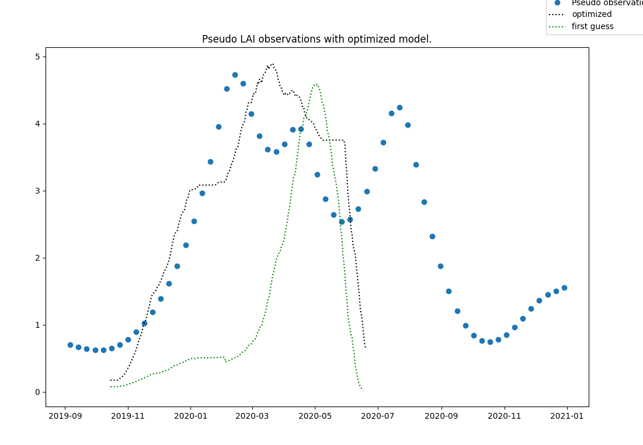

0.08

optimum at TSUM1: 965.0, TSUM2: 891.1718624830246, TDWI: 220.0, SLATB1: 0.00212, SLATB3: 0.0012, AMAXTB1: 36.0, SPAN: 41.0, KDIFTB1: 0.8, FRTB1: 0.4, FRTB9: 0.27, FLTB1: 0.613125, RMR: 0.01

minimum value = 0.7274607577817893

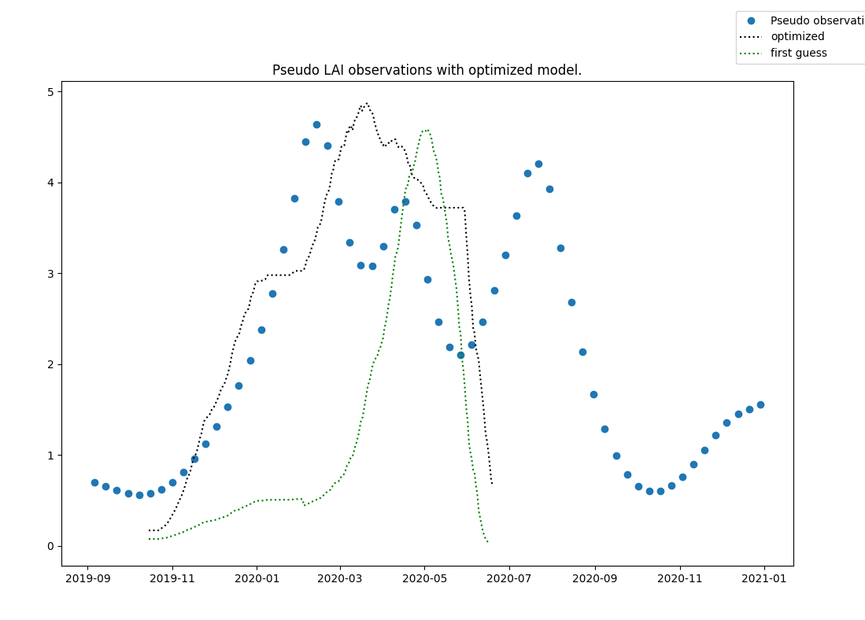

0.1

optimum at TSUM1: 965.0, TSUM2: 891.1718624830246, TDWI: 220.0, SLATB1: 0.00212, SLATB3: 0.0012, AMAXTB1: 36.0, SPAN: 41.0, KDIFTB1: 0.8, FRTB1: 0.4100000000000001, FRTB9: 0.2701875, FLTB1: 0.613125, RMR: 0.01

minimum value = 0.8922449346067628

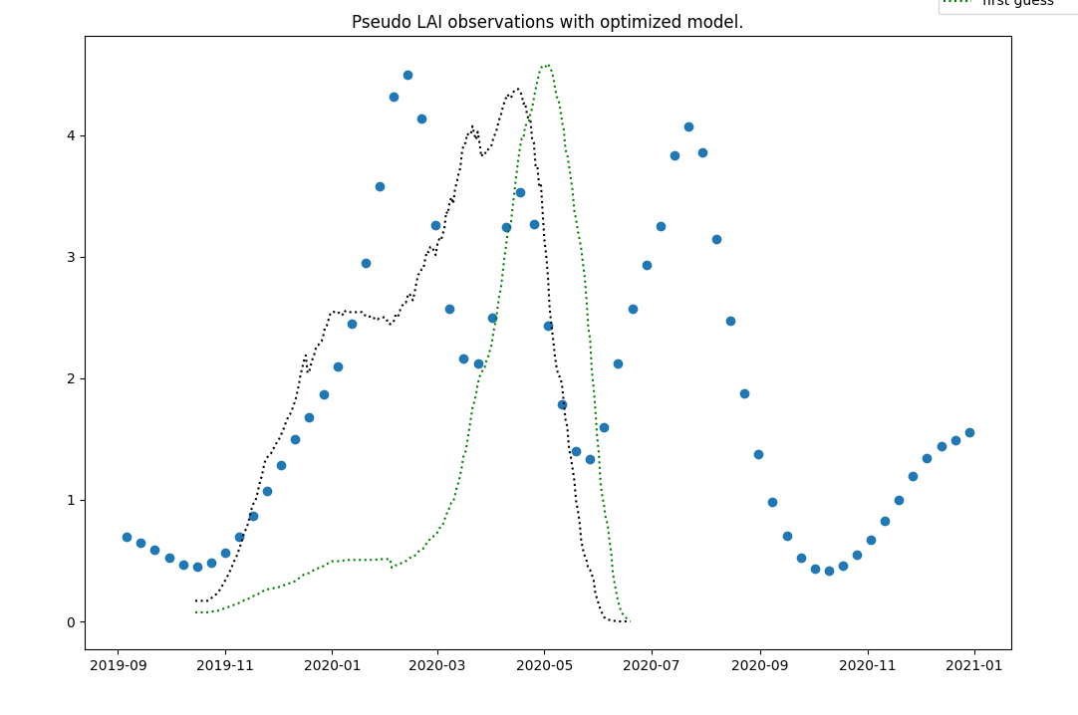

0.15

optimum at TSUM1: 950.0, TSUM2: 890.351699590683, TDWI: 220.0, SLATB1: 0.00212, SLATB3: 0.0012, AMAXTB1: 36.0, SPAN: 21.0, KDIFTB1: 0.8, FRTB1: 0.4, FRTB9: 0.33, FLTB1: 0.605, RMR: 0.02

minimum value = 0.9952423734678358

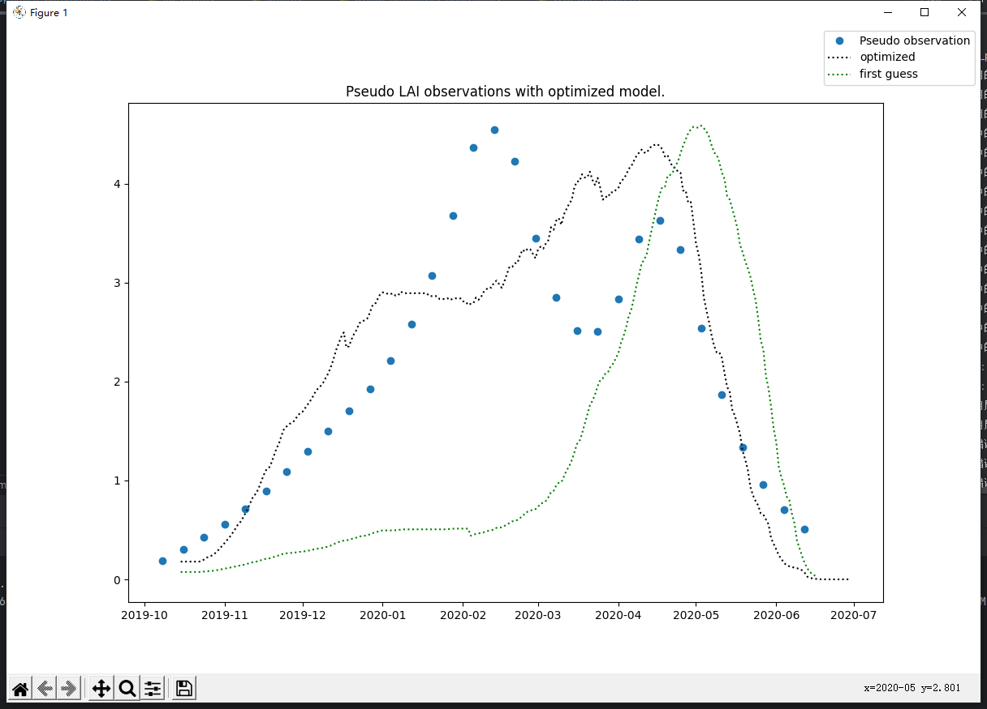

optimum at TSUM1: 1097.8125, TSUM2: 959.9999618530273, TDWI: 220.0, SLATB1: 0.00212, SLATB3: 0.0012, AMAXTB1: 36.0, SPAN: 21.0, KDIFTB1: 0.8, FRTB1: 0.4, FRTB9: 0.33, FLTB1: 0.6403124999999996, RMR: 0.02

minimum value = 0.7769081255913275

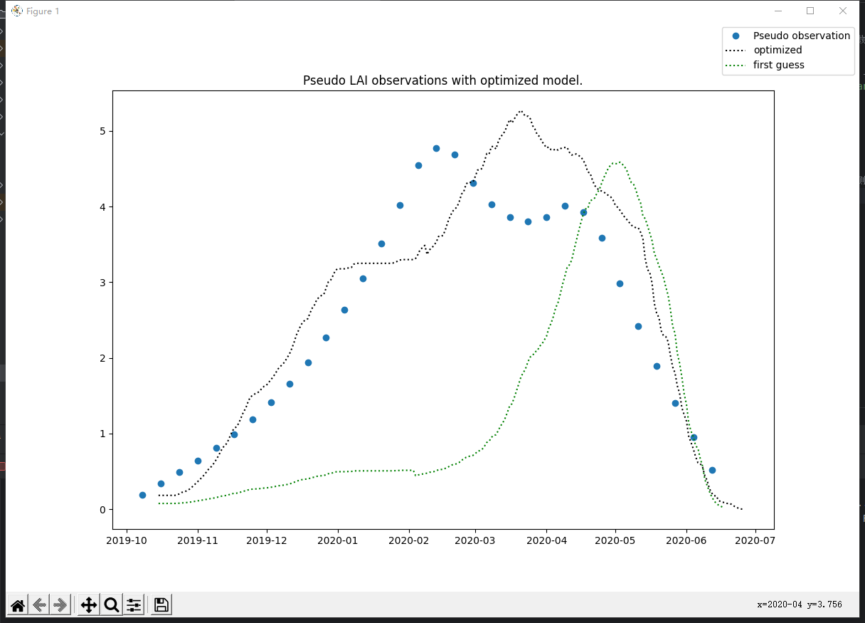

0.08

optimum at TSUM1: 1021.13037109375, TSUM2: 959.9999618530273, TDWI: 220.0, SLATB1: 0.00212, SLATB3: 0.0012, AMAXTB1: 36.0, SPAN: 29.0, KDIFTB1: 0.62, FRTB1: 0.4, FRTB9: 0.33, FLTB1: 0.647921752929687, RMR: 0.010000000000000002

minimum value = 0.7092188621548146

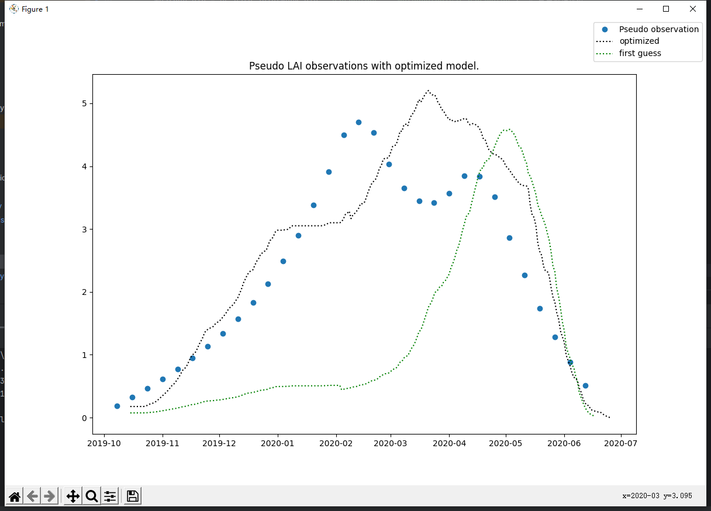

0.10

optimum at TSUM1: 1035.0, TSUM2: 959.9999618530273, TDWI: 220.0, SLATB1: 0.00212, SLATB3: 0.0012, AMAXTB1: 36.0, SPAN: 29.0, KDIFTB1: 0.62, FRTB1: 0.4, FRTB9: 0.33, FLTB1: 0.6299999999999999, RMR: 0.010000000000000002

minimum value = 0.814776164203548

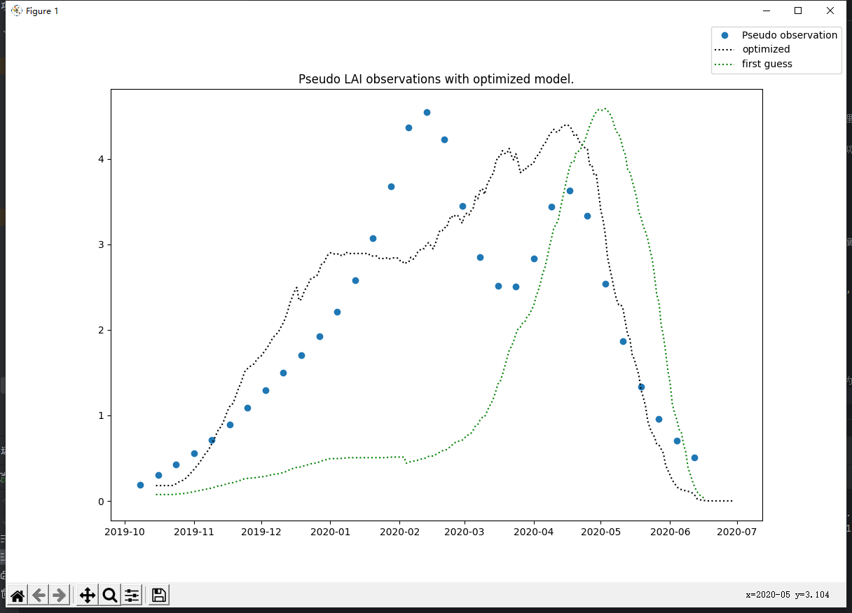

0.15

optimum at TSUM1: 1097.8125, TSUM2: 959.9999618530273, TDWI: 220.0, SLATB1: 0.00212, SLATB3: 0.0012, AMAXTB1: 36.0, SPAN: 21.0, KDIFTB1: 0.8, FRTB1: 0.4, FRTB9: 0.33, FLTB1: 0.6403124999999996, RMR: 0.02

minimum value = 0.7769081255913275

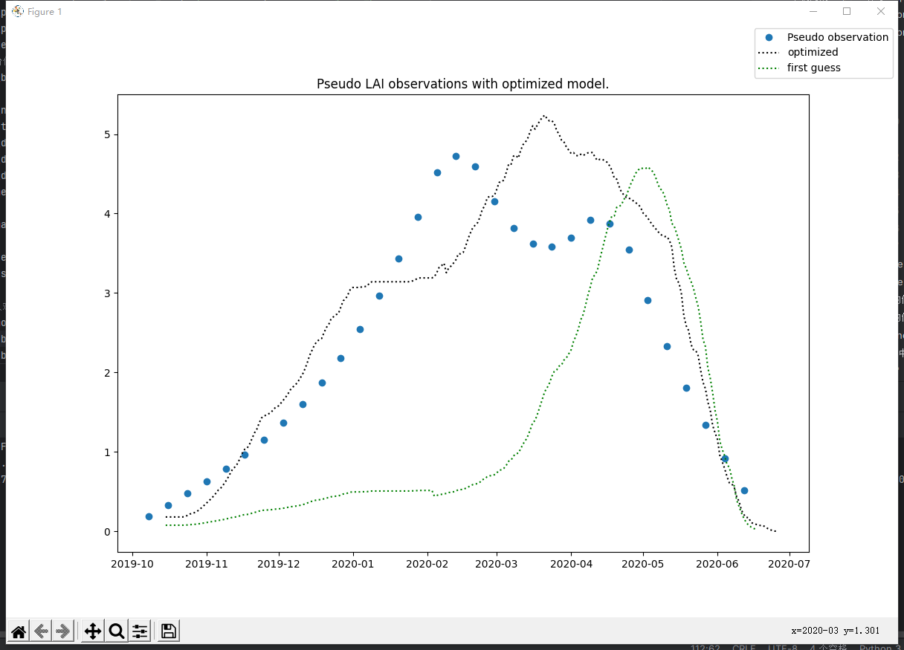

0.09

optimum at TSUM1: 1018.76220703125, TSUM2: 959.9999618530273, TDWI: 220.0, SLATB1: 0.00212, SLATB3: 0.0012, AMAXTB1: 36.0, SPAN: 29.0, KDIFTB1: 0.62, FRTB1: 0.4, FRTB9: 0.33, FLTB1: 0.6381176757812497, RMR: 0.010000000000000002

minimum value = 0.768720176514093

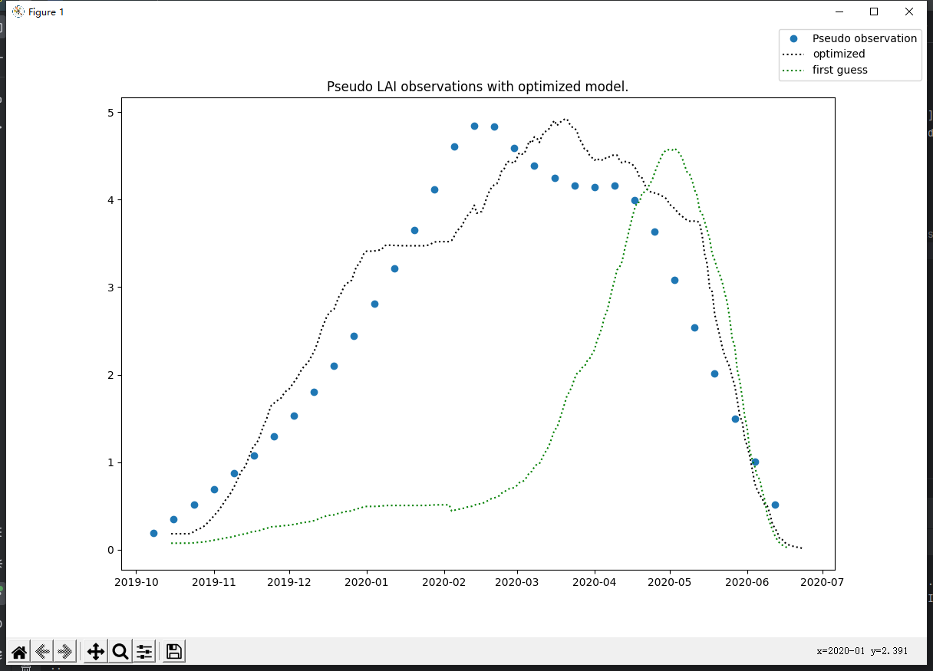

0.06

optimum at TSUM1: 976.5234375, TSUM2: 959.9999618530273, TDWI: 220.0, SLATB1: 0.00212, SLATB3: 0.0012, AMAXTB1: 36.0, SPAN: 30.155517578125, KDIFTB1: 0.8, FRTB1: 0.4, FRTB9: 0.27, FLTB1: 0.6514843750000001, RMR: 0.010000000000000002

minimum value = 0.5473377957963413

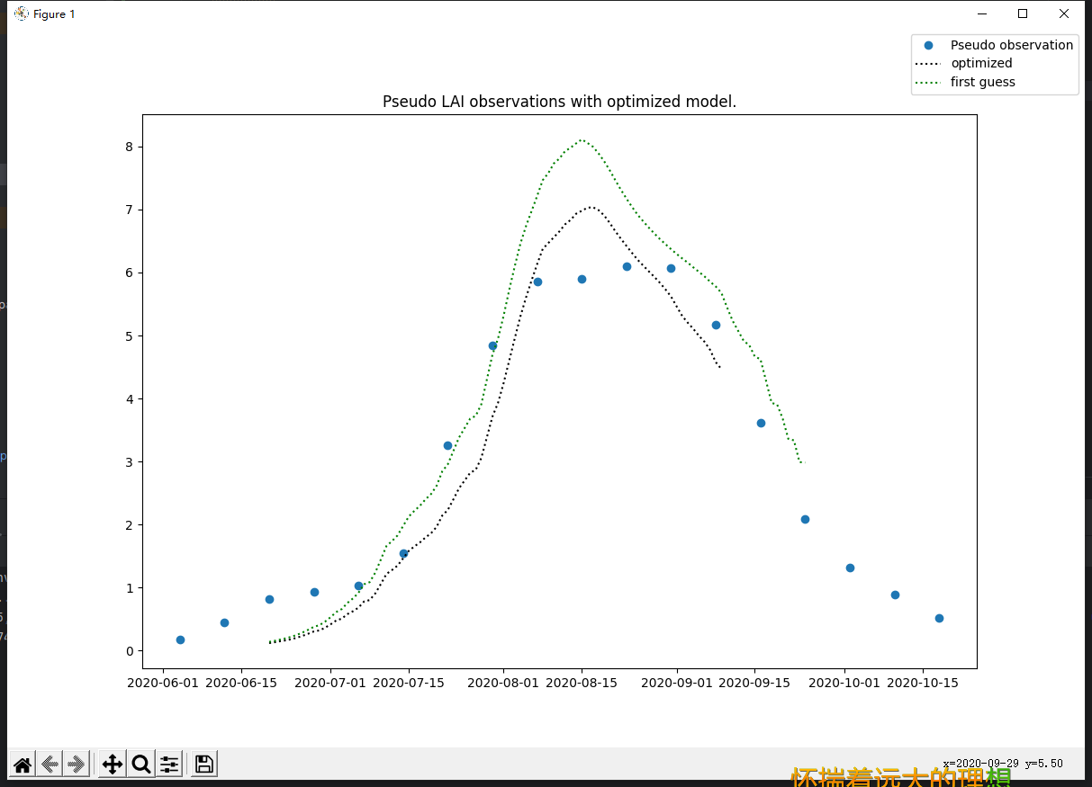

0.5

|  |  |
| --- | --- |
| 150 | 431730C201909221008 |

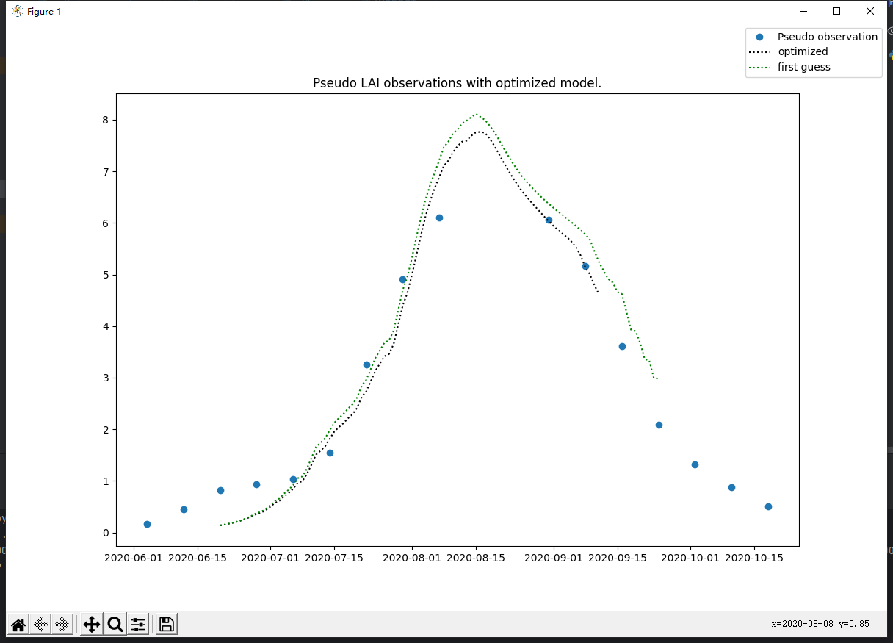

0.5

optimum at TSUM1: 1585.0, TSUM2: 500.0, SLATB3: 0.007472656250000001, TBASE: 8.888281250000006, KDIFTB7: 0.6135644531249996, EFFTB1: 0.5, CVL: 0.7671250000000004, CVO: 0.6, RMO: 0.003450000000000001, RMS: 0.022000000000000002, FRTB7: 0.46562499999999996, FLTB3: 0.5738750000000002, FLTB5: 0.35, RDI: 6.021875

minimum value = 0.4795078314983369

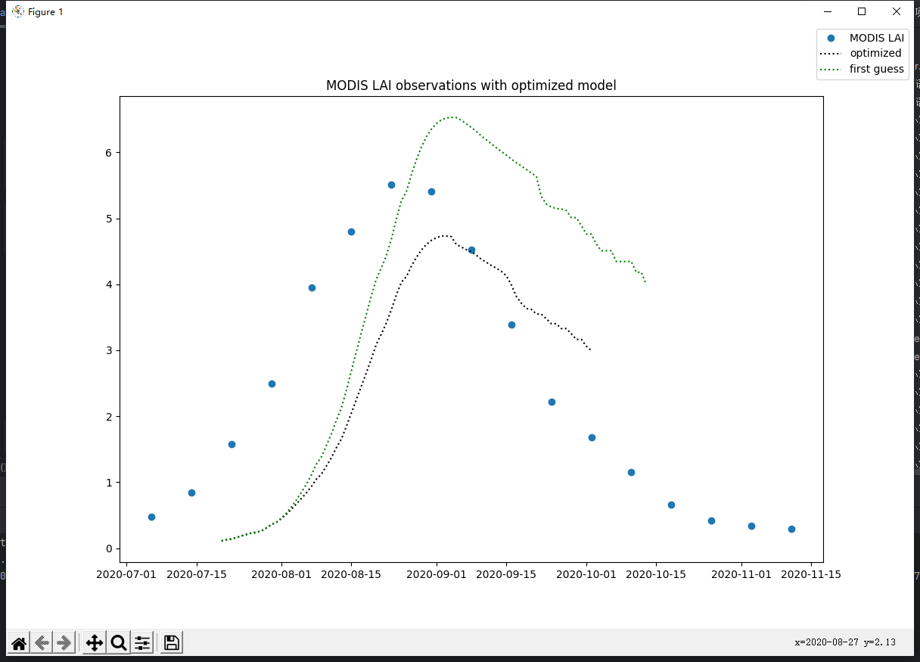

0.6 123 431729C201909282001

optimum at TSUM1: 1523.4375, TSUM2: 488.75, SLATB3: 0.0024597363281250086, TBASE: 6.0, EFFTB1: 0.4, EFFTB3: 0.40601806640625004, AMAXTB1: 42.10000000000001, CVL: 0.769, FRTB3: 0.4, FRTB5: 0.4, FLTB3: 0.67, FLTB5: 0.5, FLTB7: 0.5817890625000001, RDRSTB5: 0.0178125

minimum value = 1.75988821359049

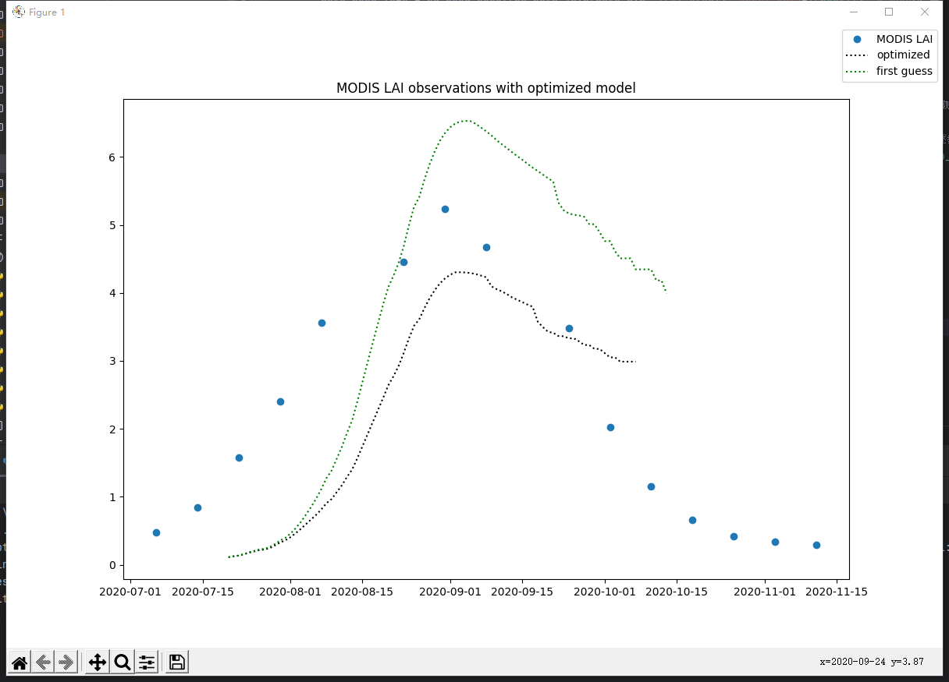

0.4

optimum at TSUM1: 1552.265625, TSUM2: 532.5, SLATB3: 0.0024328125, TBASE: 10.701855468750004, EFFTB1: 0.5354296875000002, EFFTB3: 0.3, AMAXTB1: 44.0, CVL: 0.7277500000000006, FRTB3: 0.4, FRTB5: 0.4, FLTB3: 0.6699999999999999, FLTB5: 0.5, FLTB7: 0.587537109375, RDRSTB5: 0.019625

minimum value = 1.5009306545141663

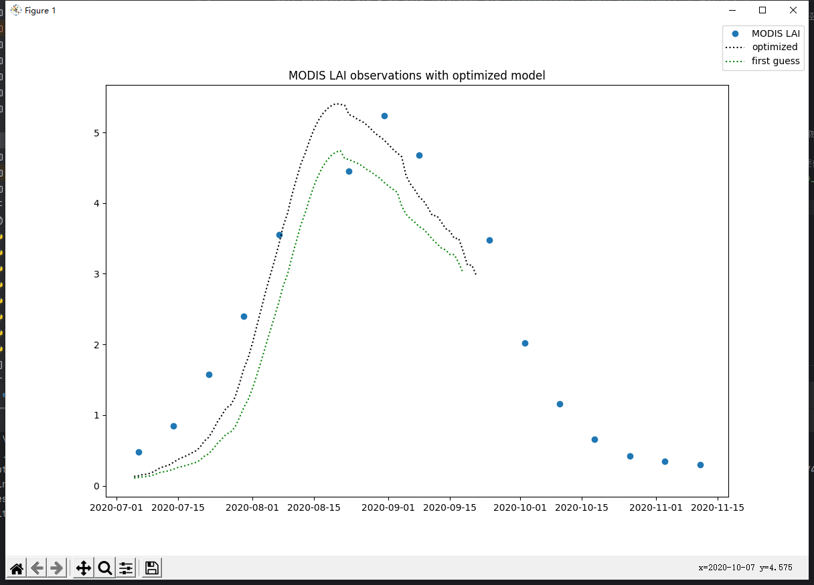

0.4播种时间7.05

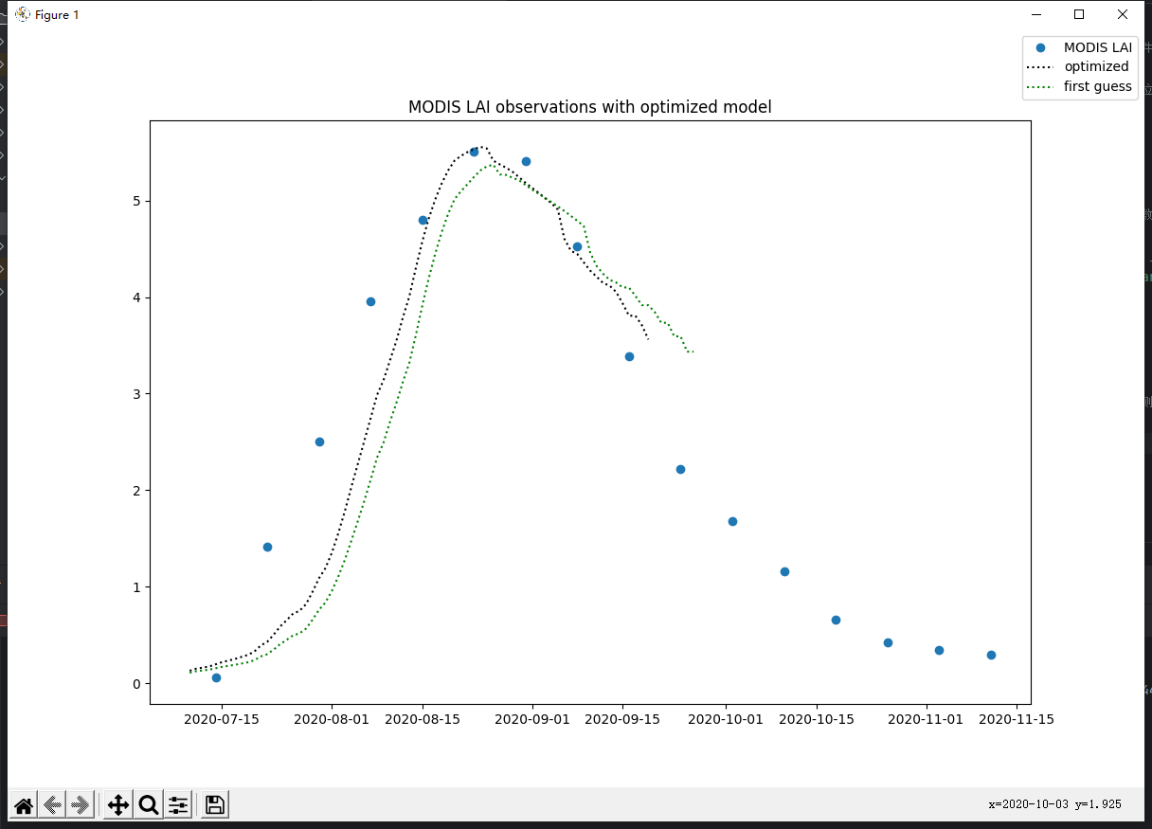

0.5播种时间7.10 123 431729C201909282001

optimum at TSUM1: 1550.0, TSUM2: 475.0, SLATB3: 0.0032685937500000024, TBASE: 6.0, EFFTB1: 0.5993750000000002, EFFTB3: 0.31550781249999993, AMAXTB1: 44.0, CVL: 0.736500000000001, FRTB3: 0.4, FRTB5: 0.4, FLTB3: 0.6606250000000009, FLTB5: 0.5, FLTB7: 0.5835000000000001, RDRSTB5: 0.01775

minimum value = 0.7251896800330373