[An Online Web-Streaming Service for Bitcoin-Exchanges]

Progress Report



Information Technology Capstone Project

COMP5703

Group Members

1. Yangkai Hong (470231528)
2. Karim Santallo (470155497)
3. Jiaqing Li (470166910)
4. Sreejith Warrier (470217050)

Table of Contents

Table of Contents i

1. Progress Status 1

2. Roles & Responsibilities 2

3. Individual Achievements 2

4. Group Collaboration 2

# Progress Status

|  |  |
| --- | --- |
| **Project Name** | An Online Web-Streaming Service for Bitcoin-Exchanges |
| **Project Start Date** | 8 August 2018 |
| **Project Manager** | Karim Santallo |

|  |  |
| --- | --- |
| Project Description | Implement a web application that retrieves, stores and visualizes data from Bitcoin exchanges. |

|  |  |  |
| --- | --- | --- |
| Project Status Report | #2 | Date:24 August 2018 |

|  |  |  |
| --- | --- | --- |
| **Status Item** | **Status up to last week** | **Planned for this week** |
| **Major deliverables** | ·Agile methodology used for the project – Scrum, which contains 5 sprints  ·Teamgantt as our project management tool, including schedule, tasks and milestones  ·Initial user stories  ·Drafted project proposal | ·Proposal submission  ·User stories filled up  ·Learn React tutorial  ·Learn D3.js tutorial  ·Learn websocket tutorial  ·Basic website skeleton |
| **Planned delivery date** | 22 August 2018 | 29 August 2018 |
| **Major issues** | ·Concerns of Related Literature section in proposal | ·Time |
| **Major risks** | ·Not enough user stories | ·My learning plan could be affected by quizs, exams and interviews |
| **External dependencies** | None | Backend API, database |
| **Estimated effort (hr)** | 18 | 17 |
| **Recorded effort (hr)** | 18 |  |
| **Status (R, Y, G)** | Green | Green |

# Roles & Responsibilities

**Yangkai Hong (me)** - Web Developer (Front-end)

·Write project problems section of proposal.

·Update user stories to help designing our product.

·Learn Front-end framework – React, to build a high quality product.

·Learn websocket to interact with our back-end API.

·Learn D3.js to visualise constant data at first, then visualise real order book data.

**Karim Santallo** – Team lead, project manager

**Sreejith Warrier** – Web Developer (Back-end)

**Jiaqing Li** – Data specialist, Quality Assurance

# Individual Achievements

·Continued drafting my section of the proposal

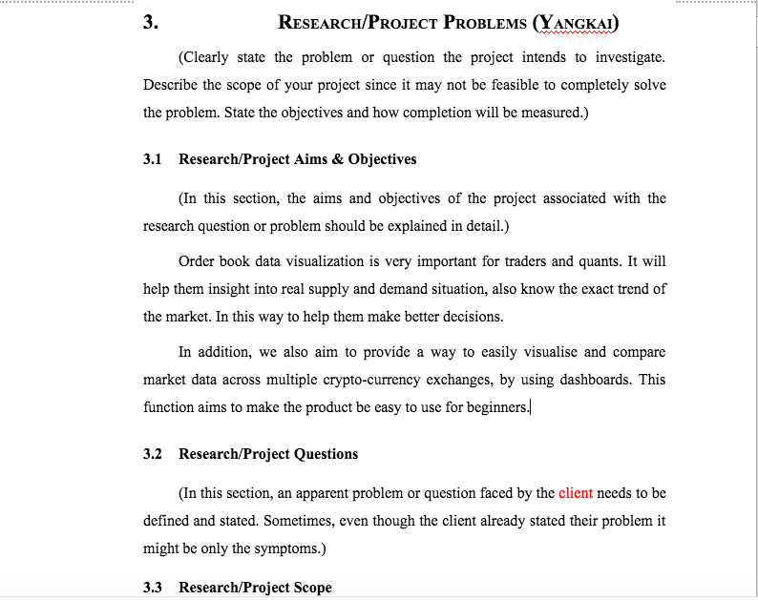

·Learned a two and half hours long React tutorial on Youtube.

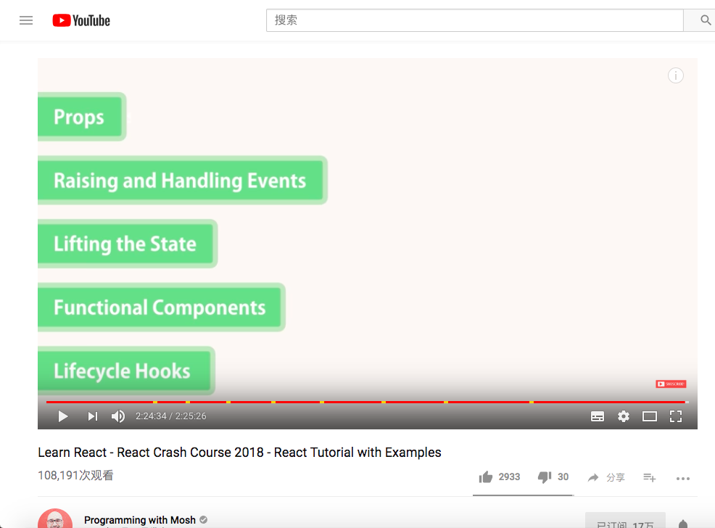

·Learned knowledge of Visual Studio Code editor, .jsx(e.g. use className instead of class), React Developer Tools in chrome, Controlled component concept, React lifecycle hooks, props, stateless functional component, class component. Developed my skills on React. Build a front-end skeleton of our product.

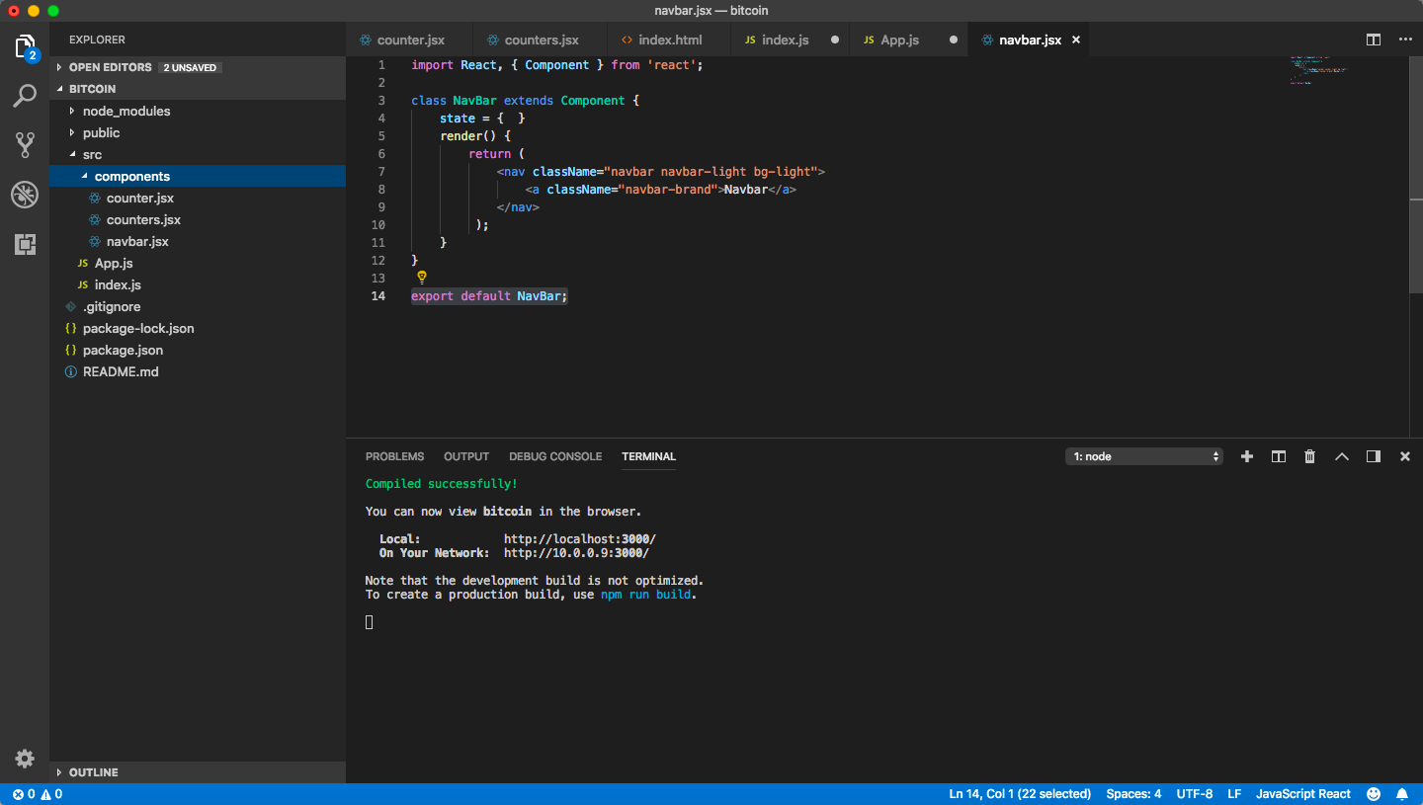

# Group Collaboration

·There was not much discussion on Slack this week because we were focus on researching of proposal. However, we made a good progress on Wednesday physical meeting. Here is our meeting minutes.

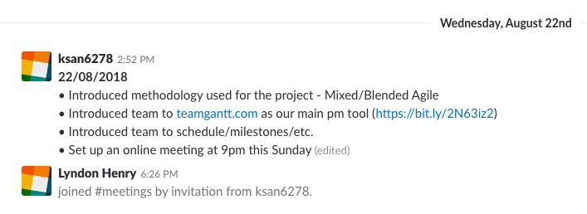

·Also, we brainstormed some user stories to help designing our product.

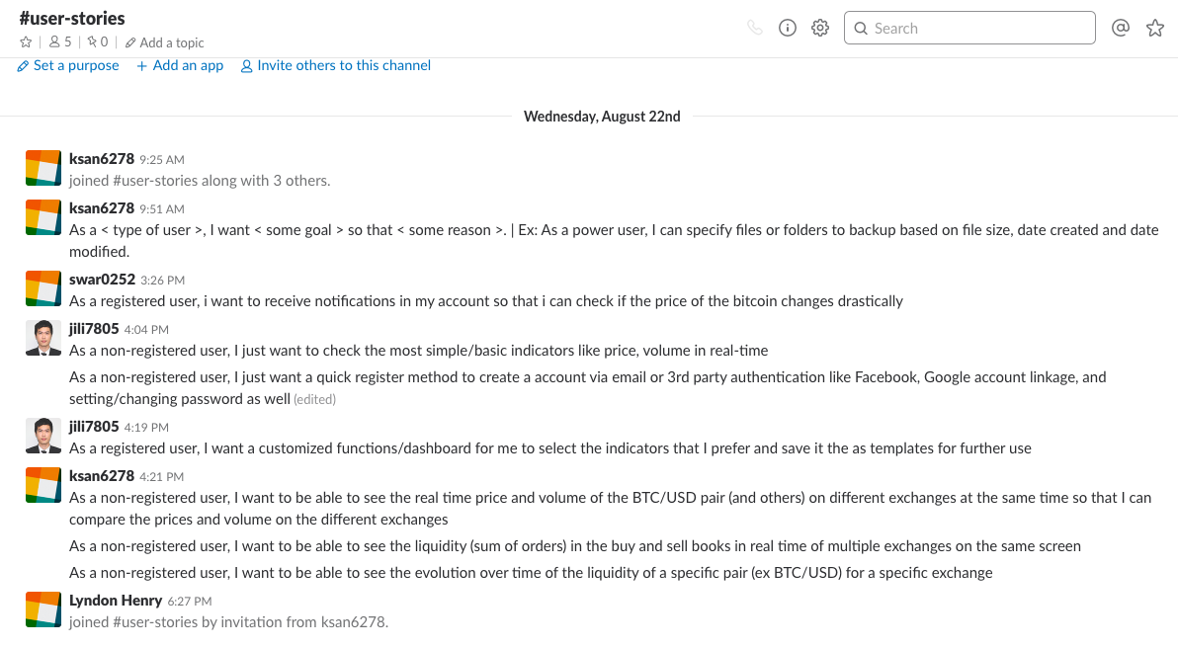

·And, we ultilized teamgantt software to cooperate on tasks. Everyone’s task progress is visible to other team members.

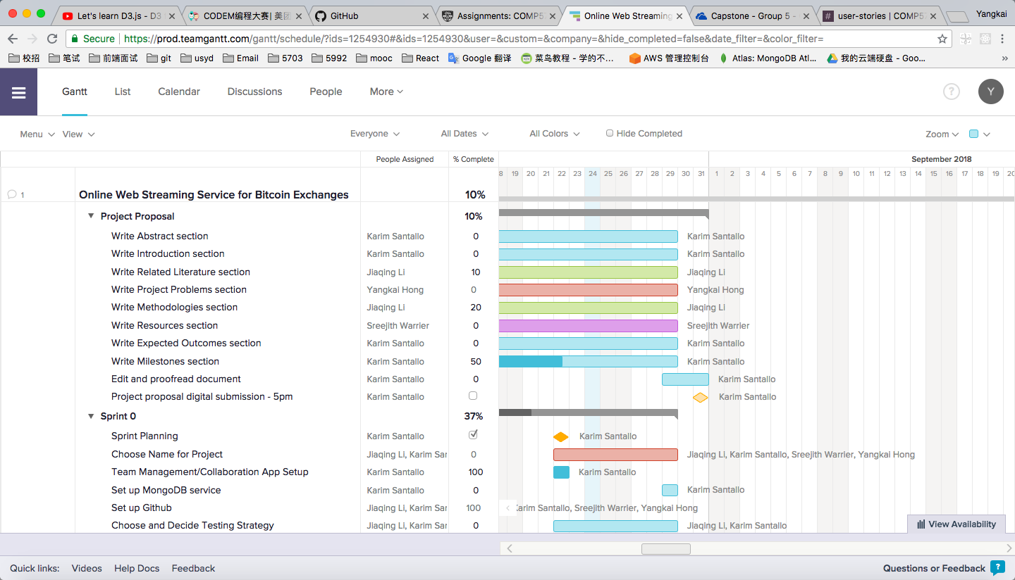

·Last, we planned an online meeting on this Sunday at 9pm to check our progress.