[An Online Web-Streaming Service for Bitcoin-Exchanges]

Progress Report



Information Technology Capstone Project

COMP5703

Group Members

1. Yangkai Hong (470231528)
2. Karim Santallo (470155497)
3. Jiaqing Li (470166910)
4. Sreejith Warrier (470217050)

Table of Contents

Table of Contents i

1. Progress Status 1

2. Roles & Responsibilities 2

3. Individual Achievements 2

4. Group Collaboration 2

# Progress Status

|  |  |
| --- | --- |
| **Project Name** | An Online Web-Streaming Service for Bitcoin-Exchanges |
| **Project Start Date** | 8 August 2018 |
| **Project Manager** | Karim Santallo |

|  |  |
| --- | --- |
| Project Description | Implement a web application that retrieves, stores and visualizes data from Bitcoin exchanges. |

|  |  |  |
| --- | --- | --- |
| Project Status Report | #5 | Date: 14 September 2018 |

|  |  |  |
| --- | --- | --- |
| **Status Item** | **Status up to last week** | **Planned for this week** |
| **Major deliverables** | ·40 commits to my forked repository  ·2 pull request merged by upstream repository  ·Dashboard component (Main layout)  ·Market Depth Chart component  ·Order Book Table component | ·Implement Price Alert component  ·Integrate front-end components and back-end services  ·Implement real-time table & charts  ·Pull request to upstream repository |
| **Planned delivery date** | 14 September 2018 | 21 September 2018 |
| **Major issues** | ·Back-end API service for candle chart delayed | ·Back-end services |
| **Major risks** | ·Database schema should be correctly designed, it affects data storage & performance a lot. | ·Database schema |
| **External dependencies** | ·Ant Design framework | ·Ant Design framework |
| **Estimated effort (hr)** | 20 | 18 |
| **Recorded effort (hr)** | 20 |  |
| **Status (R, Y, G)** | Green | Green |

# 2. Roles & Responsibilities

**Karim Santallo**

**Team Lead, Web Developer, Quality Assurance**

* Keeps the team on track to deliver a quality product on time.
* Responsible for the implementation and management of the agile methodology.
* Maintains the product backlogs and planning of sprints.
* Schedules, organises and facilitates team meetings.
* Implementing user login, logout and register functions.
* Implementing API services for Candle Chart and Order Book.

**Jiaqing Li**

**Web developer / Data specialist, Quality Assurance**

* Assist Team Lead with management duties and responsibilities.
* Assist front-end with designing MongoDB schema for Order Book.
* Collecting data into database for Order Book.
* Implementing Google and Facebook account login function.

**Sreejith Warrier**

**Lead Back-End Developer**

* Developing back-end API for providing candle chart data.
* Provides counsel on technical back-end design decisions.
* Assist with front-end development when necessary.

**Yangkai Hong** (me)

**Lead Front-End Developer**

* Implementing front-end components including Dashboard (Main layout), Candle Chart, Market Depth Chart, Order Book Table and Price Alert.
* Provides counsel on technical front-end design decisions.
* Designing API services and database schemas that front-end requires. Communicate with team members.

# Individual Achievements

1). Sent a pull request to upstream repository on Wednesday, 12 September.

Before this pull request, I solved all the conflicts between my working repository and current upstream repository. After integrating the front-end (login, register, router and dashboard) and making it runnable, I sent the pull request and be merged by upstream repository.

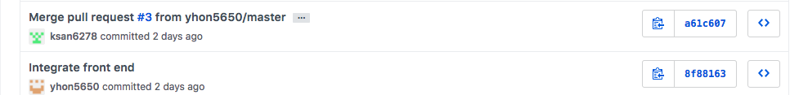

2). 40 commits to my own repository so far. Added new features, fixed bugs, integrated teamates’ works.

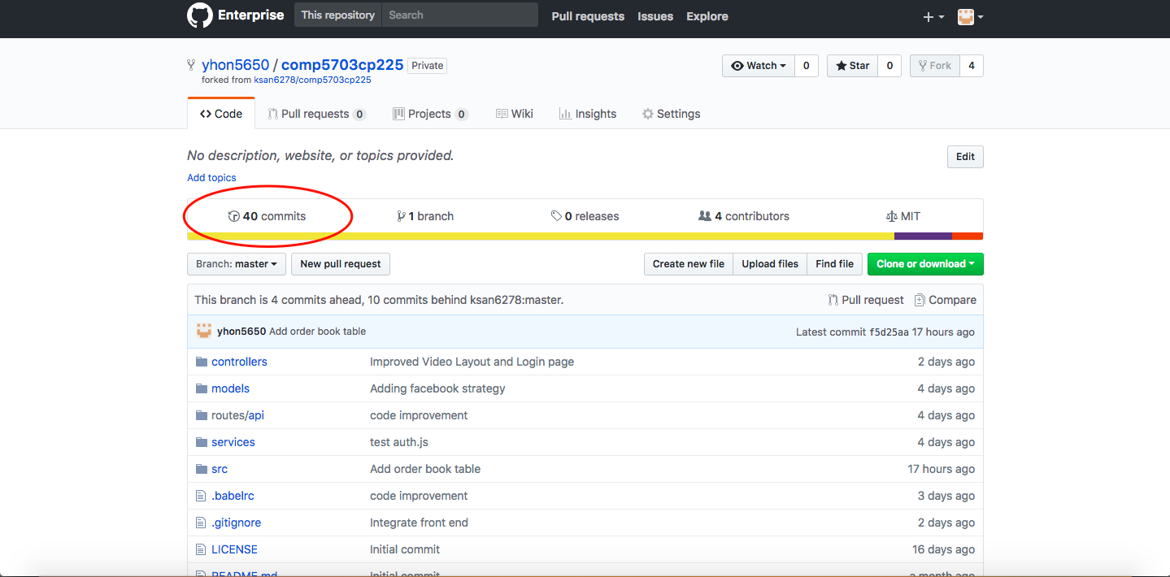

3). Learned and ultilized Ant Design, which is an enterprise-class React UI framework. Up to now, I have finished Dashboard (Main layout with navbar, sidebar, content area and footer), Order Book Table, Market Depth Chart and Candle Chart. See the figures below.

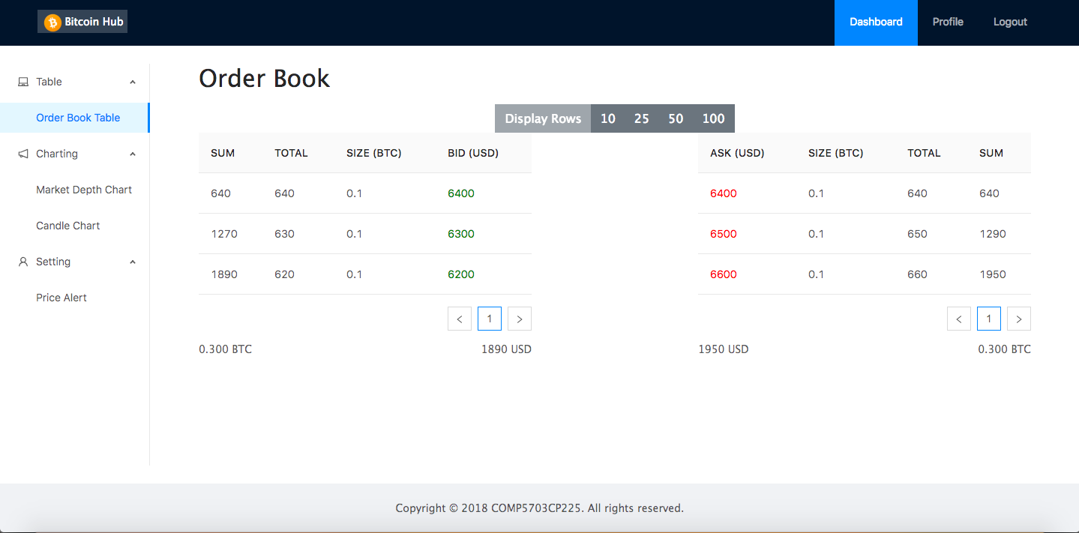

Figure 1. Dashboard – Order Book Table

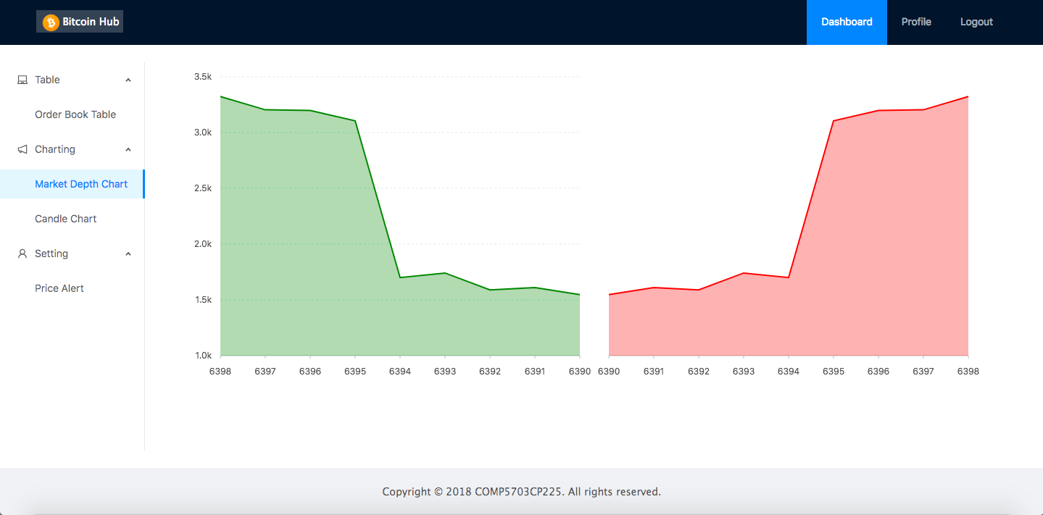

Figure 2. Dashboard – Market Depth Chart

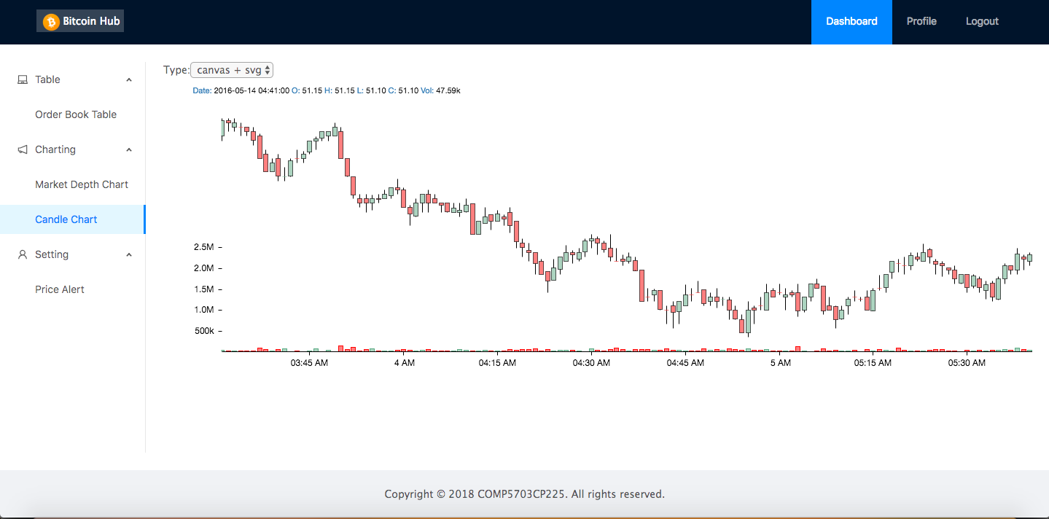

Figure 3. Dashboard – Candle Chart

# Group Collaboration

1). Communicated with our database manager about order book data schema. Explained it clearly to team and reached an agreement.

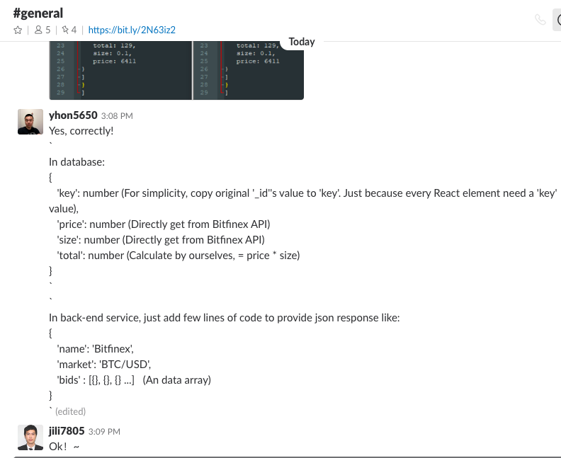

2). Discussed with project manager Karim about how to integrate our works. Finally it works.

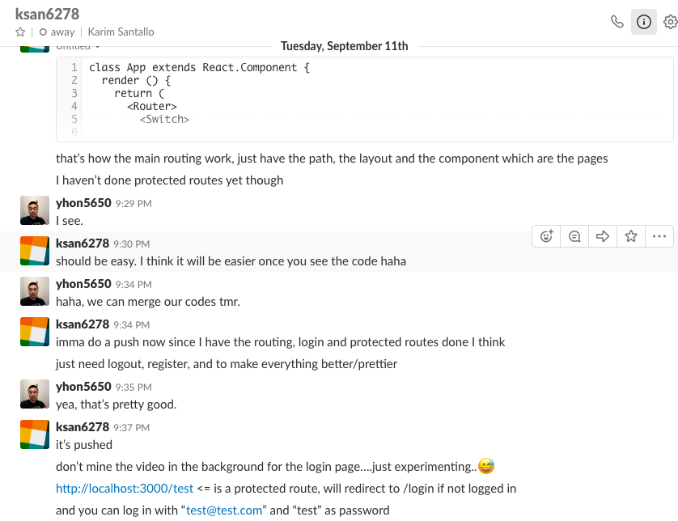

3). We planned an online meeting this Saturday, 15 Spetember to quickly catch up our progress and figure out problems & concerns.

