[An Online Web-Streaming Service for Bitcoin-Exchanges]

Progress Report



Information Technology Capstone Project

COMP5703

Group Members

1. Yangkai Hong (470231528)
2. Karim Santallo (470155497)
3. Jiaqing Li (470166910)
4. Sreejith Warrier (470217050)

Table of Contents

Table of Contents i

1. Progress Status 1

2. Roles & Responsibilities 2

3. Individual Achievements 2

4. Group Collaboration 2

# Progress Status

|  |  |
| --- | --- |
| **Project Name** | An Online Web-Streaming Service for Bitcoin-Exchanges |
| **Project Start Date** | 8 August 2018 |
| **Project Manager** | Karim Santallo |

|  |  |
| --- | --- |
| Project Description | Implement a web application that retrieves, stores and visualizes data from Bitcoin exchanges. |

|  |  |  |
| --- | --- | --- |
| Project Status Report | #6 | Date: 21 September 2018 |

|  |  |  |
| --- | --- | --- |
| **Status Item** | **Status up to last week** | **Planned for this week** |
| **Major deliverables** | ·Detailed wireframe  ·Real-time candle chart for Bitfinex (BTC/USD)  ·Volume chart component  ·Order books table component  ·Main layout implementation  ·Back-end websocket API for candle chart  ·MongoDB schemas for candle chart and order book | ·More detailed wireframe  ·Dashboard layout implementation  ·Line chart with multiple data series for dashboard  ·API services for line chart and order book  ·Real-time candle chart for HitBTC (BTC/USD) |
| **Planned delivery date** | 21 September 2018 | 28 September 2018 |
| **Major issues** | ·Candle chart unit test | ·HitBTC API |
| **Major risks** | ·Data correctness | ·Data correctness  ·Unit, component tests |
| **External dependencies** | ·Bitfinex API  ·react-stockcharts library | ·HitBTC API  ·Ant Design framework |
| **Estimated effort (hr)** | 18 | 20 |
| **Recorded effort (hr)** | 18 |  |
| **Status (R, Y, G)** | Green | Green |

# Roles & Responsibilities

**Karim Santallo**

**Team Lead, Web Developer, Quality Assurance, Designer**

* Keeps the team on track to deliver a quality product on time.
* Responsible for the implementation and management of the agile methodology.
* Maintains the product backlogs and planning of sprints.
* Schedules, organises and facilitates team meetings.
* Website wireframe design, Dashboard layout implementation, and testing.
* Quality assurance of software and report deliverables.

**Jiaqing Li**

**Data specialist, Quality Assurance**

* Assist Team Lead with management duties and responsibilities.
* Responsible for design and implementation of database functions.
* Back-end Order Book websocket API service implementation, and testing.
* Quality assurance of software and report deliverables.

**Sreejith Warrier**

**Database Administrator**

* Responsible for major data collecting and testing.
* Provides counsel on technical data collecting decisions.
* Assist with front-end development when necessary.

**Yangkai Hong** (me)

**Lead Front-End, Back-End Developer**

* Responsible for major front-end functions design, implementation, and testing.
* Provides counsel on technical front-end design decisions.
* Assist with back-end development when necessary.
* Assit with website wireframe design, responsible for implementation.
* Responsible for back-end websocket API services implementation and MongoDB schemas design.

# Individual Achievements

**1). Collecting data.**

Implemented data collecting scripts to collect Bitfinex Candle Channel data with **different time intervals** and stored data into different collections in MongoDB. It enables front-end to render chart with different time intervals, which can help improve user experience.

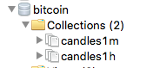

Figure 1. Database Collections

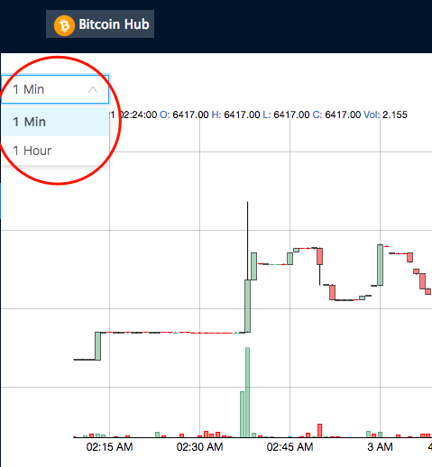

Figure 2. Front-end Time Interval Selection

In addition, the scripts keep updating the historical data to ensure 100% **data correctness**.

Figure 3 is my data collecting console logs, which shows the correct way to collect candle chart data.

As you can see, most messages from Bitfinex API are updating historical data. It is very important.

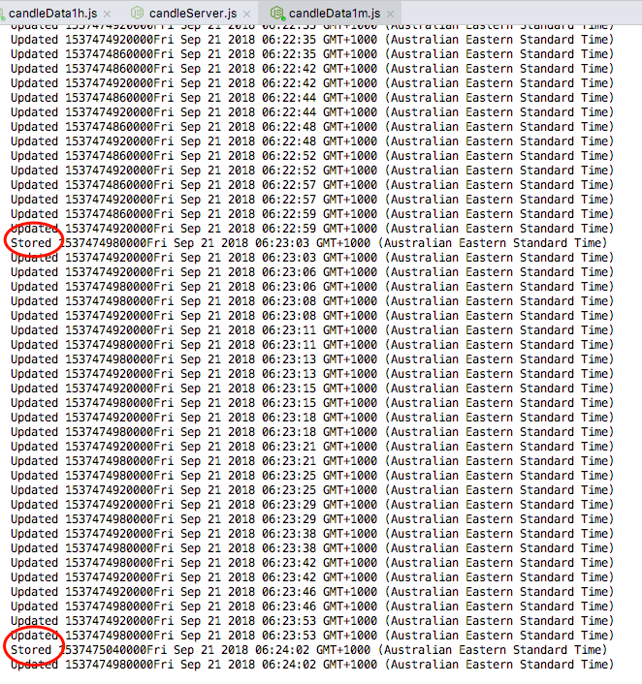

Figure 3. Data collecting console logs

**2). Back-end WebSocket API service.**

Implemented back-end WebSocket server to provide candle chart data for front-end. The server requests database and posts message to client at a certain time interval, which enables front-end to display a **real-time** chart.



Figure 4. Back-end WebSocket console logs

**3). Real-time Candle Chart for Bitfinex exchange.**

With fresh data stored in database and back-end service implemented. The front-end component is able to diplasy a real-time chart. And I had a screen recording video for this achievement. The link is <https://youtu.be/J4g5CcyQhCE>.

This achievement is a very **important milestone**. It can provide us guide to implement other functions.

# Group Collaboration

1). I had a long time conversation with our Project Manager Karim, testing the correctness of Canlde Chart implementation. Finally, we succeed and made our chart display the same data as tradingview.

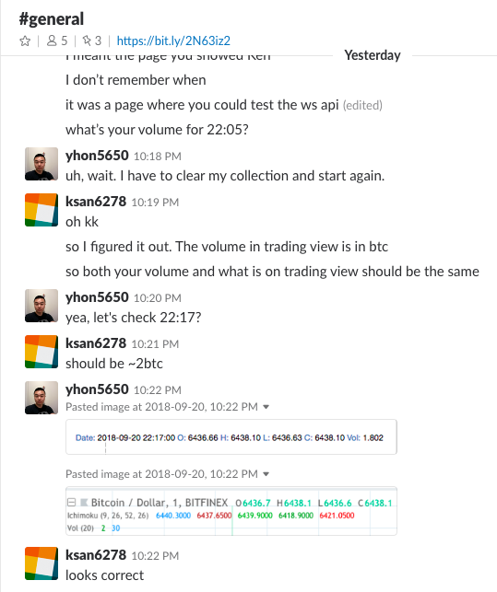

Figure 5. Candle Chart Testing Conversation

2). Project Manager Karim and I had a conversation about website **wireframe design**. This conversation helps a lot and made our tasks much more clear and easier.

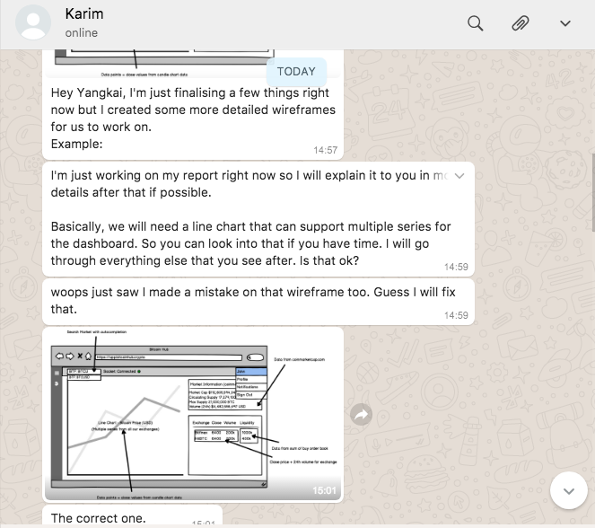

Figure 6. Wireframe Design Conversation

3). We have planned an online meeting on 8pm this Saturday to catch up our progress and solve some problems.

# Summary

**Week 6**

1). Sent pull request to our upstream repository and be merged by the owner.

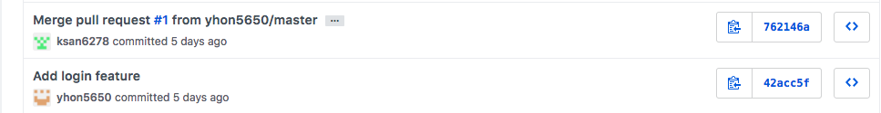

2). Deployed a demonstration to Heroku platform showing what I have done so far, and sharing it to my team.

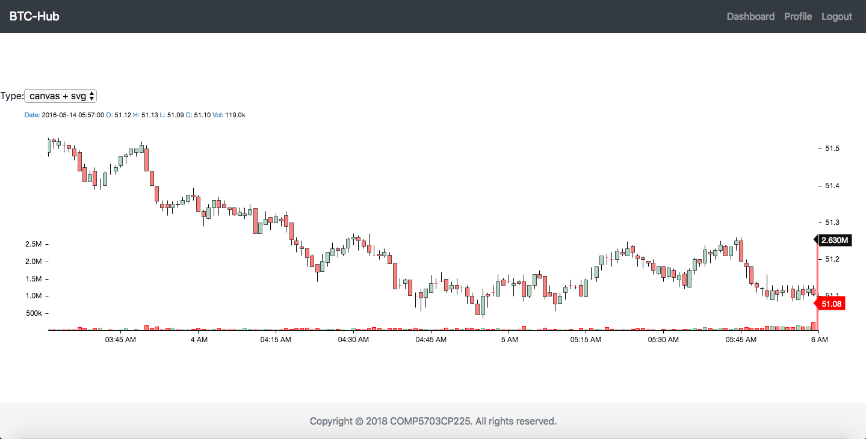

3). Developed several components, including Navbar, Footer, Signin Form, Candle chart, Price line chart and Price table, for our web application’s front-end.

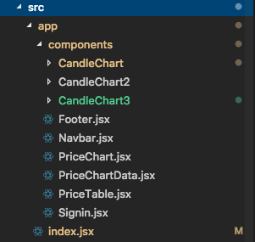

**Week 7**

1). Sent a pull request to upstream repository on Wednesday, 12 September.

Before this pull request, I solved all the conflicts between my working repository and current upstream repository. After integrating the front-end (login, register, router and dashboard) and making it runnable, I sent the pull request and be merged by upstream repository.

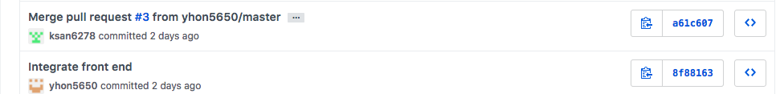

2). 40 commits to my own repository so far. Added new features, fixed bugs, integrated teamates’ works.

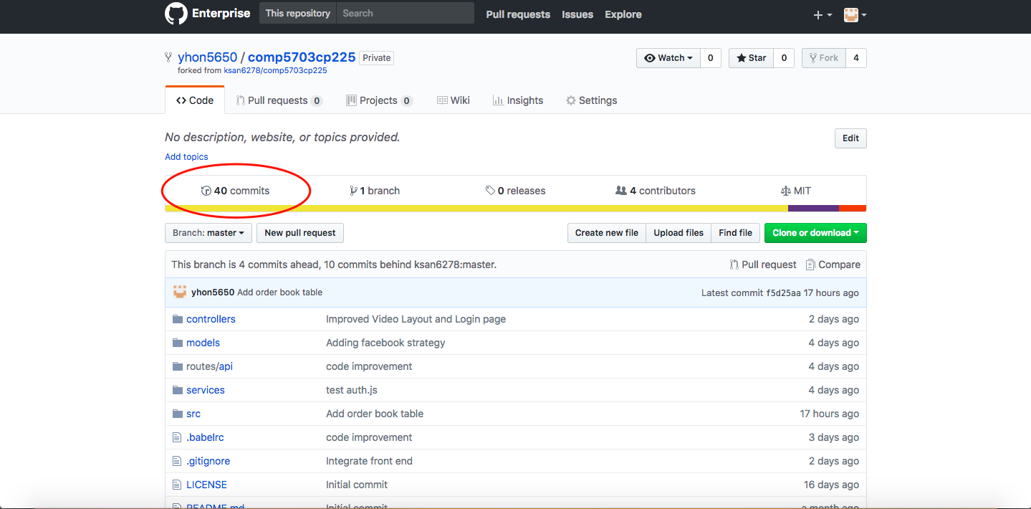

3). Learned and ultilized Ant Design, which is an enterprise-class React UI framework. Up to now, I have finished Dashboard (Main layout with navbar, sidebar, content area and footer), Order Book Table, Market Depth Chart and Candle Chart. See the figures below.

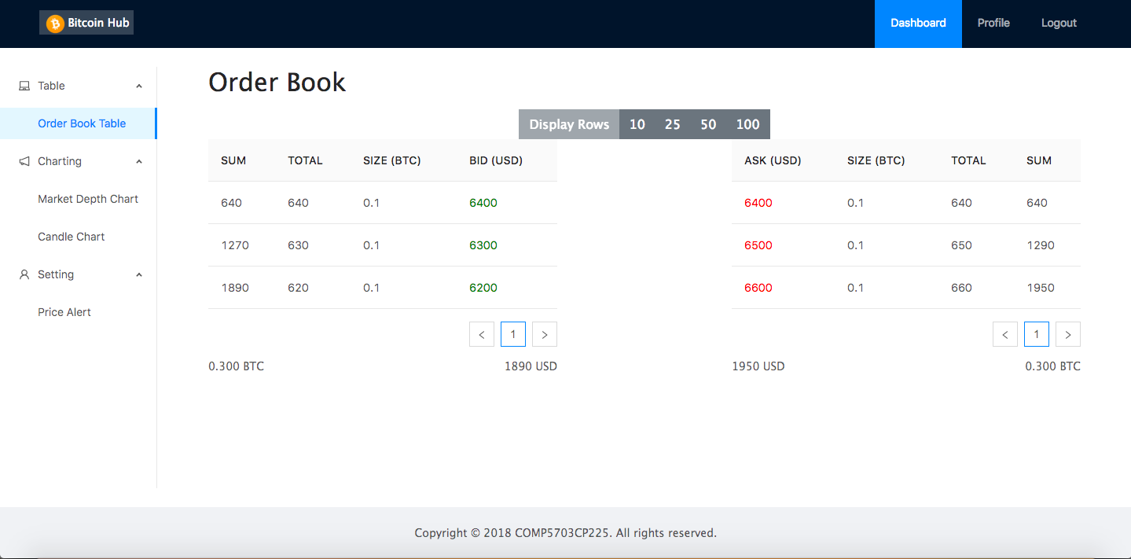

Figure 1. Dashboard – Order Book Table

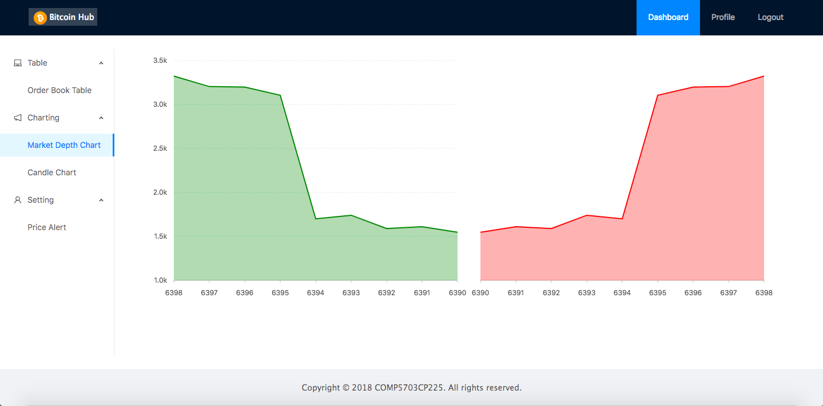

Figure 2. Dashboard – Market Depth Chart

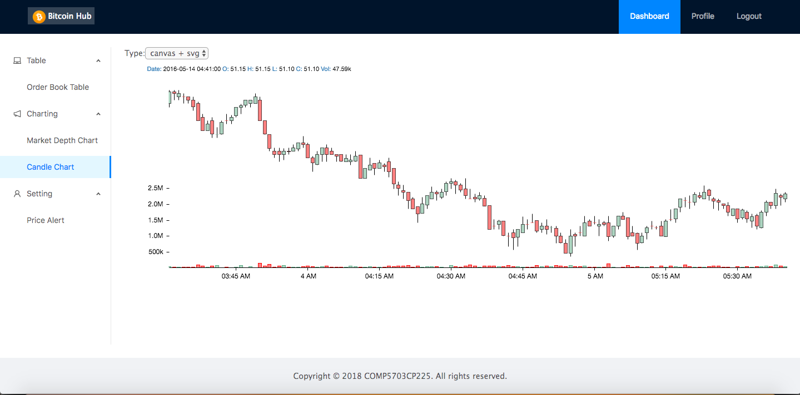

Figure 3. Dashboard – Candle Chart

**Week 8**

**1). Collecting data.**

Implemented data collecting scripts to collect Bitfinex Candle Channel data with **different time intervals** and stored data into different collections in MongoDB. It enables front-end to render chart with different time intervals, which can help improve user experience.

In addition, the scripts keep updating the historical data to ensure 100% **data correctness**.

Figure 3 is my data collecting console logs, which shows the correct way to collect candle chart data.

As you can see, most messages from Bitfinex API are updating historical data. It is very important.

**2). Back-end WebSocket API service.**

Implemented back-end WebSocket server to provide candle chart data for front-end. The server requests database and posts message to client at a certain time interval, which enables front-end to display a **real-time** chart.



Figure 4. Back-end WebSocket console logs

**3). Real-time Candle Chart for Bitfinex exchange.**

With fresh data stored in database and back-end service implemented. The front-end component is able to diplasy a real-time chart. And I had a screen recording video for this achievement. The link is <https://youtu.be/J4g5CcyQhCE>.

This achievement is a very **important milestone**. It can provide us guide to implement other functions.

**SID** _4_._7_._0_._2_._3_._1_._5_._2_._8_ Name _________________Yangkai Hong___________________________________

Student identification number First name (Preferred first name) Family name

**The submission of the deliverables up to this week required the application of the following three software development, project management and team work activities from each colleague in your team:**

* Contribution to the design and implementation of the current sprint user stories.
* Contribution to the full range of software development activities (including requirements capture, analysis and design, coding, testing and documentation).
* Contribution to group work and sharing of work.

Based on the overall combination of the contribution above, rate your teammates’ performance in the activities up to and including week 5.

**IMPORTANT: You *must* assess all your teammates. Use only whole numbers addressing the criteria below:**

|  |  |  |  |  |
| --- | --- | --- | --- | --- |
| **1**  **[0 – no contribution]** | **2** | **3** | **4** | **5** |
| Below satisfactory in 3 criteria ***or*** very poor in *any* activity | Satisfactory in 1 criteria ***and*** poor in 2 activities (none very poor) | Good in at least 2 criteria ***and*** activity in 1 | Excellent in at least 1 activity ***and*** good in 2 others | Excellent in all 3 activities |

|  |  |  |  |
| --- | --- | --- | --- |
| **Student ID** | **Name** | **Rating 0 to 5 *no fractions\*** | **Reason for rating** |
| 470155497 | Karim Santallo | 5 | ·Great project manager  ·Designed the project sprints  ·Sharing of work  ·Always available to discuss/work on the project  ·Worked on the implementation of some of the layout. |
| 470166910 | Jiaqing Li | 5 | ·Sharing of work  ·Attends group meetings and very good and responsive online communication |
| 470217050 | Sreejith Warrior | 5 | ·Contribute to implementation  ·Contribute to group work  ·Helped with storage of real-time candle chart data from Bitfinex |
|  |  |  |  |

**Comments**: